**COMPUTER STUDIES**

**PAPER 1 MARKING SCHEME**

**THEORY**

ASUMBI GIRLS HIGH SCHOOL

PRE-MOCK

MAY-JUNE

2022

**SECTION A (40 MARKS)**

***ANSWER ALL THE QUESTIONS FROM THIS SECTION IN THE SPACES PROVIDED***

1. One of the functions of an operating system is to control computer resources. State three resources under operating system control (3 marks)

**Processor**

**Input/output devices**

**Application programs**

**Storage devices**

**Communication devices and ports**

1. (a) The figure below shows the relationship between tables in a database.

Table 1

Admno

Termcode

Idno

Eng

maths

1

∞

Table3

Admno

Name

Class

∞

1

Table 2

Termid

Year

Identify two primary keys and two foreign keys used in the relationships (2 marks)

**PK FK**

**AdmNo TermId**

**TermCode AdmNo**

(b) Distinguish between bound and unbound controls as used in database forms (2 marks)

**Bound controls are used to get data from a table or query while unbound controls do not get data from a table/query/link.**

1. Explain why an impact printer is suitable for printing multiple copies (2 marks)

**They have special hammers that produce characters on a piece of paper. And behind every paper, there is a coupon copy that produces characters on another paper.**

1. State any four examples of document readers (2 marks)

**OBR**

**OMR**

**OCR**

**MICR**

1. (a) Define the term simulation (1 mark)

**This is the process of creating a model of a real object/concept in order to experiment the behavior of a real object using a computerized model**

**(b)** List two educational areas where simulation programs can be used (1 mark)

**Training drivers**

**Training pilots**

**Training engineers**

1. Explain two ways of protecting data and information against un authorized access (2 marks)

**-Password protection –allows the user to open/ modify file/doc**

**-Data encryption-only authorized user can decipher the code**

**-User and group permission to user- user access levels**

**-Firewalls- filters data and information exchanged between different networks**

**-Security monitors-keeps tracks of activities performed using computer systems e.g. CCTV**

**-Biometric security- only users whose attributes are identified can access**

1. Explain two characteristics of good information (2 marks)

**-Accuracy- should be as close to the actual value as possible**

**-Timeliness- should be available when needed**

**-Relevance- should be useful in order to give out the expected output**

**-Completeness**

1. Explain three types of errors that are likely to exist in a program (3 marks)

**-Syntax errors- errors as a result of incorrect use of a programming language e.g. spelling, incorrect punctuation, use of reserved words etc.**

**-Logical errors-errors that prevent the program from doing what it is expected to do**

**-Runtime errors- results in unexpected/ premature end of a program e.g. an attempt to divide a number by zero**

**9.** State two roles of a network admistrator (2 marks)

**-Sets up a computer network**

**-Maintain and enforce security measures on the networks**

**-Monitor use of network resources**

**-Maintain and troubleshoot network related problems**

**10.** State three negative impacts of information communication technology on the environment (3 marks)

**-The huge piles of garbage of dead computers and accessories causes pollution**

**-Massive extraction of mineral resources for making computer parts**

**-Energy consumption and radiation**

**-Disposal of nickel-cadmium laptop batteries contain cadmium which leaks to the underground water table**

11. Study the follow flowchart then answer the questions that flow.

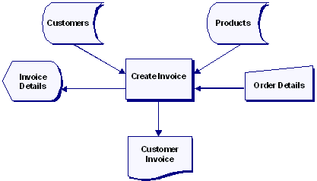

**A**

**C**

**D**

**B**

1. Identify the type of flowchart represented by the flowchart in figure (1 mark)

**System flow chart**

1. Name the flowchart symbols labeled **A, B,C and D** in the flowchart**. (**2 marks)
2. **Stored data**
3. **Screen output/ display**
4. **Manual input**
5. **Document/report**

**12.** Mary a computer student noticed that every time a person enters the computer lab, the computer screen flickered. Identify three reasons why the monitor might be flickering (3marks)

**- There may be a loose connection to the computer hence flickering when touched**

**-Cables maybe laid on the pathway hence flickering when stepped on.**

**-Electrical interference from other electrical nearby devices**

13. (a) state the importance of column breaks as used in a word processor (1 mark)

**Used to enforce an end of a column to start/ move the cursor at the beginning of the next paragraph**

**(b)** List any two line spacing specifications used in Ms- Word (1 mark)

-**Single**

**-Double**

**-1.5**

**-multiple**

14. The first column in the table below contains the formula stored in cell **C10** of a spreadsheet. Enter the formula as they would appear when copied to cell **F15** of the same spreadsheet (2 marks)

|  |  |
| --- | --- |
| **FORMULA IN C10** | **FORMULA IN F15** |
| =A5*B5 | **=D10*E10** |
| =4*B$6 | **=4*E$6** |

15. (a) Differentiate between an analog and digital data signal (2 marks)

**An analog data signal represents data that is continuous in nature while digital signal represents data that is non- continuous in nature**

**(b)** The government of Kenya is in the process of laying out fibre optic cables throughout the country. State three advantages of fibre optic cables (3 marks)

**-Not prone to electromagnetic interference**

**-Supports a high bandwidth**

**-Low attenuation thus suitable for long distance transmission**

**-Smaller and lighter than copper cables**

**-Do not generate electrical signals thus can be used in hazardous places**

**SECTION B( 60 MARKS)**

***ANSWER QUESTION 16 AND ANY OTHER THREE QUESTIONS FROM THIS SECTION***

16.(a) Draw a program flowchart that would accept and their sum. If the sum is greater than 200, it adds 30 to the sum, otherwise subtracts 20 from the sum. The program should then display the results (7 marks)

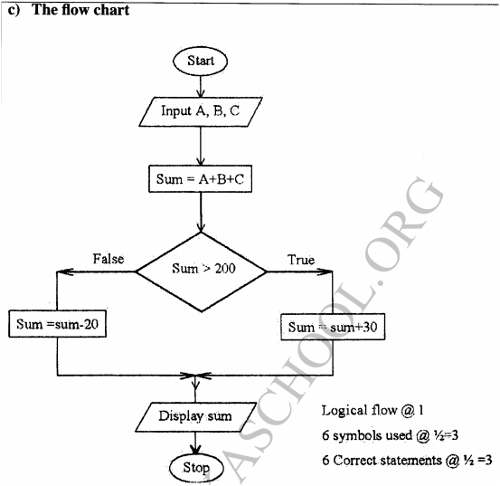

(b) Study the pseudo code below and determine its output (3 marks)

STEP 1: T=0

M=0

K=1

STEP 2 M=M+T

T=T+5

K=K+1

STEP 3 REPEAT STEP 2 WHILE K<3

WRITE M, T

EXIT

|  |  |  |
| --- | --- | --- |
| **T** | **M** | **K** |
| **0** | **0** | **1** |
| **5** | **0** | **2** |
| **10** | **5** | **3** |

**M=5**

**T=10**

(c ) (i)List two benefits of using interviews as a method of fact finding (2 marks)

-**Users can express their opinions in a detailed way**

**-Non- verbal communication can be observed**

**-Questions can be paraphrased for clarification**

**(ii)** Explain three types of system change over strategies (3 marks)

**-Parallel- both the old and the new systems operate together for a period of time before the old system is discarded.**

**-Direct- the old system is discarded and the new one implemented immediately**

**-Phased- the old system is gradually replaced in stages by the new system**

**-Pilot- a section of the organization runs the new system while the rest runs the old system.**

17. (a) state three functions of a database management system (DBMS) (3 marks)

**- allows the user to add or delete records**

**-update or modify existing records**

**-organise data for easy access, retrieval and manipulation**

**-acts as an interface between the database and other applications**

**-enforce security for data in a database**

**-keep statistics of data items in a database**

**(b)** if a database was to be created for a list, Tables, Forms, Queries and Reports are likely to be used. State the purpose of each of the objects (4 marks)

**-Table- for storing data**

**-Forms- data entry, editing and viewing the records**

**-Queries-extracting data used on some criteria/ performing calculations**

**-Reports- creating summaries for data/ performing calculations**

c) The information below is maintained by Jessica Fruit store. Study it and answer the questions that follow:

|  |  |  |  |
| --- | --- | --- | --- |
| **Product number** | **Product name** | **Qty in stock (kg)** | **Value per unit (ksh)** |
| 001 | Peach | 1000 | 200 |
| 002 | Oranges | 1200 | 200 |
| 003 | Mangoes | 1300 | 100 |
| 004 | Tomatoes | 1200 | 140 |
| 005 | Cabbages | 1500 | 25 |

Write down the query statements you can use to list the following;

i) Product names starting with letter P. (2 marks)

**Like P* or P* in query design window**

ii) Value per unit below 200. (2 marks)

**<200 in query design window.**

|  |  |  |  |  |  |  |  |
| --- | --- | --- | --- | --- | --- | --- | --- |
| (d) | | The following is a spreadsheet relating to a farmer.    A function = IF (B2<200, “Not Viable”, IF (B2>300, “Moderate”, IF (B2>1000, “Viable”))). Give the appropriate result returned in cells C2, C3, C4 and C5 | | | | | ***[2 marks]*** |
|  | | A | B | C |
| 1 | | Crop | Amount | **Not viable** |
| 2 | | Maize | 150 | **Not viable** |
| 3 | | Bean | 300 | **Not viable** |
| 4 | | Cashew nuts | 850 | **Moderate** |
| 5 | | Cabbages | 1036 | **viable** |

d) Name **four** data types used in spreadsheets. (2 Marks)

**-labels**

**- Values**

**- Formulae**

**- Functions**

18. (a) Explain the use of the following commands found in the spell check dialog box in reference to word processing (3 Marks)

**i) Change – replace a word with a spelling error with the given suggestion**

**ii) Ignore once – leave a word with a spelling error without making any change**

**iii) Add – used to add a new vocabulary in a list of suggestions into**

**(b)** State four font styles supported by Ms. Word (2marks)

* **Bold**
* **Bold italics**
* **Italics regular**
* **Underline**

**(c) Work out** the following binary arithmetic (2marks)

1. 11101.00112+ 101.0112

**11101.00112**

**+00101.01102**

**100010.10012**

1. **101001.101012-110.011012**

101001.101012

000110.011012

100011.010002

1. Using twos complement, perform the following calculation. (4marks)

**2310 - 4110**

**23=000101112**

**41=001010012 1s complement=110101102**

**2s complement=110101112**

**23-41=000101112+110101112=111011102**

***{Decimal to binary conversions 1mark each (max 2)***

***1s complement ½ mark***

***2s complement ½ mark***

***Addition 1 mark}***

1. Convert 13.12510 to decimal. (2marks)

**Whole number part Fractional part**

|  |  |  |
| --- | --- | --- |
| ***2*** | ***13*** | ***Rem*** |
| ***2*** | ***6*** | ***1*** |
| ***2*** | ***3*** | ***0*** |
| ***2*** | ***1*** | ***1*** |
|  | ***0*** | ***1*** |

**0.125 x 2=0.25**

**0.25 x 2=0.5 ½ mark**

**1mk 0.5 x 2=1.0**

**0.12510 =0.0012**

**1310=11012**

**Therefore, 13.12510 = 1101.0012 ½ mark**

1. A particular computer stores numbers in a single 8-bit word. How would it

represent 0.312510? (2 marks)

***0.3125 x 2 = 0.6250 0***

***0.6250 x 2 1.25 1***

***025 x 2 0.50 0***

***0.5 x 2 1.00 1***

***= 0.01012***

19 ( a) Explain each of the following type of operating systems (4marks)

i. Distributed

**This is an operating system that manages a group of distributed computer system. Distributed computations are carried out on more than one machine.**

ii. Multi-user.

**A multi-user operating system is one that allows for multiple users to use the same computer at the same time and/or different times. Examples include UNIX, Linux, MAC OS****and Windows Server 2003.**

b)List any two types of embedded operating systems used in modern cell phones (2marks)  
*-***Android**

**-Symbian**

**-Windows**

**-FreeBSD**

**-Minix 3**

c) Most operating systems provide a *file system*. Mention any TWO file systems used in windows environment.(2 marks)

***FAT (file allocation table)***

***FAT16***

***FAT32***

***NTFS (new technology file system)***

(d) Define the term interactive data processing. (1mark)

**In interactive data processing there is continuous dialogue between the user and the computer. As the program executes, it keeps on prompting the user to provide input or respond to prompts displayed on the screen.**

(e) Explain why input screens are better data entry designs than entering data directly a table. (2 marks)

* **Faster way of data entry**
* **One record can be viewed at a time.**
* **Data validation is possible**
* **One is able to compute data*.***

(f) State two likely causes of data and program loss in a computer system? (2 marks)

* **Computer virus corrupting data and instructions**
* **Uneven power supply to system components**
* **Theft of data or programs**
* **Disk crash**

Explain the meaning of the following terms as used in data security (2marks)

* 1. Fraud – **use of computer to conceal information or cheat other people with the intention of gaining money or information**

b. Alteration – **the legal charging of data or information with the intention of misinforming authorized users or gaining**

20. (a) The figure below shows an extract of an e-mail application.

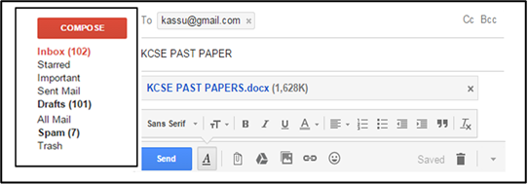

State what is meant by the following (3 marks)

1. Trash

**Acts as a dust bin for your e-mail account where all deleted mails are stored before being permanently removed from the account**

1. Spam

**This is a folder in your account where all junk and suspicious mails received are stored**

1. Inbox

**This is a folder in your account where all genuine mails received are stored**

b) Explain the following interactive sensory equipment used in virtual reality (2marks)

i) Head gear

**A device with tiny screens worn on the head, enable the weaver to view the virtual world.**

ii) Body suit

**Worn by the user, enable the wearer to explorer the virtual world**

c) Most computerized security systems make use of Biometric analysis, name **three** physical features of human beings that can be considered in this analysis (3marks)

* **Finger prints**
* **Voice recognition**
* **Eye / facial recognition.**

1. (i) Define the term networking topology (1mark)

**Refers to the arrangement of the computers, printers and other equipment connected on the network**

(ii) Distinguish between logical and physical network topologies (2marks)

**Logical (signal) topology deals with the way data passes from one device to the next in a network while physical topology refers to the physical arrangement (layout) of devices on the network**

(d) Explain the functions of the following network device (4marks)

1. Network interface card (NIC)

**Creates a physical link between the computer and the transmission media**

(ii) Gateway

**Provides access to a wide area network**

(iii) Bridge

**Device that selectively determines segment where message is to be delivered**

(iv) Repeater

**Receives a weak signal cleans and amplifies it for transmission over the next position of the network**