Name:……………………………………...............ADM No:………......Class:……....
449/1
DRAWING AND DESIGN
PAPER 1
AUGUST-SEPTEMBER
$2½ hours$
MECS CLUSTER JOINT EXAMINATION
FORM FOUR END OF TERM TWO EXAMINATION 2022
DRAWING AND DESIGN
INSTRUCTIONS TO CANDIDATES
- Write your name, index number and class in the spaces provided above.
- The paper contains three sections: Section A, Section B and Section C
- Section A carries 50 marks, section B carries 20 marks and Section C 30 marks
- The paper contains 12 PRINTED pages make sure all PAGES ARE PRINTED and NONE IS MISSING
- Answer ALL the questions in each section.

Section A (50 marks)
- (a). State three types of materials and name objects designed using the stated material
(3 marks)
Glass- glass windows, glass cups, car windscreen, glass table e.t.c
Wood- wooden table, wooden chair, wooden housing roofing e.t.c
Metal- car bodies, hummer, wheelbarrow e.t.c.
(a). Describe the following terms as used in design (2 marks)
(i). Aesthetics
It is the appearance of the final object that has been designed.
(ii). Ergonomics
It is the study of the relationship between people and the project, and the
Working environment.

- On a circle of radius 50 mm, show the following parts of a circle
(3 marks)
(i). Quadrant
(ii). Chord
(iii). A segment

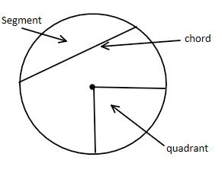

- Given the length of diagonal as 67 mm. Construct a square and measure the length of one side (3 marks)
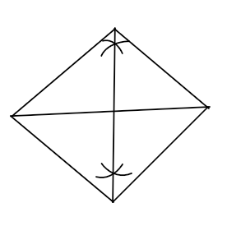

= 48 mm

- Draw the following types of keys (3 marks)

- Woodruff
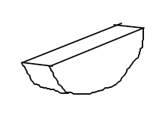

- Pratt and Whitney

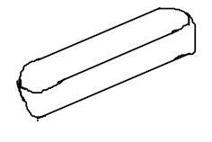

- Gib-head

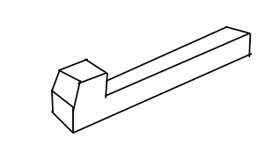

- (a). Use freehand to write the title “ISOMETRIC DRAWING” (1 mark)
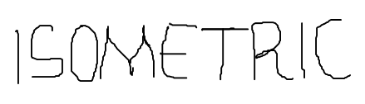

(b). Write down three factors to consider while lettering (3 marks)

Uniformity of the types of letters
Spaces between letters/words
Uniform height of letters

(c). Draw two-dimensional object and name it. (2 marks)

A rectangle

(d) Write down two information required on a title block that give information about work drawn (2 marks)

Title Block
Drawing No./ Scale

- Draw the cuboid shown below and inscribe a triangle on the faces indicated by the arrows. (5 marks)
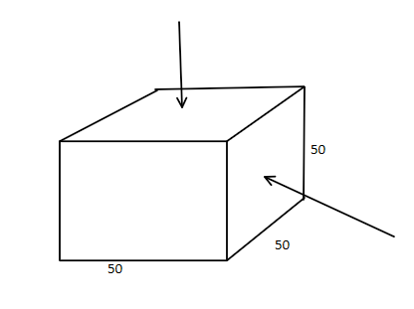

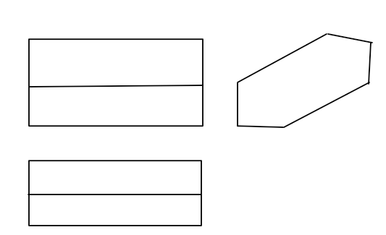
- Sketch a pictorial object for the views below in Isometric (6 marks)

- (i). Propose three types of businesses a person can engage into after studying drawing and design (1½ marks)
Architect industry
Furniture designs
Retailing of parts of a car
Retailing plumbing tools.
(ii). State fours three factors that would cause a business to succeed (1½ marks)
Favorable government policy
Good management skill
Sufficient starting capital
Fair competition
High quality of the product
Availability of the product

- Using the concentric circles method, construct an ellipse whose major axis is 80mm and minor axis is 40 mm (6 marks)
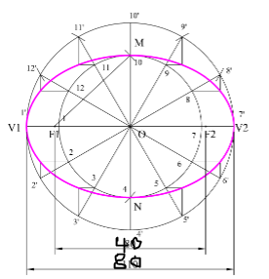

- Construct a diagonal scale of 1:10 to measure a maximum length of 1.0 m with an accuracy of 0.005 m. Indicate a length of 0.6 m (5 marks)

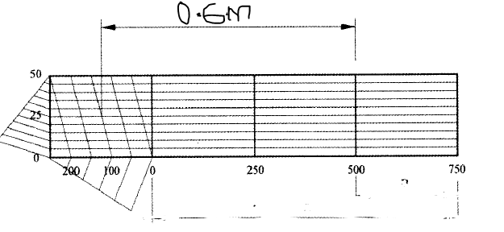

Section B (30 marks)
This question is Compulsory
It should be answered on the A3 paper provided.
Candidates are advised not to spend more than one hour on this question.

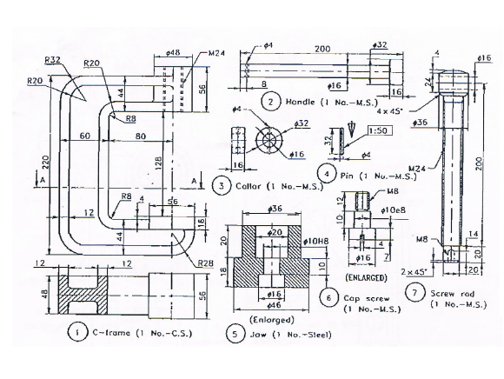
- The figure below shows views of the parts of a tool.
Draw the following,
- Sectional front elevation

- end elevation (30 marks)

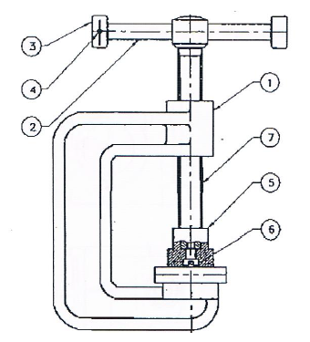

Section C (20 marks)
- (a). The figure below shows three views of a bracket in first angle projection

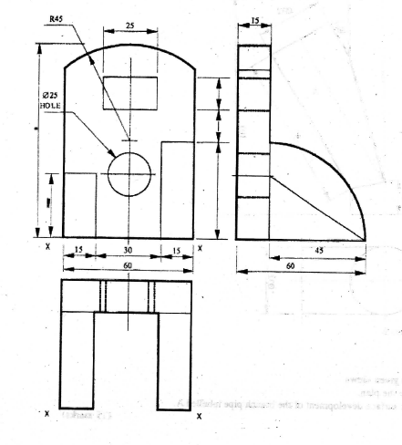

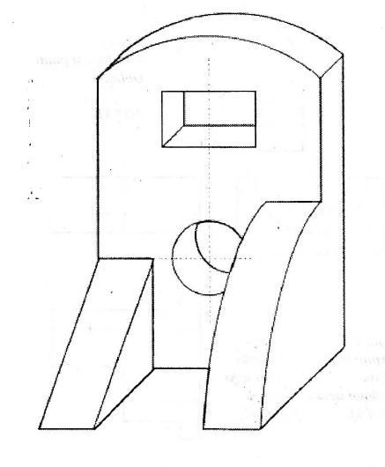

Draw, in FULL SIZE, the oblique view of the bracket with X-X as the lowest point
(15 marks)

(b). Given the length of diagonals of a kite as 91 and 52 mm and the point of intersection as 66 mm from one end of the longer diagonal. Construct the kite. (5 marks)
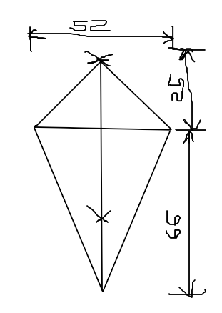

- Copy the figure and complete;
- the front elevation
- the plan
- draw the development of tube A (15 marks)
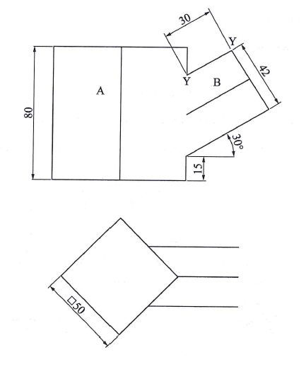

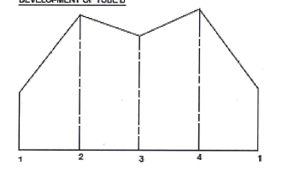
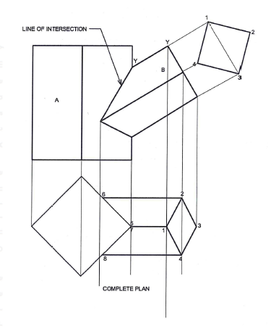

(b). Draw the front view, end view and plan of a pentagonal prism (5 marks)
