Name:……………………………………...............ADM No:………......Class:……....
449/2
DRAWING AND DESIGN
PAPER 2
MARKING SCHEME
AUGUST-SEPTEMBER
$2½ hours$
MECS CLUSTER JOINT EVALUATION
FORM FOUR END OF TERM TWO EXAMINATION 2022
DRAWING AND DESIGN
INSTRUCTIONS TO CANDIDATES
- Write your name, index number and class in the spaces provided above.
- The paper contains 4 PRINTED pages make sure all PAGES ARE PRINTED and NON IS MISSING
- Answer ALL the questions
- All the answers and working must be written on the question paper in the spaces provided below each question or in A3 paper provided.
- Label every drawing drawn on A3 paper provided
For examiner use only
A | B | C | D | E
GRAND TOTAL

DESIGN PROBLEM (40 marks)
A physically challenged patient with partial walking difficulties requires a device that can assist in walking. The device can also be used as a seat when necessary.
Design the device considering the following:
- It should be used to assist in walking with ease.
- It can be used as a seat
- It can be adjusted to desired height
- It can be folded and stored when not in use
- It should have a suitable breaking system.
Requirements
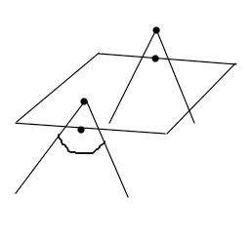
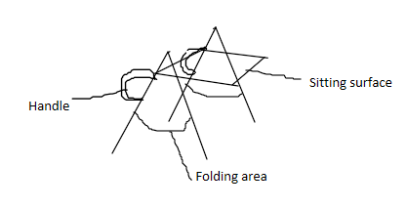
- Make freehand sketches of two possible solutions for your design (6 marks)

- Select one of the design in (a) above and make a refined labelled pictorial sketch
(14 marks)
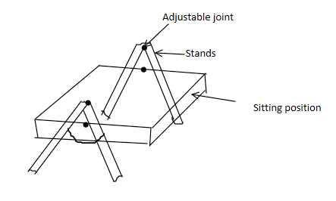

- Make detailed sketches for the mechanisms to allow for each of the considerations above
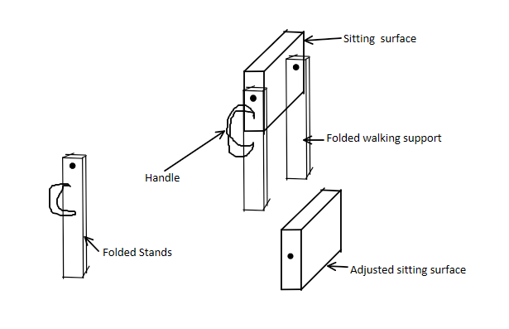
(15 marks)

- List three materials used and state one reason for the choice of each. (3 marks)
Wood- It is cheap/available
Aluminium- it is light in weight/resistant to breakage
Rubber- It is rough hence protects against sliding

- State two methods of joining the parts and state where each is used (2 marks)
Screws- joining of the sitting surface with stands
Gluing- joining the rubber with stands
Riveting- Joint the aluminium stands

