Name:……………………………………...............ADM No:………......Class:……....
449/1
DRAWING AND DESIGN
PAPER 1
AUGUST-SEPTEMBER
$2½ hours$
MECS CLUSTER JOINT EXAMINATION
FORM FOUR END OF TERM TWO EXAMINATION 2022
DRAWING AND DESIGN
INSTRUCTIONS TO CANDIDATES
- Write your name, index number and class in the spaces provided above.
- The paper contains three sections: Section A, Section B and Section C
- Section A carries 50 marks, section B carries 20 marks and Section C 30 marks
- The paper contains 8 PRINTED pages make sure all PAGES ARE PRINTED and NONE IS MISSING
- Answer ALL the questions in each section.
- All the answers and working must be written on the question paper in the spaces provided below each question.
- Label every drawing drawn on A3 paper provided
For examiner use only
Section A
1 | 2 | 3 | 4 | 5 | 6 | 7 | 8 | 9 | 10
Section B
11 | 12 | 13
GRAND TOTAL

Section A (50 marks)
- (a). State three types of materials and name objects designed using the stated material
(3 marks)

(a). Describe the following terms as used in design (2 marks)
(i). Aesthetics

(ii). Ergonomics

- On a circle of radius 50 mm, show the following parts of a circle
(3 marks)
(i). Quadrant

(ii). Chord

(iii). A segment

- Given the length of diagonal as 67 mm. Construct a square and measure the length of one side (3 marks)

- Draw the following types of keys (3 marks)

- Woodruff

- Pratt and Whitney

- Gib-head

- (a). Use freehand to write the title “ISOMETRIC DRAWING” (1 mark)

(b). Write down three factors to consider while lettering (3 marks)

(c). Draw two-dimensional object and name it. (2 marks)

(d) Write down two information required on a title block that give information about work drawn (2 marks)

- Draw the cuboid shown below and inscribe a triangle on the faces indicated by the arrows. (5 marks)
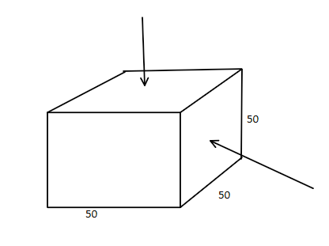

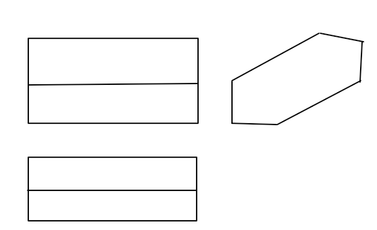
- Sketch a pictorial object for the views below in Isometric (6 marks)

- (i). Propose three types of businesses a person can engage into after studying drawing and design (1½ marks)

(ii). State fours three factors that would cause a business to succeed (1½ marks)

- Using the concentric circles method, construct an ellipse whose major axis is 80mm and minor axis is 40 mm (6 marks)

- Construct a diagonal scale of 1:10 to measure a maximum length of 1.0 m with an accuracy of 0.005 m. Indicate a length of 0.6 m (5 marks)

Section B (30 marks)
This question is Compulsory
It should be answered on the A3 paper provided.
Candidates are advised not to spend more than one hour on this question.

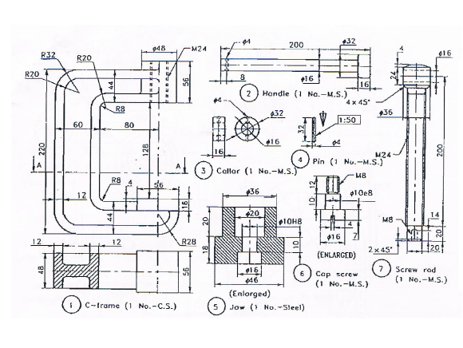
- The figure below shows views of the parts of a tool.
Draw the following,
- Sectional front elevation

- end elevation (30 marks)

Section C (20 marks)
Choose any ONE question from this section
- (a). The figure below shows three views of a bracket in first angle projection
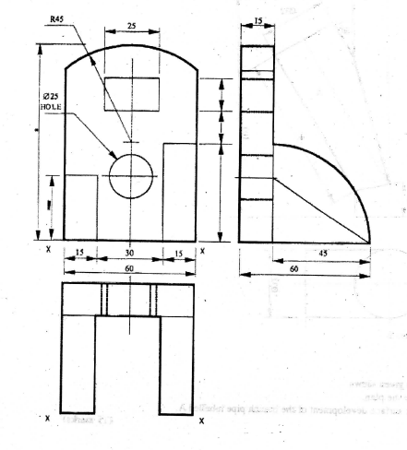

Draw, in FULL SIZE, the oblique view of the bracket with X-X as the lowest point
(15 marks)

(b). Given the length of diagonals of a kite as 91 and 52 mm and the point of intersection as 66 mm from one end of the longer diagonal. Construct the kite. (5 marks)

- (a). Copy the figure and complete;
- the front elevation
- the plan
- draw the development of tube A (15 marks)
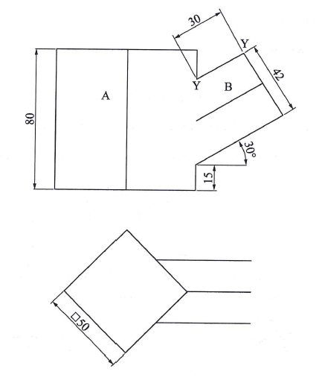

(b). Draw the front view, end view and plan of a pentagonal prism (5 marks)

