Name………………………………………..ADM No……………. Class………………..

448/2
ELECTRICITY
Paper 2
AUGUST-SEPTEMBER 2022
Time: 2 ½ hours

MECS CLUSTER JOINT EXAMINATION

FORM FOUR END YEAR EXAMINATION 2022
ELECTRICITY

Instructions To Candidates

1. There are FIVE exercises in this paper
2. Candidates are allowed 30 minutes for each exercise
3. Each exercise will be awarded a maximum of 20 marks
4. Write your Name and Index number at the top of this page
5. Do NOT do work related to other stations while at a different station
6. Attempt All the exercises as directed by the examiner(s)
7. All dimensions are in millimeters unless it’s indicated otherwise

For Examiner’s Use Only

Exercise | 1 | 2 | 3 | 4 | 5 | Total
Total Marks
Marks Scored
Grand Total

This paper consists of 8 printed pages. Candidates should confirm that all the pages are printed as indicated and that no questions are missing.

EXERCISE 1
- Figure 1 shows an electrical circuit.
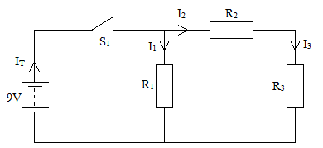
Figure 1
- Using the components, materials and equipment provided. Connect the circuit as shown in Figure 1 on the breadboard.
Let the examiner check your work. (6 marks)

- With S₁ ON, measure and record the total current I_{T}.
I_{T}=………………………………………. mA (1 mark)

- Measure and record the currents.
I₁=………………………………………. (mA)
I₂=………………………………………. (mA)
I₃=………………………………………. (mA)

- (i) In the circuit, replace R₃ with R₄.
Let the examiner check your work. (2 marks)
(ii) Repeat steps (a) to (c). (4 marks)
I_{T}=………………………………………. (mA)
I₁=………………………………………. (mA)
I₂=………………………………………. (mA)
I₃=………………………………………. (mA)

- (i) Explain the relationship between currents I₂ and I₃ (2 marks)
………………………………………………………………………………………………………………………………………………………………………………………………………………………………………………………………………………………………………………………………………………………………………………………………………………………………………………………………………………………………
(ii) State the effect on the current I_{T} when R₃ is replaced with R₄. (2 marks)
EXERCISE 2
- Using the tools, equipment and materials provided, fabricate the bracket shown in Figure 2. (20 marks)
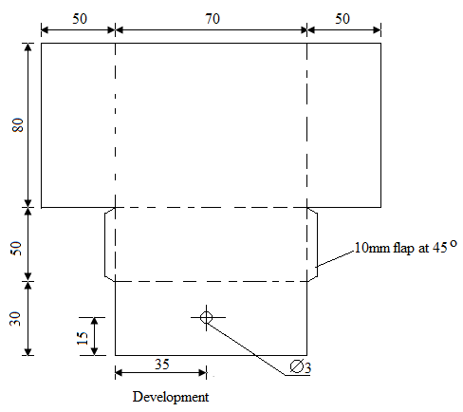
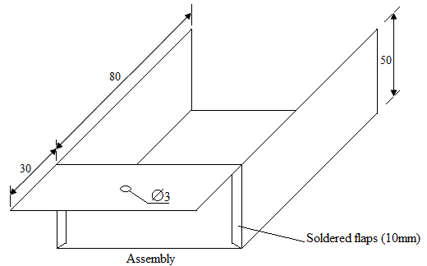
Figure 2

EXERCISE 3
- Using the tools, materials and equipment provided, carry out the following tasks.
- Terminate the three heat resistant flexible cable to the top plug and the iron box. (15 marks)
- Turn the thermostat switch ‘ON’ at the maximum position. (1 mark)
- Measure and record the values of Resistance of the element in Table 1. (4 marks)
TEST BETWEEN | READINGS OBTAINED
- Live and Neutral at plug
- Live and Earth at Plug
- Earth at Plug and Iron box body
- Neutral at Plug and Iron box

EXERCISE 4
- Figure 3 shows the block diagram of an electronic circuit marked R.
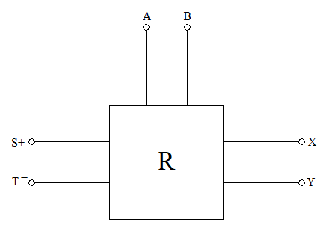
Figure 3
Use the equipment and accessories provide to perform the following tasks;
- Set the power supply voltage to 10V output.
- With the power supply off and switch S off, connect the equipment to the terminals of circuit R at points (+) and (-) as shown.
- A and B as an Ohmmeter
- X and Y an ammeter
- S and T to power supply.
Let the examiner check your work. (3 marks)

- Turn the power supply ON and turn the switch ON.
Adjust the potentiometer to obtain R_{L} values as shown in Table 2.
- In each case, measure and record in table 2 the corresponding values of circuit current I and calculate values of circuit power in Watts.
R_{L}(kΩ) | I(A) | P(W)
0
5
10
15
20
25
30
40
60
80
100

(11 marks)
- Plot a graph of power against load resistance on the graph provided on the last page. (4 marks)
- Determine the value of load resistance that allows maximum power transfer from the graph provided in 4(e). (2 marks)

EXERCISE 5
- Figure 4 shows the layout of a lighting final circuit.
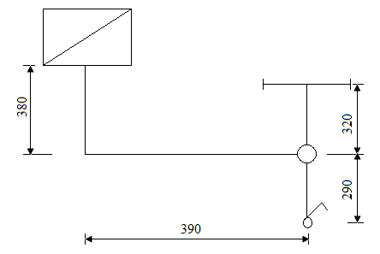
Figure 4
Using PVC sheathed cable, install the circuit such that the lamp is controlled from one point. (20 marks)

