Name………………………………………..ADM No……………. Class………………..

448/1
ELECTRICITY
MARKING SCHEME
Paper 1
(THEORY)
AUGUST-SEPTEMBER 2022
Time: 2 ½ hours

MECS CLUSTER JOINT EXAMINATION

FORM FOUR END YEAR EXAMINATION 2022
ELECTRICITY

INSTRUCTIONS TO CANDIDATES

- Write your name, admission number and class in the spaces provided
- Each candidate should have the following:
- Drawing paper,A4
- Drawing instruments
- Electronic calculator
3. This paper has two sections; A and B
4. Answer ALL the questions in section A and ANY FOUR in section B
5. All measurements are in millimeters unless it is stated otherwise .

This paper consists of 11 printed pages, a certain that all pages are printed and no questions are missing

SECTION A (48marks)
Answer all the questions in this section in the spaces provided

- (a) List four insulating materials used in electrical installations. (2 marks)
-PVC
-bakelite
-Polychloroprene
-rubber

(b) State two advantages of PVC sheathed cables over tough rubber sheathed. (2 marks)
It is the cheapest system
It is easy and quick to install
P.v.c. is impervious to many chemicals and free from ageing

- (a) State Lenz’s law of electromagnetic induction. (2 marks)
The direction of induced emf is such that itopposes the change that causes it

(b) Name four applications of electromagnets. (2 marks)
DC machines
AC machines
Measuring instruments
Moving coil loud-speaker

- (a) Name four National Polytechnics in Kenya. (2 marks)
Eldoret, kabete, Kisumu, Meru, Nyeri

(b) List two business opportunities in the field of electricity. (1 mark)
Electrical/ Electronics parts seller
Electronics repair shop
Electronics waste disposal
Cyber café shop

- (a) State how each of the following electrical material waste should be disposed safely:
- Burnt fluorescent tubes; (½ mark)
Take to hazardous waste collection centre
- Damaged computers. (½ mark)
Donated to community as second or third grade computers
(b) State the application of each of the following types of extinguishers:
- Carbon dioxide; (1 mark)
Extinguish electric fires
- Water.
Extinguish solid fuel and fluid fuel fires (1 mark)
- (a) Figure 1 shows a carbon resistor with color codes. Determine the value of the resistor given, (2 marks)

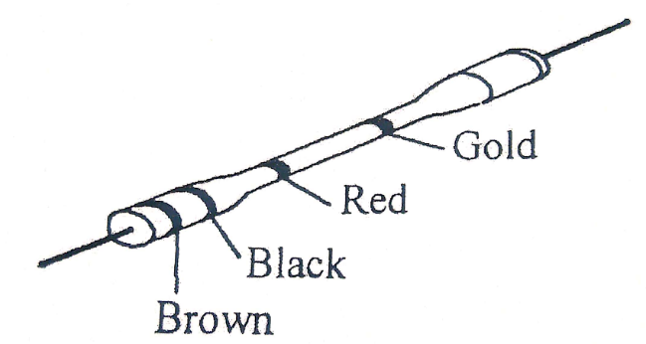

1 0 x 10² ±5%
1KΩ

- Figure 2 shows a resistive circuit.
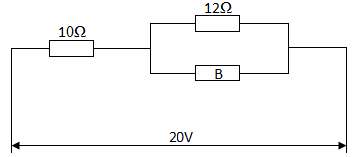

Determine the:
- Value of the resistor B if the total circuit resistance is 20Ω; (4 marks)

$10+\frac{12xB}{12+B}=20$

2B=120
B=60Ω

- Total circuit current. (2 marks)

I=$\frac{V_{s}}{R_{t}}$ $\frac{20}{20}=1A$
- (a) Name four parts of a fluorescent fitting. (2 marks)

Starter
Electrodes
Tube
choke

- List four marking out tools used in fabricating sheet metal casing. (2 marks)
Scriber
Steel rule
dividers
try square
centre punch

- (a) Figure 3 shows two views of an object drawn in third angle projection.
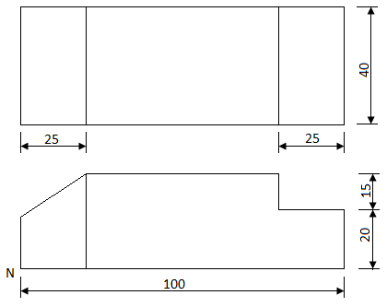

On the grid provided, make a free hand isometric sketch with corner N as the lowest point. (3 marks)

(b) Outline two ways that can be used to troubleshoot a faulty television. (2 marks)
Test working of fuse plug
Test capacitor at the input

- (a) With the aid of sketches, distinguish between P-N-P and an N-P-N transistor. (3 marks)

(b) Name four applications of a P-N junction diode. (2 marks)

Power rectification
In smoothing circuits
In photo diodes
In light emitting diodes
In zener diodes

- (a) State three advantages of digital instruments over analogue instruments. (3 marks)
Easy to read
More accurate
Less expensive

(b) An ideal transformer connected to a 240V mains supplies a 12V, 120W lamp. Calculate the:
- Transformer’s turns ratio; (3 marks)
$\frac{V_{1}}{V_{2}} =\frac{240}{12}=20$

- Current taken from the supply. (3 marks)

$\frac{V_{1}}{V_{2}}=\frac{I_{2}}{I_{1}} I_{1}=\frac{12}{120}x10 =1A$

(c) With the aid of diagram describe 'armature reaction' in d.c motors (3mks)

This is the distortion and weakening of the main magnetic field in a dc machine due the field’s reaction with the armature’s magnetic flux.

Normal axis
Shifted Neutral axis
Direction of rotation
N
S

SECTION B (52 marks)
Answer any four questions in the spaces provided.
- (a) (i) Convert 23₁₀ to binary. (2 marks)

111₂

(ii) Convert 11011₂ to decimal. (2 marks)

27₁₀

(b) state seven types of logic gate;
(4 marks)

NOT gate, OR gate ,AND gate,NOR gate, the NAND gate, the XOR gate and the XNOR gate.

(ii) Draw a truth table for the; NAND. (4 marks)

A | B | F
0  0  1  1 | 0  1  0  1 | 1  1  1  0

(c) Name two applications of logic gates. (1 mark) In burglar alarms
As switches
For computation analysis in circuits
- (a) Draw a sine wave and indicate the following:
- Peak value; (5 marks)
- Instantaneous value;
- Cycle.

Alternation
Vpp
Vm
Cycle

(b) Figure 4 shows an RLC circuit. The frequency is 50Hz
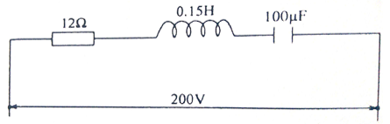

Calculate the:
- Inductive reactance; (2 marks)
$X_{L}=2πfL=2πx50x0.15=47.1$Ω

.
- Capacitive reactance; (2 marks)

$$X_{c}=\frac{1}{{2πfc}_{}}=\frac{1}{2πx50x100µF} 31.831Ω$$

- Circuit impedance; (2 marks)

$Z=\sqrt{{(R}^{2}}+\left({X_{L}}^{}-{X_{C}}^{}\right)\sqrt{144}+233.14=377.14Ω$

- Circuit current. (2 marks)

I=$\frac{V_{s}}{Z}=\frac{200}{377.14}=0.530A$

- (a) State;
- Two advantages of a moving coil instrument. (2 marks)
It is shielded from magnetic fields
Inexpensive compared to moving iron meters
Have uniforn scale

- Two essential features of an analogue instrument. (2 marks)
Controlling feature
Damping feature
Deflecting feature

(b) With the aid of a labelled diagram, explain the Flemmings right hand rule to demonstrate the direction of induced EMF. (6 marks)

N
S
Coil on former
Battery
I
Magnetic
Flux

(c) show that for two capacitors C₁ and C₂ connected in series, the total capacitance is given by:
$$C_{T}=\frac{C_{1}×C_{2}}{C_{1}+C_{2}}$$
(3 marks)

$\frac{1}{C_{t}}=\frac{1}{C_{1}}+\frac{1}{C_{2}}=\frac{C_{1}+C_{2}}{C_{1}C_{2}}=C_{t}=c_{1}c_{2/c_{1}+c_{2}}$
- (a) State:
- Two advantages of trunking over steel conduit wiring systems. (2 marks)
cables are laid in rather than pulled in.
can take large number of cables

- Two advantages of MCBs over rewirable fuses. (2 marks)
Can be reset after rectifying fault
Faulty circuit is indicated by MCB
Can be used as a switch
(b) (i) Draw and label a diagram of a switch start fluorescent fitting. (6 marks)

Fluorescent coating
Iron cored inductor
A.C. supply
Glass tube containing low-pressure mercury vapour and argon gas
Oxide coated lamp electrode
Fluorescent coating
P.f. Correction capacitor
Glow starter with R.I.S. capacitor
L
N

(ii) Outline three tests carried out in a completed electrical installation. (3 marks)

Earthing tests

Ring circuit continuity test
Insulation resistance tests
Verification of polarity tests
- Figure 5 shows a machine block drawing of an isometric projection.
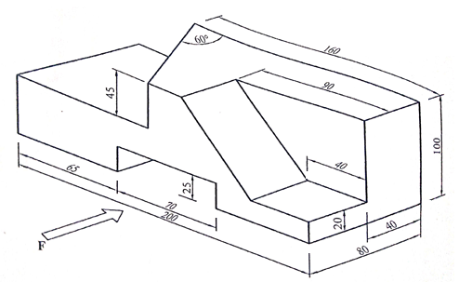
Draw the following views in full size in first angle projection:
- Front elevation in the direction of arrow F:
- Plan;
- Indicate six dimensions. (13 marks)

Solution-3mks mks
Accuracy-3mks
Neatness-2mks
Dimensions-4mks
Borderline-1mk

THIS IS THE LAST PRINTED PAGE

