NAME: …………………………………………………ADM……………CLASS………….…
SCHOOL…………………………………….CANDIDATE’SSIGNATURE:……………………
DATE: ……………….……………………...…

443/2
AGRICULTURE
PAPER 2
September-2022
TIME: 2 HOURS

SUNRISE 2 EVALUATION EXAM - 2022

INSTRUCTIONS TO CANDIDATES:
- Write your name and index number in the spaces provided.
- Sign and write the date of examination in the spaces provided
- This paper consists of three section A,B and C
- Answer all the questions in section A and B
- Answer any two questions in section C
- All the questions should answered in the spaces provided
FOR EXAMINER’S USE ONLY
SECTION | QUESTIONS | MAX SCORE | CANDIDATES SCORE
A | 1-18 | 30
B | 19 - 23 | 20
C |  | 20
 |  | 20
 | TOTAL | 90

This paper consists of 8 printed pages.
Candidates should check the question paper to ascertain all the pages are printed as indicated
And no questions are missing.

SECTION A (30 MARKS)
Answer all the questions in this section in the spaces provided.
1. (a) What is a notifiable disease (1mk)
…………………………………………………………………………………………………
…………………………………………………………………………………………………
(b) Name two notifiable diseases of cattle (1mks) ………………………………………………………………………………………………
2. Give four faults in the eggs that are detected during egg candling (2mks) …………………………………………………………………………………………………
…………………………………………………………………………………………………
…………………………………………………………………………………………………
…………………………………………………………………………………………………
3. Give two reasons for maintaining farm tools (lmk)
…………………………………………………………………………………………………
…………………………………………………………………………………………………
4 (a) Give two roles of litter in a deep litter poultry house (1mk)
…………………………………………………………………………………………………
…………………………………………………………………………………………………
(b) State one role of footbath in a poultry house ( ½ mk)
…………………………………………………………………………………………………
…………………………………………………………………………………………………
5. Mention four advantages of embryo transplant (2mks)
…………………………………………………………………………………………………
…………………………………………………………………………………………………
…………………………………………………………………………………………………
…………………………………………………………………………………………………
6. Give functional difference between the following tools (2mks)
(a) Stock and die and pipe cutter
…………………………………………………………………………………………………
(b) Ball pein hammer and claw hammer
…………………………………………………………………………………………………
7. State four features of an ideal calf pen (2mks)
…………………………………………………………………………………………………
…………………………………………………………………………………………………
…………………………………………………………………………………………………
………………………………………………………………………………………………
8. State four signs of furrowing observed in pigs (2mks)
…………………………………………………………………………………………………
…………………………………………………………………………………………………
…………………………………………………………………………………………………
…………………………………………………………………………………………………
9. State three methods of restraining cattle ( 1 ½ mk)
…………………………………………………………………………………………………
…………………………………………………………………………………………………
…………………………………………………………………………………………………
10. Give four ways of stimulating milk let down in a dairy cow (2mks) …………………………………………………………………………………………………
…………………………………………………………………………………………………
…………………………………………………………………………………………………
……………………………………………………………………………………………
11. Differentiate between cropping and harvesting in fish keeping. (1 mark) …………………………………………………………………………………………………
12. Name the dairy breed of cattle which (lmk)
(a) Produces the highest yield of milk
…………………………………………………………………………………………………
(b) Produces milk with the highest butterfat content
…………………………………………………………………………………………………
13. State four pre-disposing factors of mastitis (2mks)
…………………………………………………………………………………………………
………………………………………………………………………………………………
…………………………………………………………………………………………………
…………………………………………………………………………………………………
14. Name any two renewable sources of power in the farm (lmk)
…………………………………………………………………………………………………
………………………………………………………………………………………………
15. State four factors considered when computing a ration for livestock on the farm(2mks)
………………………………………………………………………………………………
…………………………………………………………………………………………………
…………………………………………………………………………………………………
…………………………………………………………………………………………………
16. State two ways in which digestion of food in pigs differs from that in Ruminants(2mks.)
…………………………………………………………………………………………………
…………………………………………………………………………………………………
17. State two conditions which would make it necessary to feed bees (lmk)
…………………………………………………………………………………………………
…………………………………………………………………………………………………
18. State two ways of caponization in poultry ( 2mks)

…………………………………………………………………………………………………
…………………………………………………………………………………………………
…………………………………………………………………………………………………
…………………………………………………………………………………………………

SECTION B (20 MARKS)
Answer all questions in this section in the spaces provided
19. The diagram below is a cross section of part of a cow’s udder.
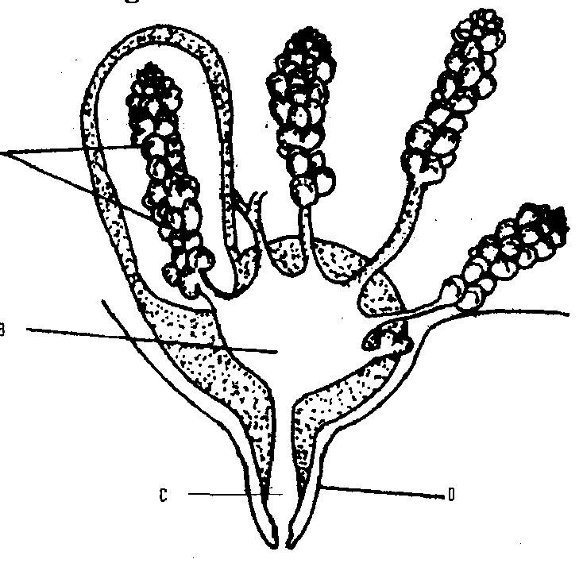
A
B
C
D

a) Label the parts marked A,B,C and D (2mks)
A………………………………………
B………………………………………
C……………………………………….
D……………………………………….
b) Name two hormones that control milk - let down in a dairy cow. (2mks)
…………………………………………………………………………………………………
…………………………………………………………………………………………………
c) What is a dry cow therapy (1mk)
……………………………………………………………………………………………….
20.(a) Identify each of the parasites of livestock shown below. (2marks)
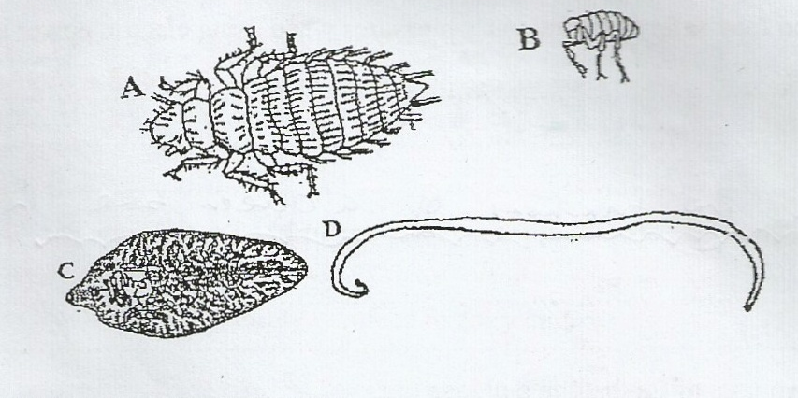

A………………………………………………………………………………………………
B………………………………………………………………………………………………
C………………………………………………………………………………………………
D………………………………………………………………………………………………
(b) What is the difference between parasites A and Band parasites C and D? (1mark)
…………………………………………………………………………………………………………………………………………………………………………………………………………………………………………………………………………………………………………...…………………………………………………………………………...…………………
(c ) Suggest an effective control measure of the parasites labelled C (1mark)
…………………………………………………………………………………………………………………………………………………………….……………………………………
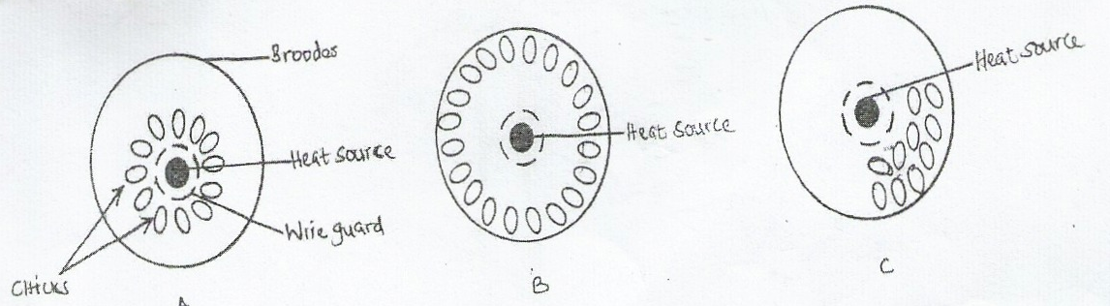
21.Below are illustrations showing the behavior of chicks in various brooders. Study the diagrams and answer the questions that follow.

- State the environmental problem in each brooder as illustrated by the behavior of the chicks (3marks)
A……………………………………………………………………………………………
B……………………………………………………………………………………………
C……………………………………………………………………………………………
- State two ways of overcoming the problem in B (2marks)
…………………………………………………………………………………………………………………………………………………………….……………………………

(iii)Why brooder is recommended to be round in shape (1mks)
………………………………………………………………………………………………
22.Below is a diagram of a farm implement
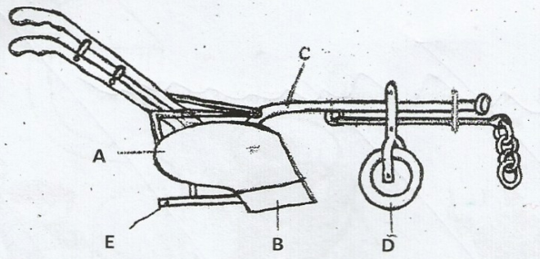

(a)Identify the implement (½ mark)
…………………………………………………………..
(b) Label the parts marked A, B, C, D and E. (2 ½ marks)
A……………………………………………….…….…………………………………………
B…………………………………………………….…………………………………………
C……………………………………………………….………………………………………
D……………………………………………………………..…………………………………
E…………………………………………………………………………………………………
(c ) State the functions of the parts labelledC and E (2mks)
……………………………………………………………………………………………………………………………………………………………….……………………………………………………………..…………………………………………………..……………………………………………

SECTION C (40 mks)
Answer any two questions from this section in the spaces provided after question
23. (a) Discuss the management of layers from one day old to the start of laying in a deep litter System. (14mks)
(b) Explain management practices that would improve fish production. (6mks)
24 (a )State the daily maintenance and servicing of a tractor (10marks)
(b)Describe the structural requirement to be considered when constructing a calf pen (10marks)
25 a) Explain four factors that affect digestibility of food in livestock. (8mks)
b) Explain the essentials of clean milk production (7mks)
c) State five disadvantages of natural method of mating. (5mks)

…………………………………………………………………………………………………
…………………………………………………………………………………………………
…………………………………………………………………………………………………
…………………………………………………………………………………………………
…………………………………………………………………………………………………
…………………………………………………………………………………………………
…………………………………………………………………………………………………
…………………………………………………………………………………………………
…………………………………………………………………………………………………
…………………………………………………………………………………………………
………………………………………………………………………………………………
………………………………………………………………………………………………
…………………………………………………………………………………………………
…………………………………………………………………………………………………
…………………………………………………………………………………………………
…………………………………………………………………………………………………
…………………………………………………………………………………………………
…………………………………………………………………………………………………
…………………………………………………………………………………………………
…………………………………………………………………………………………………
…………………………………………………………………………………………………
…………………………………………………………………………………………………
…………………………………………………………………………………………………
…………………………………………………………………………………………………
…………………………………………………………………………………………………
…………………………………………………………………………………………………
…………………………………………………………………………………………………
…………………………………………………………………………………………………
…………………………………………………………………………………………………
…………………………………………………………………………………………………
………………………………………………………………………………………………
………………………………………………………………………………………………
…………………………………………………………………………………………………
…………………………………………………………………………………………………
…………………………………………………………………………………………………
…………………………………………………………………………………………………
…………………………………………………………………………………………………
…………………………………………………………………………………………………
…………………………………………………………………………………………………
…………………………………………………………………………………………………
…………………………………………………………………………………………………
…………………………………………………………………………………………………
…………………………………………………………………………………………………
………………………………………………………………………………………………
…………………………………………………………………………………………………
…………………………………………………………………………………………………
…………………………………………………………………………………………………
…………………………………………………………………………………………………
…………………………………………………………………………………………………
…………………………………………………………………………………………………
…………………………………………………………………………………………………
…………………………………………………………………………………………………
…………………………………………………………………………………………………
…………………………………………………………………………………………………
…………………………………………………………………………………………………
…………………………………………………………………………………………………
…………………………………………………………………………………………………
…………………………………………………………………………………………………
…………………………………………………………………………………………………
…………………………………………………………………………………………………
………………………………………………………………………………………………
………………………………………………………………………………………………
…………………………………………………………………………………………………
…………………………………………………………………………………………………
…………………………………………………………………………………………………
…………………………………………………………………………………………………
…………………………………………………………………………………………………
…………………………………………………………………………………………………
…………………………………………………………………………………………………
…………………………………………………………………………………………………
…………………………………………………………………………………………………
…………………………………………………………………………………………………
…………………………………………………………………………………………………
………………………………………………………………………………………………
…………………………………………………………………………………………………
…………………………………………………………………………………………………
…………………………………………………………………………………………………
…………………………………………………………………………………………………
…………………………………………………………………………………………………

