NAME:………………………………………….. ADM………………CLASS……………………..
SCHOOL:……………………………………… CANDIDATE’S SIGN ………………………..
DATE …………………………………………..
443/1
AGRICULTURE
Paper 1
September-2022
Time: 2 Hours

SUNRISE 2 EVALUATION EXAM - 2022

443/1
AGRICULTURE
Paper 1
September- 2022
Time: 2 Hours
INSTRUCTIONS TO CANDIDATES
1. Write your name and index number in the spaces provided above
2. Sign and write the date of examination in the spaces provided above.
3. This paper consists of three sections: A, B and C
4. Answer all the questions in section A and B and any two questions from section C
5. Do not remove any pages from this booklet

For Examiner’s Use Only

Section | Question | Maximum Score | Candidate’s Score
A | 1 – 18 | 30
B | 19 – 23 | 20
C |  | 20
 |  | 20
 | Total Score | 90

This paper consists of 12 printed pages. Candidates should check the question paper to ensure that all pages are printed as indicated and no questions are missing.
SECTION A (30 MARKS)
Answer all the questions in this section in the spaces provided.

1. State two ways in which agriculture contributes directly to the development of
industries. (1mk)
…………………………………………………………………………………………………….……………………………………………………….………………………………………………………
2. What is a micro catchment ? (½ mk)
……………………………………………………………………………………………………………………………………………………………………………………………………………………
3. State any three details contained in a delivery note. (2mks)
……………………………………………………………………………………………………………………………………………………………………………………………………………………………………………………………………………………………………………………..……….
4. Outline any four problems farmers face when marketing their products. (2mks)
…………………………………………………………………………………………………………………………………………………………………………………………………………………………………………………………………………………………………………………………………………………………………………………………………………………………………………
5. Name three sites for agro forestry trees. (1 ½ mks)
………………………………………………………………………………………………………………………………………………………………………………………………………………………………………………………………………………………………………………………………
6. State two ways in which land consolidation improves farm management. (1mk)
…………………………………………………………………………………………………….
…………………………………………………………………………………………………….
…………………………………………………………………………………………………….
b) State four advantages confers to a farmer with land title deed (2mks)
…………………………………………………………………………………………………………………………………………………………………………………………………………………………………………………………………………………………………………………………………………………………………………………………………………………………………………
7. Give four reasons for earthing up some crops. (2mks)
…………………………………………………………………………………………………….……………………………………………………………………………………………………………….
………………………………………………………………………………………………………. ……………………………………………………………………………………………………….
8. Give two reasons for testing soil in the farm. (1mk).
…………………………………………………………………………………………………….
…………………………………………………………………………………………………….
…………………………………………………………………………………………………….
9. List four examples of variable inputs in maize production. (2mks)
…………………………………………………………………………………………………….
…………………………………………………………………………………………………….
…………………………………………………………………………………………………….
…………………………………………………………………………………………………….
10. Name four books of account kept by a farmer (2 mks)
…………………………………………………………………………………………………….
…………………………………………………………………………………………………….
…………………………………………………………………………………………………….
…………………………………………………………………………………………………….
11. Give two functions of the Agricultural Finance corporation (AFC) (2mks)
…………………………………………………………………………………………………….
…………………………………………………………………………………………………….
12. State two common symptoms of viral infection in crop (1mk)
…………………………………………………………………………………………………….
…………………………………………………………………………………………………….
13. State four conditions under which opportunity cost equals to zero (2mks)
…………………………………………………………………………………………………….
…………………………………………………………………………………………………….
…………………………………………………………………………………………………….
…………………………………………………………………………………………………….
14. Name four factors that may affect the selectivity and effectiveness of herbicides. (2mks)
…………………………………………………………………………………………………….
…………………………………………………………………………………………………….
…………………………………………………………………………………………………….
…………………………………………………………………………………………………….
15. Give two means by which water can be conveyed from the place of storage to where
it is needed on the farm. (1mk)
…………………………………………………………………………………………………….
…………………………………………………………………………………………………….
16. List four pieces of information likely to be found in a field operation record. (2mks)
…………………………………………………………………………………………………….
…………………………………………………………………………………………………….
…………………………………………………………………………………………………….
…………………………………………………………………………………………………….
17. Give four qualities of good silage. (2mks)
…………………………………………………………………………………………………….
…………………………………………………………………………………………………….
…………………………………………………………………………………………………….
…………………………………………………………………………………………………….
…………………………………………………………………………………………………….
18. A farmer was advised to apply 200kg of CAN/ha, while top dressing bean crop.
CAN contains 21% N. Calculate the amount of CAN applied per hectare. (2mks)
…………………………………………………………………………………………………….
…………………………………………………………………………………………………….
…………………………………………………………………………………………………….

SECTION B (20 MARKS)
Answer all the questions in this section in the spaces provided.
19. Below are diagrams of common weeds on the farm. Use them to answer the
questions that follow.
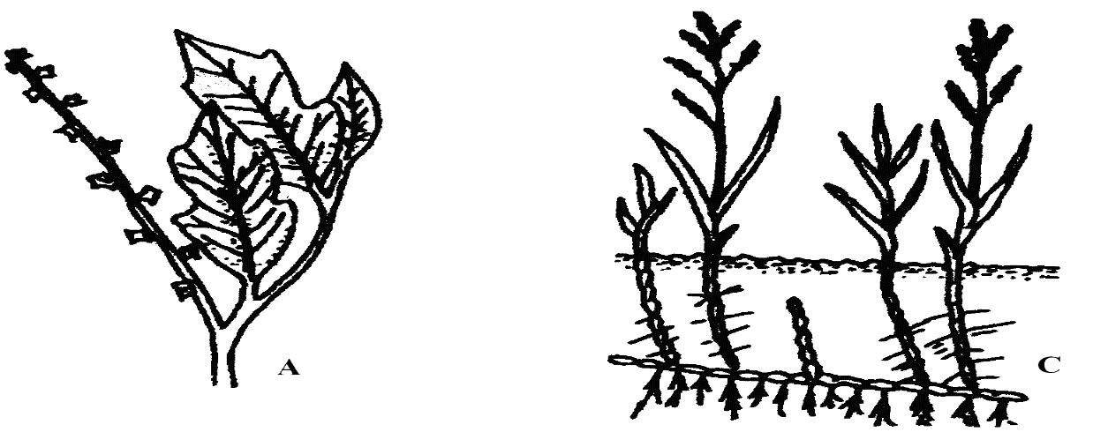

a) Identify the weeds A, B, C and D (1mks)
A………………………………………………………….
B………………………………………………………….
b) Give one negative effect of weed labeled B in livestock. (1mk)
…………………………………………………………………………………………………….
…………………………………………………………………………………………………….
c) Suggest the most appropriate method of controlling weed labeled D (1mk)
…………………………………………………………………………………………………….

20. The diagram below illustrates a method of collecting soil samples from a field

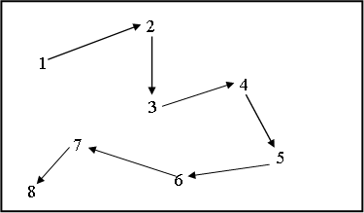
a) Identify the method illustrated above. (1mk)
…………………………………………………………………………………………………….
b) Describe four steps that should be followed when collecting soil samples. (2mks)
i)…………………………………………………………………………
ii)…………………………………………………………………………
iii)………………………………………………………………………..
iv)………………………………………………………………………..
c) State two precautions a farmer should take when collecting a representative soil
sample from the field for testing. (1mk)
…………………………………………………………………………………………………….
21. The diagram below shows a method of forage preservation
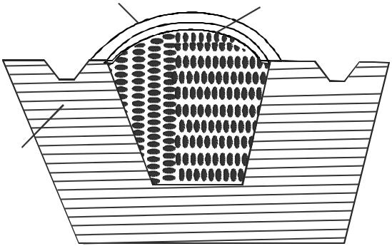
Soil layer Polythene sheet
Drainage

Forage material

Ground

a) Identify the structure above (1 mk)
……………………………………………………………………………………..
b) State the form in which the forage is preserved as illustrated above (1 mk)
……………………………………………………………………………………..
c) Give the role played by each of the following in the structure above
i) Polythene sheet (1 mk)
…………………………………………………………………………………….
ii) Drainage (1 mk)
……………………………………………………………………………………
d) Name two other methods of forage conservation (1 mk)
…………………………………………………………………………………….
22. The document shown below is a sample of a delivery note. Study it carefully and answer
the questions that follow:

DELIVERY NOTE
NO.1236
Date……………………….
FROM………………………………………………………………………..
TO……………………………………………………………………………

Please receive the following goods
Item A B
1. Chick mash 20 bags
2. Dairy Meal 10 bags
3. CAN fertilizer 4 bags (50kg)

Received the above goods in good condition and order.

Delivered by………………………………………………………………………
Received by……………………………………………………………………….

a) Name the column labeled A and B (1mk)
A…………………………………………………………………..
B…………………………………………………………………..
b) What is the purpose of this document in business transaction? (1mk)
…………………………………………………………………………………………………….
…………………………………………………………………………………………………….
…………………………………………………………………………………………………….
c) Outline four details that the document should contain for it to be complete. (2mks)
…………………………………………………………………………………………………….
…………………………………………………………………………………………………….
…………………………………………………………………………………………………….
…………………………………………………………………………………………………….

23. Study the illustration in the diagram below and answer questions that follow.
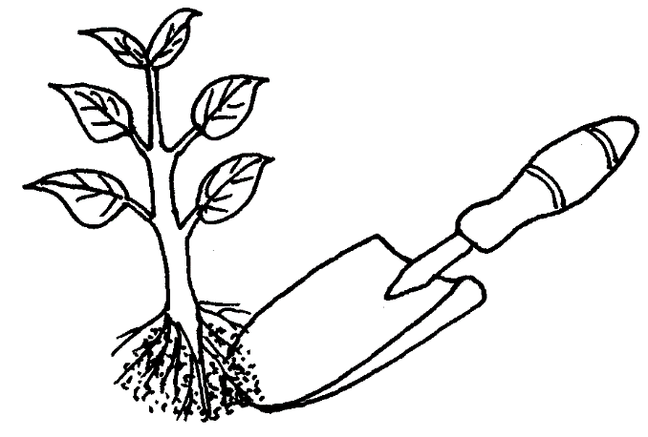
a) Identify the practice being illustrated above. (1mk)
…………………………………………………………………………………………………….
b) State three activities that should be carried out for successful results in the
practice shown above. (3mks)
…………………………………………………………………………………………………….
…………………………………………………………………………………………………….
…………………………………………………………………………………………………….

SECTION C (40 MARKS)
Answer any two questions from this section in the spaces provided after question 26.
24. a. Explain the terms risks and uncertainties in farming (2 mks)
b. State the various risks and uncertainties farmers face in fanning (12 mks)
c. Explain various ways in which farmers adjust to risks and uncertainties in farming (6mks)
25. a) Describe the characteristics of ideal agroforestry tree species (10mks)
b) Explain five physical methods of pest control (10mks)
26. a) The following information was extracted from Bidii farm’s book records as at
31st December 2022. The farm had borrowed a long term loan of 1 million from the
co-operative bank and owed Ksh.10,000 to the co-operative society shop for coffee
sprays and cattle feeds. The farm is owed Ksh.10,000 for milk delivered to New KCC. Salaries amounting to Ksh.9,500 had not been paid. The valuations of the farm were as follows.

Item Ksh.
Cattle 125,000
Goats 19,000
Poultry 35,000
Coffee trees 95,000
Equipment 40,000
Farm buildings 145,000
Stored cattle feed 4,000
Stored cattle spray 21000
Money in cash box 2,000
Land valued at 600,000
i) Prepare a balance sheet for Bidii farm as at 31st December, 2022 (7mks)
ii) Show whether Bidii farm was solvent or insolvent (1mk)
iii) Explain your answer in (ii) above. (1mk)
(b) Explain principles governing formation of cooperatives (8mks)
(c) Describe three advantages of mixed stand of pastures. (3mks)
…………………………………………………………………………………………………….
…………………………………………………………………………………………………….
…………………………………………………………………………………………………….
…………………………………………………………………………………………………….
…………………………………………………………………………………………………….
…………………………………………………………………………………………………….
…………………………………………………………………………………………………….
…………………………………………………………………………………………………….
…………………………………………………………………………………………………….
…………………………………………………………………………………………………….
…………………………………………………………………………………………………….
…………………………………………………………………………………………………….
…………………………………………………………………………………………………….
…………………………………………………………………………………………………….
…………………………………………………………………………………………………….
…………………………………………………………………………………………………….
…………………………………………………………………………………………………….
…………………………………………………………………………………………………….
…………………………………………………………………………………………………….
…………………………………………………………………………………………………….
…………………………………………………………………………………………………….
…………………………………………………………………………………………………….
…………………………………………………………………………………………………….
…………………………………………………………………………………………………….
…………………………………………………………………………………………………….
…………………………………………………………………………………………………….
…………………………………………………………………………………………………….
…………………………………………………………………………………………………….
…………………………………………………………………………………………………….
…………………………………………………………………………………………………….
…………………………………………………………………………………………………….
…………………………………………………………………………………………………….
…………………………………………………………………………………………………….
…………………………………………………………………………………………………….
…………………………………………………………………………………………………….
…………………………………………………………………………………………………….
…………………………………………………………………………………………………….
…………………………………………………………………………………………………….
…………………………………………………………………………………………………….
…………………………………………………………………………………………………….
…………………………………………………………………………………………………….
…………………………………………………………………………………………………….
…………………………………………………………………………………………………….
…………………………………………………………………………………………………….
…………………………………………………………………………………………………….
…………………………………………………………………………………………………….
…………………………………………………………………………………………………….
…………………………………………………………………………………………………….
…………………………………………………………………………………………………….
…………………………………………………………………………………………………….
…………………………………………………………………………………………………….
…………………………………………………………………………………………………….
…………………………………………………………………………………………………….
…………………………………………………………………………………………………….
…………………………………………………………………………………………………….
…………………………………………………………………………………………………….
…………………………………………………………………………………………………….
…………………………………………………………………………………………………….
…………………………………………………………………………………………………….
…………………………………………………………………………………………………….
…………………………………………………………………………………………………….
…………………………………………………………………………………………………….
…………………………………………………………………………………………………….
…………………………………………………………………………………………………….
…………………………………………………………………………………………………….
…………………………………………………………………………………………………….
…………………………………………………………………………………………………….
…………………………………………………………………………………………………….
…………………………………………………………………………………………………….
…………………………………………………………………………………………………….
…………………………………………………………………………………………………….
…………………………………………………………………………………………………….
…………………………………………………………………………………………………….
…………………………………………………………………………………………………….
…………………………………………………………………………………………………….
…………………………………………………………………………………………………….
…………………………………………………………………………………………………….
…………………………………………………………………………………………………….
…………………………………………………………………………………………………….
…………………………………………………………………………………………………….
…………………………………………………………………………………………………….
…………………………………………………………………………………………………….
…………………………………………………………………………………………………….
…………………………………………………………………………………………………….
…………………………………………………………………………………………………….
…………………………………………………………………………………………………….
…………………………………………………………………………………………………….
…………………………………………………………………………………………………….
…………………………………………………………………………………………………….
…………………………………………………………………………………………………….
…………………………………………………………………………………………………….
…………………………………………………………………………………………………….

