TRIAL EXAMINATIONS 2021
Kenya Certificate of Secondary Education (KCSE)

443/2 - AGRICULTURE - Paper 2
(THEORY)
Dec. 2021 – 2 hours

Name: …………………………………………..……...… Index No: ……….……………….
Stream: ……………….. Candidate’s Signature: …….………………....Date:…..……………

Instructions to candidates
- Write your name and index number in the spaces provided above.
- Sign and write the date of the examination in the spaces provided above.
- The paper consists of three sections A, B and C.
- Answer all questions in section A and B
- All answers should be written in the spaces provided.
- This paper consists of 12 printed pages.
- Candidates should check the question paper to ascertain that all the pages are printed as indicated and that no questions are missing.
- Candidates must answer the questions in English

For Examiner’s Use Only
Section | Question | Maximum Score | Candidate’s Score
A | 1-15 | 30
B | 16-19 | 20
C |  | 20
 |  | 20
TOTAL SCORE |  | 90

SECTION A (30 marks)
Answer ALL the questions in this section in the spaces provided.

- State two control measures for fowl pox disease in poultry. (2 marks) ………………………………………………………………………………………………………………………………………………………………………………………………………………………………

- Give two reasons for carrying out maintenance practices on a mower. (2 marks) ……………………………………………………………………………………………………………………………………………………………………………………………………………………
- Give two limitations of using solar power on the farm. (2 marks) ………………………………………………………………………………………………………………………………………………………………………………………………………………………………
- Name two methods used in selection of breeding stock in livestock production. (2 marks) ………………………………………………………………………………………………………………………………………………………………………………………………………………………………
- State four methods of controlling roundworms in livestock. (2 marks) ………………………………………………………………………………………………………………………………………………………………………………………………………………………………………………………………………………………………………………………………………………………………………………………………………………………………………………………………
- Name the type of breed into which each of the following breeds of cattle are classified.
- Aberdeen Angus. (½ marks) ………………………………………………………………………………………………………
- Guernsey. (½ marks) ………………………………………………………………………………………………………
- Sahiwal. (½ marks) ………………………………………………………………………………………………………
- Redpoll. (½ marks) ………………………………………………………………………………………………………

- Give two ways in which proper nutrition help to control livestock diseases. (2 marks) …………………………………………………………………………………………………………………………………………………………………………………………………………
- Name two nutritional diseases in cattle. (2 marks) …………………………………………………………………………………………………………………………………………………………………………………………………………

- State two advantages of housing calves singly in cattle management. (1 mark) …………………………………………………………………………………………………………………………………………………………………………………………………………
- State four advantages of natural calf rearing. (2 marks) ………………………………………………………………………………………………………………………………………………………………………..........................................................................................................................................................................................................................................................................................................................................................................
- State four reasons for dehorning in cattle management. (2marks) ………………………………………………………………………………………………………………………………………………………………………………………………………………………………………………………………………………………………………………………………………………………………………………………………………………………………………………………………
- Name two methods of harvesting fish in fish pond. (1 mark) ………………………………………………………………………………………………………………………………………………………………………………………………………………………………

- State four causes of egg eating in flock of layers. (2 marks) ……………………………………………………………………………………………………………………………………………………………………………………………………………………………………………………………………………………………………………………………………………………………………………………………………………………
- State two advantages of fold system on poultry rearing. (1 mark) …………………………………………………………………………………………………………………………………………………………………………………………………………
- Name four parts of farm building that can be reinforced using concrete. (2 marks) ………………………………………………………………………………………………………………………………………………………………………………………………………………………………………………………………………………………………………………………………………………………………………………………………………………………………………………………………

- State function of the following farm tools and equipment.
- Pipe cutter (1 mark) ……………………………………………………………………………………………………………………………………………………………………………………………………..……….
- Wire strainer (1 mark) ………………………………………………………………………………………………………………………………………………………………………………………………………………
- State four ways in which vaccine can be administered to livestock. (2 marks) ………………………………………………………………………………………………………………………………………………………………………………………………………………………………………………………………………………………………………………………………………………………………………………………………………………………………………………………………
- State two disadvantages of using plunge dips in tick control. (1 mark) ………………………………………………………………………………………………………………………………………………………………………………………………………………………………
- State two features on the animal which may predispose it to livestock diseases. (1 mark) ………………………………………………………………………………………………………………………………………………………………………………………………………………………………
SECTION B (20 marks)
Answer all the questions in this section in the spaces provided.

- The following illustrations show the behavior of chicks in a brooder. Study them carefully and answer the questions that follow.
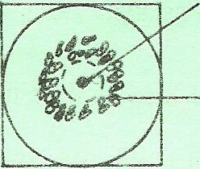
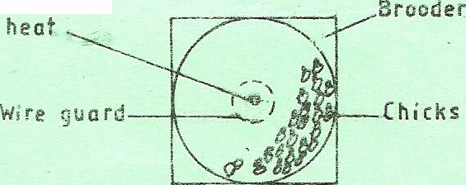
A B Source of heat

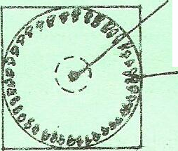
C Source of heat
- Explain the cause of behavior observed in chicks for each of the illustrations labeled A, B and C. (3 marks) ....................................................................................................................................................................................................................................................................................................................................................................................................................................................................................................................................................................................................................................................................................................................................................................................................................................................................................................................................................................................................................................................................................................................................................................................................................................................
- Give a reason for making the brooder wail round in shape. (1 mark) …………………………………………………………………………………………………………………………………………………………………………………………..………………………………………………….
- State one way of correcting the behavior of chicks shown in an above. (1 mark) ………………………………………………………………………………………………………………………………………………………………………………………………………………………………
- Diagrams M, N, P and Q represents some farm tools.
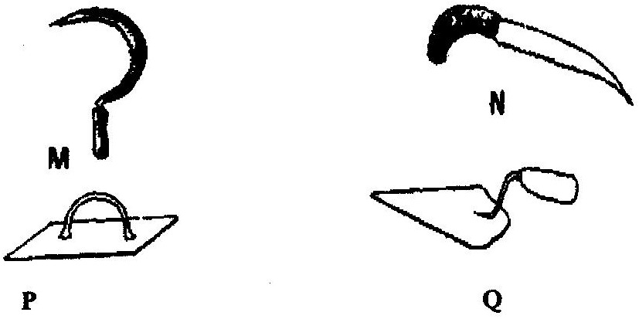

- Identify the tools; M, N, P and Q. (2 marks) ………………………………………………………………………………………………………………………………………………………………………………………………………………………………………………………………………………………………………………………………………………………………………………………………………………………………………………………………
- Give the use of each of the tools named above. (2 marks) ………………………………………………………………………………………………………………………………………………………………………………………………………………………………………………………………………………………………………………………………………………………………………………………………………………………………………………………………
- State two maintenance practices that should be carried out on tool M. (1 mark) ………………………………………………………………………………………………………………………………………………………………………………………………………………………………
- The diagram below illustrate a hoof of a sheep .Study it carefully and answer the questions that follow.
- Name the routine management practice that should be carried out on the hoof illustrated above. (1 mark) ………………………………………………………………………………………………………………………………………………………………………………………………………………………………
- State two reasons for carrying out the management practice in (a) above. (2 marks) ………………………………………………………………………………………………………………………………………………………………………………………………………………………………
- Name the two tools used to carry out the routine management practice named in (a) above. (2 marks) ………………………………………………………………………………………………………………………………………………………………………………………………………………………………
- A farmer wanted to prepare a 200kg of calf rearing ration containing 20% DCP. Using the Pears Square Method, calculate the amount of Maize containing 10% DCP and Sunflower containing 35% DCP the farmer would need to prepare the ration.(Show your working) (5 marks)
…………………………………………………………………………………………………………………………………………………………………………………………………………………………………………………………………………………………………………………………….……………………………………………………............................................................................................................................................................
SECTION C
Answer any two questions in this section in the spaces provided

- State five indicators that can be observed on a goat to confirm sickness. (5 marks)
- Describe eight physical characteristics of a poor layer in a flock of hens. (8 marks)
- Give seven harmful effects of liver fluke in sheep rearing. (7 marks)

- Outline five characteristics of a clean milk. (5 marks)
- Describe Brucellosis disease under the following sub-headings.
- Causal organism. (1 mark)
- Signs of attack. (3 marks)
- Control measures. (3 marks)
- State eight advantages of Artificial Insemination (8 marks)

- Describe five structural requirement of a good calf pen. (10 marks)
- Describe the cycle of a four stroke petrol engine. (10 marks)
………………………………………………………………………………………………………………………………………………………………………………………………………………………………………………………………………………………………………………………………………………………………………………………………………………………………………………………………………………………………………………………………………………………………………………………………………………………………………………………………………………………………………………………………………………………………………………………………………………………………………………………………………………………………………………………………………………………………………………………………………………………………………………………………………………………………………………………………………………………………………………………………………………………………………………………………………………………………………………………………………………………………………………………………………………………………………………………………………………………………………………………………………………………………………………………………………………………………………………………………………………………………………………………………………………………………………………………………………………………………………………………………………………………………………………………………………………………………………………………………………………………………………………………………………………………………………………………………………………………………………………………………………………………………………………………………………………………………………………………………………………………………………………………………………………………………………………………………………………………………
……………………………………………………………………………………………………………………………………………………………………………………………………………………………………………………………………………………………………………………………………………………………………………………………………………………………………………………………………………………………………………………………………………………………………………………………………………………………………………………………………………………………………………………………………………………………………………………………………………………………………………………………………………………………………………………………………………………………………………………………………………………………………………………………………………………………………………………………………………………………………………………………………………………………………………………………………………………………………………………………………………………………………………………………………………………………………………………………………………………………………………………………………………………………………………………………………………………………………………………………………………………………………………………………………………………………………………………………………………………………………………………………………………………………………………………………………………………………………………………………………………………………………………………………………………………………………………………………………………………………………………………………………………………………………………………………………………………………………………………………………………………………………………… ………………………………………………………………………………………………………
……………………………………………………………………………………………………………………………………………………………………………………………………………………………………………………………………………………………………………………………………………………………………………………………………………………………………………………………………………………………………………………………………………………………………………………………………………………………………………………………………………………………………………………………………………………………………………………………………………………………………………………………………………………………………………………………………………………………………………………………………………………………………………………………………………………………………………………………………………………………………………………………………………………………………………………………………………………………………………………………………………………………………………………………………………………………………………………………………………………………………………………………………………………………………………………………………………………………………………………………………………………………………………………………………………………………………………………………………………………………………………………………………………………………………………………………………………………………………………………………………………………………………………………………………………………………………………………………………………………………………………………………………………………………………………………………………………………………………………………………………………………………………………… ………………………………………………………………………………………........................
………………………………………………………………………………………………………………………………………………………………………………………………………………………………………………………………………………………………………………………………………………………………………………………………………………………………………………………………………………………………………………………………………………………………………………………………………………………………………………………………………………………………………………………………………………………………………………………………………………………………………………………………………………………………………………………………………………………………………………………………………………………………………………………………………………………………………………………………………………………………………………………………………………………………………………………………………………………………………………………………………………………………………………………………………………………………………………………………………………………………………………………………………………………………………………………………………………………………………………………………………………………………………………………………………………………………………………………………………………………………………………………………………

THIS IS THE LAST PRINTED PAGE.

