BSJE 2021
AGRICULTURE
Paper 2
443/2
MARKING SCHEME

SECTION A (30MKS)
- State two control measures for fowl pox disease in poultry. (2mrks)
- Observe hygiene in poultry house
- Regular vaccination
- Slaughter and properly dispose carcass of affected birds – rej. culling, killing atone.

- Give two reasons for carrying out maintenance practices on a mower. (2mrks)
- For safety of the user/operator
- Ensure efficiency of operations
- Increases durability
- Reduces costs on repairs and replacements
- Avoid damage to the mower.

- Give two limitations of using solar power on the farm. (2mrks)
- Solar trapping devices are expensive
- Power supply/trapping fluctuates depending on weather conditions
- Solar trapping is limited to day light
- Requires skilled labour to handle the devices

- Name two methods used in selection of breeding stock in livestock production. (2mrks)
- Progeny testing
- Mass selection
- Contemporary comparison

- State four methods of controlling roundworms in livestock. (2mrks)
- Use of antihelmintics/Drenching
- Rotational grazing
- Burning of pasture
- Apply appropriate drug
- Proper disposal of faeces/hygiene

- Name the type of breed into which each of the following breeds of cattle are classified.
- Aberdeen Angus. (½mrk)
- Beef cattle breed
- Guernsey. (½mrk)
- Dairy cattle breed
- Sahiwal. (½mrk)
- Dual purpose breed
- Redpoll. (½mrk)
- Dual purpose breed

- Give two ways in which proper nutrition help to control livestock diseases. (2mrks)
- Prevents nutrient deficiency diseases.
- Ensures resistance against disease infection.
- Name two nutritional diseases in cattle. (2mrks)
- Milk fever
- Bloat

- State two advantages of housing calves singly in cattle management. (1mrk)
- To prevent the calf from licking each other.
- To control spread of worms and skin infection.
- State four advantages of natural calf rearing. (2mrks)
- Calf takes milk at body temperature.
- Milk is free from contamination
- It prevents scouring in calves.
- Milk is provided ad libitum.

- State four reasons for dehorning in cattle management. (2mrks)
- To prevent cattle from inflicting injuries
- To make animal docile and easy to handle
- For easy transportation and feeding
- To prevent destruction of farm structures

- Name two methods of harvesting fish in fish pond. (1mrk)
- Hook and line
- Use of nets
- Skets
- Spears /hapoon
- Draining water in the pond

- State four causes of egg eating in flock of layers. (2mrks)
- Presence of broken or soft shelled eggs
- Bright light in the nest
- Idleness
- Inadequate laying nests
- Mineral deficiency
- Greediness of the birds.

- State two advantages of fold system on poultry rearing. (1mrk)
- Manure is evenly distributed
- Less feeds is used
- Reduces built up of parasites and diseases
- Birds are protected from diseases

- Name four parts of farm building that can be reinforced using concrete. (2mrks)
- Walls
- Floor/ Slab
- Pillars
- Lintel

- State function of the following farm tools and equipment.
- Pipe cutter (1mrk)
- Cutting PVC /plastic pipes
- Wire strainer (1mrk)
- Tightening wires during fencing
- State four ways in which vaccine can be administered to livestock. (2mrks)
- By injections
- Orally through the mouth
- By inhalation, through nose
- Through the cloaca

- State two disadvantages of using plunge dips in tick control. (1mrk)
- High initial construction cost (high capital)
- Dangerous for young and pregnant animals and the sick
- Requires a lot of water
- Poisoning by swallowed dip wash

- State two features on the animal which may predispose it to livestock diseases.
(1mrk)
- Species of the animal
- Breed of the animal
- Age of the animal
- Sex of the animal
- The colour of the animal

- The following illustrations show the behavior of chicks in a brooder. Study them carefully and answer the questions that follow.
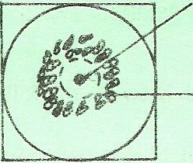
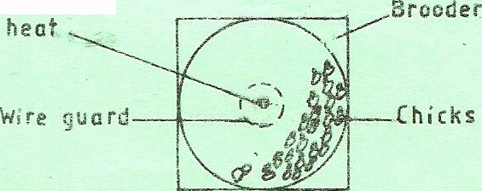
A B Source of heat

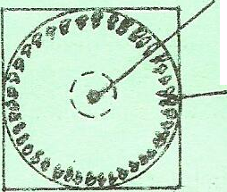
C Source of heat
- Explain the cause of behavior observed in chicks for each of the illustrations labeled A, B and C. (3marks)
- A- Presence of draught makes the chicks to crowd on one side of the brooder.
- B- Cold/inadequate heat makes the chicks to crowd around the heat source.
- C- High/Excess heat makes the chicks to move away from the heat source.

- Give a reason for making the brooder wail round in shape. (1 mark)
- To discourage overcrowding of chicks at the corners to avoid suffocation.
- State one way of correcting the behavior of chicks shown in an above. (1mrk)
- Ventilation on the side where the draught is coming should be closed.
- Diagrams M, N, P and Q represents some farm tools.
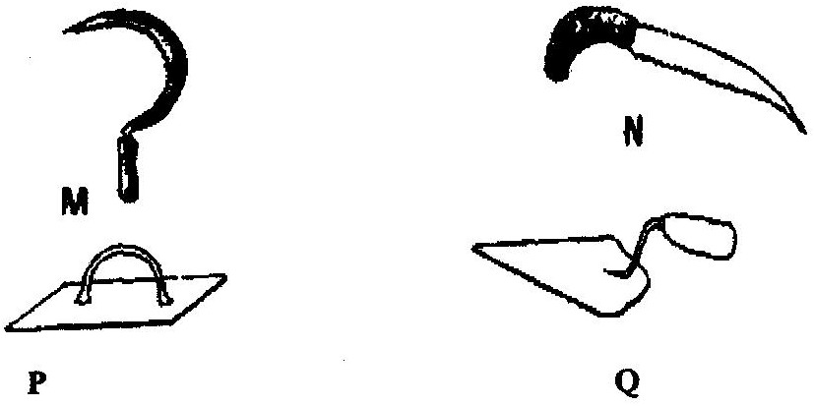

- Identify the tools; M, N, P and Q. (2mrks)
- M – Sickle
- N – Pruning saw
- P – Float
- Q – Garden trowel
- Give the use of each of the tools named above. (2mrks)
- M – Harvesting rice/grasses
- N – Pruning/cutting stems/branches in crops e.g. coffee citrus.
- P – Spreading screed on concrete floors/wall
- Q – Transplanting seedlings
- State two maintenance practices that should be carried out on tool M (1mrk)
- Replacing broken handles

- The diagram below illustrate a hoof of a sheep .Study it carefully and answer the questions that follow.
- Name the routine management practice that should be carried out on the hoof illustrated above. (1 mark)
- Hoof trimming
- State two reasons for carrying out the management practice in (a) above. (2 marks)
- To prevent lameness/ difficulty in walking
- To control foot rot
- To ease mating
- Name the two tools used to carry out the routine management practice named in (a) above. (2mrks)
- Hoof trimming knife
- Hoof cutter
- Hoof rasp

- A farmer wanted to prepare a 200kg of calf rearing ration containing 20% DCP. Using the Pearson Square Method, calculate the amount of Maize containing 10% DCP and Sunflower containing 35% DCP the farmer would need to prepare the ration. (Show your working) (5 marks)

- State five indicators that can be observed on a goat to confirm sickness. (5mrks)
- By checking the appetite and feeding - if low or excessive it indicates that the goat is sick
- Defaecation - inconsistency in texture, colour, smell, frequency and posture, presence of arasite segments, egg, larvae or blood
- Urination - irregular posture, colour and and frequency;
- Change in temperature above or below the normal range;
- Respiratory rate - irregular respiration shown by non-rhythmic inspiration and expiration indicates ill health.
- Pulse rate - Abnormal pulse rate under normal physiological status indicates ill- health.
- Production level - Loss of weight, emaciation and reduced production rate. Abnormal discharges
- Posture - while standing or lying.
- Behaviour eg. abnormal sound, aggression, excitement.
- Appearance - eg. dullness, restlessness, pot belly, bloated.
- Movement eg. gait, eg, standing or limping when walking.
- Mucuors membranes (abnormal) eg. bright red colour, yellowish, blueish depending on disease.
- Skin/animal coat - (abnormal) starring hair, coat, sores/wounds on skin.
- Describe eight physical characteristics of a poor layer in a flock of hens. (8mrks)
- Combs and wattles - small/shrivelled/shrunken. Dry scaly and place.
- Eyes - dull and pale yellow.
- Beak - yellowish in colour.
- Abdomen/breast - hard and full
- Vent - round, dry and less active
- Space between kee and pelvic bone - small and fits only one or two fingers
- Plumage - preened & glossy (smooth) beautiful
- Moulting - early moulting
- Shanks/feet - Yellowish in colour
- Broodiness - Is common/early moulting
- Temperament - easy and dull

- Give seven harmful effects of liver fluke in sheep rearing. (7mrks)
- Digestive upsets due to blocking of bile duct.
- Emaciation/recumbency leading to death
- Anaemia due to destruction-of-liver tissues
- Swollen lower jaw/Oedema in the jaws.
- Swollen abdomen.
- Destruction of liver tissues /haemorrhage

- Outline five characteristics of a clean milk. (5mrks)
- Free from disease causing micro-organisms/pathogens
- Free from hair, dirt or dust.
- Free from bad odours and tastes/has good flavours.
- Chemical composition within expected standards.

- Describe Brucellosis disease under the following sub-headings.
- Causal organism. (1mrk)
- Brucella arbortus; bacteria
- Signs of attack. (3mrks)
- Premature birth
- Retained placenta if abortion occurs
- Infertility of the cow/low libido in bulls
- A yellowish brown,slimy, odourless discharge from the vulva.
- Control measures. (3mrks)
- Use of artificial insemination
- Slaughtering affected animal
- Attendant should avoid contact with aborted foetus
- Blood test should be carried out for all breeding animal
- Hygiene in the animals’ house

- State eight advantages of Artificial Insemination (8mrks)
- Economical use of semen
- It control transmission of breeding diseases
- It prevent large bulls from injuring small cows
- It reduces expenses of keeping a male animal
- Semen can be stored for long
- It helps to control inbreeding
- It makes research work easier
- It eliminate the threat of keeping the bull
- A small scale farmer who cannot afford to buy superior bull can have the cows served at low low cost
- Sires that are unable to serve cows due to heavy weight or injury can produce semen to serve cows

- Describe five structural requirement of a good calf pen. (10mrks)
- Should be clean and easy to clean
- Be warm and dry
- Have adequate space to allow exercise and feeding
- Should be properly lit and allow sunlight for vitamin D
- Have proper drainage to avoid dampness
- Draught free to prevent chilling
- Be well ventilated to allow fresh air

- Describe the cycle of a four stroke petrol engine. (10mrks)
Induction
- Piston move downward
- Volume increases while pressure reduces
- Inlet valve opens while exhaust valve remains closed
- Air- to fuel mixture is sacked into the cylinder
Compression
- Inlet valves closes
- Piston moves up the cylinder
- Exhaust valve remains closed
- Air – to fuel mixture is compressed
- Pressure increases while volume decreases
Power/ignition
- Inlet and exhaust valve remains closed
- Pressure increases while volume decreases
- Spark is produced to ignite the fuel air mixture
- Piston moves down the cylinder
Exhaust
- Exhaust valves opens
- Piston moves up the cylinder
- Burnt air fuel mixture is expelled

