SUNRISE 2 GEOGRAPHY PP2 MARKING SCHEME
1. a) Differentiate between mining and quarrying. (2mks)
Mining is the process of extracting valuable mineral ores – both solid and liquid- from the earth while quarrying is the removal of rocks to form blocks (hard core) ballast for building and road construction.
b) List down three oil producing countries in the Middle East (3mks)
- Saudi Arabia
- Iran
- Iraq
- Kuwait
- Qatar
- United Arab Emirates
2. a) Name two forest reserves in Kenya (2mks)
- Arabuko Sokoke forest reserve
- Mt. Kenya forest reserve
- Kakamega forest
- Witu forest
b) State three characteristics of equatorial rainforest (3mks)
- The forests have a variety of tree species
- Trees are mostly hardwoods
- Trees are tall and form canopy
- Forests are evergreen as they shed leaves at different times of the year.
3. a) What is meant by the term ranching (2mks)
- Ranching is the practice of raising herds of animals in large tracts of land.
b) State three conditions which favour cattle ranching in Kenya (3mks)
- Large tracts of land in arid and semi-arid areas
- Availability of watering sites like the Lotikipi and Saiwa.
- Moderate rainfall which ensure there is enough pastures
- Moderate temperatures
4. a) Give two factors that determine the amount of water for irrigation. (2mks
- The amount of rain received in an area.
- The water retention capacity of the soils
- The type of crop and scale of operation
b) State three methods used to reclaim land in Kenya. (3mks)
- Draining of swamps and flood prone areas
- Irrigating of dry lands
- Introduction of drought resistant crops
- Afforestation
- Agroforestry
5. a) Name two major regions with high cottage industrial concentration in India (2mks)
- Mumbai
- Calcutta
- Jabalpur
- Madras
- Magpur
- Bhapal

b) State three reasons why new county government system in Kenya should encourage the Jua Kali industries in their region (3mks)
- Jua-kali sector creates employment opportunities to thousands of people.
- The industry will help to raise the standards of living of the people.
- Jua-kali sector earn income to the county government through taxes.
- It produces cheaper goods than those produced in formal industries

SECTION B
Answer question 6 and any other two questions from this section.
6. The table below shows crop production in Kenya in tones for a period of five years.
Crop/Year | 2007 | 2008 | 2009 | 2010
Maize  Peas  Onions  Cabbages | 600  400  300  100 | 800  600  400  200 | 700  400  300  200 | 800  700  600  400
a) i) Using a vertical scale of 1cm represent 200 tonnes present the above data using a compound bar graph. (9mks)
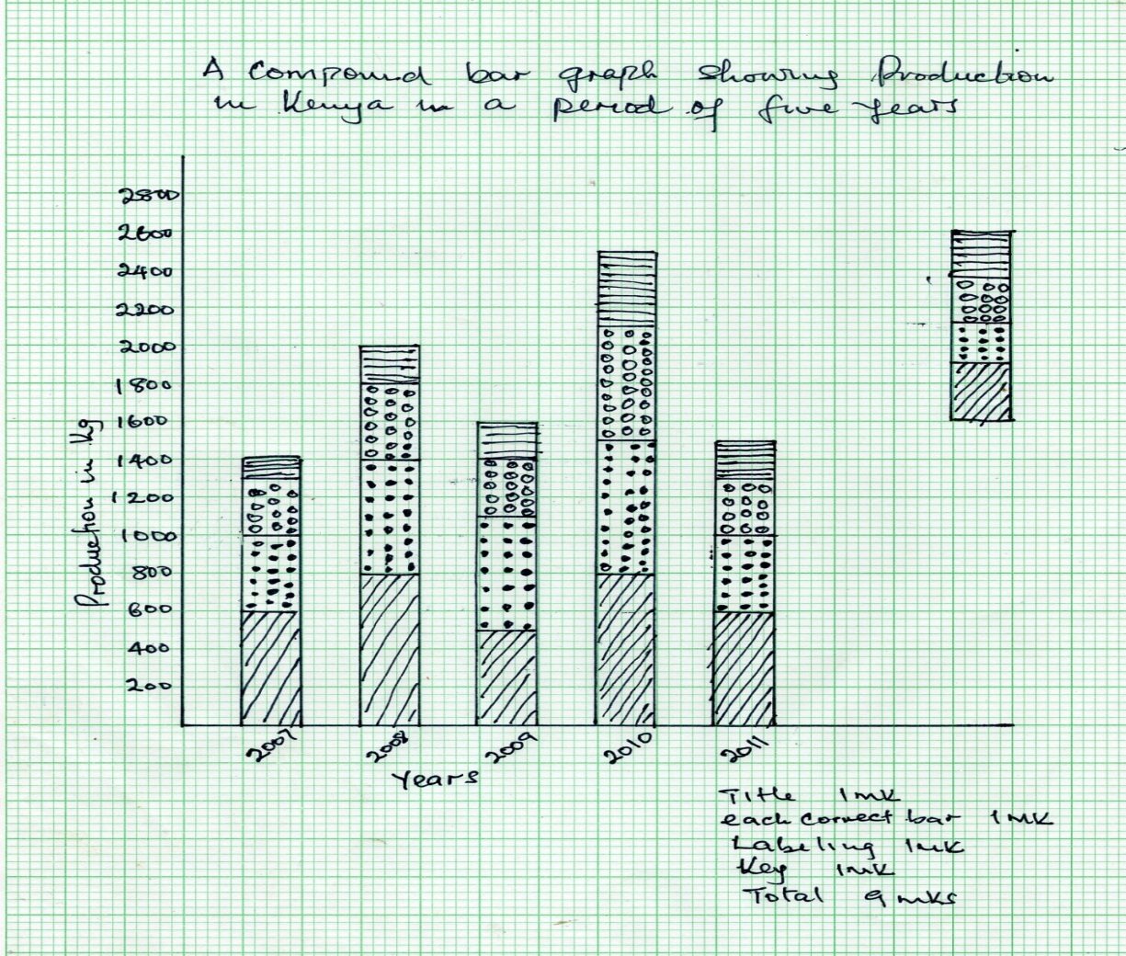

ii) State three advantages of using compound bar graph as a method of data presentation. (3mks)
- Provides a clear visual impression of the total value.
- It is easy to read the highest and lowest value at a glance.
- It facilitates comparison of data.
- The trends of the commodity in a given period can be depicted.
- A number of different variables can be represented in one bar
b) Explain how the following factors influence horticultural farming in Netherlands
i) Technology (2mks)
- Farmers use advanced technology in the green houses leading to quality produce.
ii) Marketing (2mks)
- Farmers have highly organized co-operative societies which market or auction the products.
c) State three features of horticultural farming in Netherlands. (3mks)
- Farms are generally small in size
- Farmers use advanced/highly specialized techniques of crop production e.g green houses
- The farms are intensively used.
- Farming is largely labour intensive.
d) Explain three difficulties that farmers in Kenya experience in marketing horticultural produce. (6mks)
- Impassible roads during the rainy season make it difficult for the perishable produce to reach the market.
- Poor marketing structure lead to reliance on middlemen who exploit farmers.
- Low quality produce make farmers incur loses/demolorised.
- Farmers face stiff competition from established or upcoming producer.
- Fluctuation of world market prices cause inconsistency in the profit margins thus discouraging farmers.
- Limited preservation facilities leads to spoilage of farmers’ produce

7. a)i) What is forestry? (2mks)
- It is the science of planting and caring of forests and their associated resources.
- Practice of managing and using trees/forests with associated resources. (any)
ii) Explain three factors that favour the growth of natural forests on the slopes of Mt. Kenya. (6mks)
- The area receives high rainfall 1000-2200mm throughout the year which encourages continuous growth of trees.
- Has deep fertile soils that allow roots to penetrate deep into ground to support the trees.
- Well drained soils thus there is no water logging which can interfere with the growth of variety of trees.
- The area is a gazette forest reserve which are prohibited hence allowing forests to grow without interference.
- The steep slopes discourage human activities thus enabling forests to thrive. (first)
b) Name three exotic species of trees planted in Kenya. (3mks)
- Pine
- Cypress
- Wattle
- Blue gum/Eucalyptus
c) State four ways in which the clearing of the forests has affected the natural environment in Kenya. (4mks)
- Lead to reduce volume of water in the rivers/cause rivers to dry up.
- Lead to destruction of natural habitat for wildlife.
- Changes in rainfall pattern/desertification
- Interfere with the natural beauty of the environment
- Disrupted the ecosystem
- Accelerated the soil erosion
d) Discuss 3 challenges experienced in the exploitation of tropical hardwood forests in Kenya. (6mks)
- Trees occur in mixed stand – exploitation is difficult.
- Huge buttress roots as the base of the trees making felling cumbersome
- Dense undergrowth – thick forest – hinder accessibility
- Huge trunks – difficult to exploit.
- Trees are heavy limiting use of rivers to transport
e) Give the differences in the exploitation of softwood forests in Kenya and Canada under the following sub-headings
i) Period of harvesting (2mks)
- Kenya – Done throughout the year while Canada is done in winter and early spring.
ii) Distribution of softwood. (2mks)
- Kenya – mainly in highlands while in Canada is both highlands and lowlands
- Kenya – Small percentage of the total land while in Canada large tracts are covered.
8. a) i) Name two countries found in the North West Pacific fishing ground. (2mks)
- Japan
- China
- Malaysia
- Indonesia
ii) Explain four physical factors that favour fishing in the above fishing ground. (8mks)
- Japan is generally mountainous which does not favour agriculture making fishing the only economic activity.
- Numerous islads provide good breeding ground for fish hence fishing.
- Extensive continental shelf are shallow providing light for the growth of plankton which is food for fish.
- Cool temperatures arising form the meeting of cold oxygen and warm kurosino providing conditions for plankton survival
b) Describe the following methods of fishing
i) Drifting (4mks)
- The net is placed vertically to hang it in water
- The net is fitted with floats on the upper edge and weights below and then placed a few meters below the water and pulled by powerful boats called drifters.
- When fish swim into the net they are entangled by their gills and cannot get out of the net.
- Once enough fish are caught the net is hauled onto the boat and fish is removed.
ii) Purse Seining (4mks)
- The purse seine net is laid in a circle to enclose a school of fish.
- At the bottom of the net are rings through which passes a rope .
- One end of the rope is attached to a boat and the other part is pulled by another boat around a school of fish.
- When the circle is completed, the rope is pulled to close the net forming a bow-like shape hence trapping fish.
- The net is then hauled to the shore and fish is removed.
c) Compare fishing in Kenya and Japan under the following sub-headings
i) Fishing ground (2mks)
Japan’s main fishing ground is marine while Kenya’s is mainly inland.
ii) Climate (2mks)
Kenya’s climate is warm discouraging growth of planktons and the variety of fish species therefore fishing is not elaborate while Japan’s climate is cool favoring planktons growth hence intensive fishing.
d) State three significance of fishing to the economy of Kenya. (3mks)
- Export of fish earn foreign exchange used to develop the economy.
- Fishing is a source of government revenue through taxation which is invested in other areas.
- Fishing waters produce raw material to produce lubricants, fertilizers and cosmetics.
- Fish creates employment opportunities that earns income to fishermen.
- Fishing is a sport that attract tourists thus generate foreign exchange for the country.

9. a) i) What is wildlife? (2mks)
Wildlife refers to all undomesticated plants and animals in their natural habitat.
ii) Name three natural habitats for wildlife. (3mks)
- Forests
- Woodlands
- Acacia/Savanna grasslands
- Scrublands
- Desert and semi arid land
- Rivers, lakes, swamps
b) Explain three human factors that favour tourism in Kenya. (6mks)
- Wide cultural heritage
- Relative political stability
- Fairly good transport and communication network
- Well organized package tours
- Advertisement
- Availability of accommodation (well explained)
c) Explain four roles played by the Kenya Tuorism Development Corporation in promoting tourism in Kenya (8mks)
- Advertises Kenya as a tourism destination
- Provides advisory services to tourism industry
- Provides affordable and accessible finance
- Ensures there is adequate security in collaboration with the government
d) Explain three factors that hinder domestic tourism in Kenya. (6mks)
- Negative attitude towards local tourism by the citizens
- High cost of accommodation in the lodges and hotels discourages many local tourists
- Poor transport and communication network of roads leading to the parks and other attractive sites.
- Differential treatment given to the foreign tourists discouraged the locals.
- Inadequate knowledge on the tourist attraction sites.

10. a) Name four geothermal power sites in Kenya (4mks)
- Olkaria
- Eburu near Naivasha
- Lake Bogoria
- Menengai
b) State four factors that influenced the location of Olkaria Geothermal unit. (4mks)
- The area had small population hence less cost of resettling people.
- Presence of many geysers to generate the necessary steam to turn turbines
- There was need to open up the area since it was remote
- Presence of hard basement rock
c) i) State four factors that limit the expansion of Geothermal power production in Kenya. (4mks)
- Inadequate capital for investment
- Inadequate skilled labour
- Inadequate technology
- Government bureaucracy and political interference
ii) Explain five ways in which Kenya has benefited from development of the Seven Forks Dam H.E.P. projects. (10mks)
- The dams have provide useful sites for education purposes.
- It has led to reduction of importation of power, thus saving the foreign exchange.
- It has lead to control of floods in lower parts of River Tana thus reducing the incidents of loss of life and farm produce in the area.
- Dams are used for generating electricity which is used for industrial and domestic purposes.
- The dams are tourists attractions which generate foreign exchange for the country.
- The reservoirs provide fishing grounds which supply fish to the local people.
- It has led to improvement of roads making the area more accessible
- The scheme led to the development of industries thus creating employment opportunities.
d) State three benefits of rural electrification in Kenya. (3mks)
- It wood reduce cutting down of trees as electricity would be available for domestic use.
- More people would invest in rural areas which would lead to higher standards of living
- Would encourage setting up of industries in the rural areas thus stimulating decentralization of industries.
- It would attract/improve social amenities in rural areas reducing the need for people to move to urban centres.
- It would encourage development of horticultural farming as storage of perishable products will be possible.

