**TRIAL EXAMINATION 2021**

**Kenya Certificate of Secondary Education (KCSE)**

**312/2 - GEOGRAPHY - Paper 2**

**Dec. 2021 – 2 ¾ hours**

**Name: ………………………………………..…….......… Adm No: ……….……………….**

**Stream**: ……………… **Candidate’s** **Signature**: …….………………....**Date**:…..…………...

**Instructions to candidates**

1. *Write your name, admission number and class in the spaces provided above.*
2. *Sign and write the date of the examinations in the spaces provided.*
3. *This paper consists of two sections;* ***A*** *and* ***B***
4. *Answer* ***all*** *the questions in section* ***A*** *in the spaces provided after each question.*
5. *In section* ***B****, answer* ***question 6*** *and any other* ***two*** *questions.*
6. *Answers* ***must*** *be written in the spaces provided at the end of question 10.*
7. ***This paper consists of 7 printed pages.***
8. ***Candidates should check the question paper to ascertain that all the pages are printed as indicated and that no questions are missing.***
9. ***Candidates should answer the questions in English.***

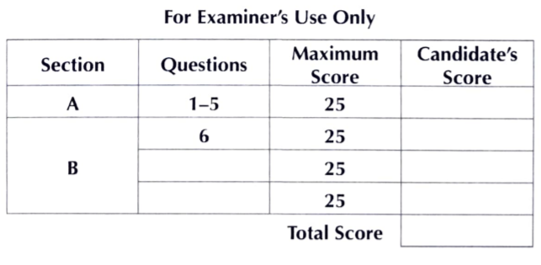

**SECTION A**

Answer ***all*** the questions in this section

1. (a) Define the term agroforestry. (2 marks)

(b) Give ***three*** uses of the mangrove trees. (3 marks)

1. (a) Name ***two*** areas where diamonds are mined in South Africa. (2 marks)

(b) State ***three*** negative effects of mining on the physical environment. (3 marks)

1. (a) Name the spectacular wildlife activity across the Mara river that is considered one of the new wonders of nature. (2 marks)

(b) State ***three*** characteristics of package tourism. (3 marks)

1. (a) Name ***two*** types of railway rail currently operated in Kenya by railway services. (2 marks)

(b) State ***three*** conditions of roads in Kenya that may lead to motor vehicles accidents. (3 marks)

1. Below is a map of the Ruhr industrial region in Germany. Use it to answer the questions that follow.

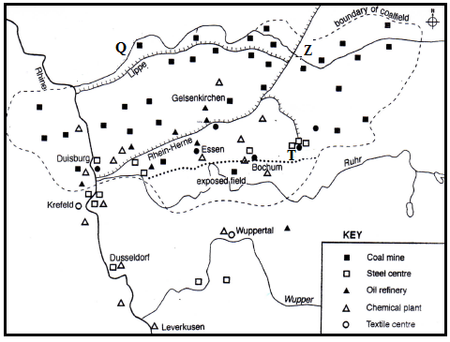

1. Name:
2. The river marked **Q**. (1 mark)
3. The town marked **T**. (1 mark)
4. The canal marked **Z**. (1 mark)
5. Give ***two*** reasons why the Ruhr region has lost some of its importance as an industrial centre in recent years. (2marks)

**SECTION B**

*Answer* ***question 6*** *and any other* ***two*** *questions in this section*

1. Study the photograph below and use it to answer questions (a) and (b)

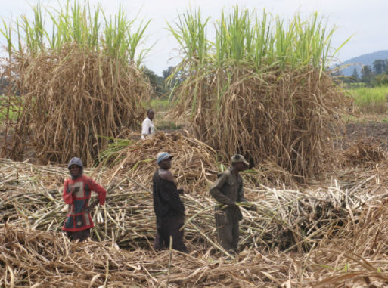

1. (i) Name the activity taking place in the photograph. (1 mark)

(ii) Identify the type of photograph shown above. (1 mark)

(iii) State ***three*** reasons for the identification in (ii) above. (1 mark)

(iv) Identify ***four*** safety measures that the people in the photograph have taken as they carry out the above activity. (4 marks)

1. (i) Draw a rectangle measuring 15cm by 10cm to represent the area covered by the photograph. (2 marks)

(ii) On the rectangle sketch and label ***four*** main features shown on the photograph (4 marks)

1. 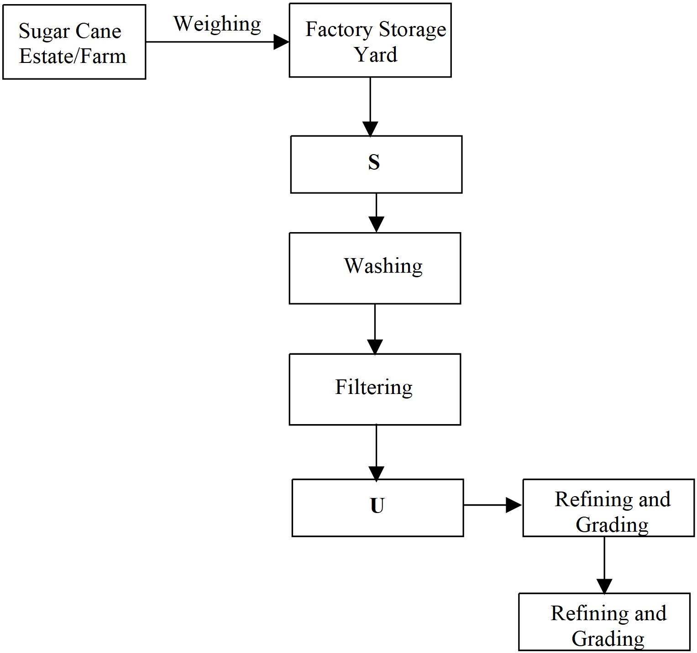Below is a flow chart showing the processing of sugar cane. Study it and answer questions, 6(b) (i) and (ii).
2. Name the processes labeled **S** and **U**. (2 marks)
3. Give ***two*** bi-products from the process labeled **U**. (2 marks)
4. Explain ***three*** possible solutions to the problem of exploitation by the middle men in sugar cane farming. (6 marks)
5. (a) (i) Give ***two*** disadvantages of using agro-chemicals as a method of controlling tsetse flies. (2 marks)

(ii) State ***three*** physical factors which should be considered when selecting a waste land to be reclaimed for agricultural use. (3 marks)

(b) (i) State ***three*** benefits that resulted from the reclamation of Yala swamp. (3 marks)

(ii) Give ***three*** advantages of irrigation over rain fed agriculture. (3 marks)

1. The map below shows some irrigation schemes in Kenya. Use it to answer questions (c) (i) and (ii).

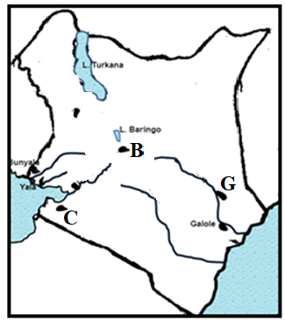

1. Name the irrigation schemes above labeled **B**, **C** and **G**. (3 marks)
2. State ***five*** challenges which the schemes labeled **B** faces. (5 marks)
3. (i) Name ***two*** main polders in the Netherlands. (2 marks)

(ii) Give ***four*** ways in which the polders in the Netherlands have contributed to Horticultural farming in the country. (4 marks)

1. (a) (i) Define the term fisheries. (2 marks)

(ii) State ***two*** characteristics of pelagic fish. (2 marks)

(b) The map below shows major world fishing grounds. Use to answer the questions that follow.

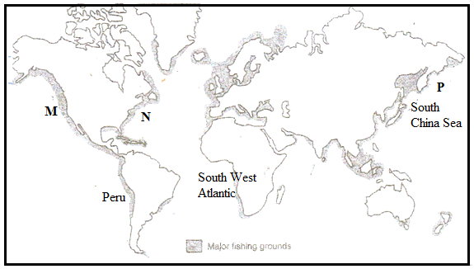

1. Identify the ***two*** ocean currents that converge in the fishing ground marked **P**. (2 marks)
2. Name ***two*** major fishing countries in the South West Atlantic fishing grounds (2 marks)
3. State ***two*** physical factors favouring fishing in the South West Atlantic fisheries (2 marks)

(c) (i) Identify the fishing method below (1 mark)



(ii) Describe how the above fishing method is carried out. (4 marks)

(d) (i) What is fish cage farming? (2 marks)

(ii) Give ***two*** reasons why tilapia is the most common fish species in fish farming. (2 marks)

(iii) Compare fishing in Japan and Kenya under the following subtopics:

* Technology (2 marks)
* Market (2 marks)
* Tradition (2 marks)

1. (a) The sketch map below shows Hydro-Electric power stations along River Tana. Use it to answer the questions that follow.

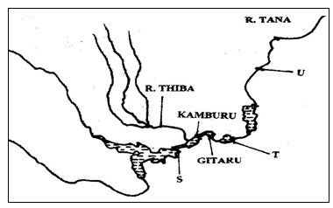

1. Identify the hydroelectric power stations marked **S** and **T**. (2 marks)
2. Name the proposed hydroelectric power station marked **U** (1 mark)
3. State ***three*** physical factors that led to the establishment of seven forks hydroelectric power project along river Tana (3 marks)
4. What is the name of the multi-purpose hydroelectric power dam recently commissioned by the Ethiopian government on the Blue Nile? (1 mark)

(b) (i) Name ***three*** sources of green energy (3 marks)

(ii) Name ***three*** potential sites of geothermal power in Kenya. (3 marks)

(c) (i) Define biomass (2 marks)

(ii) State ***four*** causes of energy crisis. (4 marks)

(d) Explain ***three*** effects of power rationing in Kenya. (6 marks)

1. (a) Define the following terms:
2. Census (2 marks)
3. Infant mortality rate (2 marks)

(b) (i) Explain ***three*** efforts taken by the Kenya government to reduce cases of infant mortality. (6 marks)

(ii) State ***three*** challenges the Kenyan Government faces in her effort to control the Covid-19 mortality in the country. (3 marks)

(c) (i) Using the table below calculate the inter-census numerical population increase (2 marks)

|  |  |
| --- | --- |
| **Year** | **Total population** |
| 1979 | 15,327,061 |
| 1969 | 10,942,705 |

(ii) Give the meaning of brain drain. (2 marks)

(iii) State ***three*** measures that the Kenya government should undertake to check on brain drain. (3 marks)

(d) (i) Name ***two*** Scandinavian countries with slow population growth. (2 marks)

(ii) Give ***three*** measures taken by the above countries to increase their population growth (3 marks)

**THIS IS THE LAST PRINTED PAGE.**