BONDO SUB COUNTY JOINT EVALUATION EXAMINATION
MARKING SCHEME
Kenya Certificate of Secondary Education
312/2 - GEORGRAPHY - Paper 2

NOV 2021 - 2 Hours 45 Mins
Name:………………………………………………………………………Index Number:……………..
Candidate’s Signature:…………………………………………………..Date:…………………………..
Instructions to Candidates
- This paper has two sections A and B
- Answer all the questions in section A
- Answer question 6 and any other two questions from section B in the space provided
- Candidates should answer the questions in English

For Examiner’s Use Only
Section | Questions | Maximum Score | Candidate’s Score
A | 1 - 5 | 25
 | 6 | 25
B |  | 25
 |  | 25
Total Score |  | 100

SECTION A
Answer all the questions in this section
- (a) Define the term agroforestry (2marks)
- This is the growing of trees, crops and keeping livestock on the same piece of land at the same time.
(b) Give three uses of the mangrove trees (3 marks)
- absorbs Co₂ and purifies the atmosphere
- The bark has tannin used in tanning leather
- Used as firewood
- Timber for construct
- Aesthetic valve / environmental beauty
Any 3 x 1 = 3 mks
- (a) Name two areas where diamonds are mined in South Africa (2marks)
- Prestoria
- Koffle
- Jaggersfontein
- Kimberly
Any 2 x 1 = 2 mks
(b) State three negative effects of mining on the physical environment (3 marks)
- pollution of air, water, land and noise
- Dereliction of land/ugly land surface
- Loss of biodiversity
- Disruption/ lowering of the water table
- Leads to soil erosion/degeneration
Any 3 x 1 = 3 marks
- (a) Name the spectacular wildlife activity across the Mara river that is considered one of the new wonders of nature (2 marks)
- Wild beast migration
(b) State three characteristics of package tourism (3marks)
- The tourists travel in large numbers
- The tour is organized by an agency
- The tourist enjoy similar facilities
- The prices are fairly low
3 x 1 = 3 marks

- (a) Name two types of railway rail currently operated in Kenya by railway services. (2mark)
- Meter gauge
- Standard gauge
Any 2 x 1 (2 mark)
(b) State three conditions of roads in Kenya that may lead to motor vehicles accidents (3marks)
- Missing road sign
- Pot holes
- Sharp bends
- Narrow roads
- Misty /toppy or dusty conditions that reduce visibility
- Steepness
- Slippery conditions
Any 3 x 1 = 3 marks
- (a) Below is a map of the Ruhr industrial region in Germany

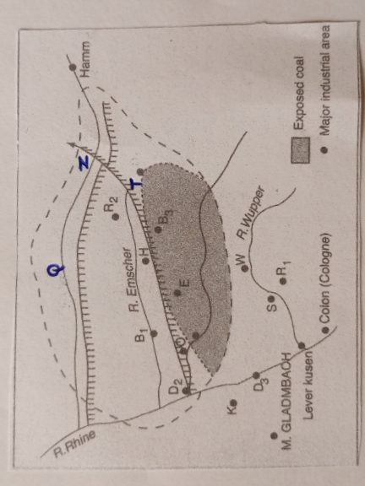

Name the:
- The river marked Q
Q – River lippe
- The town marked T
T – Dortmund
- The canal marked Z
Z – Dortmund Elms
(b) Give two reasons why the Ruhr region has lost some of its importance as an industrial centre in recent years. (2marks)
- The decline of use of coal as a source of energy in the industries
- Depletion of prime minerals especially coal and iron ore in the region
- Competition for activities from upcoming industrial areas.
2 x 1 = 2 marks

SECTION B
Answer question 6 and any other two questions from this section
- Study the photograph below and use it to answer questions (a)

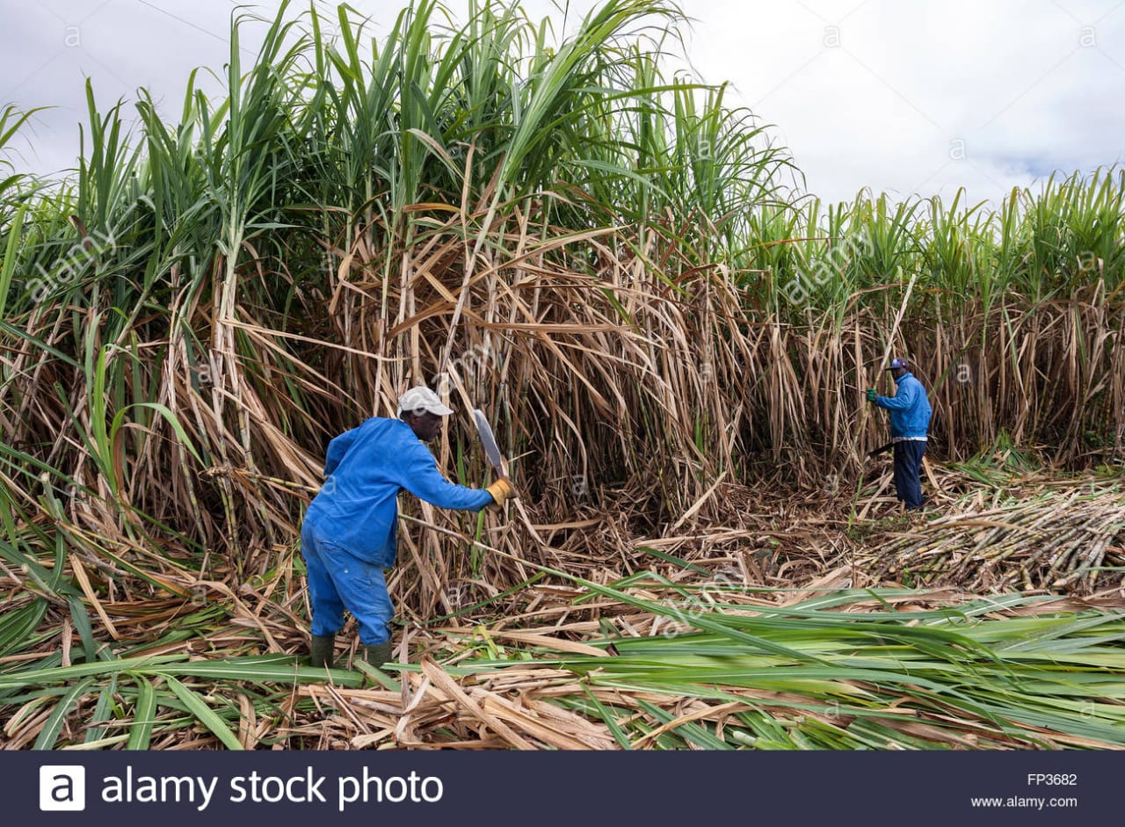

- (i) Name the activity taking place in the photograph (1mark)
- Sugarcane harvesting/ Cane cutting
(ii) Identify the type of photograph shown above (1mark)
- Ground general view
(iii)State three reasons for the identification above (3marks)
- A large area is covered
- Many features are shown
- The features diminish in size as one moves to the background
- The photograph has three parts, the fore ground, middle and back.
3 x 1 = 3 marks
(iv)Identify four safety measures that the people in the photograph have taken as they carry out the above activity (4marks)
- Hands covered with gloves
- Gum boots to protect from sharp stumps stalks
- Cap to protect them from strong shine
- Bright cover all for easy identification
- Working at a distance from each other
4 x 1 = 4 marks

(vi) Draw a rectangle measuring 15cm by 10cm to represent the area covered by the photograph(2marks
(vii) On the rectangle sketch and label four main features shown on the photograph (4 marks)
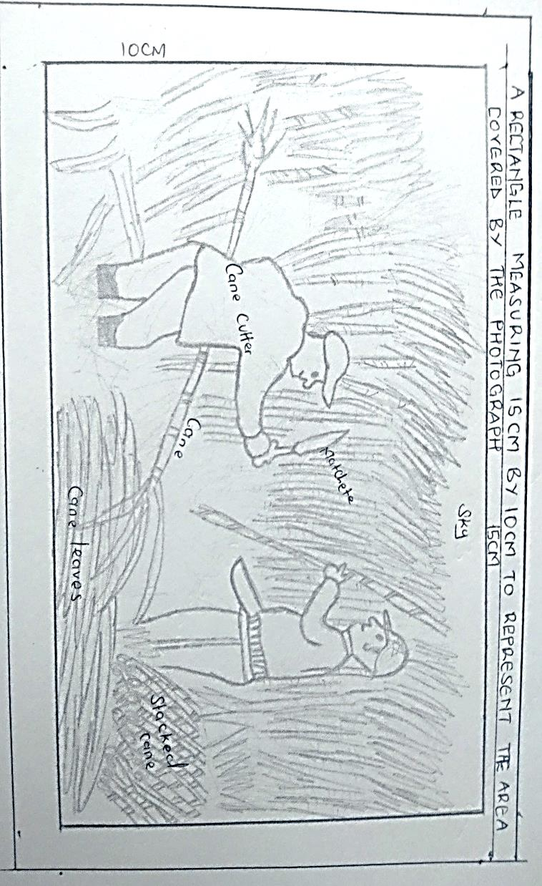

(b)Below is a flow chart showing the processing of sugar cane. Study it and answer questions,6(b)(i)
and (ii)

Sugar cane Weighing Factory storage yard
estate or farm

S

Washing to remove
Impurities

Filtering

U

Crystalization
Refining and
grading

Marketing
- Name the processes labeled S and U (2marks)
U – boiling / Crushing of cane
S – evaporation
- Give two by-products from the process labeled U (2marks)
- Molasses
- Sugar wax
- Explain three possible solutions to the problem of exploitation by middle men in sugar cane farming (6marks)
- Formation of farmers’ co-operative societies to help them market their produce.
- Contract signing as out growers to ensure direct payment by sugar companies.
- Direct individual delivery by the farmer to any sugar factory. 3x2=6 marks

- (a) (i) Give two disadvantages of using agro-chemicals as a method of controlling tse tse flies.
(2marks)
- May kill unintended organisms hence creating imbalance in biodiversity.
- May cause soil, air and water pollution.
- Some contribute in the destruction of the ozone layer.
- Tse tse flies may develop immunity to insecticides hence becoming uncontrollable
2 x 1 =2 marks
(ii) State any three physical factors which should be considered when selecting a waste land to be reclaimed for agricultural use (3marks)
- The size of the area is big enough to justify reclamation
- Soil fertility to minimize the cost of improving on them
- The climate – this should be suitable for the intended crop
- Terrain – Should be gentle / undulating for mechanization
- Pests and diseases – The area should have a low incidence of pests and diseases which lower production.
- x 1 = 3 marks
(iii) State three benefits that resulted from the reclamation of Yala swamp (3marks)
- Control of floods in the area
- Increased agricultural output i.e rice, maize
- Stimulated employment opportunities and raised standards of living.
- Increase of land for agriculture and settlement
- Controlled the cases of waterborne diseases i.e Malaria and bilhazia
- Opened up the remote area as roads, schools come up
any 3 x 1 = 3 marks
- (i) Give three advantages of irrigation over rain fed agriculture (3 marks)
- Cultivation can be done all year round
- River water contains fertile silt
- Enables cultivation of marginal dry areas.
- The irrigation dams may have other uses i.e H.E.P production
- Free of flooding as the amount of water is controlled.
any 3 x 1 = 3 marks

The map below shows some irrigation schemes in Kenya. Use it to answer question b(ii) and b(iii)

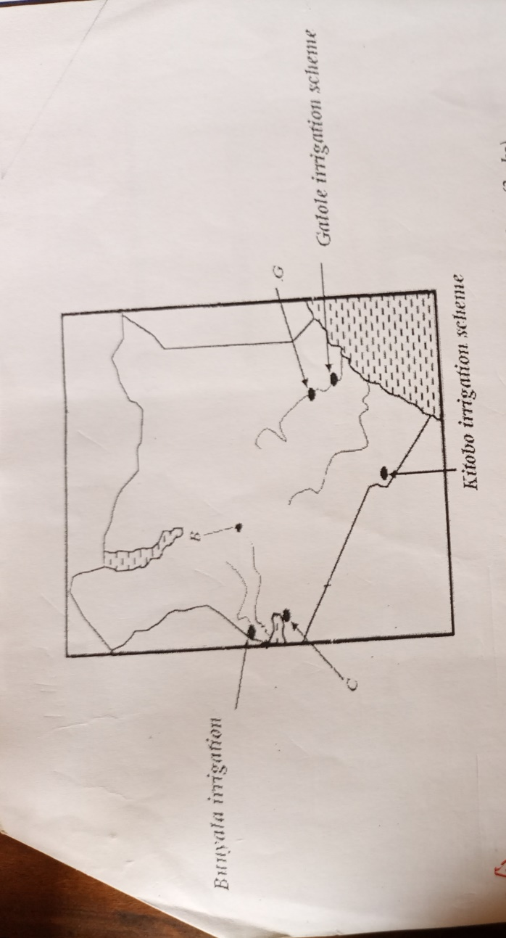ii) Name the irrigation schemes above labeled B,C and G (3marks)
B – Perkerre
C – West kano
G – Bura
any 3 x 1 = 3 marks
iii) State five challenges which the schemes labeled B faces (5marks)
- Low fluctuation of water during the dry season
- Siltation of canals increasing cast of dredging
- Rapid growth of weeds which lower crop production
- High evaporation rates leading to salinization of soils.
- Flooding during heavy rains
- Tribal conflict between the Tugen and pastrolist Ngemps
- Conflict with the National irrigation board over titles for land ownership.
any 5 x 1 = 5marks
- (i) Name two main polders in the Netherland (2marks)
- The delta plan
- The zulder zee (South sea)
any 2 x 1 = 2marks
(ii)Give four ways in which the polders in the Netherlands have contributed to Horticultural farming in the country. (4 marks)
- The polders have fertile soils from the sea bed used in horticulture farming.
- The polders have increased area of land for large scale horticulture production.
- The fresh water lakes created in the area i.e lake Yssel provide water for irrigation and desalinization of soils.
- The polders are gentle/undulating allowing for mechanization.
- The walls of the dykes are used as roads to transport the produce to the market.
Any 4 x 1=4marks
- (a) (i)Define the term fisheries (2 marks)
- Fisheries are water bodies where aquatic organisms/fish are reared for exploitation
2 marks
(ii) State two characteristics of pelagic fish (2 marks)
- They are small in size
- Found near the surface
- Live in groups shoals
- Are migratory
any 2 x 1 = 2marks
(b) The map below shows major world fishing grounds. Use to answer the questions that follow.
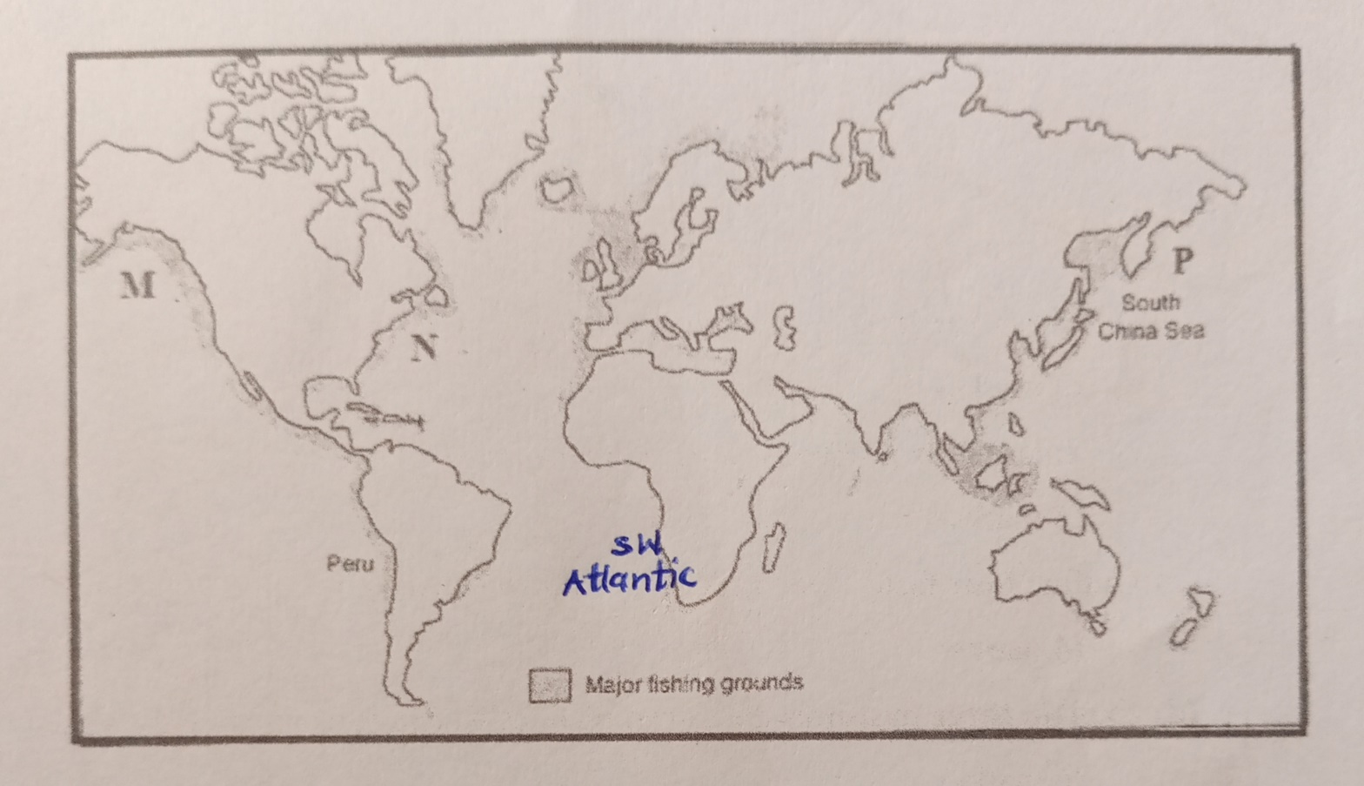
(i)Identify the two Ocean currents that converge in the fishing ground marked P. (2marks)
- The cold oya siwo and warm kuro siwa
2mark

(ii)Name two major fishing countries in the South West Atlantic fishing grounds (2marks)
- South Africa
- Namibia
- Angola
(iii)State two physical factors favouring fishing in the S.W Atlantic fisheries (2marks)
- The Coast is washed by the cold bengwela current
- The Coast is indented i.e in walvis bay in Namibia
- Shallow broad continental shelf which allows sunlight infiltration for plankton growth.
any 2 x 1 = 2 marks
(c)(i) Identify the fishing method below (1mark)
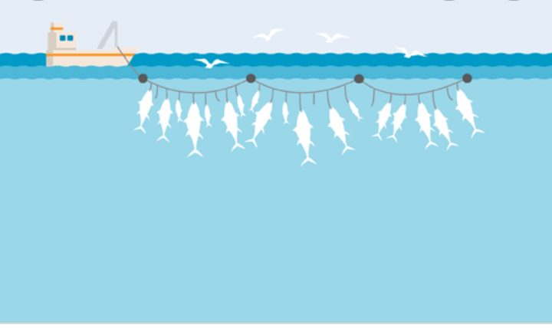
- Commercial long line ( 1 mk)
(ii) Describe how the above fishing method is carried out (4 marks)
- There is a long line about meters pulled by a boat.
- The long line has floats at the top from the long line are several small lines which are hooked at the end and baited
- The fish are trapped by their gills when they try to eat the bait.
- After sometimes the lines are pulled out of water and the fish emptied.
any 4 x 1 = 4 marks
(d)(i) What is fish cage farming (2 marks)
- This is the rearing of fish in water bodies using cage like structures
2 x 1 = 2marks

(ii) Give two reasons why tilapia is the most common fish species in fish farming (2 marks)
- It breeds fast
- Resistant to diseases
- Most palatable (liked)
- Can survive in different environment
2 x 1 = 2 marks
(iii)Compare fishing in Japan and Kenya under the following subtopics (2 marks)
- Technology
The japan uses modern boats with refrigerator in deep waters while Kenya use simple boats in the shallow waters.
- Market
The fish caught in Japan is for domestic and mainly export, Kenya is mainly for domestic market
- Tradition
The Japanese have a seafaring tradition while in Kenya only the communities, around the Lake and the sea engage in major fishing
- (a) The sketch map below shows Hydro-Electric power stations along River Tana
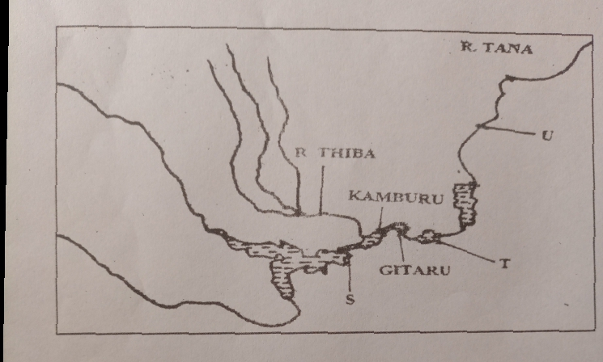
- Identify the H.E.P stations marked Sand T (2 marks)
S – Masinga station
T – Kindaruma station
- Name the proposed H.E.P station marked U (1 mark)
U – Mutonga
- State three physical factors that led to the establishment of seven forks hydroelectric power project along river Tana (3 marks)
- Regular and constant supply of water from River Tana
- Presence of large volume of water from River Tana
- Presence of hard basement rock that provided foundation for dam and power house construction.
- Presence of rapids and waterfalls that provided steep gradient (hydraulic head) for H.E.P production.
- Presence of deep and steep narrow gorges that provided enough space for large reservoirs and reduced cost of dam construction.
3 x 1 = 3marks
- What is the name of the Multi purpose H.E.P dam recently commissioned by the Ethiopian government on the blue Nile. (2marks)
- Grand Ethiopian Renaissance Dam
(b) (i) Name three sources of green energy (3marks)
  - Sun
  - Geothermal steam
  - Water tides/waves
  - Wind
  - Biomass
3 x 1 = 3 marks
(ii) Students of Mawingo Secondary school carried out a field study on Geothermal sites in the Kenya Rift Valley.
Name three Geothermal potential sites they may have identified (3marks)
- Ol karia
- Suswa
- Lake bagoria and Magadi
- Longanol
- Eburu
- Mai Mahiu
- Menegai crater
(iii)Name a method they used to record data (1mark)
- Video taping
- Photographing
- Field sketching
- x 1 = 1mark

(c)(i) Define the term Biomas? (2marks)
- Biomas are energy sources derived from organic matter
2x 1 = 2 marks
(ii) What is energy crisis? (2 marks)
- This refers to a situation where the prices of fossil fuels rises uncontrollably as a result of demand surpassing supply.
2 marks
(iii) Explain three effects of power rationing in Kenya (6 marks)
- Unemployment due to closure of industries leading to inability to pay workers.
- Slow industrial growth due to low energy to run machines in industries
- Drainage of foreign exchange from important of energy to cater for the shortage.
- Discourage foreign investors in the country because there is uncertainty of the future growth for their investments.
- Lowers the number of tourists in the country because their desired comfort offered by power is lacking.
- Reduction in government revenue got from taxation of goods from industries and from payments of consumed energy
- x 2 = 6 marks
- (a)Define the following terms (2marks)
(i)Census
- This is the official count of all persons in a defined area at a specific time
(ii) Infant mortality rate (2marks)
- This is the number of children who die before attaining the age of one year
(b)(i) Explain three efforts taken by the Kenya government to reduce cases of infant mortality
(6marks)
- Improved nutrition, free children feeds given by the ministry of health.
- Mandatory prenatal and post natal clinic attendance to monitor child and mother and to take immunization
- Issuance of the malaria testing, drugs and nets to expectant mothers.
- Educating mothers on the importance of breast feeding and spacing children
3 x 2 = 6 marks
(ii)State three challenges the Kenyan Government faces in her effort to control the Covid-19 mortality in the country (3marks)
- Mutation of the disease into new variants
- Corruption i.e embezzlement of donor funding by corrupt Government officials
- Limited donor support
- Uncooperative citizens towards Covid -19 containment measures.
any 3 x 1 =3marks
(b)(i) Using the table below calculate the inter-census numerical population increase (2marks)
Year | Total population
1979 | 15,327,061
1969 | 10,942,705
= 4,384,356
(2marks)
(ii)Give the meaning of the term Brain drain (2marks)
- The migration of highly trained or qualified people from a particular country
2 x 1 = 2 marks
(iii)State three measures that the Kenya government should undertake to check on Brain drain (3marks)
- Offer higher salary perks to the skilled man power
- Improving working conditions in their work places i.e safety
- Sponsoring them to take further studies locally and abroad.
- Educating them to be patriotic and help build their county.
3 x 1 = 3 marks
(c)(i) Name two Scandinavian countries with slow population growth (2 marks)
- Norway
- Sweden
- Denmark
- Finland
- Ice land
Any 2 x 1 = 2 marks
(ii) Give three measures taken by the above countries to increase their population growth (3marks)
- Prolonged maternity for the women and also men as an incentive to give birth to more children
- The government give free medical services, tax help to the mother and child
- Educating the public on the need to have more children so as to reduce dependency on migrant workers.
- Free education to the children up to the university.
3 x 1 = 3 marks
This is the last printed page

