TRIAL EXAMINATIONS 2021
Kenya Certificate of Secondary Education (KCSE)

312/1 - GEOGRAPHY - Paper 1

Dec. 2021 – 2 ¾ hours

Name: ………………………………………..…….......… Index No: ……….……………….
Stream: ……………… Candidate’s Signature: …….………………....Date:…..…………...

Instructions to candidates
- Write your name, admission number and class in the spaces provided above.
- Sign and write the date of the examinations in the spaces provided.
- This paper consists of two sections; A and B
- Answer all the questions in section A in the spaces provided after each question.
- In section B, answer question 6 and any other two questions.
- Answers must be written in the spaces provided at the end of question 10.
- This paper consists of 4 printed pages.
- Candidates should check the question paper to ascertain that all the pages are printed as indicated and that no questions are missing.
- Candidates should answer the questions in English.

SECTION A
Answer all the questions in this section
- (a) If the time in Town Y which is 75⁰ W is 5 a.m., what is the time in town P which is 40⁰ E? (3 marks)
(b) How does rotation of the earth cause the occurrence of day and night? (2 marks)
- (a) Name two elements of weather that can be recorded at a school weather station. (2 marks)
(b) The diagram below represents a weather measuring instrument. Use it to answer the following questions.
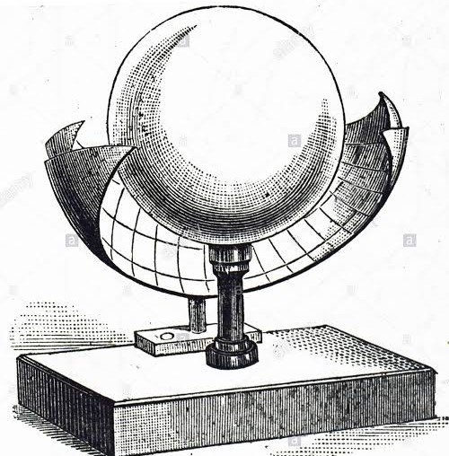
- Identify the weather element measured using the above equipment. (1 mark)
- Describe how the above instrument is used. (2 marks)
- Describe how igneous rocks are formed (5 marks)
- (a) Name the types of delta found at the mouth of;
- River Nile (1 mark)
- River Omo (1 mark)
(b) State three conditions necessary for the formation of a delta (3 marks
- The diagram below shows mountain vegetation zones, use it to answer the questions that follow.
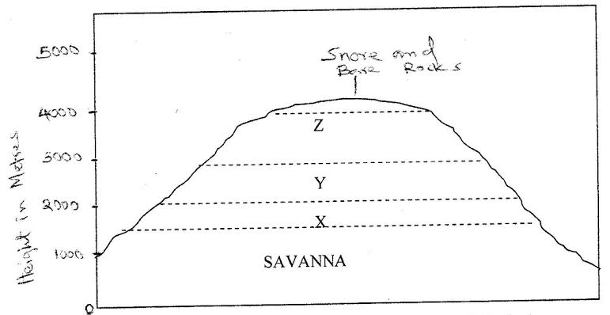
- Name the vegetation zones marked X, Y and Z. (3 marks)
- State two reasons why the mountain top has no vegetation. (2 marks)

SECTION B
Answer question 6 and any other two questions from this section.
- Study the map of Kijabe 1:50, 000(sheet 134/3) provided and answer the following questions
- (i) Identify two types of scales used in the map of Kijabe (2 marks)
(ii) Name any two drainage features found in Kijabe (2 marks)
- (i) Measure the distance of the road B3 from Narok to the junction at road 4104. Give your answers in kilometers and meters. (2 marks)
(ii) Give the economic activities represented by the following features in Kijabe (4 marks)
- Saw mills.
- Water troughs
- Forest guard post
- Kagwe Carbacid plant
- Name three human features found in grid square 3690. (2 marks)
- Describe the distribution of natural vegetation in the area covered by the map. (6 marks)
- Citing evidence from the map, explain three factors that have favored trade in Kijabe area (6 marks)

- (a) (i) Name one tectonic forces that causes faulting. (1 mark)
(ii) Differentiate between a normal fault and a reverse fault. (2 marks )
(b) Using labelled diagrams, describe how the following features are formed
- Block mountain (8 marks)
- Fault steps (8 marks)
(c) Explain three ways in which faulting may influence drainage (6 marks)

- (a) (i) Give three underground features found in a karst landscape (2 marks)
(ii) State three reasons why there are few settlements in a karst landscape. (3 marks)
(b) Describe how the following surface features in limestone are formed:
- Grikes and Clints (4 marks)
- Uvala (5 marks)
(c) Explain three negative effects of resultant features in limestone areas on human activities.(6 marks)
(d) Students of Nyamira Girls High School are planning to go for a field study in areas of Karst scenery.
- State two reasons why it was important to seek permission from school administration (2 marks)
- Give two reasons why they would need a map of the area of study (2 marks)

- (a) (i) Define desertification (2 marks)
(ii) State two factors influencing wind transport (2 marks)
(b) Describe how the following features are formed:
- Oasis (5 marks)
- Bajada (5 marks)
(c) Explain three significance of desert land forms to human activities (6 marks)
(d) You intend to carry out a field study in a desert landform
- Give two methods you would use to collect information (2 marks)
- State the follow up activities you would carry out after the field study (2 marks)

- (a) What is glacier (2 marks)
(b) State the distinctive characteristics of the following features resulting from glacial erosion;
- Corrie (2 marks)
- A pyramidal peak (2 marks)
(c) Describe how the following features are formed;
- Terminal moraine (4 marks)
- Crag and Tail (4 marks)
- Cirque lake (5marks)
(d) Explain three positive effects of glaciation in lowlands (6marks)

THIS IS THE LAST PRINTED PAGE

