**312/2**

**GEOGRAPHY**

**FORM FOUR**

**2 3/4HOURS**

ASUMBI GIRLS HIGH SCHOOL

PRE-MOCK

MAY-JUNE

2022

**Instructions to candidates**

1. *This paper has* ***two*** *sections* ***A*** *and* ***B****.*
2. *Answer* ***all*** *questions in section* ***A****.*
3. *In section* ***B*** *answer question* ***6*** *and any* ***other two*** *questions.*
4. *All answers must be written in the answer booklet provided.*
5. ***This paper consists of 4 printed pages.***
6. ***Candidates should check the question paper to ascertain that all the pages are printed as indicated and that no questions are missing.***
7. ***Candidates should answer the questions in English.***

**SECTION A**

***Answer all the questions in this section***

1. (a) What is industrial inertia? (2mks)

(b) Give **three** reasons why industrialists prefer locating new industries where old ones exist. (3mks)

1. (a) What is under population? (2mks)

(b) State **two** advantages of a large population in a developed country (2mks)

1. (a) Name **two** areas in Kenya where flowers are grown in green houses (2mks)

(b) Give **three** reasons why flowers are grown under green houses. (3mks)

1. (a) Name **two** types of placer mining (2mks)

(b) State **three** negative effects of open cast mining on the environment (3mks)

1. (a)(i) Apart from freshian cows name three other dairy cattle reared in Kenya.(3mks)

(ii) Give **two** ways in which farming contributes to water pollution. (2mks)

(b)(i) What is emigration? (1mk)

**SECTION B**

***Answer question 6 and any other two questions in this section.***

1. Hypothetical figures showing sugar production from various factories in Kenya on ‘000’ tonnes.

Factory Production on tonnes

Mumias 48 200

Nzoia 26 000

Chemilil 36 000

Sony sugar 28 000

Muhoroni 20 400

Total 158 600

1. (i) Using a pie chart of radius 4cm present the data above (show your calculations) (5mks)

(ii) What percentage of total sugar production was contributed by Mumias? (2mks)

(iii) State **three** advantages of using pie-charts to present statistical data. (3mks)

1. Explain **four** problems facing sugar cane farming in Kenya. (8mks)
2. Describe how sugar is processed in the factory. (4mks)
3. Give **three** government support actions to sugar cane farmers. (3mks)
4. (a) What is energy? (2mks)

(b) List **four** examples of renewable types of energy (4mks)

(c)(i) State **three** limitations of Geothermal energy (3mks)

(ii) Define energy crisis? (2mks)

(iii) Explain **four** ways Kenya is dealing with energy crisis? (8mks)

(d)(i) Highlight **three** significance of energy (3mks)

(ii) Give **three** ways in which atmosphere is heated (3mks)

1. (a) List **four** tourist sites in the Coastal countries (4mks)

(b) Compare national parks and game reserves (5mks)

(c) Explain **four** negative effects of tourism (8mks)

(d)(i) Highlight **four** measures taken by the government of Kenya to promoting tourism (4mks)

(ii) Differentiate between tourism in Kenya and Switzerland. (4mks)

1. (a)(i) What is fishing and fisheries (4mks)

(ii) Explain **three** physical factors that favour fishing (6mks)

(b)List **three** types of fish caught in North East pacific fishing ground. (2mks)

(c)(i) State the significance of fishing industry in Kenya. (3mks)

(ii) Explain **four** problems facing fishing in Kenya. (8mks)

(d) State **two** methods that are used to manage and conserve fish in Kenya (2mks)

1. Use the map of East Africa to answer questions a(i) and (ii)

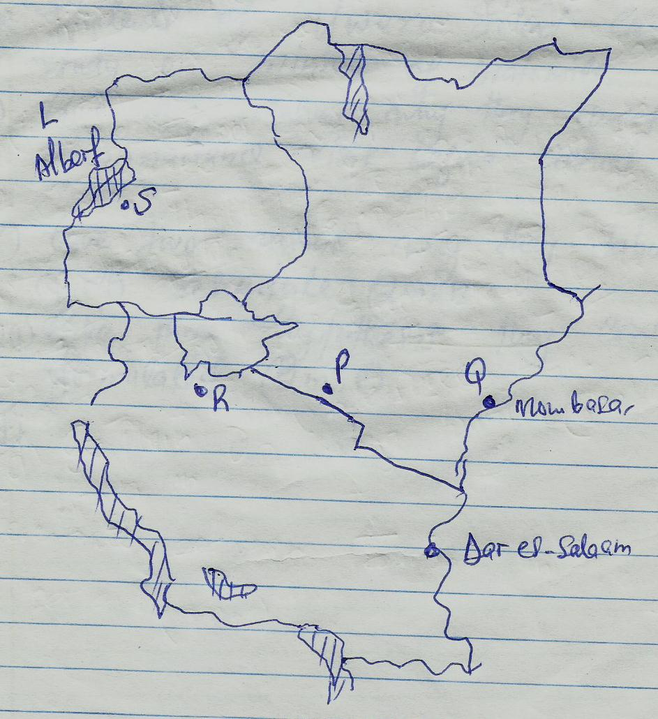

(a)(i) Name the minerals mined at the following marked areas S, P, and Q (3mks)

(ii) State **three** types of minerals. (3mks)

(b) Describe how alluvial placer method of mining is carried out. (4mks)

(c)(i) Mention **two** parts through which some of the minerals mined in East Africa are exported (2mks)

(ii) Explain **three** ways in which mining derelicts can be reclaimed (6mks)

(d) Students of Uwezo School carried a field study on mining of Diatomite in Nakuru County.

(i) Give **two** reasons why they carried out a reconnaissance visit before actual study. (2mks)

(ii) Give **two** reasons why they tabulated a work scheduled (2mks)

(iii) Give **three** hypothesis they could have formulated. (2mks)