MARKING SCHEME.
SECTION A: 25 MARKS
1. a) State two differences between a national park and a game reserve.( 2 mks)
- National park is managed by the national government while the game reserve is managed by the county government
- In the national parks no human activities or grazing is allowed while in the game reserve grazing is allowed.
- National park mainly conserves wildlife, scenery and historic sites while game reserve mainly conserves wildlife and scenery. ( any 2×1) 2mks
b) State three importance of domestic tourism.( 3mks)
- To increase the consumption of local wildlife products
- To increase the money circulation in the country
- To facilitate the interaction between different communities thus promoting national unity
- To increase employment opportunities
- To create awareness about the environment
- For people to appreciate their cultural heritage.
- To make use of tourist facilities during the low season
- To enhance the need for conservation and preservation of the environment.
( any 3×1) 3mks
2. a) Name two tree species of coniferous forests.( 2mks)
- Pine kei apple
- Spruce jacaranda
- Fir ( any 2×1) 2mks
- Cedar
- cypress
- African pencil
- eucalyptus/blue gum
- wattle
b) Give three characteristics of tropical hardwood forests that hinder their exploitation. (3mks)
- most of the trees are heavy hence difficult to haul or transport
- most of the forest have thick undergrowth make them impassable/ inaccessible
- most of the trees have large buttress roots that make them difficult to cut
- Most of the forests occur in mixed stand making them difficult to locate and extract the valuable tree species.
- Most of the trees take a long time to mature
- Experience very high amounts of rainfall making the roads impassable.
- The forests are habitats to wild animal that attack people and kill them.
(Any 3×1= 3mks)
3. a) Outline three problems facing wheat growing in Canada.( 3 mks)
- Frost that destroys the crop leading to lower yields
- Attack by pest e.g. shiny weevil lowering production
- Outbreak of diseases e.g stem rust lowering production
- Fluctuation of the world market prices leading to lower profits
- Soil exhaustion leading to lower yields
- Competition from other producing countries reducing the market for the crop
- Overproduction floods the market leading to lower prices
- Frozen waters during winter limiting accessibility in the wheat farms
( any 3×1= 3mks)
b) List two exotic beef cattle reared in Kenya. (2 mks)
- Aberdeen angus
- Hereford
- Short horn
- Galloway ( any 2×1) 2mks
4. a) Differentiate renewable and non-renewable source of energy.( 2mks)
Renewable sources of energy are those that can be regenerated and used for a very long time while non- renewable source of energy are those once used they became exhausted. √√ 2 mks)
b) State three problems experienced due to over-dependence on petroleum oil (3mks)
- Importation of oil drains off foreign exchange leading to unfavorable balance of trade
- High cost of transportation when there are crisis
- Closure of some industries which depend on petroleum and petroleum product as a raw material
- Leads to high cost of production which increases the prices of manufactured goods. ( any 3 ×1= 3mks)
5. a) Name two types of manufacturing industries in Kenya.( 2 mks)
- Agricultural food processing industries
- Agricultural non-food processing industries
- Non-agricultural processing industries. ( any 2 ×1 =2mks)
b) State three problems facing jua-kali industries in Kenya (3mks)
- Competition from well-established factory manufactured goods hence reduced sales
- Inadequate capital to invest
- Discrimination of goods due to negative attitude on the products leading to low demand.
- A rise in cost of materials resulting in increase in the prices of goods limiting the growth of industries
- Exploitation by middle men who offer low prices. ( any 3×1=3mks)

SECTION B: 75 MARKS
ANSWER QUESTION 6 AND ANY OTHER TWO
6. The table below shows crop production in Kenya for a period of five years in 1000 kilograms. Use it to answer question (a)
CROP/YEAR | 2005 | 2006 | 2007 | 2008 | 2009
Coffee | 1000 | 900 | 800 | 700 | 800
Tea | 700 | 700 | 600 | 680 | 600
Cotton | 500 | 400 | 300 | 600 | 350
pyrethrum | 300 | 200 | 300 | 440 | 450

(a) (i) Using a scale of 1 cm represent 200 kilograms present the above data using a compound bar graph.(9 marks)
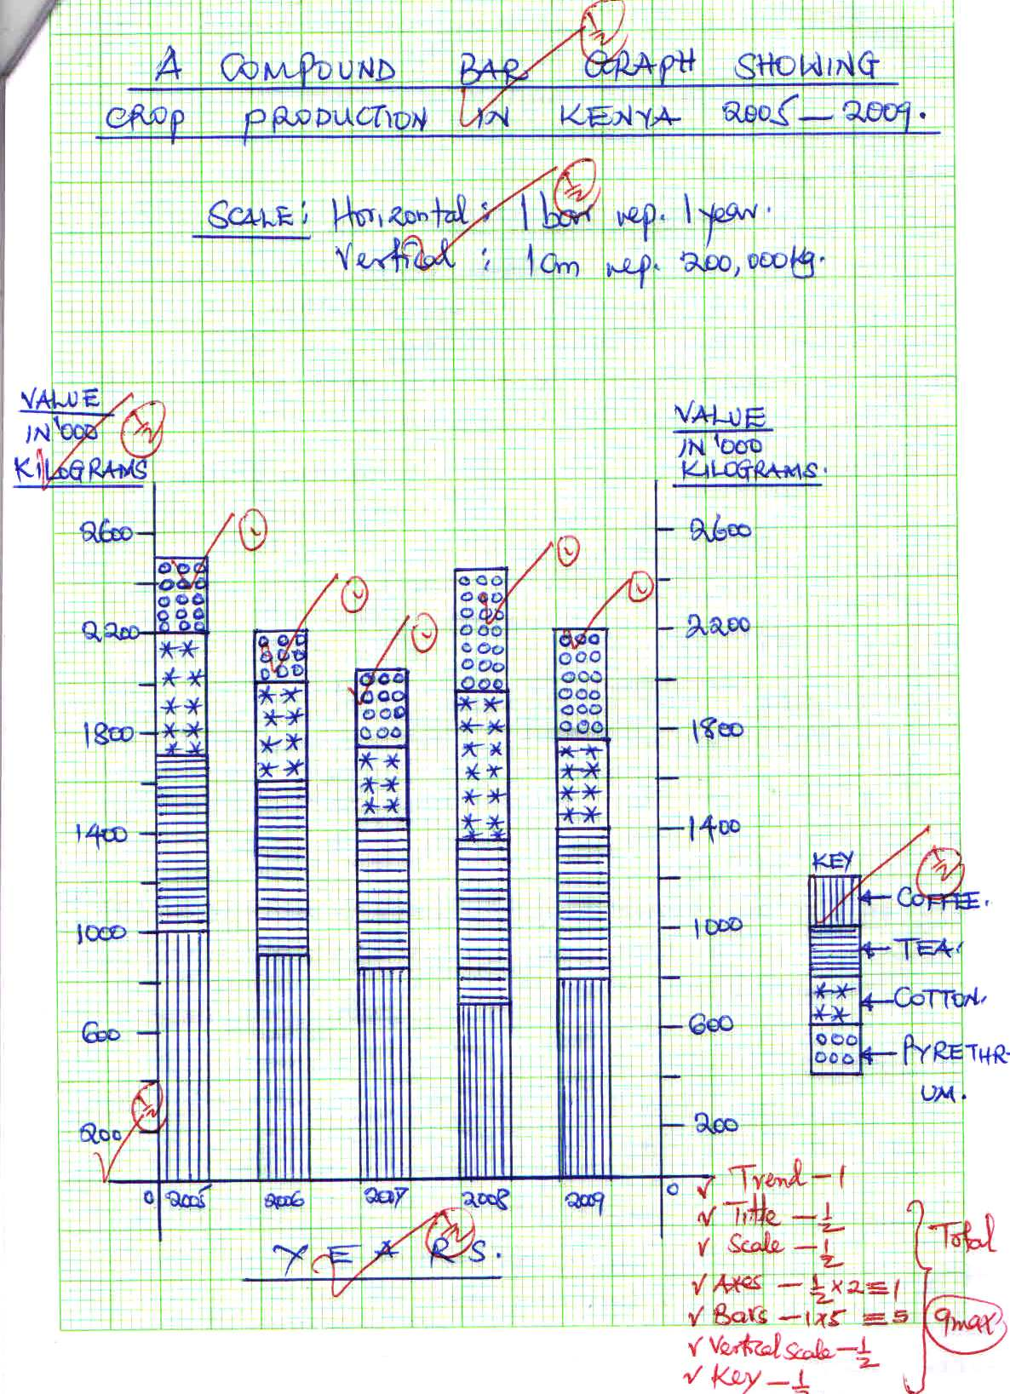
(ii) List two advantages of using a compound bar graph to represent statistical data. (2 marks)
- Facilitates comparison of data
- A number of variables can be represented in one bar
- Changes /trend is easy to trace
- Good visual impression ( any 2 ×1= 2marks)
(b) (i) Other than port harcout, name other towns associated with oil palm growing in Nigeria. (2 Marks)
- Sapele
- calaboar
(ii) State three physical conditions that favor the growth of oil palm in Nigeria. (3 marks)
- high well distributed rainfall of 2000mm per year
- high relative humidity
- high temperatures of 24-30℃
- deep, fertile well drained porous and rich in humus soils.
- Plenty of sunshine during the ripening period
- Gentle slopes /undulating landscape
- Land less exposed to strong winds ( any 3×1= 3mks)
(c) Describe the cultivation of oil palm from land preparation to harvesting. (6 marks)
- The nursery is prepared
- The land is cleared and ploughed
- Hole are dug and spaced at 9m by 9m
- The seedling are transplanted from the nursery to the holes
- Weeding and spraying is done regularly
- Manuring and addition of fertilizers is done
- The maturing trees flower and bear fruits after 3-4 years
- The mature fruits are harvested using a curved knife or hook
(any 6×1=6mks)
(d) Give three uses of palm oil. (3 marks)
- Used as cleansing agent in the tin industry
- Used for making margarine/cooking oil
- Used for making candles
- Used for making cosmetics
- Used for sweets and confectionaries
- Used as lubricant
- Used for making soap
- Used as food
- Used in the pharmaceutical industries. ( any 3×1= 3mks)
7. The world map below shows the major fishing grounds
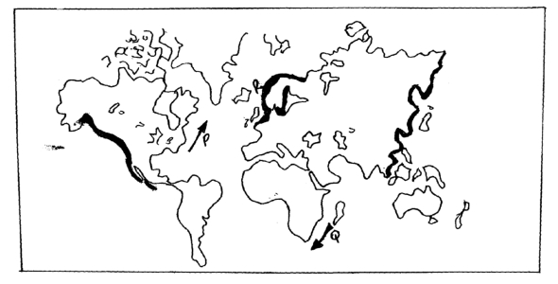
(a) Name the
(i) Ocean currents marked P and Q (2mks)
- P:warm gulf stream
- Q: Mozambique/alguhas warm current
(ii) Three types of fish caught at the coast of Canada (3mks)
- Salmon, mackerel, herring, sardines,pilchards,tuna,flounder, and haddock
( any 3×1= 3mks)
(b) Explain how the following factors favor fishing in Japan
(i) Ocean current (4mks)
- The meeting/convergence of the warm kurosiwo and cold oyashiwo causes upwelling of water which bring fish food to the surface./increases supply of oxygen required for the growth of fish and growth of plankton
- The ocean currents provide ideal temperature for survival of numerous species of fish/ growth of plankton.
- The warm kurosiwo current raises the temperature of the ocean water making it ice free encouraging fishing throughout the year ( any 2×2=4 mks)
(ii) Nature of the coastline (4mks)
- The indented/irregular sheltered coastline provide secure breeding ground for fish.
- The indented/irregular coastline provide suitable/ideal sites for the development of ports ( any 2×2= 4mks)
(iii) Level of technology (2mks)
- Modern/advanced technology encourages large scale commercial fishing/deep sea fishing/Limited technology discourages deep sea fishing.
- Modern /advanced fishing encourages large catch of fish/Limited technology allows only a small catch of fish .( any 1×2= 2mks)
(c) Describe how purse seining method is used in fishing (7mks)
- Uses two boats one large and one small
- The net has floats on top and weight at the bottom to keep it in a vertical position
- The net has a string along at the bottom edge
- The fishermen locates area rich in fish
- The string at the bottom is pulled to close the net at the bottom and trap the fish
- The net is pulled out of the water and fish is hauled/emptied into the larger boat for preservation and transportation. ( 7×1= 7 marks)
(d) Give three methods used to preserve fish (3mks)
- Sun drying
- Salting
- smoking
- Refrigeration ( any 3×1= 3 mks)

8. The table below shows the quantity of mineral produced in Kenya in tones between years 2001 and 2005.
Use it to answer questions a(i) and (ii).
Mineral / Years | 2001 | 2002 | 2003 | 2004 | 2005
Soda ash | 297780 | 304110 | 352560 | 353835 | 360161
Fluorspar | 11885 | 85015 | 80201 | 117986 | 109594
Salt | 5664 | 18848 | 21199 | 31139 | 26595
Others | 6093 | 7000 | 4971 | 6315 | 8972
Source: Economic Survey, 2006.
- Calculate the average production of soda ash over five year period. (2 Marks)
297780+304110+352560+353835+360161=1,400,436√
1,400,436/5=280,087.2 tonnes√

- Calculate the total mineral production for the year 2003. (1 Mark)
352560+80201+21199+4971=458,931tonnes

- Give three uses of soda ash. (3 Marks)
- Used in manufacture of soap
- Used in manufacture of glass
- Used in manufacture of detergents
- Used in paper and pulp industry
- Used in oil refining
- Used in textile industry ( any 3×1=3mks)
b) i) Name the main places in Kenya where the following minerals are mined: -
a) Flour spar-keriovalley
b) Titanium- kwale county
c) Gold- migori or kakamega. (3 Marks)
ii) State two problems associated with shaft mining. (2 Marks)
- Sometimes mines are flooded with water causing waterborne diseases
- The dust produced causes respiratory diseases
- Emission of poisonous gases causes death/ respiratory diseases
- Collapse of mines leading to death of miners ( any 2×1= 2mks)
c) Explain four ways in which gold mining has contributed to the economy of South Africa. (8 Marks)
- When exported earns the country foreign exchange
- Gold has been used as a unit of exchange for paying international debt
- Has led to development of social amenties
- Has led to urbanization of towns such as witwatersland
- Has led to industrialization hence larger market for the goods
- Has created employment opportunities raising the standard of livings
- Has led to development of transport network. ( any 4 ×2 = 8 mks)
- Explain three negative effects of mining on the environment. (6 Marks)
- Dumping of rock waste has led to loss of biodiversity
- Has led to land dereliction leading to wastage of of agricultural land
- Open pits that are left behind are breeding grounds for mosquitoes
- Causes environmental pollution e.g harmful gases released contaminates the air./mineral waste dumped into the rivers leading to death of aquatic life.
- Mining disrupts the water table leading to shortage of water
- Bare surfaces left due to clearing of the vegetation the land becomes prone to soil erosion. ( any 3×2=6 mks)
9. (a) i) Apart from geothermal power, name three other renewable sources of energy in Kenya (3mks)
- Wind
- Solar/sun
- Wood
- Biogas. ( any 3×1=3mks)
ii. State four factors that limit exploitation of geothermal power in Kenya (4mks)
- Inadequate/shortage of capital to invest in geothermal power production
- Shortage of skilled labor to install the geothermal power
- Low level of technology which hinders exploitation of energy
- Political interference in the project. ( any 4×1=4 mks)
(b). i. Give three factors considered when setting up a hydroelectric power generating plant (3mks)
- Presence of deep valley/a river gorge to save on cost of construction.
- Regular/reliable water supply to ensure continuous generation of power
- A hard basement rock to provide firm foundation for the construction of a dam.
- Presence of waterfall/steep gradient to provide hydraulic force for power generation.
- Impervious/impermeable rock to prevent seepage ( any 3×1= 3mks)
ii. List three advantages of electricity over other sources of energy (3mks)
- It is renewable.
- It is non pollutant
- It is relatively cheap
- It is easy to transport using wires
- It is easy to use
- It is adjustable to any fraction of energy using transformers
- Convenient to use. ( any 3×1= 3mks)
c) i) What is energy crisis (2mks)
it is the situation where the demand for oil is higher than the supply leading to higher oil prices√√/ a situation where the demand for a given fuel exceed supply√√
ii. Give two causes of energy crisis (2mks)
- Rapid depletion of oil resources leading to a reduction in the supply of oil when the demand for it increases
- Political disagreements between two trading partners leading to withdrawals of oil leading to shortage
- Shift from the use of wood fuel to oil as source of energy
- Slow development of other renewable sources of energy
- Imposition of sanctions on an oil producing country forcing to export only a limited quantities
- High cost of prospection of oil leading to a reduction of oil supply when the demand is increasing
- Sharp rise in demand of oil due to increasing population
- Wastage and misuse of energy
- Overdependence on oil and its products leading to high demand
- Collusion by oil producing countries causing artificial shortage in order to maintain profits
- Political disagreements making the oil producing countries to withhold oil causing crisis (any 2×1= 2mks)

10. Below is a sketch map showing Lake Victoria. Use it to answer question (a)
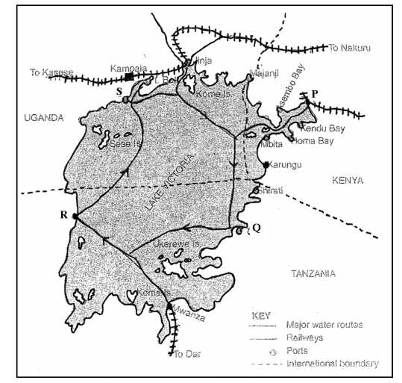

- i) Name the ports marked P, Q, R, S (4mks)
P – Kisumu
Q- Musoma
R – Bukoba
S – Entebbe
ii) Give four advantages of air transport over water transport. (4mks)
- Air transport is faster
- Air transport is less affected by congestion
- Air transport is easier in transporting perishable goods
- Air transport is most comfortable over long distances.
- Air transport allows access to remote areas.( any 4×1 = 4 mks)

b) i) Name three types of communication. (3mks)
- Oral/verbal communication
- Written communication
- Visual/audio communication
- Sign language. ( any 3×1 =3mks)

ii) Explain four problems facing transport and communication in Africa.(8mks)
- Difficult terrain – Africa is characterized by difficult terrain
- Lack of an integrated traffic system – Different countries has different traffic rules.
- Landlocked countries- A number of African countries are located far inland and away from oceans, thus denying them direct link to the sea.
- Shortage of navigable rivers – fluctuations in river levels and presence of obstacles.
- Uninhabited land- such areas are uneconomical
- Thick vegetation- It makes it different and expensive to construct transport system.
- Different railway and road systems.
- Political barriers- Political animosity between countries
- Inadequate capital – Heavy capital investment is required.
- Poor technology and shortage of skilled labour
- High fuel costs- Africans are unable to cope with the ever increasing prices of petroleum.
- Security – vandalism of communication facilities, road sign, Terrorisms, wars in several countries. (Any four well explained4 x 2 = 8mks)

c) Explain the role of the Great Lakes and St. Lawrence Seaway to the economies of Canada and the USA. (6mks)

- Source of foreign exchange for the two countries because many tourists are attracted to beautiful scenery e.g. Niagara Falls.
- Dams along the seaway are used to produce H.E.P. which stimulated growth of industries.
- Fishing is undertaken in dams and lakes along the water way.
- Development of agricultural activities along the seaway e.g. villages which practice horticultural farming.
- It’s a source of employment e.g. tour guides, security, transport, etc.
- Source of revenue to U.S.A. and Canada from toll charges paid by ships which go there.
- Lakes and the seaway are sources of fresh water for domestic and industrial purposes.
- Increased trade between the two countries and other countries of the world.
- Reduction of transport costs to and from the interior of the continent. ( any 3×2= 6marks)

