GEOGRAPHY PAPER 1 312/1
MARKING SCHEME
SECTION A
Answer all the questions in this section.
- (a) What is a Land Breeze (2mks)
Refers to a mass of cool air blowing from the land to the sea during the night 1x2 = 2mks
(b) Give three ways in which sea breeze influence the adjacent land. (3mks)
- It lowers the temperature of the adjacent land.
- It may increase rainfall
- It may increase relative humidity
- It moderates diurnal range of temperature
- It may lead to convectional rainfall. Any 3x1 = 3 marks

- State 5 characteristics of the mantle.
- It is composed of upper mantle and lower mantle.
- It has an average thickness of 2900 km
- It has a density of 3.0 – 3.3g/cm³
- The dominant mineral is olivine (ferrous magnesium silicate)
- It has a high temperature of about 4000⁰c
- The rocks are in semi-molten state. Any 5x1= 5 marks

- (a) Differentiate between magnitude and intensity of an earthquake. (2mks)
Magnitude refers to the amount of energy given off by an earthquake while intensity refers to how hard or strong an earthquake shakes the ground.1x2=2marks

(b) State three precautions which can be taken against earthquake destruction?
- Avoiding settling in earthquake prone regions.
- Discouraging construction of high building and constructing earthquake resistant structures eg. Bridges
- Timely warning of the occurrences of an earthquake.
- Constructing dykes along the coast to prevent Tsunamis. Any 2x1 = 2mks
- (a) Give two causes of Ocean currents (2mks)
- Winds
- Rotation of the earth
- Shape of the landmasses
- Temperature and water density
Any 2x1 = 2mks
(b) List three reasons why Oceans tend to heat more slowly than land masses. (3mks)
- Water surfaces reflect much light
- Water is mobile with circulating currents
- Large volume of water has to be heated deep / through penetration any 3x1= 3marks

- (a) What is humus (2mks)
This is the black/dark brown thin layer on the top soil made of decomposed dead plants or animal materials /remains. 1X2 = 2mks

(b) State three ways through which humus improve the quality of a soil.
- It helps to improve soil texture, tilth and structure.
- It provides essential soil minerals from the decomposed plant matter.
- It enables the soil to retain moisture and prevents leaching of soil minerals salts.
- It facilitate aeration of the soil
- It is a source of food for micro- organisms in the soil. Any 3x1 =3mks

SECTION B
Answer question6 and any other two questions in this section.
- a) (i) Give the six figure grid reference of the trigonometrical station (2610m) (2mks)
377939 or 378939 1x2 =2marks

(ii) What is the general flow of River Gatamaiyu South Eastwards / North West to South East
1X2= (2mks)

b) (i) Measure the length of Nairobi-Naivasha railway to the west of easting 27 and east of easting 24. Give your answer in kilometers. ( 2mks)
4.7km +0.1 km
(ii) Citing evidence from the map, identify three social services offered in the area covered by the map (6mks)
- education services evidenced by many schools
- health /medical services evidenced by hospital and dispensary.
- Religious services evidenced by churches for example at grid square 3890.
- Water supply services evidenced by pump house at grid square 3198
- Security services evidenced by police station at grid square 3097.
Services -any 3x1= 3mks
Evidence -any 3x1= 3mks
N.B service can score alone but evidence cannot score alone.

c) (i) Explain three physical factors favouring cattle rearing in the area covered
by the map. (6mks)
- Gentle slopes in the South Western side which offers suitable sites for the growth of pasture which forms food for cattle/ Gentle slopes also facilitate easy movement of cattle from one place to another.
- High rainfall evidenced by many permanent rivers which provide adequate drinking water for cattle.
- Cool temperatures evidenced by high altitude and forest. This provides ideal condition for dairy farming.
Any 3x2 = (6mks)

(ii) Identify three physical features found at grid square 2695 (3mks)
- Scrub
- River
- River valley
- Gentle slope any 3x1 = (3 mks)

d) (i) On the graph paper provided draw a rectangle measuring 12cm by 8cm to represent the area bordered by Easting 26 and Easting 29 and northing 94 and 96 (2mk)
(ii) On it mark and label
- All weather road loose surface (1mk)
- Power line
- 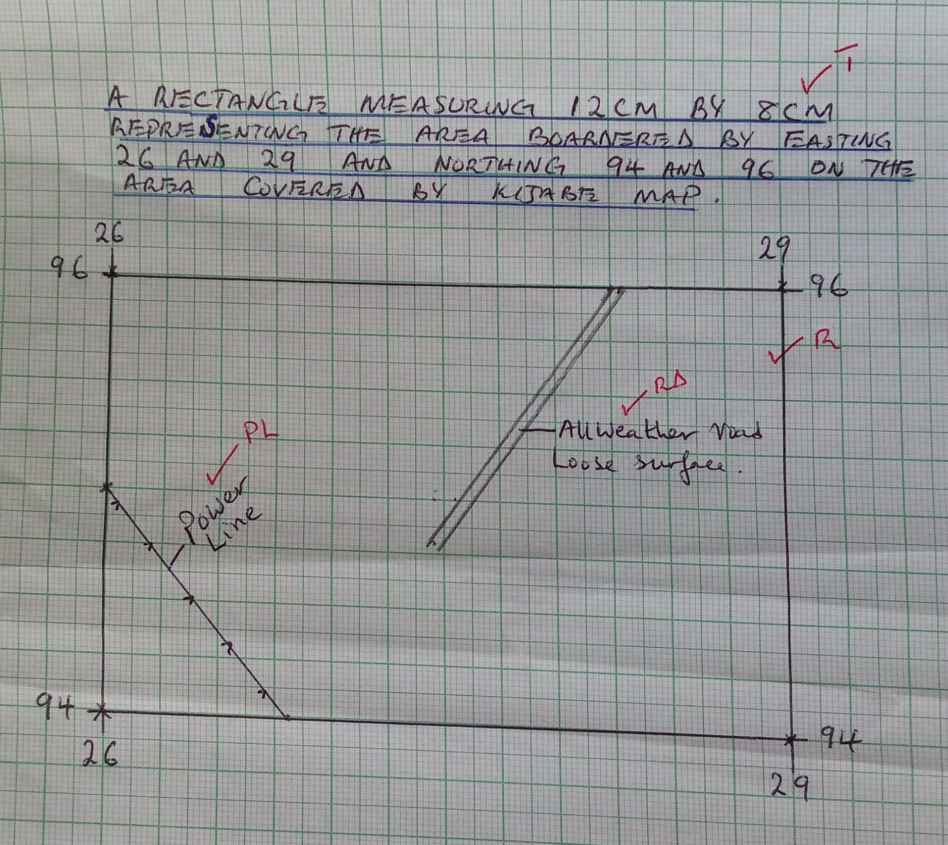e (1mk)

- (a) (i) State two processes of wind erosion in the desert areas ( 2mks)
- Abrasion
- Deflation
- Attrition Any 2x1= (2mks)

(ii) Give three reasons why wind action is effective in the hot deserts. (3mks)
- The presence of loose unconsolidated dry masses of sand and gravel which are easily acted upon by wind.
- The occurrence of strong tropical storms within most hot deserts which move violently.
- Absence of vegetation cover since most hot deserts are bare. ( any 3x1= 3mks)

(iii) With aid of well labelled diagrams describe the formation of Yardangs. (7mks)
- Vertical and alternating layers of resistant and less resistant rock outcrop lying parallel to the direction of the prevailing wind.
- Wind abrasion and deflation erode the soft rocks creating large furrows between the hard layers.
- Continued wind abrasion and deflation deepens the furrows leaving the hard layers standing out as ridges
- The ridges are called yardangs.

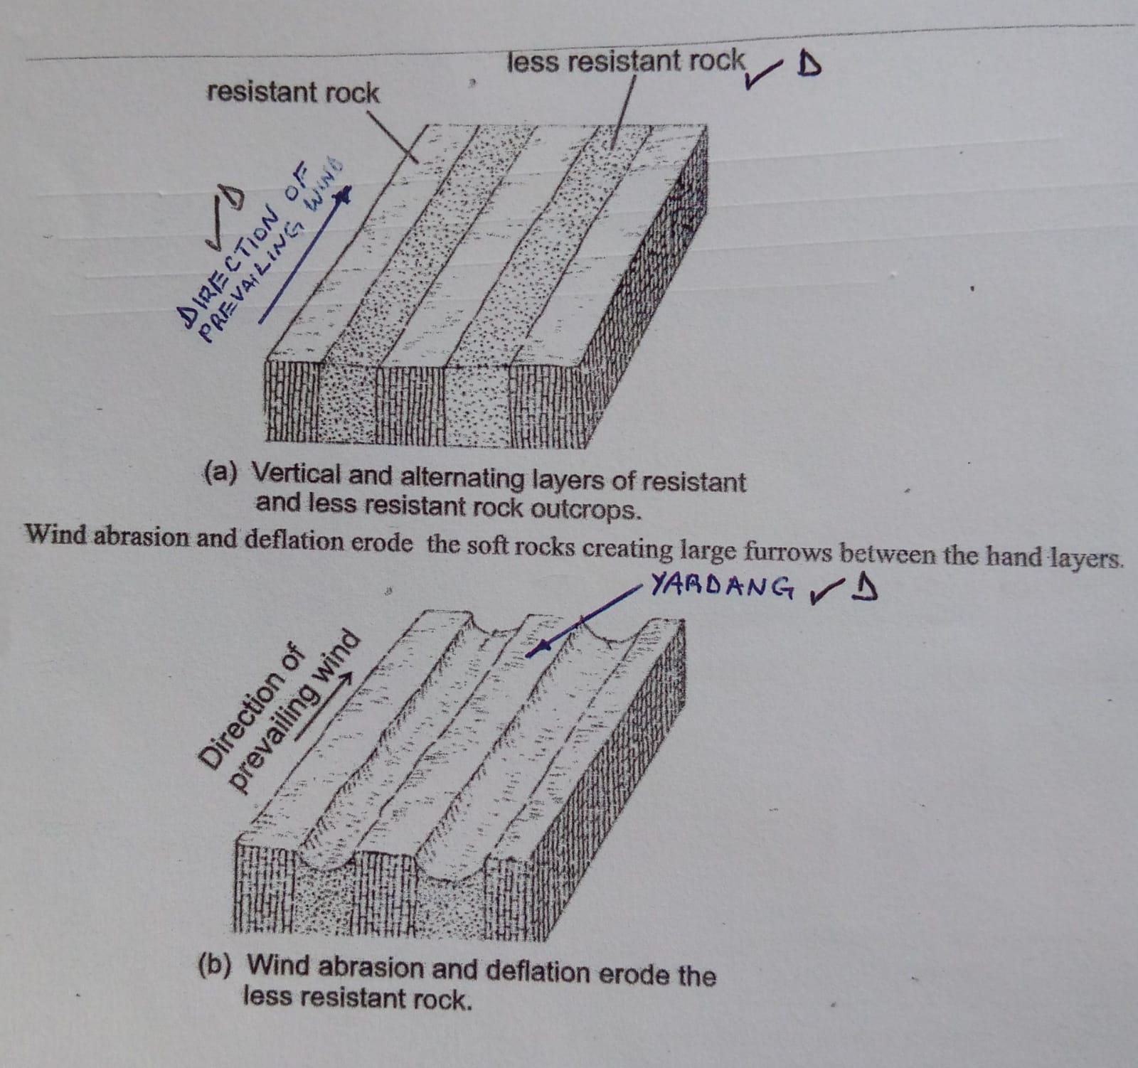
text - 4mks
diagrams - 3mks
(on wind, resistant and less resistant rock and yardangs. )
(b) i)State two factors that influence the transportation of materials in the desert by wind (2mks)
- The speed and force of the wind
- Nature of the load
- Presence of obstacles reduce the speed of wind and force the wind to deposit some of the load
- Absence of vegetation cover. Any 2x1 = (2mks)

(ii)Give three processes through which wind transport materials in desert (3mks)
- Saltation
- Suspension
- Surface creep 3x1 =3mks
(iii)Name two features that are formed due to action of water in deserts. (2mks)
- Wadis
- Alluvial fans / bajadas
- Mesas and buttes
- Canyons
- Pediments
- Pediplanes
- Inselbergs Any 2x1 = (2mks)
c) Explain three positive effects of desert landforms to human activities (6mks)
- Desert features like Zeugen, Yardangs and rock pedestals forms beautiful scenery that attract tourists earning a country foreign exchange.
- When loess is deposited in wet areas it forms fertile soils for agriculture.
- Extensive bare desert surfaces are used as testing, grounds for military weapons car and jet engines.
- Oasis found in some deflation hollows forms sources of water for irrigation, livestock or domestic use.
- Players and Salinas are economically used for salt production.
Any 3x2= (6mks)

- (a) i) List two effects of horizontal earth movements
- Stretching the rocks of the earth crust
- Shortening of the rocks of the earth crust
- Shearing of the rocks of the crust Any 2x1= (2mks)

(ii) Give three causes of earth movements
- Movement of magma within the crust
- Gravitative pressure
- Convectional current in the mantle
- Isostatic adjustment Any 3x1= (3mks)
b) i) Name and describe three types of plate tectonic boundaries (6mks)
- Constructive / extensional /divergent boundary – The plates move away from each other creating a new crust known as extension boundary.
- Destructive / compressional/ convergent boundary- The plates move towards each other due to convectional current and as they move they may collide with each other forming compressional boundary.
- Transform / conservative boundary -The plates moves past each other due to convectional current such that no new materials are added or lost.
Naming 3x1= (3mks)
Describing 3x1= (3mks)
N.B: name can score alone without description, but description cannot score alone
(ii) Name three types of folds (3mks)
- Simple symmetrical fold
- Asymmetrical folds
- Isoclinal folds
- Overthrust folds
- Over fold
- Recumbent
- Synclinorium anticlinorium complex Any 3x1 = (3mks)

c) With aid of well labelled diagrams, describe the formation of fold mountains (7mks)
- A wide shallow depression called geosyncline is formed on the earth surface due to earth movement
- The geosyncline gets filled up with water forming a sea.
- Weathering and erosion occurs in the surrounding highlands.
- The sediments are deposited on the seabed forming thick layers.
- The weight of the sediments causes subsidence/ sinking of the geosyncline and accumulation of more sediments which triggers compressional forces.
- The layers of sediments are subjected to compressional forces which causes them to fold,these folds forms thefold mountains.

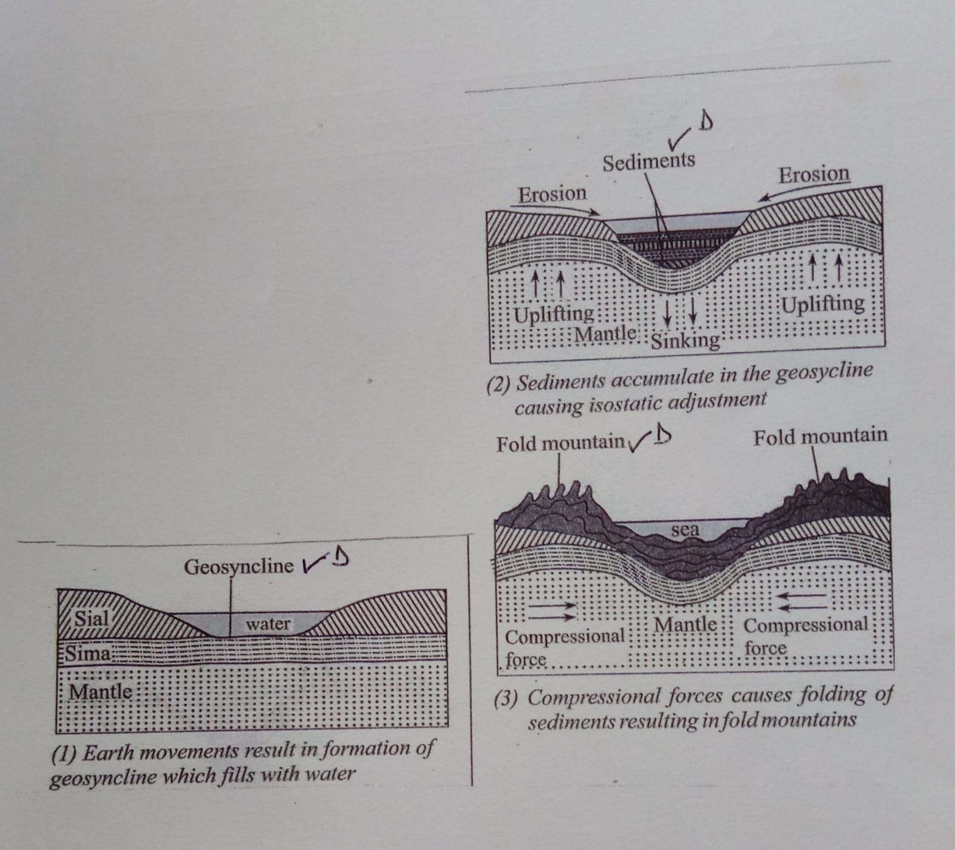

Text 4mks
Diagram 3mks

d) State four significance of folding to the human and physical environment. (4mks)
- Fold mountains landscape provides a unique scenery that attract tourist.
- Fold mountains forms barriers to transport and communication.
- Folding process brings minerals to the surface facilitating easy extraction.
- Warmer slopes of fold mountains encourage settlement and agriculture.
- Heavy rainfall received on windward slopes of fold mountains support agriculture.
- Cold descending winds on fold mountains cause harm to crops Any 1x4= (4mks)

- a) Define the following term;
- water table – It is the upper level of the zone of saturation of water in permeable rocks which keep on fluctuating (2mks)
- aquifer – It is a permanently saturated rock which can hold water in its mass that is found between layers of impermeable rocks (2mks)
b) Explain how the following factors influence the occurrence of underground water.

- Nature of the rock (2mks)
rock with pores/cracks allow more infiltration to occur. ( 1x2=2 marks)
ii) Gradient of the land (2mks)
- Flat areas like plains give water time to infiltrate as water remain stagnant for a long time.
- Steep slopes will allow a lot of surface run off hence less infiltration (Any 1x2 ( 2mks)

c) State four conditions that are necessary for the formation of an artesian well (4mk)

- An aquifer must be sandwiched between two layers of impermeable rocks so as to retain water
- One or both ends of the aquifer must be exposed in a region which has high rainfall.
- The aquifer must be syncline to ensure that the water has sufficient pressure to flow out naturally.
- The aquifer must be of the same permeable material.
- The mouth of the well must be lower than the water intake area for water to flow out naturally by hydraulic pressure.
- The artesian well must be sunk to reach below the water table in the permeable rock for it to have water permanently. Any 4x1 = (4mks)

d) i) Explain three conditions that are necessary for the development of Karst Scenery
- Presence of thick limestone or dolomite or chalk which consist of calcium carbonate to react with rainwater for carbonation and solution process to take place.
- The rocks should be hard and well jointed to allow water to percolate along the joints for carbonation process to take place.
- Presence of a hot humid climate with moderate rainfall to facilitate chemical weathering.
- The water table should be deep far below limestone rock surface to allow the formation of Karst features. Any 3x2 = (6mks)

(ii) Give two reasons why there are few settlements in the Karst region (2mks)
- Limestone region are covered with thin soils which limit agriculture.
- The areas are rocky hence unsuitable for human activities.
- The areas have rugged surfaces which are unsuitable for human settlement.
- Karst regions have poor vegetation cover.
- There is inadequate water supply since most of the water sinks underground.
Any 2x1 = (2mks)
e) Students carried out a field study in a karst landscape.
(i) State two methods they would have used to record data (2mks)
- Photographing / film /video taking
- Writing notes /taking notes.
- Drawing sketches /diagrams ( any 2x1= 2mks)
(ii) State three importance of studying a karst landscape through field work. (3mks)
- It gives first hand information.
- It makes learning real and interesting
- It enhances visual memory
- It helps the students to apply the knowledge learnt in classroom.
- It helps students to develop manipulative skills of observation and recording data.
Any 3x1= (3mks)

- (a) i) What is an ice sheet (2mks)
An ice sheet is a large continuous mass of ice which covers extensive areas of lowland.
1x2 = (2mks)

(ii)Explain the reason why there are no ice -sheets in Kenya (2mks)
Kenya is located within the tropics where the temperatures are high discouraging formation of ice sheets. 1x2= (2mks)

b) Describe the formation of a pyramidal peak. (5mks)
- Ice accumulates in several pre-existing shallow depression on a mountain side.
- Nivation and abrasion make the depression deeper.
- The sides of the two depressions are eroded through plucking making them wider.
- The back walls are eroded through plucking which makes them retreat.
- The processes form several adjacent cirques around the mountain sides.
- Back walls of adjacent cirques continue to be eroded eventually resulting in the cirques being separated by narrow steep ridges called aretes.
- * Where Several aretes converge at the top of the mountain, a steep sided peak is formed.
- This peak is called pyramidal peak.
Any 5x1 = (5mks)
NB. The point on * must be mentioned to score maximum marks. (5mks)
- i) Name three types of moraine (3mks)
- Terminal moraine
- Lateral moraine
- Medial moraine
- Ground/subglacial moraine
- Recessional moraine
- Englacial moraine Any 3x1 = (3mks)
(ii) Explain four effects of glaciated features in upland areas. (8mks)
- Glacial upland areas form beautiful features such as pyramidal peaks which attract tourists
- Glaciated mountains encourage the growth of forests which encourage lumbering supporting the building industry
- Water falls formed in glaciated uplands provide suitable sites for hydroelectric power production which is used in industries and domestic use.
- Corrie lakes / tarns offer suitable areas for fishing
- U-shaped glacial valley, form natural route ways where roads and railways are well- sheltered natural harbours as well as rich fishing grounds promoting fishing industries
- Melt water on glaciated mountain form sources of rivers that provide water for industrial, domestic and agricultural use. Any 4x2= (8mks)

d) Students from a school near Mt. Kenya were planning to carry out a field study on the glaciated features on the mountain

i) Give three reasons why it would be difficult to undertake the field study on glaciated features on the mountain
- Inaccessibility of some features due to the rugged terrain
- Heavy rainfall and extreme low temperature would hinder their activities.
- Thick vegetation in the lower slopes may hinder their movement.
- Attacks from wild animals may make it difficult to access the area. Any 3x1 = (3mks)

ii)Highlight three methods of collecting data they would have used (3mks)
- Taking photographs/video/films
- Observation
- Counting
- Measuring
Any 3 x1 = (3mks)

CONIFIDENTIAL

FORM 4 GEOGRAPHY PAPER 1
312/1 CONIFIDENTIAL

- PROVIDE A MAP OF KIJABE EAST AFRICA 1:50,000 SHEET 134/3
- PROVIDE A GRAPH PAPER.

Name:…………………………………School………………………..
Class:……AdmNo:……..Index:……………………………………

GEOGRAPHY
312/1 PAPER 1
TIME 2HRS 45 MIN.

FORM 4
END OF TERM TWO 2021 EXAMINATION
Kenya Certificate of Secondary Education
312/1
2 HRS 45 MIN.

INSTRUCTION TO CANDIDATE.
- This paper has two sections A and B.
- Answer All questions in section A.
- In section B, Answer question six and any other two questions.

For Examiners use Only
SECTION | QUESTION | MAX SCORE | CANDIDATES SCORE
A | 1-5 | 25
B | 6  7  8  9  10 | 25  25  25  25  25
TOTAL SCORE

SECTION A
Answer all the questions in this section.
- (a) What is a Land Breeze (2mks)
(b) Give three ways in which sea breeze influence the adjacent land. (3mks)
- State 5 characteristics of the mantle.
- (a) Differentiate between magnitude and intensity of an earthquake. (2mks)
(b) State three precautions which can be taken against earthquake destruction?
- (a) Give two causes of Ocean currents (2mks)
(b) List three reasons why Oceans tend to heat more slowly than land masses. (3mks)

- (a) What is humus (2mks)
(b) State three ways through which humus improve the quality of a soil.

SECTION B
Answer question and any other two questions in this section.
You are provided with a map of Kijabe East Africa 1: 50,000 sheet 134/3, use it to answer the following questions.
- a) (i) Give the six figure grid reference of the trigonometrical station (2610m) (2mks)
(ii) What is the general flow of River Gatamaiyu
b) (i) Citing evidence from the map, identify three social services offered in the area covered by the map (6mks)
c) (i) Explain three physical factors favouring cattle rearing in the area covered
by the map. (6mks)
(ii) Identify three physical features found at grid square 2695 (3mks)
d) (i) On the graph paper provided draw a rectangle measuring 12cm by 8cm to represent the area bordered by Easting 26 and Easting 29 and northing 94 and 96 (2mk)
(ii) On it mark and label
- (a) (i) State two processes of wind erosion in the desert areas
(ii) Give three reasons why wind action is effective in the hot deserts. (3mks)
(iii) With aid of well labelled diagrams describe the formation of Yardangs. (7mks)
(b) i)State two factors that influence the transportation of materials in the desert by wind (2mks)
(ii)Give three processes through which wind transport materials in desert (3mks)
(iii)Name two features that are formed due to action of water in deserts. (2mks)
c) Explain three positive effects of desert landforms to human activities (6mks)

- (a) i) List two effects of horizontal earth movements
(ii) Give three causes of earth movements (3mks)
(iii) Give three causes of earth movements (3mks)
b) i) Name and describe three types of plate tectonic boundaries (6mks)
(ii) Name three types of folds (3mks)
c) With aid of well labelled diagrams, describe the formation of fold mountains (7mks)
d) State four significance of folding to the human and physical environment. (4mks)
- a) Define the following term;
- water table – (2mks)
- aquifer –
b) Explain how the following factors influence the occurrence of underground water.
- Nature of the rock (2mks)
ii) Gradient of the land (2mks)
c) i) State four conditions that are necessary for the formation of an artesian well (4mk)
(ii) Give two reasons why there are few settlements in the Karst region (2mks)
e) Students carried out a field study in a karst landscape.
(i) State two methods they would have used to record data (2mks)
(ii) State three importance of studying a karst landscape through field work. (3mks)
- (a) i) What is ice sheet (2mks)

(ii)Explain the reason why there are no ice -sheets in Kenya (2mks)
b) Describe the formation of a pyramidal peak. (5mks)
© i) Name three types of moraine (3mks)
(ii) Explain four effects of glaciated features in upland areas. (8mks)
d) Students from a school near Mt. Kenya were planning to carry out a field study
on the glaciated features on the mountain

i) Give three reasons why it would be difficult to undertake the field study on glaciated
features on the mountain (3mks)
ii)Highlight three methods of collecting data they would have used (3mks)

