MURANGA EXTRA COUNTY JOINT EXAMINATION
GEOGRAPHY 312/1
SEPTEMBER 2022
TIME:2HRS 45MINS

Name ………………………………….Class….Adm No………
Date ………………………………………...

Instructions to Candidates
- This paper has two sections: A and B
- Answer all the questions in section A
- Answer question 6 and any other two questions from section B
- This paper consists of 4 printed pages. Ensure ALL the 10 questions are printed.
.

For examiners use only

SCORE

SECTION A
QUESTION 6
QUESTION 7
QUESTION 8
QUESTION 9
QUESTION 10
TOTAL MARKS

SECTION A: ANSWER ALL QUESTIONS IN THIS SECTION. (25MKS)

1a) Define the term Geography. (2mks)
b) What is the relationship between Geography and Chemistry. (2mks)

2a) State three characteristics of intrusive igneous rocks. (3mks)
b) Give two earthquake zones of the world (2mks)

3a) What is folding. (2mks)
b) Give four of features formed as a result of folding. (4mks)

4a) State three stages of the hydrological cycle. (3mks)
b) State two factors that influence the amount of surface run-off. (2mks)

5. | (a)The diagram below shows a river capture. Name the parts marked K and L | (2mks)
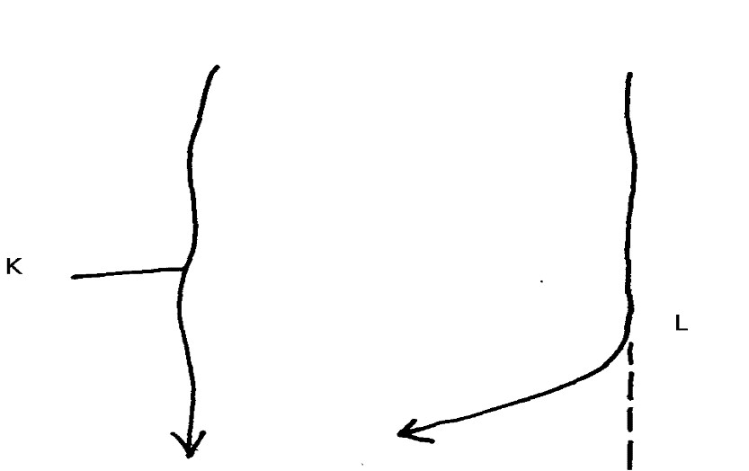
(b) | Outline three ways through which a gorge is formed |  |  |  | (3mks)

SECTION B: ANSWER QUESTION SIX AND ANY OTHER TWO QUESTIONS IN THIS SECTION. (75MKS)

6.Study the map of NYERI 1:50,000 provided and use it to answer the following questions.
(a) (i) Determine the longitudinal extent of the area covered by the map. (2mks) (ii) From which hemisphere of the globe was the map taken? (1mk)
iii) Give three physical features found in grid square 5065. (3mks)
(b) (i) What is the bearing of the Air Photo Principal Point (104 KE 024) at grid square 6048 from trigonometrical station primary SKP 211 at grid square 6654? (2mks)
(ii) Give the sheet to the North West and South of the area covered by the map. (2mks)

(c) Citing evidence from the area covered by the map, give two social functions of Mweiga town to the north of the area. (4mks)
- Describe the drainage of the area covered by the map. (5mks)

e) Explain three factors that have influenced distribution of settlement in the area covered by the map (6mks)

7. a) What is a rock (2mks)
b) i) Name two examples of extrusive igneous rocks (2mks)
ii) Give three sources of sedimentary rocks. (3mks)
iii)State three reasons why sedimentary rocks are widespread in the coastal plains of Kenya. (3mks
c) State four factors that influence the change of original rocks to metamorphic rocks (4mks)
d) You are planning to carry out a field study on the rocks within your school environment.
i) Give three secondary sources of information you would use to prepare for the field study (3mks)
ii) State three advantages of dividing the students into groups during the field study (3mks)
iv) Identify three problems you are likely to face during the study (3mks)
- Give two advantages of studying the rocks through fieldwork. (2mks)

8. a) (i) Name three types of faults. (3marks)
(ii) Apart from compressional forces, explain two other processes that may cause faulting.
(4 marks)
b) i) With the aid of well labelled diagrams, describe how compressional forces may have led to the formation of the Great Rift Valley. (8marks)
ii) Apart from the Rift valley, name two other resultant features of faulting (2mks )
c) Explain four effects of faulting on human activities. (8 marks)

9a) i) What is the process through which wave transport the eroded materials along the coast. (1mks)
ii) State three factors that influence wave deposition. (3mks)
b) i) Name two types of submerged coasts. (2mks)
ii)State three characteristics of emerged highland coast. (3mks)
c) With the aid of well labelled diagrams, describe the formation of a spit. (7mks)
d) Students from Moi secondary school were planning to conduct a field study on wave erosional features to areas along the coast.
i) Give three ways in which the students will prepare for the field study (3mks)
ii) Name three erosional features they are likely to identify. (3mks)
iii) Identify three methods of data collection that they will use during the field study. (3mks)
10. a) i) What is soil catena? (2 marks)
ii) Draw a well labelled diagram showing the structure of a well-developed soil profile. (5 marks)
b) Differentiate between mineralization and humification in soil formation. (2 marks)
c) State three factors that determine the colour of soil. (3 marks)
d) (i) State four factors that influence soil formation. (4 marks)
(ii) Explain how the following farming practices can cause soil degradation:
- Burning. (2 marks)
- Continuous application of fertilizer on farm land. (2 marks)

- Monoculture. (2 marks)

iii) State three uses of soil. (3 marks)

