BSJE 2021
Kenya Certificate of Secondary Education (KCSE)

233/2 - CHEMISTRY - Paper 2
(Theory)
Nov/Dec. 2021 – 2 Hours

Name: …………………………………..… Index No: ……….………...Stream ……..
School: ………..…………………………………………………………………………...
Candidate’s Signature: ..………………………………...…. Date:……………………

Instructions To Candidates
- Write your name and index number in the spaces provided above
- Sign and write the name of your school in the spaces provided
- Answer all the questions in the spaces provided
- Non-programmable silent electronic calculators and KNEC mathematical tables may be used
- All working must be clearly shown where necessary
- This paper consists of 16 printed pages
- Candidates should check the question paper to ascertain that all the pages are printed as indicated and that no questions are missing.
- Candidates should answer the questions in English.

For Examiner's use only
Question | Max. Score | Score
1 | 11
2 | 11
3 | 12
4 | 12
5 | 11
6 | 12
7 | 11
TOTAL SCORE | 80

- The table below shows the ions of elements W, X, Y, Z, and their electron arrangement.
The letters do not represent the actual symbols of the element.
Ion | Electron configuration
W ⁻ | 2.8.8
X²⁺ | 2.8.8
Y³⁺ | 2.8
Z²⁻ | 2.8
- Which two elements belong to the same period? Give a reason. (2 marks)
………………………………………………………………………………………………………………………………………………………………………………………………
- In which group of the periodic table does Y belong? (1 mark)
………………………………………………………………………………………………………………………………………………………………………………………………
- Write the formula of the compound formed between W and X (1 mark)
………………………………………………………………………………………………
- What type of bond is formed between W and X. Explain. (2 marks)
………………………………………………………………………………………………………………………………………………………………………………………………

- What is a coordinate bond? (1 mark)
………………………………………………………………………………………………………………………………………………………………………………………………
- Draw a dot (•) cross (×) diagram to show bonding in the Ammonium ion (NH₄⁺)
(N = 7, H = 1) (2 marks)
………………………………………………………………………………………………………………………………………………………………………………………………………………………………………………………………………………………………………………………………………………………………………………………………………………………………………………………………………………………………
- Aluminum chloride and sodium chloride are both chlorides of period 3 elements.
Use this information to explain the following observations.
- A solution of A1CI₃ in water turns blue litmus paper red while that of sodium chloride does not (1 mark)
………………………………………………………………………………………………………………………………………………………………………………………………
- The melting point of sodium chloride (801°C) is higher than that of AlC1₃ (180°C).
(1 mark)
………………………………………………………………………………………………………………………………………………………………………………………………

- Give the names of the following compounds:
- CH₃COOCH₂CH₃ (1 mark)
………………………………………………………………………………………………
- CH₃CHCHCH₂CH₃ (1 mark)
………………………………………………………………………………………………
- Study the information in the table below ad answer the questions that follow.
No. of carbon atoms per molecule | Relative molecular mass of hydrogen
2 | 28
3 | 42
4 | 56

- Write the general formula of the hydrocarbons in the table. (1 mark)
………………………………………………………………………………………………
- Predict the relative molecular mass of the hydrocarbon with 5 carbon atoms. (1 mark)
………………………………………………………………………………………………………………………………………………………………………………………………
- Determine the molecular formula of the hydrocarbon in ii) above and draw its structural formula. (2 marks)
………………………………………………………………………………………………………………………………………………………………………………………………
………………………………………………………………………………………………………………………………………………………………………………………………
- Study the scheme given below and answer questions that follow.
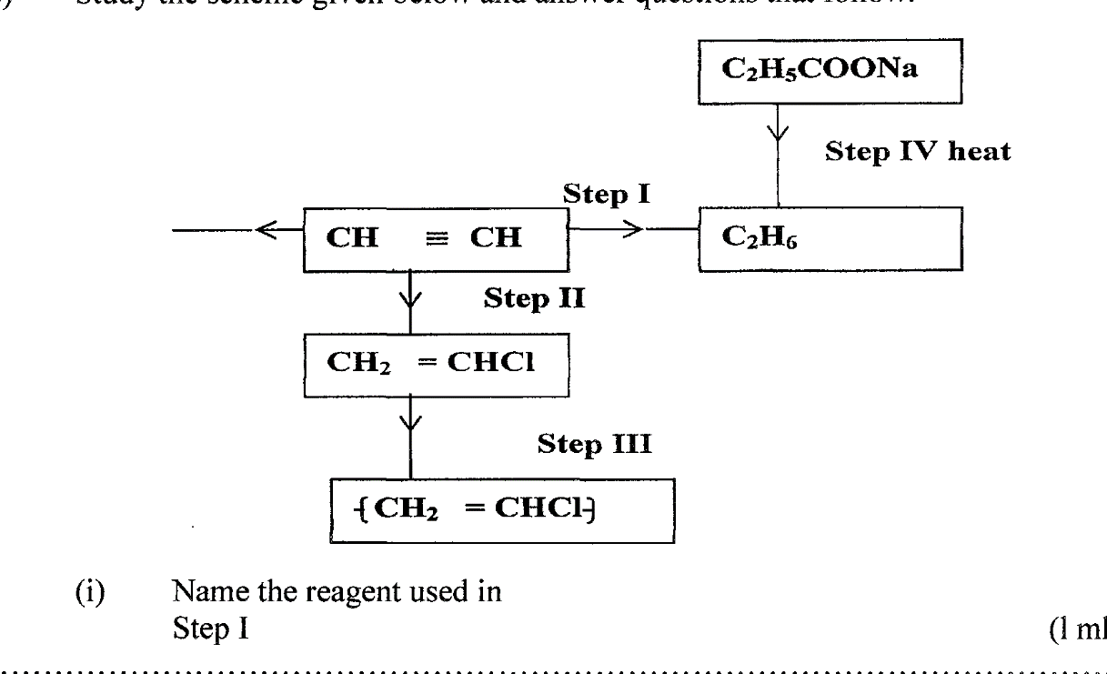
- Name the reagent used in
Step I (1 mark)
………………………………………………………………………………………………
Step II (1 mark)
………………………………………………………………………………………………
Step III (1 mark)
………………………………………………………………………………………………
- Write an equation for complete combustion of CH CH (1 mark)
………………………………………………………………………………………………………………………………………………………………………………………………
- Explain one disadvantage of the continued use of items in step III. (1 mark)
………………………………………………………………………………………………………………………………………………………………………………………………
………………………………………………………………………………………………

- The solubilities of potassium nitrate and potassium bromide at different temperatures was determined. The following data was obtained.
Temperature ⁰C |  | 0 | 10 | 20 | 30 | 40 | 50 | 60 | 70 | 80
Solubility g/100g H₂O | KNO₃ | 5 | 15 | 26 | 43 | 61 | 83 | 105 | 135 | 165
 | KBr | 50 | 55 | 60 | 65 | 70 | 77 | 85 | 90 | 95

- Plot a graph of solubility against temperature for both salts on the same axis (3 marks)
- What was the solubility of each salt at 65⁰C (1 mark)
…………………..………………………………………………………………………………
- 100g of a saturated solution of potassium nitrate at 70⁰C was cooled to 20⁰C. What mass of the salt will be crystallized? (2 marks)
………………………………………………………………………………………………………………………………………………………………………………………………………………………………………………………………………………………………………..
- Study the flow chart below and answer the questions that follow.
Solid A
and
Gas B
Metal carbonate
Heat
Dil. HCl
Solution
C
Deep blue solution E
Solid D
A few drops of NH_{3(aq)}

Excess of
NH_{3(aq)}

- Write an equation for the formation of solid A and gas B. (1 mark)
…..……………………………………..…………………………………………………..
- Name:
Solution C …………………………………………………………...…… (1 mark)
Solid D ………………………………………………………….………… (1 mark)
- Write the formula of the complex ion in solution E. (1 mark)
………………………………………………………………………………………………………

- Study the flow chart below and answer the questions that follow.
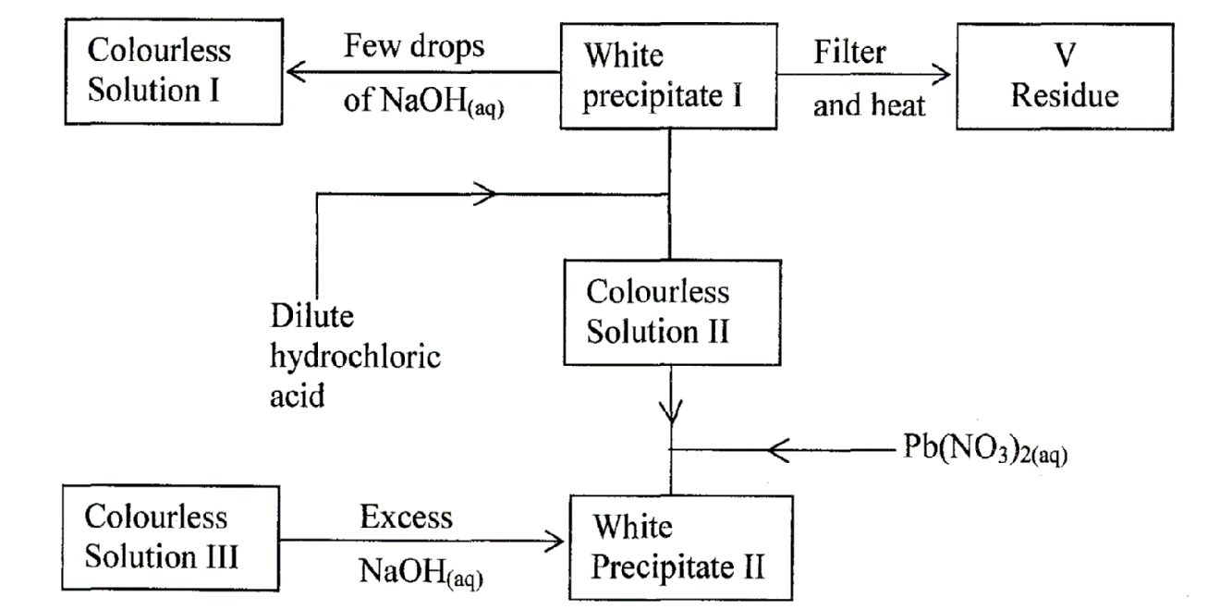
Residue V was yellow when hot and white when cold. Identify:
- White precipitate I. (1 mark)
…………………………………………………………………………………………………..
- Solution II. (1 mark)
…………………………………………………………………………………………………..
- Residue V. (1 mark)
………………………..…………………………………………………………………………
- Write an ionic equation for the reaction of solution II with Pb(NO₃)_{2 (aq)} (1 mark)
………………………………………………………………………………………………
- Write observations that would be made when ammonia solution is added drop-wise till in excess to the colourless solution II (l mark)
………………………………………………………………………………………………………………………………………………………………………………………………
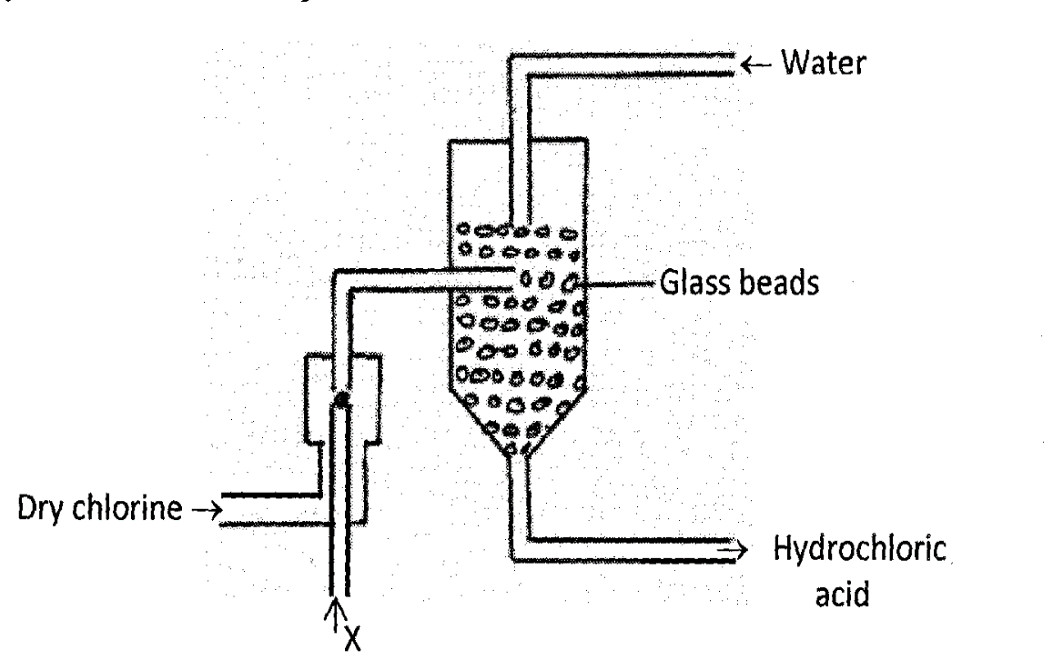
- The diagram below represents a set-up for large scale manufacture hydrochloric acid. Study it and answer the questions that follow:
- Name substance X. (1 mark)
………………………………………………………………………………………………………………………………………………………………………………………………
- What is the purpose of glass beads? (1 mark)
………………………………………………………………………………………………………………………………………………………………………………………………
- Give one source of substance X used in the above process. (1 mark)
………………………………………………………………………………………………………………………………………………………………………………………………
- Give two uses of hydrochloric acid. (2 marks)
………………………………………………………………………………………………………………………………………………………………………………………………
- The table below shows the ammeter readings obtained when two different electrolytes the same concentration was tested.
Electrolyte | Ammeter reading (Amps)
Hydrochloric acid | 4.0
Ethanoic acid | 1.2

Why does Ethanoic acid give a lower ammeter reading? Explain your answer (2 marks)
………………………………………………………………………………………………………
………………………………………………………………………………………………………
- The figure below shows parts of Le’Clanche cell (dry cell).
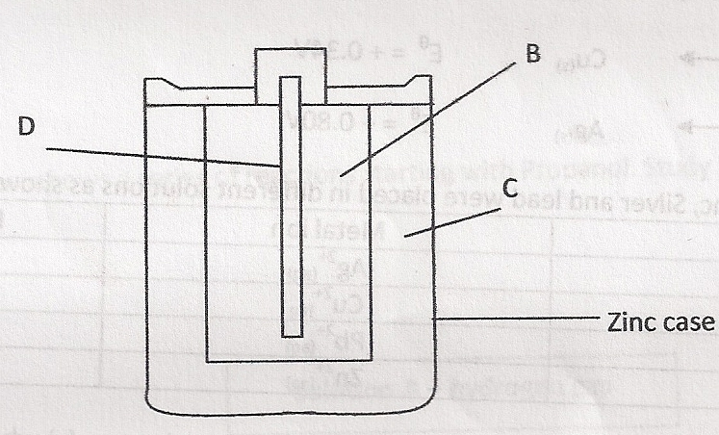
- Name:
- Substance D (1 mark)
………………………………………………………………………………………………...
- Mixture B (1 mark)
………………………………………………………………………………………………...
- Electrolyte C (1 mark)
………………………………………………………………………………………………..
- In the cell, the electrolyte is a paste. Explain. (1 mark)
………………………………………………………………………………………………..………………………………………………………………………………………………..……
- The following reaction occurs when the cell is in use.
MnO₂
Zn_{(s)} + 2NH₄⁺_{(aq)} Zn²⁺_{(aq)} + 2NH_{3(aq)} + H₂O_{(l)}

Given that:
Zn²⁺_{(aq)} + 2e⁻ Zn(s) E^{Ф} = -0.76V
MnO₂
2NH⁺_{(aq)} + 2e⁻ 2NH_{3(g)} + H₂O_{(l)} E^{Ф} = +0.74V
Calculate the e.m.f. of the cell. (2 marks)
…………………………………………………………………………………………………………………………………………………………………………………………………………………………………………………………………………………………………….………………
- Use the standard reduction electrode potentials given below to answer the questions that follow.
Zn²⁺_{(aq)} + 2e⁻ Zn(s) E^{Ф} = -0.76V

Pb²⁺_{(aq)} + 2e⁻ Pb(s) E^{Ф} = -0.13V

Cu²⁺_{(aq)} + 2e⁻ Cu(s) E^{Ф} = +0.34V

Ag²⁺_{(aq)} + 2e⁻ Ag(s) E^{Ф} = +0.80V

The metal copper, zinc, silver and lead were placed in different solutions as shown:

Metal | Metal ion | Reaction / No reaction
Cu | Ag²⁺_{(aq}
Zn | Cu²⁺_{(aq)}
Ag | Pb²⁺_{(aq)}
Pb | Zn²⁺_{(aq)}

- Indicate in the table with a tick (√) where a reaction occurs and a cross (×) where no reaction occurs. (2 marks)
- Identify the strongest reducing agent. (1 mark)
………………………………………………………………………………………………………………………………………………………………………………………………

- Draw a well labeled diagram of the electrochemical cell when copper and magnesium half cells are connected. (3 marks)
……………………………………………………………………………………………………………………………………………………………………………………………………
……………………………………………………………………………………………………………………………………………………………………………………………………
- On the diagram you have drawn in e i) above, label the anode and the cathode and show the direction of flow of electrons. (2 marks)

- The set up below is used to prepare nitric acid
Glass cork
Mixture X
Red brown fumes

- Name the reagents in mixture X (1 mark)
……………………………………………………………………………………………… ………………………………………………………………………………………………
- Write an equation for the reaction which takes place in the glass retort (1 mark)
………………………………………………………………………………………………
…………………………………………………………………………………………….
- Explain the reason why the apparatus used is all glass and why heating should be gentle as possible. (2 marks)
………………………………………………………………………………………………………………………………………………………………………………………………………………………………………………………………………………………………

- Study the flow chart below and answer the questions that follow.
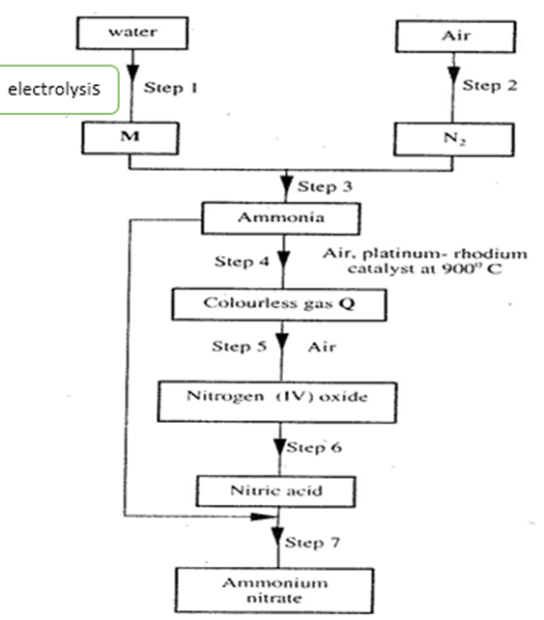
- Name element M. (l mark)
…………………………………………………………………………………………….
- Why is it necessary to use excess air in step 4? (1 mark)
…………..…………………………………………………………………………………..
………..……………………………………………………………………………………..
- Identify gas Q (l mark)
……………………………………………………………………………………………..
- Write an equation for the reaction in step 7 (l mark)
………………………………………………………………………………………………
- Give one use of ammonium nitrate. (l mark)
………………………………………………………………………………………………
- Ammonia can be formed by the reaction shown below

N₂ _{(g)} + 3H₂ _{(g)} 2NH₃ _{(g)} ; ∆H = - 92kJ/mol
State and explain what happens if:
- The volume of the system is increased (1 mark)
………………………………………………………………………………………………
...…………………………………………………………………………………………….
- Cold water is poured over the system (1 mark)
………………………………………………………………………………………………
………………………………………………………………………………………………
- In an experiment to determine the heat of combustion of compound X, a pupil used heat from the burning compound of X to heat 100cm³ of water in a beaker. He obtained the following results:
Volume of water in the beaker = 100cm³
Initial temperature of water = 17ºC
Final temperature of water = 42⁰C
Initial mass of burner + compound X = 10.5g
Final mass of burner + compound X = 10.2g.
- Determine the mass of the compound burnt? (1 mark)
…………………………………………………………………………………………………..
……………..……………………………………………………………………………………
- Calculate the rise in temperature? (1 mark)
…………………………….…………………………………………………………………….
………………………….……………………………………………………………………….

- Determine the amount of heat produced by the compound (2 marks)
(specific heat capacity 4200Jg⁻¹K⁻¹, density of H₂O = 1g/cm³)
………………………..…………………………………………………………………………
…………………………………………………………………………………………………..
……………………..……………………………………………………………………………
- Calculate the molar heat of combustions of compound X (2 marks)
(R.M.M. of X = 256)
…………………………………………………………………………………………………..
…………………………………………………………………………………………………..
…………………………………………………………………………………………………..
- Use the following thermochemical equations below to answer the questions that follow.
C₂H_{6 (g)} + ⁷/₂ O_{2 (g)} 2CO_{2(g)} + 3H₂O _{(s)} ∆H₁, = -1560kJmol⁻¹
C _{(graphite)} + O_{2(g)} CO_{2 (g)} ∆H₂ = - 394 kJ mol⁻¹
H_{2 (g)} + ½ O_{2(g)} H₂O_{(l)} ∆H₃ = - 286 kJ mol⁻¹
- Calculate the molar enthalpy of combustion of C₂H₆. (2 marks)
………………………………………………………………………………………………………………………………………………………………………………………………
………………………………………………………………………………………………
………………………………………………………………………………………………
- Draw an energy level diagram for the reaction represented by the first equation above (3 marks)
………………………………………………………………………………………………
………………………………………………………………………………………………………………………………………………………………………………………………………………………………………………………………………………………………

