**NAME ………………………………………………..…………… DATE ……………..**

**ADM NO ……………………………**

***END OF TERM 2 EXAMINATION***

**233/2**

**CHEMISTRY**

**PAPER 2**

**(THEORY)**

**TIME: 2HOURS.**

**INSTRUCTIONS TO CANDIDATES**

* Write your name and admission number in the spaces provided above.
* write the date of exam in the spaces provided above.
* Answer **ALL** the questions in the spaces provided.
* Mathematical tables and silent electronic calculators may be used.
* All working **MUST** be clearly shown where necessary.

**FOR EXAMINER’S USE ONLY**

|  |  |  |
| --- | --- | --- |
| **Questions** | **Maximum score** | **Candidates score** |
| 1 | 10 |  |
| 2 | 13 |  |
| 3 | 11 |  |
| 4 | 12 |  |
| 5 | 11 |  |
| 6 | 14 |  |
| 7 | 9 |  |
| **Total score** | **80** |  |

***This paper consists of 12 printed pages.***

***Candidates should check to ensure that all pages are printed as indicated and no questions are missing***

1. a What is an electrolyte (1mk)

bi. State how the following substance conduct electricity

i. Molten calcium chloride ( ½ mk)

ii. Graphite ( ½ mk)

c. The diagram below shows a set up that was used to electrolyze molten lead (II) iodide

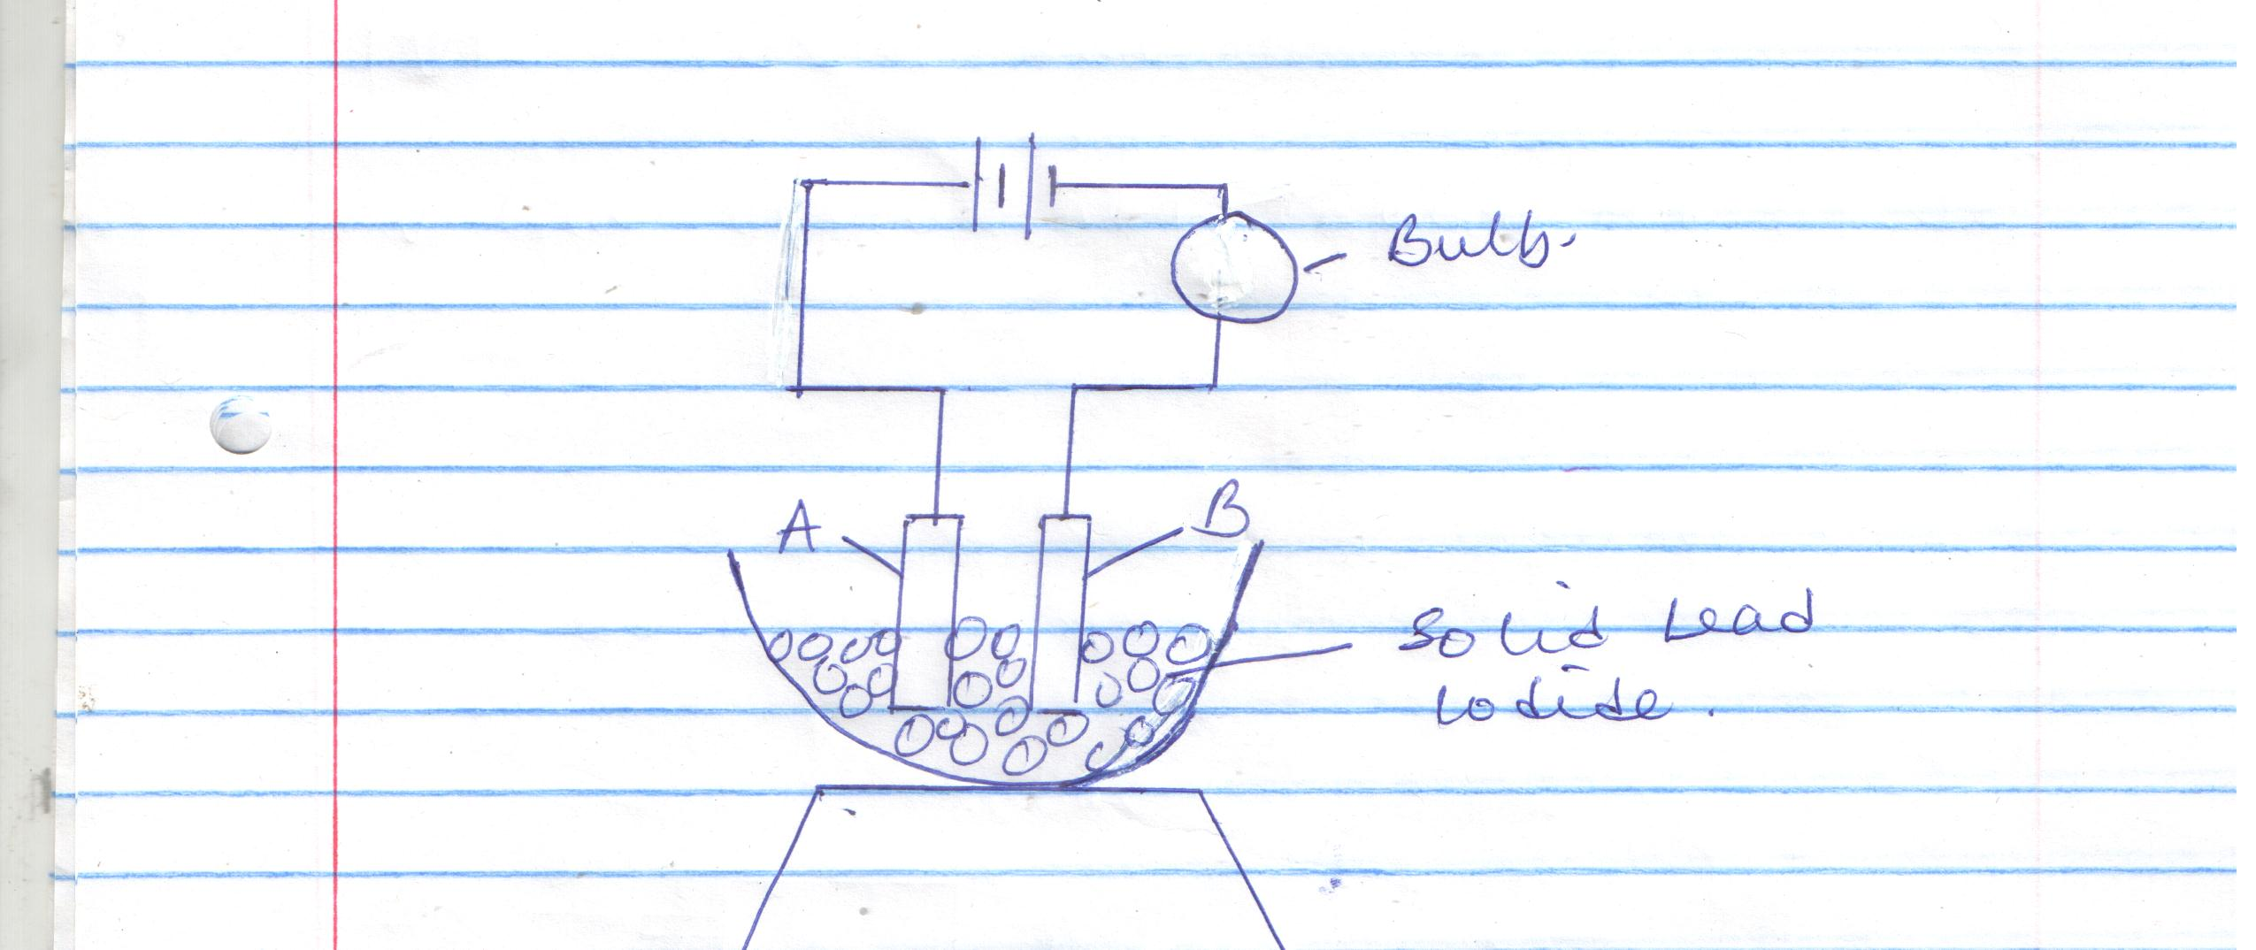

i. Name electrodes A and B on the diagram 2mks

ii. What is omitted in the above set-up for the electrolysis process to take place? (1mk)

iii. Explain why the bulb lights when the omission is corrected (2mks)

iv. State the observation made at B(1mk)

v. Write the ionic equation for the reaction taking place;2mks

A:

B:

2. a) Draw the structural formula of . **(3 marks)**

1. 2,3-dimethylpentane
2. Pent-2-yne
3. 2,3-dimethylbutane

(b)Study the reaction scheme below and answer the questions that follow.

Glucose

H2 (g)/Nickel

Ethene

Conc.H2SO4

**J**

STEP I

Step II

Step III

**j**

Acidified KMnO4

Ethanol

**K**

(i)Name the process in step I **(1 mark)**

…………………………………………………………………………………………………………………………………….

…………………………………………………………………………………………………………………………………….

(ii)Give the two conditions necessary in step II **(2 marks)**

…………………………………………………………………………………………………………………………………….

……………………………………………………………………………………………………………………………………..

…………………………………………………………………………………………………………………………………….

(iii)State the observation made in step III. **(1 mark)**

…………………………………………………………………………………………………………………………………..

…………………………………………………………………………………………………………………………………..

(iv)Name compound J. **(1 mark)**

…………………………………………………………………………………………………………………………………..

(v)Draw the structural formula of compound K. **(1 mark)**

(c) Water is added dropwise to calcium carbide in a conical flask.

(i)Identify the gas produced. **(1 mark)**

………………………………………………………………………………………………………………………………….

(ii)Write a chemical equation for the reaction that occurs. **(1 mark)**

……………………………………………………………………………………………………………………………………

(d)Part of a polymer is required below.

H H H H

C C C C

H CH3 H CH3

1. Draw the structural formula of the monomer of this polymer.  **(1 mark)**
2. State one use of this polymer. **(1 mark)**

……………………………………………………………………………………………………………………………..

3. The grid below represents part of the periodic table. Study it and answer the questions that follow. The letters are not the actual symbols of the elements.

|  |  |  |  |  |  |  |  |  |
| --- | --- | --- | --- | --- | --- | --- | --- | --- |
|  |  |  |  |  |  |  |  |  |
| **Y** | R |  |  |  |  | Q | **X** |  |
|  | V |  | **W** |  |  |  |  | U |
|  |  |  |  |  |  |  |  |  |

(a)Select an element whose oxide is amphoteric.**(1 mark)**

**………………………………………………………………………………………………………………………………**

(b)On the grid indicate with letter J the position of element J which is in period 3 and forms a stable ion J2**-. (1 mark)**

(c)Draw a dot-cross diagram to show bonding in the compound consisting of elements V and X only. **(2 marks)**

(d)Write an equation to show the formation of an ion of R. **(1 mark)**

**…………………………………………………………………………………………………………………………………**

(e)Which is the least reactive element? Give a reason for your answer. **(2 marks)**

**………………………………………………………………………………………………………………………………..**

(f)Write an equation for the reaction that occurs when element Y is placed in water.

**(1 mark)**

(g)How does the atomic radius of W compare with that of V? Explain. **(2 marks)**

(h)Name the chemical family to which elements R and V belong. **(1 mark)**

4. a) Use the chart below to answer the questions that follow.

**Iron**

**Gas N**

**Solid P**

**Lead (II) oxide /heat**

**Solid M**

**Liquid L**

**Steam**

**+**

Identify:

Gas **N** …………………………………………………………………………. **(½ mark)**

Solid **P** ……………………………………………………………………….. **(½ mark)**

Solid M………………………………………………………………………. **(½ mark)**

Liquid **L**…………………………………………………………………….. **(½ mark)**

b) Name the method that can be used to extract oil from castor oil seeds. **(1 mark)**

c) i) In the method named above, state the property of oil that enables the extraction to take place. **(1 mark**)

ii) Describe an experimental procedure that can be used to extract oil from the seeds. **(3 marks)**

d) How is phosphorus stored in the laboratory? Explain your answer. **(1 mark)**

e) i) In the fractional distillation of liquid air water is removed, name two other substances that are removed. **(1 mark)**

ii) Why must water be removed? **(1 mark)**

iii) State the processes involved in fractional distillation of liquid air. **(2 marks)**

5. Study the flow chart below showing the Solvay process and use it to answer the questions that follow.

Brine

Ammonia absorber

CO2(g)

Carbonator

Heat

Limestone

NH4Cl (aq)

CaO(s)

ProcessY Y

NaHCO3(S)

X

NH3 recovery/heat

Slaker

Process T

Ca(OH)2

Na2CO3(s)

a) Write the equation for the reaction producing substance X.**(1 mark) …………………………………………………………………………………………………………………………..**

b) Name processes Y and T. **(1 mark)**

**Y…………………………………………………………………………………………………………………………**

**T…………………………………………………………………………………………………………………………**

c) In the carbonator, two reactions take place. Write the two equations for the reactions. **(2 marks)**

d) Explain why the Solvay process is said to be one of the most efficient industrial process. **(1 marks)**

e) 16.8g of sodium hydrogen carbonate are completely decomposed by heating. Calculate;

i) the mass of the resulting solid produced. **(3 marks)**

ii) the volume in litres of the gas produced at s.t.p **(2 marks)** (Molar Gas Volume at s.t.p =22400 cm3, Na=23.0, C=12.0, H= 1.0, O=16.0)

f) Give two industrial uses of sodium carbonate. **(1 mark)**

**6.** a) Dissolving of potassium nitrate in water is an endothermic process. Explain the effect of increase in temperature on the solubility of potassium nitrate (2mks)

b. The table below shows the solubility of potassium sulphate and potassium chlorate (V) at different temperatures

|  |  |  |  |  |  |  |
| --- | --- | --- | --- | --- | --- | --- |
| Temperature oc | 0 | 20 | 40 | 60 | 80 | 100 |
| Solubility of K2SO4 g/100g of water | 8.0 | 10.0 | 14.0 | 17.5 | 20.0 | 22.0 |
| Solubility of KClO3 g/100g of H2O | 3.0 | 5.0 | 15.5 | 24.0 | 38.0 | 53.0 |

i. On the grid provided (graph paper) draw the solubility curves for both salts on the same axis. (Temperature on the X-axis) (3mks)

ii. A solution of potassium sulphate contains 20g of the salt dissolved in 100g of water at 100oc. This solution is allowed to cool to 25oc.

i. At what temperature will crystals first appear (1mk)

ii. What mass of crystals will be present at 25oc (1mk)

iii. Which of the two salts is more soluble at 30oc (1mk)

iv. Determine the concentration of potassium sulphate in moles per litre when the solubility of the two salts are the same (K=39.0, O=16.0 S = 32.0) (3mks)

v. 100g of water at 100oc contains 19g of potassium sulphate and 19g of potassium chlorate (V). Describe how a solid sample of potassium sulphate at 60oc can be obtained (1mk)

vi) Study the solubility curves below and answer the questions that follow.

100

80

60 Potassium Nitrate

40

30

20 Calcium carbonate

0 20 40 60 80 100

Temperature (0C)

(i) At what temperature would equal amounts of potassium nitrate and calcium ethanoate dissolve in 100g of water? (1 Mark)

....................................................................................................................................................................................................................................................................

(ii) Explain how you would prepare a saturated solution containing 80g of potassium nitrate in distilled water. (1 Mark)

.................................................................................................................................................................................................................................................................... ....................................................................................................................................................................................................................................................................

**7.**a) State two reasons why wood charcoal is not a suitable fuel for cooking. **(1 mark**)

b) In the equation below, identify the reagent that acts as a base. Give a reason

(2 marks)

H2O2 (aq) + H2O (l) H3O+ (aq) + H2O (aq)

…………………………………………………………………………………………………………………………………………………………………………………………………………………………………………………………………………………………………………………………………………………………………………

(II) Distinguish between a strong and weak acid. Give an example of each (2 Marks)

…………………………………………………………………………………………………………………………………………………………………………………………………

c) In order to determine the molar enthalpy of neutralization of sodium hydroxide, 50cm3 of 2M sodium hydroxide and 50cm3of 2M hydrochloric acid both at the same initial temperature were mixed and stirred continuously with a thermometer. The temperature of the resulting solution was recorded after every 15 seconds until the highest temperature of the solution was attained. Thereafter the temperature of the solution was recorded for a further two minutes.

The sketch below was obtained when the temperature of the mixture were plotted against time. Study and answer the questions that follow.



i)What is the significance of point y2  **(1mark)** **(1 mark)**

**……………………………………………………………………………………………..**

ii) Explain why there is a temperature change between points y1 and **y2 (1 mark)**

iii) Explain how the value of temperature rise obtained in this experiment would compare with the one that would be obtained if the experiment was repeated using 50cm3 of 2M methanoic acid instead of hydrochloric acid. **(2 marks)**