NAME ………………………………………cls……………… DATE…………………………
admo . ……………………index no…………. CANDIDATE’S SIGNATURE …………………..

233/2
CHEMISTRY
PAPER 2
(THEORY)
TIME: 2 Hours
MURANG’A EXTRA COUNTY SCHOOLS EXAMINATION
FORM 4
TERM 2 – AUGUST 2022
Instructions to Candidates
- Write your name and index number in the spaces provided above
- Sign and write the date of examination in the spaces provided.
- Answer all the questions in the spaces provided
- KNEC Mathematical tables and silent electronic calculator may be used.
- All the working must be shown clearly where necessary
- Candidates should answer questions in English.
For Examiner’s Use Only
Questions | Maximum Score | Candidate’s Score
1 | 12
2 | 12
3 | 8
4 | 10
5 | 14
6 | 14
7 | 10
TOTAL SCORE | 80

- The grid below represents part of the periodic table. Study it and use it to answer the questions that follow. The letters do not represent actual symbols of the elements.

M
 |  |  |  |  |  |  | B
G | T |  | H |  |  | J | L | R
 |  |  |  |  |  |  | V
S

- An element X forms a divalent cation with the electron configuration 2.8.8. Place element X in its position on the grid (1 mark)

- Element G was put in a trough with cold water containing phenolphthalein indicator
- State two observations made during the reaction (2 marks)
…………………………………………………………………………………………………………………………………………………………………………………………………………………………………………………………………………………………………………………………………………………………………………………………………………………………………………
- Write a chemical equation for the reaction (1 mark)
……………………………………………………………………………………………………………………………………………………………………………………………………………………
- Compare the reactivity of G and S with cold water. Explain (2 marks)
…………………………………………………………………………………………………………………………………………………………………………………………………………………………………………………………………………………………………………………………………………………………………………………………………………………………………………
- Draw dot(o) and cross (x) diagram showing bonding when element T and element L combine to form a compound. (1 mark)
……………………………………………………………………………………………………………………………………………………………………………………………………………………
- Kamau accidentally mixed a chloride of S, iron (III) chloride and an oxide of H. Describe how he obtained a solid sample of each. (3 marks)
………………………………………………………………………………………………………………………………………………………………………………………………………………………………………………………………………………………………………………………………………………………………………………………………………………………………………………………………………………………………………………………………………………………………………………………………………………………………………………………………
- Explain why at room temperature, an oxide of G is a solid while an oxide of J is gaseous. (1 mark)
…………………………………………………………………………………………………………………………………………………………………………………………………………………………………………………………………………………………………………………………………………………………………………………………………………………………………………
- State one use of element R (1 mark)
……………………………………………………………………………………………………………………………………………………………………………………………………………………
- The flow diagram below shows reactions starting with propanol. Study it and use it to answer the questions that follow.
Ethane
Q

H₂(g) Step 5 Step 7

Polymerization
Propene
X
Sodium propanoate
Step 2
Step 1 step 4 NaOH
Z
Propanol
Cl₂ Step 6
M
Step 3

- Name the process in (1 mark)
- Step 1 ………………………………………………………………………………
- Step 3 ………………………………………………………………………………

- State the condition in (2 marks)
- Step 1 ………………………………………………………………………………
- Step 5 ………………………………………………………………………………
- Draw the structure of substance (2 marks)

- X

- Z

- Name the reagent used in (2 marks)
- Step 7 ………………………………………………………………………………
- Step 3 ………………………………………………………………………………

- Identify substance (1 mark)
- M ………………………………………………………………………………
- Q ………………………………………………………………………………

- Describe an experiment used to distinguish between the product in step 1 and step 7 (2 marks)
………………………………………………………………………………………………………………………………………………………………………………………………………………………………………………………………………………………………………………………………………………………………………………………………………………………………………………………………

- Write an equation for the reaction of
- Propanol with potassium (1 mark)
………………………………………………………………………………………………………………………………………………………………………………………………………………………………
- Propene with oxygen (1 mark)
………………………………………………………………………………………………………………………………………………………………………………………………………………………………

- A student reacted 6g of magnesium ribbon with 50 cm³ of 0.1M Hydrochloric acid and measured volume of hydrogen gas given off every 10 seconds for 60 seconds. The table below gives the results obtained.
Volume of hydrogen gas (cm³) | 0 | 9 | 15 | 19 | 20 | 20 | 20
Time taken (seconds) | 0 | 10 | 20 | 30 | 40 | 50 | 60

- On the grid below, plot a graph of Volume of hydrogen gas (y – axis) against time (x – axis) (3 marks)

- From the graph determine:
- Volume of gas produced at time 25 seconds ………………………………. (1 mark)
- Time taken for 12 cm³ of hydrogen gas produced …………………………… (1 mark)
- Explain the shape of the curve between 40 – 60 seconds (1 mark)
………………………………………………………………………………………………………………………………………………………………………………………………………………………………………………………………………………………………………………………………………………
- The experiment was repeated using 1M Hydrochloric acid.
- On the same axes sketch the curve that would be obtained (1 mark)

- Explain your answer in d(i) above (1 mark)
………………………………………………………………………………………………………………………………………………………………………………………………………………………………………………………………………………………………………………………………………………
- Study the flow diagram below and use it to answer the questions that follow

Gas A
Nitric (V) acid
Catalyst M Excess oxygen Water
Brown gas T
Ammonia gas
Step 1 Step 2 Step 3
Hydrogen Catalyst B

- Name; (2 marks)
- Gas A ………………………………………………………………………………
- Catalyst M ………………………………………………………………………………
- Catalyst B ………………………………………………………………………………
- Gas T ………………………………………………………………………………
- Write an equation for: (2 marks)
- Step 1
………………………………………………………………………………………………………………………………………………………………………………………………………………………………
- Step 3
………………………………………………………………………………………………………………………………………………………………………………………………………………………………
- Name the main source of gas A (1 mark)
………………………………………………………………………………………………………………
- Ammonia gas was passed through a combustion tube containing heated copper (II) oxide as shown in the diagram below.

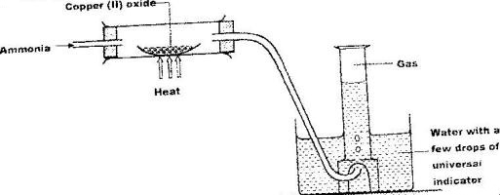
z
- State and explain one observation made in the combustion tube (2 marks)
………………………………………………………………………………………………………………………………………………………………………………………………………………………………
………………………………………………………………………………………………………………Identify gas Z (1 mark)
………………………………………………………………………………………………………………
- What property of ammonia is being investigated? (1 mark)
………………………………………………………………………………………………………………
- Name a suitable drying agent for ammonia gas (1 mark)
………………………………………………………………………………………………………………
- The diagram below shows the set – up used to investigate enthalpy of combustion of ethanol when 450cm³ of water was heated

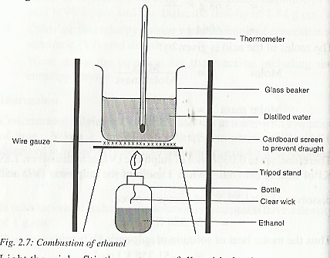
The data below was obtained during the experiment
Volume of water = 450 cm³
Initial temperature of water = 23.0 ⁰C
Final temperature of water = 41.0 ⁰C
Mass of the lamp + ethanol before heating = 141.7g
Mass of the lamp + ethanol after heating =140.2 g
Density of water = 1g/cm³
Specific heat capacity = 4.2 Kj Kg⁻¹ K⁻¹
- Calculate;
- Heat evolved during the experiment (2 marks)
………………………………………………………………………………………………………………………………………………………………………………………………………………………………
- Moles of ethanol that reacted (C=12.0, H= 1.0, O=16.0) (1 mark)
………………………………………………………………………………………………………………………………………………………………………………………………………………………………
- Molar heat of combustion of ethanol (2 marks)
………………………………………………………………………………………………………………………………………………………………………………………………………………………………
- Write a thermochemical equation for the reaction (1 mark)
………………………………………………………………………………………………………………………………………………………………………………………………………………………………

- The theoretical molar enthalpy of combustion of ethanol is – 1260 kJ/Mol. Give two reasons why the experimental value is less (2 marks)
………………………………………………………………………………………………………………………………………………………………………………………………………………………………………………………………………………………………………………………………………………………………………………………………………………………………………………………………
- Name two factors to consider before choosing a fuel (2 marks)
………………………………………………………………………………………………………………………………………………………………………………………………………………………………

- Study the information below and use it to answer the questions that follow
∆H^{θ} lattice = MgCl₂ - 2477kjmol⁻¹
∆H^{θ} hydration Cl⁻¹ (aq) -363kjmol⁻¹
∆H^{θ} hydration Mg⁺² (aq) -1891jmol⁻¹

- Define the molar enthalpy of solution combustion of a substance? (1 mark)
……………………………………………………………………………………………………………………………………………………………………………………………………………………

- Using the above information Draw an energy level diagram to represent the heat of solution of Magnesium Chloride (1 mark)
……………………………………………………………………………………………………………………………………………………………………………………………………………………………………………………………………………………………………………………………………………
iii) Calculate the heat of solution of Magnesium Chloride (2 marks)
………………………………………………………………………………………………………………
………………………………………………………………………………………………………………
………………………………………………………………………………………………………………

- Use the reduction potentials below for P, Q, R, S and T to answer the questions that follow.
Reaction | E º value (V)
P²⁺ (aq) + 2e⁻ → P (s) | – 0.79
2Q⁺ (aq) + 2e⁻ → Q₂ (s) | 0.00
R²⁺ (aq) + 2e⁻ → R (s) | + 0.45
S²⁺ (aq) + 2e⁻ → S (s) | – 0.21
½ T₂ (g) + 2e⁻ → T ⁻ (aq) | + 2.91

- Identify;
- The element that is likely to be hydrogen (1 mark)
……………………………………………………………………………………………………
- The strongest reducing agent (1 mark)
……………………………………………………………………………………………………
- The half cells of P and R were combined
- Draw the electrochemical cell formed (3 marks)

- Calculate the e.m.f. of the cell formed (1 mark)
………………………………………………………………………………………………………………
- During the extraction of sodium using the Down’s cell, molten sodium chloride is electrolyzed.
- State the role of the following in the cell (2 marks)
Calcium chloride ………………………………………………………………………………………………………

Steel diaphragm
………………………………………………………………………………………………………

- State the observation made at the anode (1 mark)
………………………………………………………………………………………………………………………………………………………………………………………………………………

- Write an equation for the reaction at the cathode (1 mark)
………………………………………………………………………………………………………………………………………………………………………………………………………………

- 2A was passed through molten sodium chloride for 2 hours and 35 minutes. Calculate the mass of sodium metal formed (1F= 96,500C, Na=23, Cl=35.5) (2 marks)
………………………………………………………………………………………………………………………………………………………………………………………………………………………………………………………………………………………………………………………………………………………………………………………………………………………………
………………………………………………………………………………………………………………………………………………………………………………………………………………
- State two applications of electrolysis (2 marks)
………………………………………………………………………………………………………………………………………………………………………………………………………………………………………………………………………………………………………………………………………………………………………………………………………………………………

- The set up below was used to prepare hydrogen chloride gas and salt T.
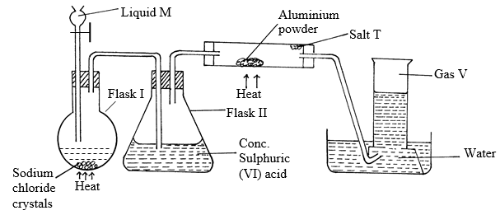
- Identify the following
- Liquid M……………………………………………………………………. (1 mark)
- Gas V………………………………………………………………………. (1 mark)
- Salt T……………………………………………………………………… (1 mark)
- Write balanced chemical equations for reactions that occur at:
- Flask I (1 mark)
………………………………………………………………………………………………………
- Combustion tube. (1 mark)
………………………………………………………………………………………………………
- Name the process that formed salt T as shown in the diagram. (1 mark)
………………………………………………………………………………………………………
- Sulphuric (VI) acid is used as a drying agent in this experiment. Explain why calcium
oxide is unsuitable for the same purpose in this reaction. (1 mark)
………………………………………………………………………………………………………
………………………………………………………………………………………………………
- The water in the trough was found to have a pH of 2.0 at the end of the experiment. Explain. (1 mark)
………………………………………………………………………………………………………
………………………………………………………………………………………………………

- In the space provided below, draw a well labelled diagram showing how you would dissolve hydrogen chloride gas in water. (1 mark)
………………………………………………………………………………………………………
……………………………………………………………………………………………………
- Explain why hydrogen chloride gas dissolved in methylbenzene does not react with calcium carbonate. (1 mark)
………………………………………………………………………………………………………
………………………………………………………………………………………………………

