MECS END OF TERM TWO 2022 CHEMISTRY PAPER ONE MARKING SCHEME PP 1
1.i. substance that produces useful energy when it undergoes a chemical or nuclear reaction. 1MK
ii. -It burns very rapidly producing large amounts of gases which in turn create a huge thrust as they escape.
-It has a very high heat of combustion (4740 kJ mol–1).
-It ignites easily.
ANY 1MK
2. foms positive ions like group I elements½MK
H(g) H⁺ (g) + e⁻ 1MK
From negative ions like group VII elements½MK
H(g) + e⁻ H⁻(g) 1MK
3.i.Rusting
ii. – Iron nails CHANGES brown./ RUSTS
- Water rises up the delivery tube/water level drops in the trough
4. I. manufacture of glass, soaps and detergents
ii. in paper and textile industries(accept any)
b. Ca²⁺(aq) + CO₃²⁻(aq) CaCO₃(s)
Mg²⁺(aq) + CO₃^{2–}(aq) CaCO₃(s)
5. -Add water to the solid in a boiling tube and divide the solution into two (1mk)
-add ammonia solution to the two prepared solutions, until in excess (1mk)
A white ppt that ½MK dissolves in excess shows the presence of Zinc ions while a white ppt that doesn’t dissolve shows the presence of aluminium ½MK ions.
6.i. Concentrated sulphuric (VI) acid
ii. Collection over water
drawing and workability
labelling
ConcH₂SO₄
iii. HCOOH(s) CO(g) + H₂O(g)
7. i.a. hydrogen
b. copper(ii) oxide
c. water
ii. it is impure and impurities raise the boiling point
8. i) Metals, the ionic is smaller than the atomic radius
ii. C
9.
Effect on rate | Explanation
increases | Powdered zinc offers a large surface area.
increases | particles collide more
10. a. Rhombic
b. monoclinic
c. Rhombic
11. -Place some flowers in the mortar and crush using the pestle while adding propanone a little at time.Decant the extract in a clean beaker
-Place a drop of the extract at the centre of the filter paper and allow it to spread as far as possible.
-Add a drop of propanone at the centre of the filter paper of the filter paper and allow it to spread as far as possible. A chromatogram showing red and yellow colours is seen.
12. $\frac{6xQ+7xW}{100}=6.94$
Q+W=100
Elimination
6Q +7W =694
6Q + 6W= 600
W=94%
Q= 6%
13. i. effervesence/stream of bubbles
ii. White suspension/ precipitate is formed
Ca(s) + H₂O (l) Ca(OH)₂ (aq) + H₂(g)
14. i.Less volatile,can displace more volatile acids from their salts
ii.Oxidising agent
15. Moles of NaOH that reacted
0.1------------1000
?---------------24.8 =0.00248moles½MK
Moles of the acid that reacted with the base
NaOH : HCl
1 : 1
0.00248: 0.00248 moles½MK
Moles of the acid in 100cm³
0.2-----------------1000cm³
………………….100cm³ =0.02moles½MK
Moles of the acid that reacted with the carbonate
0.02 moles- 0.00248moles =0.01752moles½MK
Moles of the carbonate that reacted with the acid
CaCO3 : HCl
1 : 2
? : 0.01752 =0.00876moles½MK
Mass of the carbonate that reacted
Moles x molar mass
0.00876 x 100 = 0.876 g½MK
Percentage of calcium carbonate in limestone
$\frac{0.876}{1}$x100 = 87.6%½MK
16. -sublimes on heating
-It is deliquescent
orange brown, soluble in water
ii- Fe(s) + Cl₂(g) FeCl₃(s)
17. -Keep substances free from moisture
- Heat substances that require strong heating
- Holding substances being heated
18.
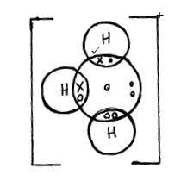
19. a. Burn in a non-luminous flame, carbon burns in a yellow flame, copper (ii) oxide burns in a green flame
b. Add dilute sulphuric (vi) acid, copper (ii) oxide dissolves to form a blue solution while carbon doesn’t dissolve.
c. Heat strongly in a boiling tube, carbon forms a colourless gas that forms a white ppt with while lime water copper(ii) oxide doesn’t.
d. add copper (ii) oxide to each of them and heat strongly, carbon forms a brown substance while copper(ii0 oxide doesn’t.
20.- Add sodium metal into distilled water, to form sodium hydroxide
-Bubble carbon (iv) oxide gas through sodium hydroxide solution for a long period of time to form sodium hydrogen carbonate.
-Evaporate sodium hydrogen carbonate solution to saturate then cool to crystallize
21.i.They are plant extracts that show different colours in acid and base
ii.Do not have a long shelf life
Do not show consistent results
22. -used water softening
-Extraction of some metals
23.IUPAC: International union of pure and applied chemistry
DDT: Dichlorodiphenyltrichloroethane
24.i. Fission: splitting of a heavy nuclide when bombarded with a fast moving neutron
Fusion: small nuclei combine together when made to collide at high velocity (Both correct)
ii.
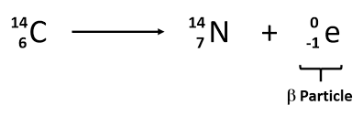
25. 2C + 3H₂ +O₂ CH₃CH₂OH

+O₂ +O₂ +O₂

(- 393x2) +(-296x 3)= H + -1386
-1674+ 1386 = -290kJ/mol
2 CO₂ + 3 H₂O
26.i. Pb(NO₃)₂
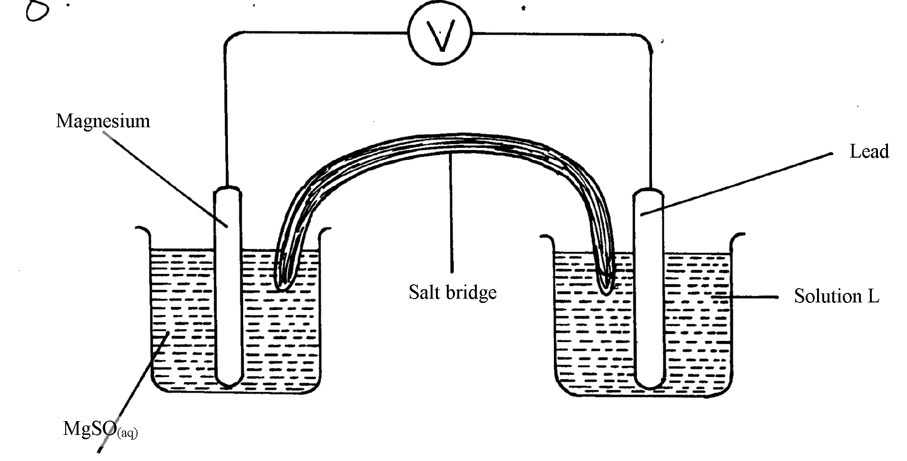ii.
MgSO_{4(aq)}

iii. Mg(s)/Mg²⁺(aq)//Pb²⁺(aq)/Pb(s)
27. i.At constant temperature and pressure the rate of diffusion of a gas is inversely proportional to the square root of its density.
ii. 100cm³--------------30sec
150cm³--------------? =45 sec
$$\frac{Ta}{Tb}=\frac{\sqrt{Da}}{Db}$$
T²= 2025 x 46/44 = 46.01 sec
28. Q-Ethanol
Z- Ethanoic acid
ii. 2CH₃CH₂OH(l) + 2K(s) 2CH₃CH₂OK(l) + H₂(g)
CH₃COOH(aq) + Na₂CO₃(s) CH₃COONa(aq) + CO₂(g) + H₂O(l)
29i.-The rate of forward reaction is equal to the rate of backward reaction
-at equilibrium the concentration of the reactants and products do not change
ii. pressure will have no effect on the equilibrium because, number of molecule on the reactant and products side are equal.

