Name:……………………………………………………….. Adm. No………………………..

School………………………………………………………… Date:……………………….

233/1
CHEMISTRY
Paper 1
THEORY
Time: 2 Hours
KENYA CERTIFICATE OF SECONDARY EDUCATION
END OF TERM II EXAMINATION
2021

Instructions to candidates:

- Write your name, Admission Number and school in the spaces provided above
- Sign and write the date of examination in the spaces above
- Answer ALL the questions in the spaces provided below each question.
- Mathematical tables and silent electronic calculators may be used.
- All working MUST be clearly shown where necessary
- This paper consists of 14 printed pages.

FOR EXAMINER’S USE ONLY

QUESTIONS | MAXIMUM SCORE | CANDIDATE’S SCORE
1 -30 | 80
TOTAL SCORE | 80

1. Molten sodium chloride and graphite both conduct electricity. State their difference in electrical conductivity. (2mks)
……………………………………………………………………………………………………………………………………………………………………………………………………………….
……………………………………………………………………………………………………………………………………………………………………………………………………………….

2. Element R has atomic number 8 and a mass number 16.
(i) Draw the atomic structure of element R. (1mk)

(ii) Explain why R forms a hydride with a low boiling point. (1mk)
………………………………………………………………………………………………………………………………………………………………………………………………………………………………
3. Study the diagram below and answer the questions that follow.
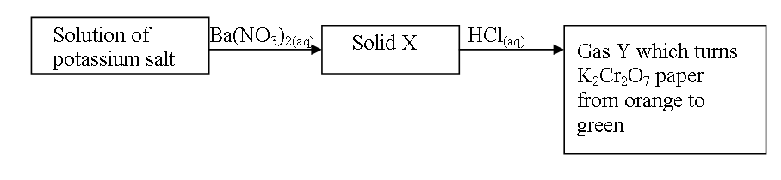
(a) Name (i) Solid X (1mk)
……………………………………………………………………………………………………………………………………………………………………………………………………………….
(ii) Gas Y (1mk)
……………………………………………………………………………………………………………………………………………………………………………………………………………….

4. Compare the second ionization energy of magnesium with its first ionization energy. Explain your answer. (2mks)
……………………………………………………………………………………………………………………………………………………………………………………………………………….
……………………………………………………………………………………………………………………………………………………………………………………………………………….

5. The set-up represented below can be used to separate ethanol from its mixture with water.

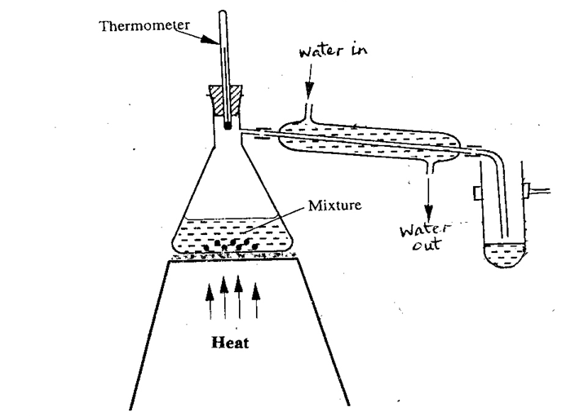

(a) Identify an error in the set-up. (1 mk)

………………………………………………………………………………………………………
(b) Name this method of separation. (1 mk)

…………………………………………………………………………………………………….…
(c) What properties make it possible to separate ethanol from water by this method? (1 mk)

………………………………………………………………………………………………………
………………………………………………………………………………………………………

6. Element K has two isotopes ²⁰K and ²²K with relative abundance of 90% and 10% respectively.
a) What are isotopes? (1 mk) ……………………………………………………………………………………………………………………………………………………………………………………………………………………

b) Determine the relative atomic mass of element K. (2 mks)
………………………………………………………………………………………………………………………………………………………………………………………………………………………………………………………………………………………………………………………………

7. Xg of Potassium hydroxide were dissolved in water to make 100cm³ of solution.50cm³ of solution required 50cm3 of 2M Nitric acid for complete neutralization. Calculate the mass X of Potassium hydroxide. (3mks)
……………………………………………………………………………………………………………………………………………………………………………………………………………….
……………………………………………………………………………………………………………………………………………………………………………………………………………….
8. Sulphur burns in air to form a gaseous product.
i) What is the colour of the flame of burning sulphur? (1 mk)
…………………………………………………………………………………………………………….…
ii) Give an equation for the reaction that takes place when the gaseous product is bubbled through water. (1 mk)
………………………………………………………………………………………………………….……
iii) State one importance of the product formed in (ii) above. (1 mk) ………………………………………………………………………………………………………….……
9. The figure below shows a paper that was placed horizontally across the middle of a non-luminous flame and quickly withdrawn.

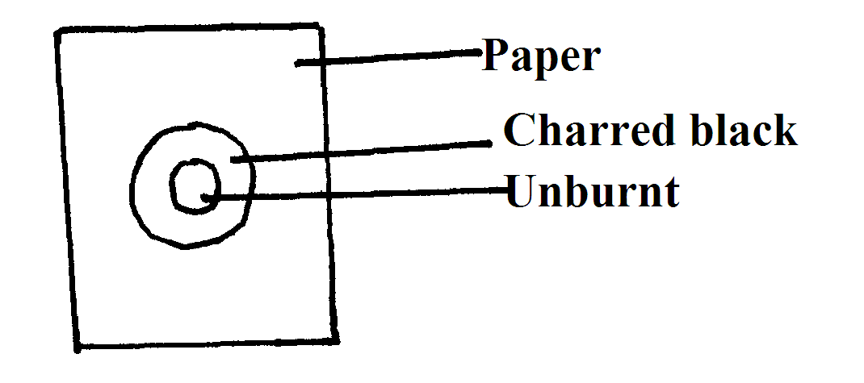

(a) Explain the observations. (1mk)
……………………………………………………………………………………………………………………………………………………………………………………………………………….

(b) Why is luminous flame not used for heating in the laboratory? (1mk)
……………………………………………………………………………………………………………………………………………………………………………………………………………….
10. Study the diagram below and answer the questions that follow.
Concentrated sodium hydroxide solution
Tube B
Tube A
Iron wool
Dry chlorine gas
Heat
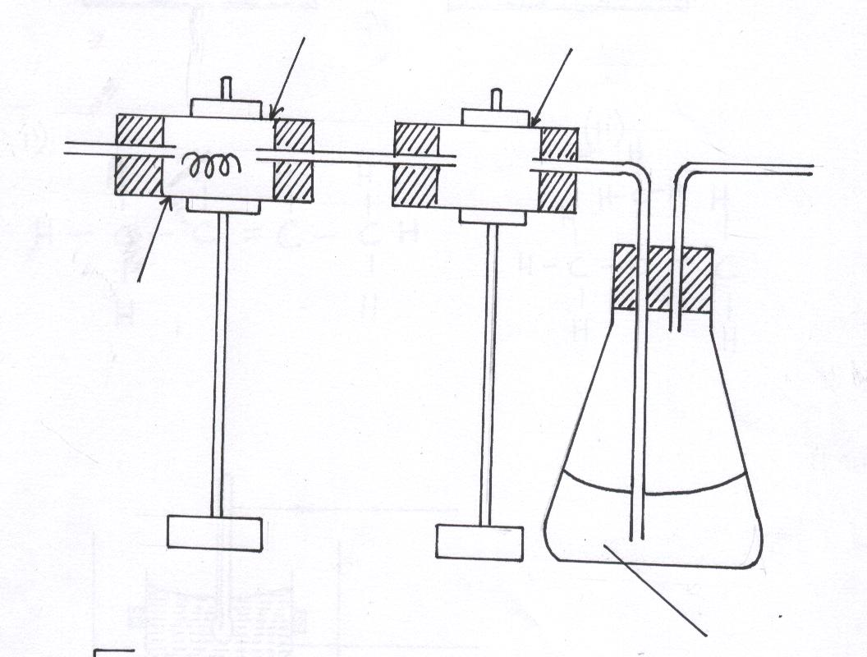

(i) What is observed when the hot iron wool reacts with chlorine gas? (1mk)
………………………………………………………………………………………………………………………………………………………………………………………………………….……

(ii) What is the purpose of:
a) Tube B (1mk)
……………………………………………………………………………………………………
b) Concentrated Sodium hydroxide solution. (1mk)
……………………………………………………………………………………………………
11. The table below shows results obtained from experiment carried out on a suspect salt solution M.
Experiment | Results
- A few drops of Barium nitrate added to solution M | No ppt/ colourless solution
- A few drops of lead (II) nitrate added to solution M. | White ppt
- Ammonia solution added dropwise until in excess | White precipitate  Colourless solution

- Identify the cation and anion present in solution M. (1mk)
Cation (½ mk)
………………………………………………………………………………………….
Anion (½ mk)
………………………………………………………………………………………....
b) Write an ionic equation for the formation of white precipitate in experiment II (1mk)
…………………………………………………………………………………………………………………………………………………………………………………………………………….…
c) Write the formula of the Ion responsible for formation of colourless solution in experiment III
(1mrk)
………………………………………………………………………………………………………………………………………………………………………………………………………………
12. The diagram below shows a set-up of apparatus used to prepare oxygen gas and pass it over burning candle. The experiment was allowed to run for several minutes.

Liquid M

Flask I
Burning candle
Sodium peroxide
Water
Flask II
To pump

- Identify liquid M. (1mk)
……………………………………………………………………………………………………………………………………………………………………………………………
- The pH of the solution in flask II was found to be less than 7. Explain. (2mks)
……………………………………………………………………………………………………………………………………………………………………………………………………………………………………………………………………………………………….
iii) Write an equation for the reaction that forms oxygen gas in the set up. (1mk)
……………………………………………………………………………………………………………………………………………………………………………………………………………….
13. Briefly explain the following
(i) Alkaline earth metals are generally less reactive than alkali metals. (1mk)
……………………………………………………………………………………………………………………………………………………………………………………………………………….
(ii) Melting point of alkali metals decrease down the group while melting point of halogens increases down the group. (2mks)
……………………………………………………………………………………………………………………………………………………………………………………………………………….
……………………………………………………………………………………………………………………………………………………………………………………………………………….
(iii) Group VIII elements are gases at room temperature. (1mk)
……………………………………………………………………………………………………………………………………………………………………………………………………………….
14. How would you obtain a sample of pure iodine from a mixture of iodine and lead (II) sulphate. (2mks)
……………………………………………………………………………………………………………………………………………………………………………………………………………….
……………………………………………………………………………………………………………………………………………………………………………………………………………….
15. The table below indicates the PH values of solutions labelled A, B, C, D and E
Solution | A | B | C | D | E
pH value | 5 | 13 | 2 | 10 | 7

Identify the solution:
(i) Containing highest concentration of hydrogen ions. ( ½ mk)
……………………………………………………………………………………………………………………………………………………………………………………………………………….

(ii) That is likely to be ethanoic acid. Give a reason. (1mk)
……………………………………………………………………………………………………………………………………………………………………………………………………………….

(iii) That is likely to be common salt solution. ( ½ mk)
……………………………………………………………………………………………………………………………………………………………………………………………………………….

16.The table below shows physical properties of some substances. Use the information to answer the questions that follow.
Substance | Density (gm⁻³) | M-P (^{O}c) | B.P (^{O}c) | Electrical conductivity  Solid Liquid
M  O  P  Q  R | 3.5  0.8  3.8  21.4  1.53 | 801  -114  3550  -39  660 | 1413  -84.9  4827  357  2470 | POOR  POOR  POOR  GOOD  GOOD | GOOD  POOR  POOR  GOOD  GOOD

(i) Which of the elements is a liquid at room temperature. Explain (1mk)
……………………………………………………………………………………………………
(ii) Identify the type of structure in
P…………………………………………………………………………
R………………………………………………………………………… (1mk)
(iii) Which element would be the most suitable for use in over-head electric wire transmission? (2 mks)
……………………………………………………………………………………………………………………………………………………………………………………………………….………
17. An element Y has relative atomic mass 6.939 and atomic number 3. it has two isotopes with atomic mass 6.015 and 7.016. Calculate the relative abudance of the isotopes. (3mks)

18. (a) Give the name of the organic compound formed when methanol and ethanoic acid reacts in the presence of concentrated sulphuric (VI) acid. (1mk)
……………………………………………………………………………………………………………………………………………………………………………………………………………….

(b) Write the structural formula of
2 – methylpropane (1mk)
……………………………………………………………………………………………………………………………………………………………………………………………………………….

19. The diagram below shows how magnesium reacts with steam.
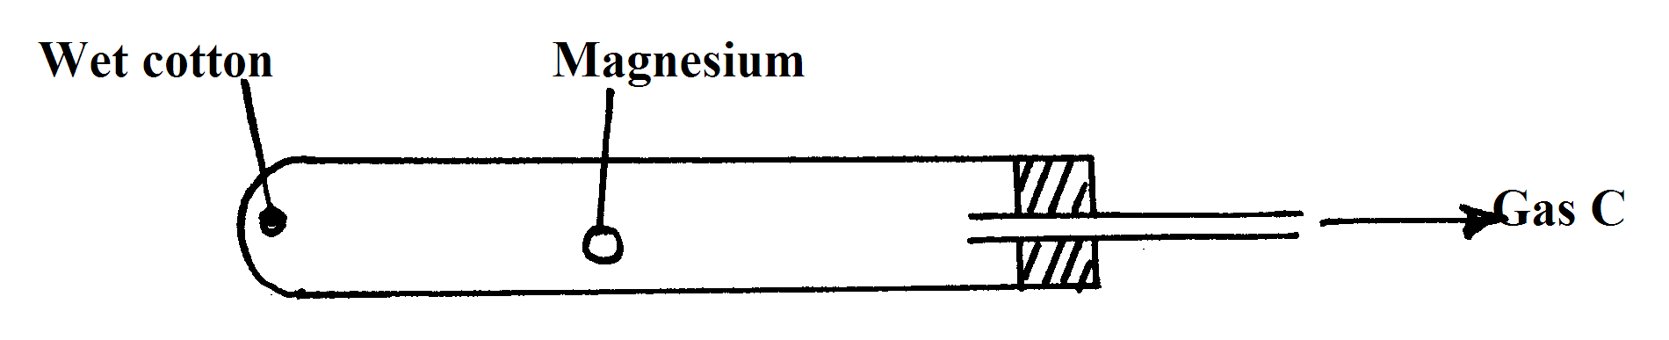
(i) Gas C would not be produced as in the set-up but when certain condition is introduced gas C is produced. On the diagram indicate the condition that was omitted. (1mk)

(ii) Describe how gas C is produced after the mistake was corrected in the set-up. (1mk)
……………………………………………………………………………………………………………………………………………………………………………………………………………….
20. Study the information in the table below and answer the questions that follow. The letter do not represent the actual symbols of the elements.
Element atomic number electronic arrangement
X 16
Y 19
(a) Complete the table by writing the electronic arrangement of the elements (1mk)

(b) Which type of bond is formed between X and Y. explain (2mks)
……………………………………………………………………………………………………………………………………………………………………………………………………………….
……………………………………………………………………………………………………………………………………………………………………………………………………………….

21. Hydrogen chloride gas was passed into water as shown below.
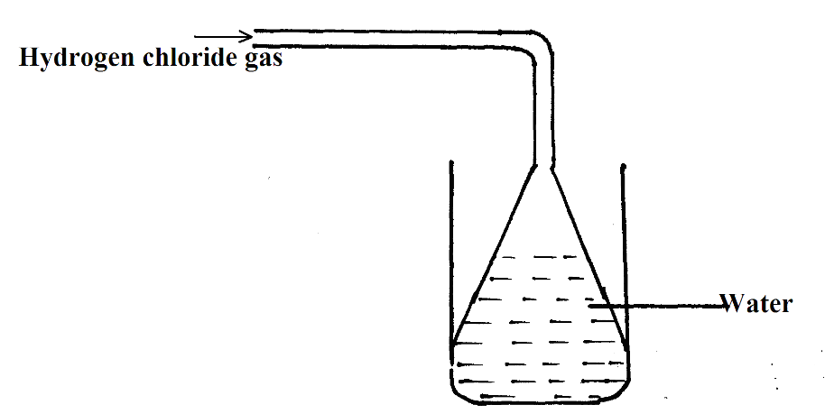
(a) When a blue litimus paper was dropped into the resulting solution, it turned red. Give a reason for the observation. (1mk)
……………………………………………………………………………………………………………………………………………………………………………………………………………….
(b) What is the function of the funnel? (1mk)
……………………………………………………………………………………………………………………………………………………………………………………………………………….
22. The paper chromatogram below shows the identification of unknown metal ions in mixture M. The reference ions X, Y and Z are also shown. The experiment was done in an ascending method.
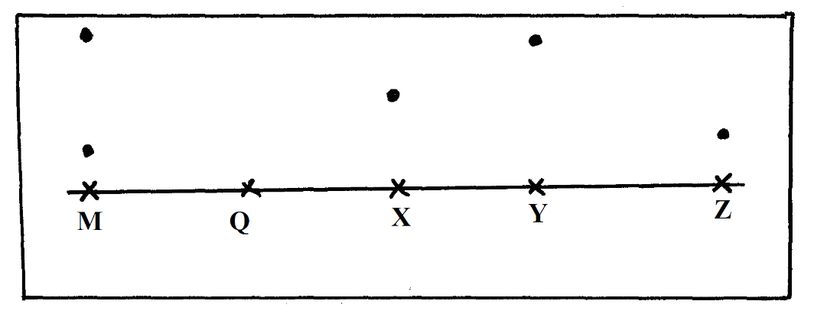
X – Vanadium (IV) ion (V⁴⁺) Y – Chromium (III) ion (Cr³⁺) Z – Copper(II) ion (Cu²⁺)

(a) Name the ions present in the mixture M. (1mk)
……………………………………………………………………………………………………………………………………………………………………………………………………………….
(b) Indicate the solvent front on the diagram. (1mk)
(c) Mixture Q contains all the three ions. Show the chromatography of Q. (1 ½ mks)

23. The set-up below shows the preparation of carbon (II) oxide.
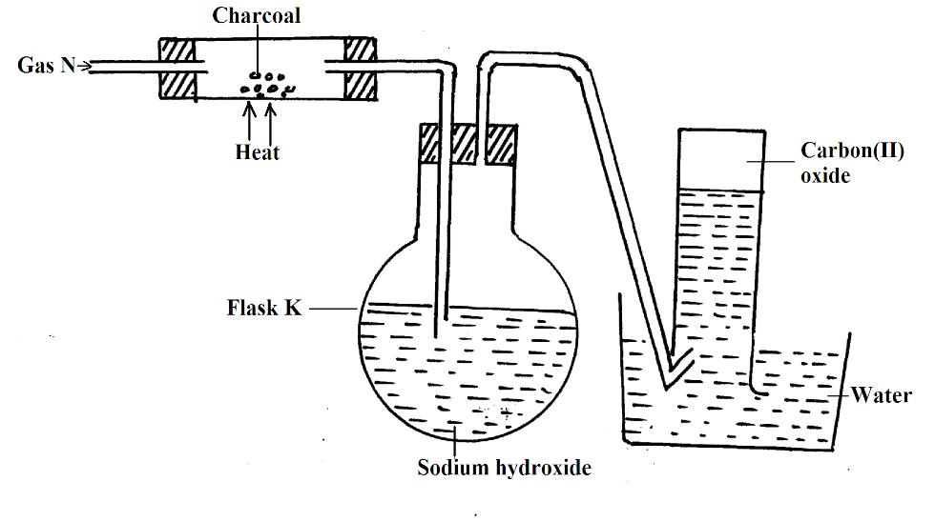
(a) Name gas N (1mk)
……………………………………………………………………………………………………………………………………………………………………………………………………………….
(b) What is the purpose of sodium hydroxide in flask K? (1mk)
……………………………………………………………………………………………………………………………………………………………………………………………………………….
(c) Why is it necessary to carry out this experiment in a fume cupboard? (1mk)
……………………………………………………………………………………………………………………………………………………………………………………………………………….
24. Determine the oxidation states of the underlined elements (2mks)
i) Fe (CN)₆³⁻ ii) K [Cr (CN)₆]⁴⁺
Oxidation state of Fe Oxidation state of Cr
……………………………………………………………………………………………………………………………………………………………………………………………………………………………….

25. The diagram below shows a structure (i) of water molecules
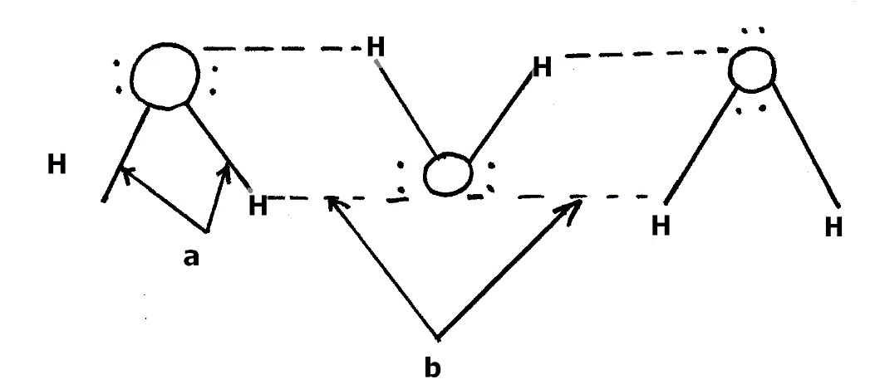
i) Name the bonds labelled ( 1 mk)
a) ………………………………………………………………………………………….
……….……………………………………………………………………………………
b…………………………………………………………………………………………..
……………………………………………………………………………………………
ii) Using dots (.) and cross(x) diagram show the bonding in the compound phosphonium ion
PH₄⁺ (H = 1, P = 15) (1mks)

26. When dry hydrogen gas was passed over a heated lead (II) oxide sample in a combustion tube and the gaseous product cooled, a colourless liquid was obtained.
(a) (i) Name the colourless liquid. ( ½ mk)
……………………………………………………………………………………………………………………………………………………………………………………………………………….
(ii) Describe a chemical test you would use to confirm the colourless liquid in a (i) above. (2mks)
……………………………………………………………………………………………………………………………………………………………………………………………………………….
……………………………………………………………………………………………………………………………………………………………………………………………………………….
(b) What observation can be made in the combustion tube at the end of the experiment? ( ½ mk)
……………………………………………………………………………………………………………………………………………………………………………………………………………….
(c) Write a chemical equation for the reaction between hydrogen and heated lead (II) oxide. (1mk)
……………………………………………………………………………………………………………………………………………………………………………………………………………….
27. State one use of:
a) Calcium nitrate (1 mrk)
………………………………………………………………………………………………………..

b) Magnesium hydroxide (1 mrk)
……………………………………………………………………………………………………….
28. Coloured flower placed in a gas jar containing gas X immediately turned colourless. A solution of gas X in water formed a white precipitate with silver nitrate solution. The precipitate was insoluble in nitric (V) acid but dissolved in excess aqueous ammonia.

(a) What is the identity of gas X? (1mk)
……………………………………………………………………………………………………………………………………………………………………………………………………………….
(b) Write down the balanced chemical equation of the reaction that took place when:
(i) Solution of gas X in water reacted with silver nitrate solution. (1mk)
……………………………………………………………………………………………………………………………………………………………………………………………………………….
(ii) Aqueous ammonia was added to the resulting mixture in b(i) above. (1mk)
……………………………………………………………………………………………………………………………………………………………………………………………………………….
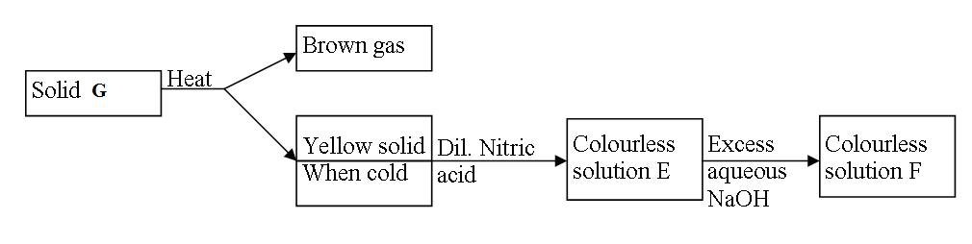
29. Study the flow chart below and answer the questions that follow.

(a) Identify solid G (1mk)
……………………………………………………………………………………………………………………………………………………………………………………………………………….

(b) Write the formula of the complex ion in solution F (Imk)
……………………………………………………………………………………………………………………………………………………………………………………………………………….
30. Describe how you would obtain solid sample of sodium carbonate from a mixture of lead carbonate and sodium carbonate powders. (2mks)
……………………………………………………………………………………………………………………………………………………………………………………………………………….
……………………………………………………………………………………………………………………………………………………………………………………………………………….

THIS IS THE LAST PRINTED PAGE

