SUNRISE EVALUATION EXAM FORM 4 - 2022
NAME: ………………………………………………ADM NO: …………CLASS…………
SCHOOL…………………………………………………………………….DATE: …..…….
F4 PHYSICS
Paper 3
Time 2 HOURS
SEPTEMBER -2022.
INSTRUCTIONS TO CANDIDATES:
- Write your name and index number in the spaces provided above.
- Sign and write the date of the examination in the spaces provided above.
- You are supposed to spend the first 15 minutes of the 2 ½ hours allowed for this paper reading the whole paper carefully before commencing your work.
- Marks are given for a clear record of the observation actually made, their suitability, accuracy and the use made of them.
- Candidates are advised to record their observations as soon as they are made
- Non-programmable silent electronic calculators may be used.
- Candidates should check the question paper to ascertain that all the pages are printed andthat no questions are missing.
For Examiner’s Use Only.
Question | Maximum score | Candidate’s score
1 | 20
2 | 20
Total | 40

This paper consists of 10 printed pages candidates should check the questions to ascertain that all pages are printed as indicated and that no questions are missing
QUESTION 1
You are provided with the following
- A voltmeter
- Two dry cells and a cell holder
- A switch
- A resistor labelled R (3.9Ω)
    - A wire mounted on a mm scale and labelled G
- A micrometer screw gauge (to be shared)
- Six connecting wires with six crocodile clips
Proceed as follows.
(a) Record the length L_{O} of the wire labelled G
L_{O} = ........................................................................
Use the micrometer screw gauge provided to measure the diameter of the wire labelled G at two different points and determine the average diameter, d
The diameter d₁ = ............................................ mm, d₂ = ............................................... mm (1 mark)
Average diameter d = ............................................................. mm (1 mark)
............................................................................................................................................................... ............................................................................................................................................................... ...............................................................................................................................................................
Determine the radius r of the wire in metres. (1 mark)
Radius r = ......................................................... m
............................................................................................................................................................... ............................................................................................................................................................... ...............................................................................................................................................................

(b) Set up the apparatus as shown in the circuit diagram in figure 1.
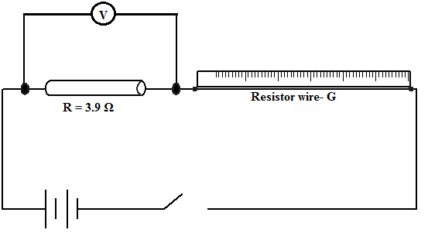
Fig 1
(i) Use the voltmeter provided to measure the p.d. V _{R} across R and p.d. V_{G} across G when the switch is closed.
V_{R} = .................................................................... volts (1 mark)

V_{G} = ..................................................................... volts (1 mark)
Open the switch
(ii) Use the value of R provided and the value of V_{R} in b(i) above to calculate the current I flowing through R when the switch was closed. (1 mark)
...........................................................................................................................................................................................................................................................................................................................................................................................................................................................................
I = .............................................................. Amperes.
(iii) Determine the constant H given that
(1 mark)
..........................................................................................................................................................................................................................................................................................................................................................................................................................................................................
H = ................................................Ωm⁻¹
(c) Connect the voltmeter across R as shown in figure 2 below.
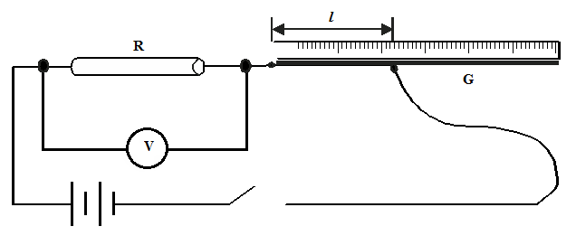
Fig 2
Adjust the position of one crocodile clip on the wire G to a point such that the length lof the wire in the circuit in 5cm(see figure 2 above) close the switch.
Read and record in table 1 the value of p.d. across R. Open the switch.
(d) Repeat the procedure in (c) above for the other values of L shown in the table 1. (3 marks)
Table 1.
Distance L (cm) | 0 | 2 | 10 | 20 | 30 | 40 | 50 | 70
p.d. V across RV

(e) i) On the grid provided next page, plot the graph of V(y-axis) against l. (5 marks)
ii) From the graph, determine l₁, the value of l when $V=\frac{V_{o}}{2}$where V_{O} is the p.d. where l = 0 (1 mark)
(f) Determine the constant D for the wire given that $D=\frac{R}{l_{1}}×\frac{300}{V_{o}}$ (2 marks)
............................................................................................................................................................................................................................................................................................................................................................................................................................................................................................
(f) Determine the constant p given that $p= \frac{πr^{2}}{2}(D+H)$, where r is the radius of the wire in metres. (2 marks)
.............................................................................................................................................................................................................................................................................................................................................................................................................................................................................................

QUESTION 2
Section A
You are provided with the following
- A candle
- A lens and a lens holder
- A screen
- A metre rule

a) Set up the apparatus as shown in figure below (ensure that the candle flame and the lens are approximately the same height above the bench)

b) Set the position of the lens so that the 40cm from the candle (U=40). Adjust the position of the screen until a sharp image of the candle flame is obtained. Measure the distance, V between the lens and the screen. Record the value of V₁ V = ………… cm) 1mk)

c) Repeat the procedures in b) above for other values of U in the table b below.
Table b)
U(cm) | 45 | 50 | 55
V(cm)
Magnification (m) $\frac{v}{u}$

d) Given that f = $\frac{v}{m+1,}$

where f is the focal length of the lens, use the results in table above to determine the average values of f. 4mks)
PART B.

You are provided with the following:
- rubber bung.
- vernier calipers.
- beam balance.

Proceed as follows:

- Using a vernier caliper, measure the lengths D, d, and h as shown in figure 2.
d
h
D
Figure 2

D = ....................................................... m (1 mark)
d = ........................................................ m (1 mark)
h = ........................................................ m (1 mark)

- (i) Measure the mass, M of the rubber bung using the beam balance.
M = ....................................................... kg (1 mark)

d + D
4
(ii) Given that Q = , determine the value of Q. (1 mark)

M
h
(iii) Determine the value of r given that πrQ² = (3mark)

(iv)what are the units of r (1 mark)

(v) what is the significance of r (1 mark)

SECTION C
You are provided with the following
- a metre rule
- a retort stand, one boss, one clamp
- One 500ml beaker ¾ full of water
- One 100g mass
- One 50g mass
- 3 pieces of thread approximately 30cm long

Procedure
a) Balance the metre rule horizontally by suspending it from the stand and clamp with one of the threads.
Record the balance point G

G = __________________ cm (1mark)

b) suspend the 100g mass from the metre rule at a point such that x =5cm from point G, with the 100g mass completely immersed in water in the beaker hang the 50g mass from the metre rule.
Note the point of suspension (p) of the mass
P=______________ (1mark)

c ) Calculate the apparent weight of the 100 g mass in water. (3mark)

d)Find the upthrust of 100g mass in water. (2marks)

