SUNRISE 2 EVALUATION EXAM FORM 4 - 2022
NAME: ………………………………………………ADM NO: …………CLASS…………
SCHOOL…………………………………………………………………….DATE: …..…….
PHYSICS
Paper 2
Time 2 HOURS
June/July -2022
Student Target

Instructions to candidates

- Write your name, admission number, class and date in the spaces provided at the top of the page.
- This paper consists of two sections A and B.
- Answer all the questions in the two sections in the spaces provided after each question
- All working must be clearly shown.
- Electronic calculators, mathematical tables may be used.
- All numerical answers should be expressed in the decimal notations.
- This paper consists of 14 printed pages. Candidates should check to ascertain that all pages are printed as indicated and that no questions are missing.
SECTION | QUESTION | MAX MARKS | CANDIDATE’S SCORE
A | 1 – 12 | 25
B | 13 | 11
 | 14 | 11
 | 15 | 13
 | 16 | 06
 | 17 | 14
TOTAL |  | 80

ACHIEVED

SECTION A: (25 MARKS)

- Differentiate between primary and secondary cells (1mk)
……………………………………………………………………………………..……………
……………………………………………………………………………………..……………
2. The diagram in figure 1 below shows the displacement against time for a wave whose wavelength is 4.0mm.
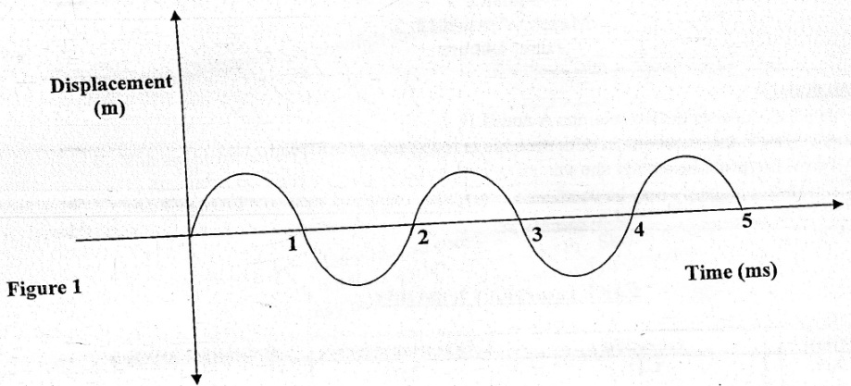

Determine the velocity of the wave. (3mks)
……………………………………………………………………………………..……………
……………………………………………………………………………………..……………
……………………………………………………………………………………..……………
……………………………………………………………………………………..……………
- The figure 2 below shows a thin wire connected to a charge generator and placed close to a candle flame.
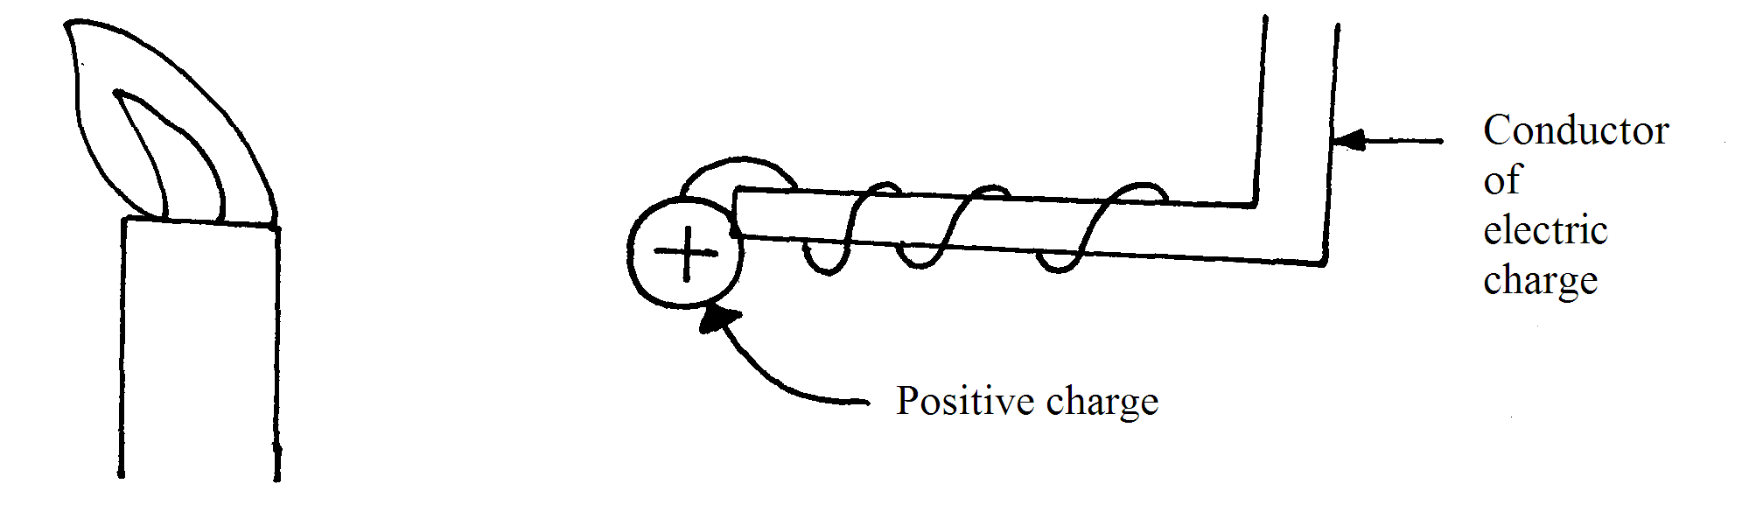
Explain why the candle flame is deflected as shown. (2mks)
……………………………………………………………………………………………………………………………………………………………………………………………………………………………..
- What is thermionic emission? (1 mk)
…………………………………………………………………………………………………………………………………………………………………………………………………………………….
- Ultraviolet radiation incident on a zinc plate releases electrons from the zinc surface. The energy of each incident proton is 5.4eV. Zinc has a work function of 4.3eV.
(i) State the name given to this effect. (1 mk)
…………………………………………………………………………………………………………
(ii) What is meant by work function of the metal? (1 mk)
……………………………………………………………………………………………………………………………………………………………………………………………………………………
(iii) An electron is emitted from the surface of zinc. Calculate the maximum kinetic energy of the electron in Joules. (2 mks)
…………………………………………………………………………………………………………………………………………………………………………………………………………………………………………………………………………………………………………………………………………………………………………………………………………………………………………
- A vibrating tuning fork of frequency 512Hz was brought close to two test tubes X and Y
With water levels as shown in fig. 3
Fig. 3
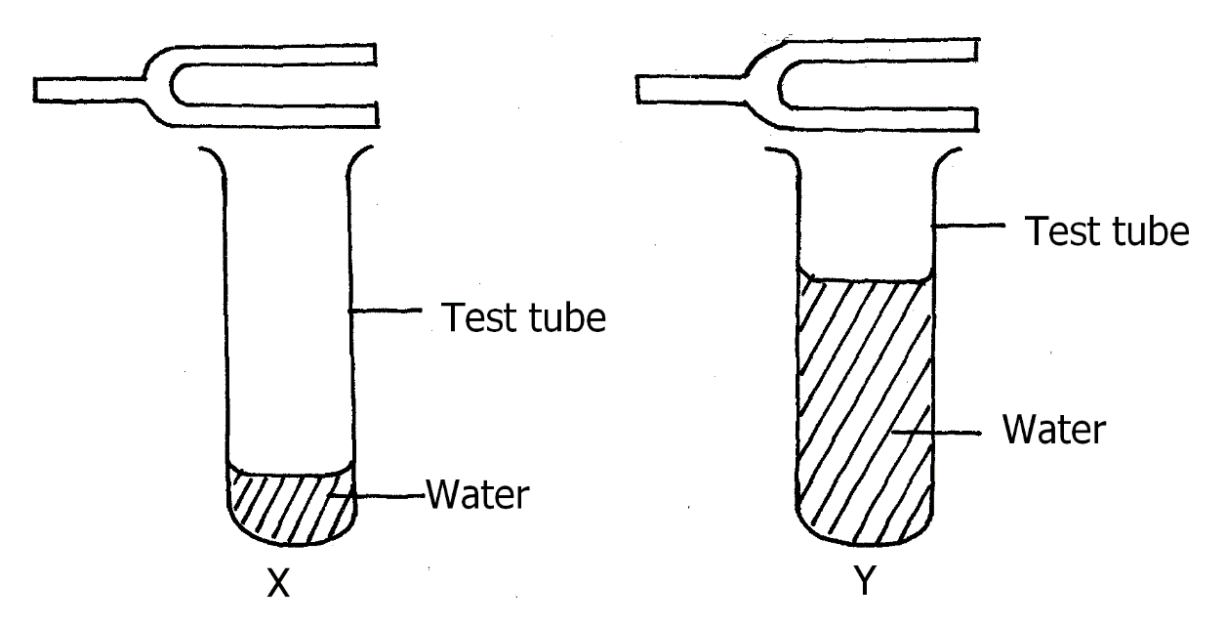
It was observed that loud sound is produced in test tube X but not in Y. Explain this observation. (2mks)
………………………………………………………………………………………………………
………………………………………………………………………………………………………
………………………………………………………………………………………………………
………………………………………………………………………………………………………

- The chart below shows an arrangement of different parts of the electromagnetic spectrum.
Radio | A | Visible | Ultra-violet | X-rays | Gamma-Rays

Name the radiation represented by A (1mk)
………………………………………………………………………………………………………
………………………………………………………………………………………………………
- The figure 4 below shows a container loader which uses electromagnet to offload containers from a ship.
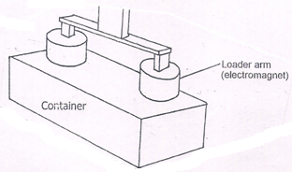

(i) Why should the container be made of iron. (1 mrk)
………………………………………………………………………………………………………………………………………………………………………………………………………………………………
(ii) State two ways in which the loader can be made to lift a heavier container. (2 mrks)
………………………………………………………………………………………………………………………………………………………………………………………………………………………………………………………………………………………………………………………………………………

- The figure below shows an object O and it’s image I formed by a concave mirror. The diagram is drawn to scale.
0
I

Using a suitable ray, determine the focal length (f) and the radius of curvature (r) of the
mirror. (3 marks)

f ……………… cm

r………………. cm

- State two differences between pinhole camera and the human eye. (2 marks)
………………………………………………………………………………………………………………………………………………………………………………………………………………………………………………………………………………………………………………………………..
- Give a reason why soft iron is used as a core of the coil of an electric bell. (1 mark)
…………………………………………………………………………………………………………………………………………………………………………………………………………………...
- State two uses of gold leaf electroscope. (2 marks)
………………………………………………………………………………………………………………………………………………………………………………………………………………………………………………………………………………………………………………………………

SECTION B: (55 MARKS)
- a) Define a resistor. (1 mark)
………………………………………………………………………………………………………………………………………………………………………………………………………………………………
b) The figure below shows three resistors connected to 12v supply of internal resistance of 0.2Ω.

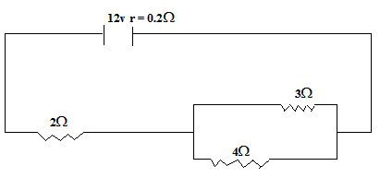

Calculate
i) The effective resistance. (3 marks)
………………………………………………………………………………………………………………………………………………………………………………………………………………………………………………………………………………………………………………………………………………………………………………………………………………………………………………………………………………………………………………………………………………………………………………………………………………………………………………………………………………………………………………
ii) The total current in the circuit. (2 marks)
………………………………………………………………………………………………………………………………………………………………………………………………………………………………………………………………………………………………………………………………………………………………………………………………………………………………………………………………………….
iii) the current through the 4Ω resistance. (3 marks)
………………………………………………………………………………………………………………………………………………………………………………………………………………………………………………………………………………………………………………………………………………………………………………………………………………………………………………………………………….
c) If the current flows for 2 minutes calculate the total energy dissipated. (2 marks)
…………………………………………………………………………………………………………………………………………………………………………………………………………………………………………………………………………………………………………………………………………………………………………………………………………………………………………………………………………..
d) State two applications of resistors in real life situation. (2 marks)
(i) ..............................................................................................................................................................
(ii)...............................................................................................................................................................

- Define the following terms.
i) Capacitor (1 mark)
………………………………………………………………………………………………………………………………………………………………………………………………………………………………
ii) Capacitance (1 mark)
………………………………………………………………………………………………………………………………………………………………………………………………………………………………
b) Three capacitors are connected to a 10v battery.
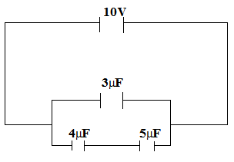

Calculate
i) The effective capacitance (3 marks)
………………………………………………………………………………………………………………………………………………………………………………………………………………………………
………………………………………………………………………………………………………………………………………………………………………………………………………………………………

ii) The total charge (3 marks)
……………………………………………………………………………………………………………………………………………………………………………………………………………………………
………………………………………………………………………………………………………………………………………………………………………………………………………………………………
c) State three factors that determine the capacitance of a capacitor. (3 marks)
i)
ii)
iii)

- (a ) X- rays are used for detecting cracks inside metal beams; (i) State the type of the X- rays used. (1mark)
……………………………………………………………………………………………………….
……………………………………………………………………………………………………….
(ii) Give a reason for your answer in (i) above. (1mark)
…………………………………………………………………………………………………….... ………………………………………………………………………………………………………
(b) Figure shows the features of an X- ray tube
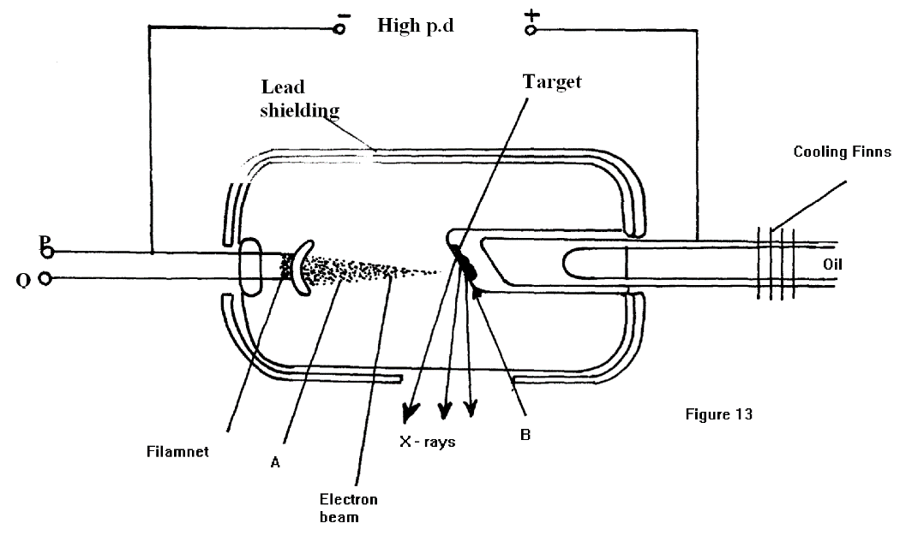
i) Name the parts labelled A and B. (2marks)
A……………………………………………………………………………………….
……………………………………………………………………………………….
B………………………………………………………………………………………..
(ii) Explain how a change in the potential across P changes the intensity of the X- rays produced in the tube. (2 marks)
………………………………………………………………………………………………………………………………………………………………………………………………………………………………………………………………………………………………………………………………………………………………………………………………
(iii) During the operation of the tube, the target becomes very hot. Explain how this heat is caused. (2 marks)
……………………………………………………………………………………….
……………………………………………………………………………………….
………………………………………………………………………………………..
……………………………………………………………………………………….
……………………………………………………………………………………….
……………………………………………………………………………………….
(iv) What property of lead makes it suitable for use as shielding material?(1mark)
……………………………………………………………………………………….
……………………………………………………………………………………….
………………………………………………………………………………………..
(c) ln a certain X- ray tube, the electrons are accelerated by a Pd of 12000V. Assuming all the energy goes to produce X- rays, determine the frequency of the X- rays produced. (Planck’s constant h= 6.62 x 10⁻³⁴ JS and charge on an electron, e = 1.6 x 10 ⁻¹⁹C). (4marks)

……………………………………………………………………………………………………………………………………………………………………………………………………………………………………………………………………………………………………………………………………………………………………………………………………………………………………………………………………………………………………………………………………………………

- A student connected a circuit as shown in figure 16 below hoping to produce a rectified out put
T
a.c
TO
CRO
B
D₂
R
Fig 16.

(a) Sketch the graph of the output on the CRO screen (2mark)
………………………………………………………………………………………………………………………………………………………………………………………………………………………………………………………………………………………………………………………………………………………………………………………………………………………………………………………………………………………………………………………………………………………………………………………….
(b) Explain how the output above is produced (2marks)
……………………………………………………………………………………………………………………………………………………………………………………………………………………………………………………………………………………………………………………………………………………………………………………………………………………………………………………………………………………………………………………………………………………………………..

(c) Name other two uses of a junction diode (2marks)
……………………………………………………………………………………………………………………………………………………………………………………………………………………………………………………………………………………………………………………………………………

- (a) Thorium decays to protactinium by emission of a beta particle (β) as shown.

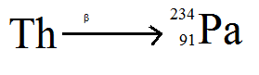

Determine the atomic and mass number of thorium
Atomic number …………………mass number ……………………(2marks)

  - The figure 15 below shows the path taken by three radiations A,B and C from
a radioactive source through an electric field.
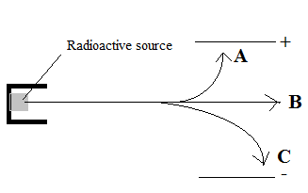
Fig.15
(i) Identify the radiation B (1 mark)
………………………………………………………………………………………………………………………………………………………………
(ii) Give a reason for the difference in deviation shown by A and C
(2 marks)
………………………………………………………………………………………………………………………………………………………………………………………………………………………………………………………………………………………………

  - The table 1.Below shows results obtained from a G-M tube when a radioactive sample was placed near it.

Time (min) | 0 | 1 | 2 | 3 | 4 | 5 | 6
Counts per (min) | 1048 | 994 | 926 | 838 | 719 | 557 | 330
Correct count

(i) Given that the background radiation was 30 counts per minute, fill in the blank
spaces in the table. (3mark)

(ii) Draw a suitable graph on the grid provided. (5marks)

(ii) From the graph determine the half-life of the sample. (1mark)
………………………………………………………………………………………………………………………………………………………………………………………………………………………………

