**SUNRISE EVALUATION EXAM FORM 4 - 2022**

NAME: ………………………………………………ADM NO: …………CLASS…………

SCHOOL…………………………………………………………………….DATE: …..…….

PHYSICS

Paper 1

Time 2 HOURS

June/July *-*2022

**Student Target**

**Instructions to candidates**

* Write your name, admission number, class and date in the spaces provided at the top of the page.
* This paper consists of two sections A and B.
* Answer all the questions in the two sections in the spaces provided after each question
* All working must be clearly shown.
* Electronic calculators, mathematical tables may be used.
* All numerical answers should be expressed in the decimal notations.
* This paper consists of 14 printed pages. Candidates should check to ascertain that all pages are printed as indicated and that no questions are missing.

|  |  |  |  |
| --- | --- | --- | --- |
| **SECTION** | **QUESTION** | **MAX MARKS** | **CANDIDATE’S SCORE** |
| **A** | **1 – 11** | **25** |  |
| **B** | **12** | **10** |  |
|  | **13** | **11** |  |
|  | **14** | **13** |  |
|  | **15** | **10** |  |
|  | **16** | **11** |  |
| **TOTAL** |  | **80** |  |

**ACHIEVED**



**SECTION A: (25 MARKS)**

1. The figure7 below shows a soap film in a loop of wire.

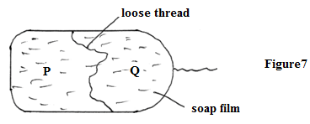

Sketch a diagram to show the behaviour of the film when punctured at P. (1 mark)

|  |
| --- |
|  |

1. A toy boat containing a leaking container of oil was placed on the surface of still water as shown in figure 9 below.

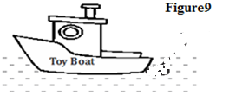

  The boat was seen moving forward due to the leakage.

1. On the diagram, indicate the point of the leakage (1mark)
2. Explain your indication in (i) above. (1mark)

………………………………………………………………………………………………………………………………………………………………………………………………………………………………

1. 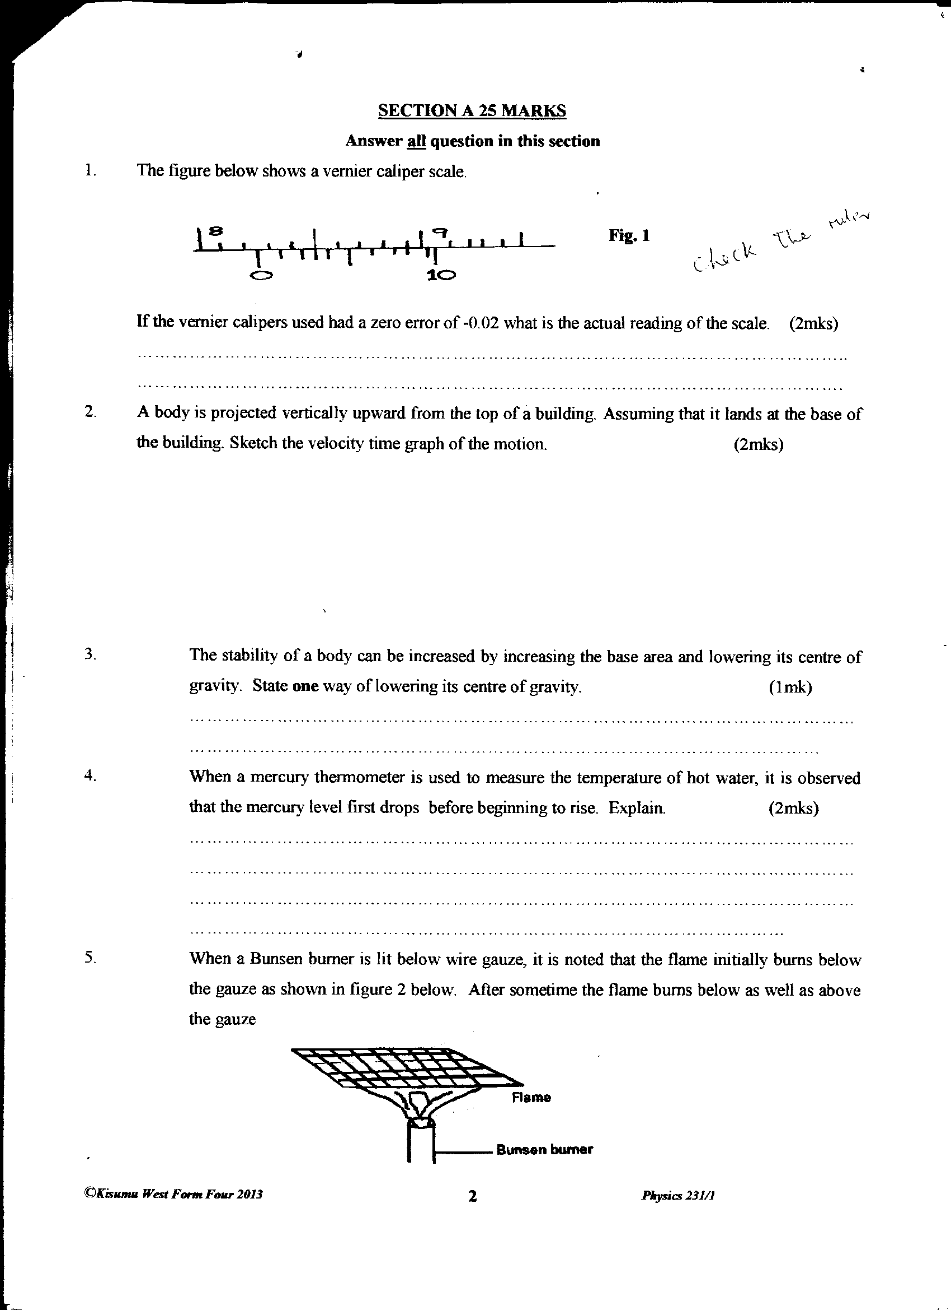The figure below shows a vernier caliper scale.

If the vernier calipers used had a zero error of -0.02 what is the actual reading of the scale. (2mks)

………………………………………………………………………………………………………………………………………………………………………………………………………………………………………………………………………………………………………………………………………………

1. The diagram in fig 5.0 shows a section of a pipe with different cross-sectional area.



If water flows with a velocity of 10m/s in section A, what would be the velocity of water in section B? (3 marks)

.......................................................................................................................................................................................................................................................................................................................................................................................................................................................................................................................

1. State a reason why transfer by radiation is faster than by conduction. (1 mark)

………………………………………………………………………………………………………………………………………………………………………………………………………………………………………………………………………………………………………………………………………………………..

1. The pulley system in the figure below supports a load of 50N.

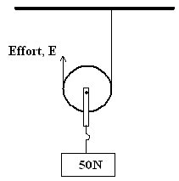

Given that the efficiency of the system is 80% calculate the effort, E. (3 marks)

…………………………………………………………………………………………………………………………………………………………………………………………………………………………………………………………………………………………………………………………………………………………………………………………………………………………………………………………………………

1. A student observed some pollen grains on the surface of water in a beaker with the help of hand lens as shown figure below.

Eye

Transparent lid

Hand lens

Pollen grains

Beaker

Water

(a) State the observation made. (1 mark)

………………………………………………………………………………………………………………………………………………………………………………………………………………………………

(b) Explain the observation in (a) above. (1 mark)

………………………………………………………………………………………………………....................………………………………………………………………………………………………………....................……………………………………………………………………………………………………

(c) What conclusion can be drawn from the above experiment? (1 mark)

………………………………………………………………………………………………………..................

1. A smooth wooden plane is inclined at an angle of 300 to the horizontal as shown in Figure 5 below. An object of mass 10kg is pulled steadily up the plane by a force of 60N. Determine;

60N

10kg

300

(a) the velocity ratio of the inclined plane. (2 marks)

………………………………………………………………………………………………………………………………………………………………………………………………………………………………………………………………………………………………………………………………………………………………………………………………………………………………………………………………

(b) efficiency of the system. (2 marks)

………………………………………………………………………………………………………………………………………………………………………………………………………………………………………………………………………………………………………………………………………………………………..

1. The Figure 6 below shows a spiral spring when not compressed and when compressed by a mass of 4.0kg.

**Fig. 6**

4.0kg

8cm

6cm

(a) uncompressed (b) Compressed.

Determine the elastic potential energy stored by the compressed spring in .

(2 marks)

………………………………………………………………………………………………………………………………………………………………………………………………………………………………………………………………………………………………………………………………………………

1. Figure 3 shows a uniform wooden plank which weighs 10N. The plank is balanced at 0.8m from one end by a mass of 2.5Kg.

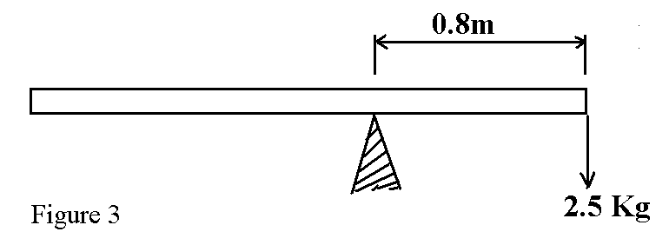

What is the length of the wooden plank in metres. (2mks)

………………………………………………………………………………………………………………………………………………………………………………………………………………………………………………………………………………………………………………………………………………

1. The figure shows the velocity time graph of two identical spheres released from the surfaces of two liquids A and B.

Time (s)

Velocity m/s)

BA

Give a reason why the terminal velocity of the sphere In B is higher than in A. (1mark)

………………………………………………………………………………………………………………………………………………………………………………………………………………………………………………………………………………………………………………………………………………

SECTION B: 55 MARKS

1. a) The figure below shows a simple mercury barometer

=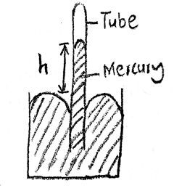

1. when the tube was tilted mercury did not fill the tube completely. Give areason for the observation (1 mark) ………………………………………………………………………………………………………………………………………………………………………………………………………………………………………………………………………………………………………………………
2. give a reason why mercury is preferred as a liquid in a glass barometer (1mark)

……………………………………………………………………………………………………………………………………………………………………………………………………………………………………………………………………………………………………………………………………………………………………………………………………………………………………………………………………………………

1. A town at an altitude of 548m has abarometric height of 70cmHg.Given that the standard atmospheric pressure is 76cmHgand that the density of mercury is 13600kg/m3, determine the density of air (4marks)

………………………………………………………………………………………………………………………………………………………………………………………………………………………………………………………………………………………………………………………

………………………………………………………………………………………………………………………………………………………………………………………………………………………………………………………………………………………………………………………………………………

b) A student half-filled a container with water, boiled the water for several minutes with the cork removed. Then later replaced the cork and poured some cold water on the container. State and explain the observation made (2marks)

………………………………………………………………………………………………………………………………………………………………………………………………………………………………………………………………………………………………………………………………………………………………………………………………………………………………………………………………

c) Determine the pressure on a piston of cross-sectional 20cm2 when a force of 50MN is applied to its surface (2marks)

………………………………………………………………………………………………………………………………………………………………………………………………………………………………………………………………………………………………………………………………………………

1. In an experiment to determine the approximate diameter of an oil molecule, the following measurements were obtained:

-diameter of oil drop=0.05cm

-diameter of oil patch=0.2m

Determine:

1. volume of oil drop (3marks)

………………………………………………………………………………………………………………………………………………………………………………………………………………………………………………………………………………………………………………………………………………

1. area of oil patch (3marks)

………………………………………………………………………………………………………………………………………………………………………………………………………………………………………………………………………………………………………………………………………………

1. thickness of oil molecule (3marks)

………………………………………………………………………………………………………………………………………………………………………………………………………………………………………………………………………………………………………………………………………………

1. state two assumptions made in the above experiment (2marks)

……………………………………………………………………………………………………………………………………………………………………………………………………………………………………………………………………………………………………………………………………………………

1. (a) Define absolute zero temperature for an ideal gas **(1 mark)**

………………………………………………………………………………………… …………………………………………………………………………………………

(b) The diagram in figure 12 below shows an experiment to investigate the relationship between volume and temperature of a fixed mass of gas at constant pressure

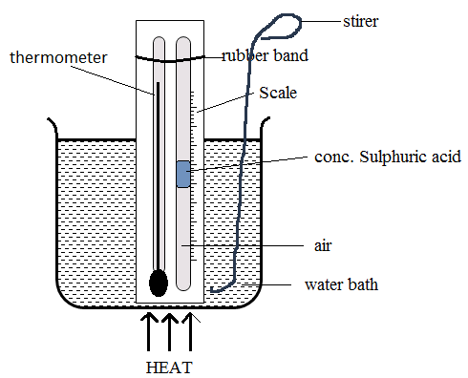

Explain the functions of:

1. Concentrated sulphuric acid **(2 marks)**

……………………………………………………………………………………………………………………………………………………………………

1. Stirrer **(1 mark)**

……………………………………………………………………………………………………………………………………………………………………

(c) Which measurements are taken in the above experiment **(2 marks)**

……………………………………………………………………………………………………………………………………………………………………………………

(d) How are the measurements used to verify Charles Law **(3 marks)**

……………………………………………………………………………………………………………………………………………………………………………………………………………...…………………………………………………………………………………………………………………………………………………………………………………………………………….....…………………………………………………………………………………………………………………………………………………………………………………………………………….....…………

(e) On the grid shown in the figure below sketch a graph of volume (cm3) against temperature (0C) for the experiment above. Clearly mark with the letter T the absolute zero temperature. **(2 marks)**

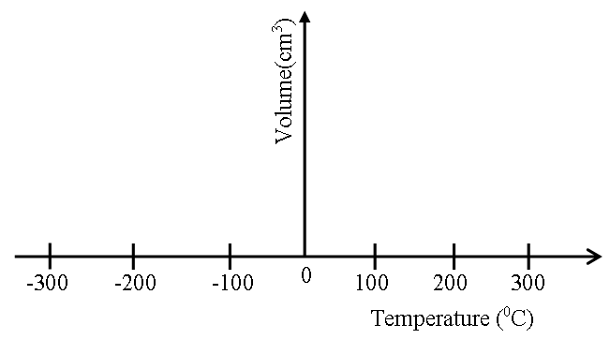

(f) What two assumptions are made in the experiment **(2 marks)**

……………………………………………………………………………………………………………………………………………………………………………………

1. A stone is whirled in a vertical circle as shown below. A, B, C, and Dare various positions of the stone in its motion.



The stone makes 2 revolutions per second in a circle of radius 0.4m, and has a mass of 100g.

1. Calculate the centripetal force acting on the stone **(3marks)**

………………………………………………………………………………………………………………………………………………………………………………………………………………………………………………………………………………………………………………………………………………………………………………………………

1. The string cuts after acquiring constant angular speed. Identify the likely position where this occurred and on the same diagram sketch the new path followed by the stone. **(1 mark)**

………………………………………………………………………………………………………………………………………………………………………………………………

1. The stone takes 0.5 seconds to land on the ground. How high is this point in (ii) above the ground? **(3marks)**

………………………………………………………………………………………………………………………………………………………………………………………………………………………………………………………………………………………………

1. How far does it travel horizontally before hitting the ground? **(3marks)**

………………………………………………………………………………………………………………………………………………………………………………………………………………………………………………………………………………………

1. a) State Newton’s second law of motion. (1 mark)

………………………………………………………………………………………………………………………………………………………………………………………………………………………………………………………………………………………………………………………………………

b) The legal speed limit on motorways is approximately 30m/s. In an incident on a motorway, a car of mass 900kg leaves a skid mark 75m long when stopping. The maximum deceleration of the car when skidding is approximately 10m/s2.

i) Show that before the incidence, the car must have been travelling above the legal speed limit.

(3 marks)

………………………………………………………………………………………………………………………………………………………………………………………………………………………………………………………………………………………………………………………………………

ii) Calculate for this skid, the maximum average braking force between each of the four tyres and the road. (3 marks)

………………………………………………………………………………………………………………………………………………………………………………………………………………………………………………………………………………………………………………………………………

iii) When the motorway is wet, the braking force provided by each wheel is reduced to 50% of the calculated in (ii) above. What is the effect of this reduced breaking force on stopping distance, explain your answer. Assume that the speed of the car before breaking is the same in both cases. (2 marks)

………………………………………………………………………………………………………………………………………………………………………………………………………………………………………………………………………………………………………………………………………

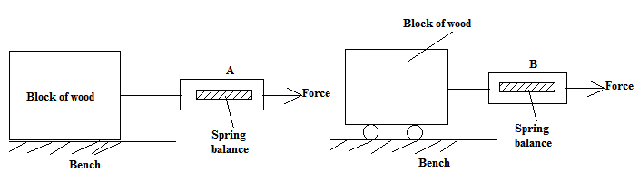 c) A student carried out an experiment to measure static friction using identical wooden blocks arranged as shown in the figure.

State and explain which spring balance will indicate a smaller reading when the block just starts to move. (2 marks)

………………………………………………………………………………………………………………………………………………………………………………………………………………………………………………………………………………………………………………………………………