TRIAL EXAMINATIONS 2021
Kenya Certificate of Secondary Education (KCSE)

232/3 - PHYSICS - Paper 3
(Practical)
Nov/Dec. 2021 – 2½ Hours

Name: …………………………………..… Index No: ….…………......Stream ………

Candidate’s Signature: ..………………..……………. Date:………………………….

Instructions to Candidates

- Write your name and index number in the spaces provided above.
- Sign and write the date of the examination paper.
- Answer ALL the questions in the spaces provided in the question paper.
- ALL working MUST be clearly shown where necessary.
- Mathematical tables and silent electronic calculators may be used.
- Candidates should check the paper to ascertain that all the pages are printed as indicated and that no questions are missing.
- Non-programmable silent electronic calculators and KNEC mathematical tables may be used.
- This paper consists of 11 printed pages
- Candidates should answer all the questions in English.
For Examiners’ Use Only:
Question | Marks | Candidate’s score
Question 1 | 20
Question 2 Part A | 8
Question 2 Part B | 6
Question 2 Part C | 6
grand total | 40

Question 1
You are provided with the following apparatus:
- Rectangular glass block
- Two plain papers
- Four optical pins
- Four paper pins or thumb pins
- Protractor
- Half meter rule

PART A
PROCEDURE:
- Place the glass block on the plain paper on its largest area, trace it’s outline and mark it’s sides ABC and D. Mark the point P₀ on the center of side BC as shown in Figure 1 below.

B
C
D
A
P_{o}
P₃
P₄
P₁
P₂

G

P_{i}

E

Figure 1

- Measure the breadth of the glass block.
b =$….……..cm$ (1 mark)
- Replace the glass block and fix an object pin at P₀ such that the pin lies along the surface of the glass block.
- With your eye on the side AD closer to A, fix pins P₁ and P₂ such that they are in line with the image P_{i} of P_{o} as seen from the side AD through the glass block.
- From the same side AD closer to D, fix pins P₃ and P₄ such that they are in line with the image Pi of P₀ seen through the glass block.
- Remove the glass block and join P₁ and P₂, and P₃ and P₄ to meet at P_{i}.

- Join P₀ to P_{i} and measure length P₀P_{i}
P₀P_{i} =…………………………………..m (1 mark)
- Determine the ratio;$\frac{b}{ b-{P_{0 }P}_{i }}$= n (2 marks)

(Hand in the outline with the question paper.) (1 mark)

PART B
- Trace the outline of the glass block again on the second plain paper and label it ABCD as shown in Figure 2.
- Construct a normal on the side AB approximately 3cm from A and measure angle of incidence i =35⁰ (secure the plain paper using paper pins).
- Replace the glass block on the outline and fix pins P₁ and P₂ along the line of 35⁰.
- Viewing from the sides CD through the block, fix pins P₃ and P₄ such that they appear in line with the images of P₁ and P₂.
- Join P₃ and P₄ and join x and y.

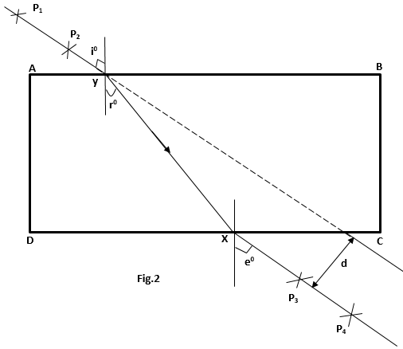
- Extend the line P₁ and P₂ to obtain lateral displacement as shown in the figure and measure the lateral displacement d and angle r⁰.
- Tabulate your results.
- Repeat the procedure in (i) to (vi) for angles of incidence 45⁰, 55⁰,65⁰ and 75⁰.
(Hand in the plain paper on which you have done your experiment together with the exam paper) (2 marks)
i⁰ | 35 | 45 | 55 | 65 | 75
r⁰
d(cm)
(5 marks)

- Plot a graph of d (cm) against r⁰ (5 marks)

- From your graph:
- Determine the value r⁰ where the lateral displacement d equals to the breadth b of the block.
r⁰ = ……………………………………………………… (1 mark)

- Given that k sin r⁰=1, determine the value of k (2 marks)
………………………………………………………………………………………………………………………………………………………………………………………………………………………………………………………………………………………………

Question 2
PART A
- A glass beaker
- A metal solid
- Some water
- Source of Heat
- A piece of cotton thread
- A plastic beaker wrapped with tissue paper on the outside.
- A thermometer
- Liquid L
- Measuring balance to be shared

Proceed as follows:
(a) Fill the glass beaker with the water provided and place it on the heat source.
Use the piece of thread to carefully lower the metal solid to the bottom of the beaker. Heat the water to its boiling point. Use the thermometer to measure its point.

Boiling point of water =………………………………Kelvin (1 mark)

b) Find the following measurements using appropriate instruments
Mass of the metal solid M_{s} = …………………………… g (½ mark)

Mass of the wrapped empty plastic beaker
M₁………………………………g (1 mark)

Use the plastic beaker to measure 240ml of liquid L, hence find the joint mass of the plastic beaker and its content liquid L,
M₂ =……………………………………………. g (½ mark)

Initial temperature of liquid L, T₁ = …………………………………..Kelvin (1 mark)
c) At boiling point of water, quickly transfer the metal solid into liquid L, stir well and measure the temperature of the mixture immediately.
Temperature of the mixture
T₂ = …………………………………. Kelvin (1 mark)
d) By using the measurements taken in parts (a), (b) and (c) as well as the equation provided below, determine the specific heat capacity of liquid L.
(Take S.H.C. of metal solid = 480Jkg⁻¹k⁻¹ and S.H.C. of plastic = 359 Jkg⁻¹k⁻¹)
(Heat lost by metal solid) = (heat gained by liquid L) + (heat gained by plastic beaker) (3 marks)
………………………………………………………………………………………………………………………………………………………………………………………………………………………………………………………………………………………………………………………………………………………………………………………………………………………………………………………………………………………………………………………………………………………………………………………………………………………………………………………………………………………………………………………………………………………………………………………………………………………………………………………………………………………………………………………………………………………………………………………………………………………………………………………………………………

PART B
You are provided with the following apparatus:
- A nichrome wire
- A 20g mass
- A meter rule
- A test –tube
- A retort stand, boss, and clamp

Proceed as follows:
- Measure the length, L, of the nichrome wire provided
L = ………………………. cm (½ mark)
- Wind the whole length of the wire tightly on the test-tube making sure that the turns are as close as possible but not overlapping. Measure the length, β, of the coil made.
β =………………………………. cm (½ mark)
- Remove the coil from the test-tube. Straighten the first and the last turns of coil. Bend one end to make a hook.
- Count and record the number, N, of complete turns remaining on the coil.
N =……………… (1 mark)
- Measure and record the distance h₁ between the end turns of the coil as shown on the Figure 1 below.

h₁= ……………………………………. (½ mark)
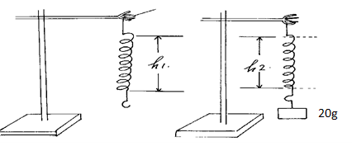
Figure 2
Figure 1

- Load a 20 g mass on the coil as shown in Figure 2 above. Measure and record the distance, h₂, between the end turns of the coil.

h₂ = ……………………………………. (½ mark)

g) Determine the spring constant K in S.I units. (1 mark)
………………………………………………………………………………………………………………………………………………………………………………………………………………………………………………………………………………………………………………………………………………………………………………………………………………………………………………………………………………………………
h) Obtain the constant, P, for the wire from the expression: (2 marks)
P = 4mgR³
Kr⁴
…………………………………………………………………………………………………………………………………………………………………………………………………………………………………………………………………………………………………………………………………………………………………………………………………………
Where: m is the mass used, g is acceleration due to gravity (g = 10m/s²),
R = L and r = β
2πN 2πN

PART C
You are provided with the following:
- Two cells
- A 2.5 V torch bulb in a bulb holder
- 10 Connecting wires
- Switch
- Ammeter (0 – 3A),
- Voltmeter (0 – 5 V)
- Two cell holders
PROCEDURE 1
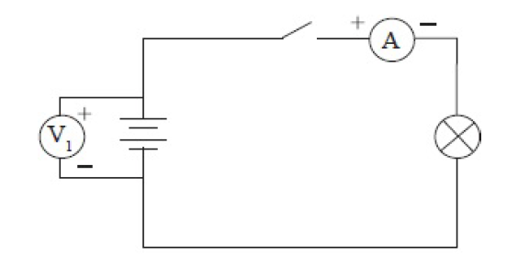

SET UP ONE

Set up the circuit shown in figure above.
a) Read and record the voltmeter V₁ and ammeter A₁ readings.

V₁ ………………………………………………………………………….. (½ mark)

• Switch on the circuit.
b) Read and record the voltmeter and ammeter readings. Note the brightness of
the bulb.
V₂ ……………………………………………………………….. (½ mark)

A₁………………………………………………………………….. (½ mark)

PROCEDURE 2
• Connect the circuit as shown in figure below

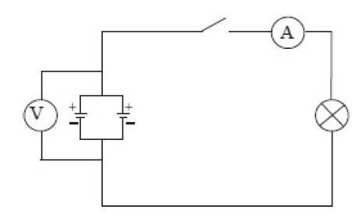 SET UP TWO
c) Read and record the voltmeter reading V₃

V₃ ………………………………………………………………….. (½ mark)

• Put on the switch. Take note of the brightness of the bulb
d) Read and record the voltmeter and ammeter readings.

V4 ………………………………………………………………………….. (½ mark)

A2………………………………………………………………………….. (½ mark)

e) Compare the values of V₁ and V₃ (1 mark)

………………………………………………………………………………………………………………………………………………………………………………………………………………………………
f) Make a conclusion on (e) above (1 mark)
………………………………………………………………………………………………………………………………………………………………………………………………………………………………
g) In which set up does the bulb light for a longer time? Explain in terms of A₁ and A₂ (1mark)
………………………………………………………………………………………………………………………………………………………………………………………………………………………………………………………………………………………………………………………………………………

