ASUMBI GIRLS HIGH SCHOOL
PRE-MOCK
MAY-JUNE
2022
MARKING SCHEME
232/2 PHYSICS
FORM FOUR PAPER 2
(THEORY)
SECTION A (25 MARKS)
ANSWER ALL QUESTIONS IN THIS SECTION IN THE SPACES PROVIDED.
- Figure 1 shows a ray of a light incident on a plane mirror.
Figure 1

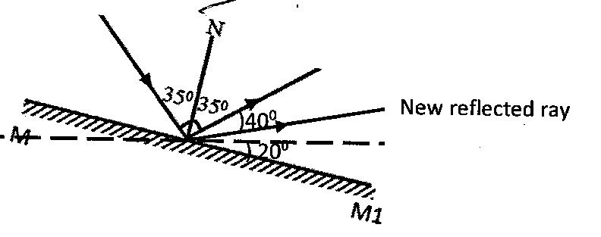

The plane mirror is then rotated clockwise through an angle of 200 keeping the incident ray fixed. Determine the new angle of reflection by drawing. (2mks)
Angle of incidence = $\frac{{70}^{0}}{2}$ = ${35}^{0}$
Angle of reflection =${35}^{0}$
New angle of reflection = 354+ (2$×20)$ =${75}^{0}$

- The figure below shows a current carrying conductor passing between two cardboards. Show the direction of the deflection on each compass on the cardboard. (2mks)

- 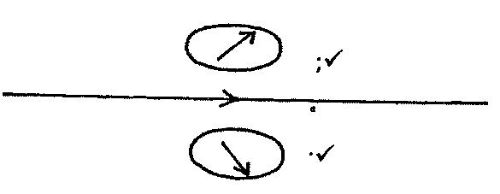

- An object O is placed in front of a concave mirror and on the principal axis, as shown in the figure below. Complete the light ray diagram to locate the position of the image. (3mks)

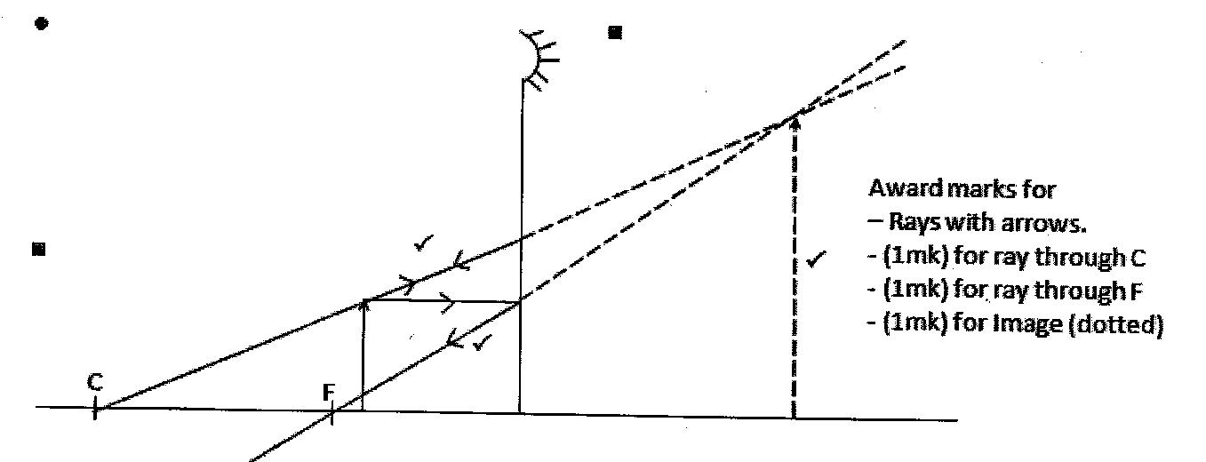
Award marks for
Rays with arrows
1mk for ray through C
1mk for ray through F
1mk for image (dotted)
- Give a reason why lecture theatre halls are covered with soft perforated materials. (1mk)
- To absorb sound and prevent echoes
- State one factor which does not change as water waves move from shallow deep end. (1mk)

- Frequency of the sources
- The figure below show a CRO screen display trace when the Y-amplification control and time base settings are 100mV and 0.8ms/cm respectively.
Calculate:
- The peak potential difference. (2mks)
- Peak value = 4cm$×\frac{100}{1000}$ = 0.4V

- The frequency of the signal. (2mks)
- Period T=8$×\frac{0.8s}{1000}$ = 0.0064s
- Two similar razor blades were placed on a wooden block and the other on an iron block as in figure 7.
Figure 7.
It was observed that the razor blade on the wooden block is attracted by the magnet while that on the iron block was not. Explain. (2mks)
- The magnet induces magnetism into the razor
- Which in turn induces the iron block
- Hence the razor remains attracted to the iron
- The figure below represents a ray of light falling normally on the curved surface of a semi-circular plastic block at X, meeting the opposite face at an angle of incidence of 30⁰ and emerging into the air at an angle of 40^{0.}

Calculate refractive index of the plastic. (3mks)
n=$\frac{{sin 40}^{0}}{{sin 30}^{0}}$
=1.286

- A bar magnet is moved into a coil of insulated copper wire connected to a centre-zero galvanometer, as shown in the figure below.

Show on the diagram the direction of induced current in the coil. (1mk)

- Determine the cost of using an electric heater rated 3kW for 12 hours given that the cost of electricity per kilowatt hour is sh 8.00. (2mks)
- Electrical energy used =Vlt
- P$×t$
- (3$×12)kWh$
- =36kWh
- Cost = (36$×8) shillings$
- = sh 288.00
- An electric heater rated 240V, 3000W is to be connected to a 240V mains supply, through a 10A fuse. Determine whether the fuse is suitable or not. (3mks)
- P=V1
- I =$\frac{p}{v}=\frac{3000}{240}$ = 12.5A
- The fuse is not suitable since the appliance is drawing more current than the fuse ratinf
- The fuse will blow off
- The chart below shows an arrangement of different parts of the electromagnetic spectrum
Radio | A | Infrared | Visible | B | X-Rays | Gamma Rays
State one use of the radiation represented by B. (1mk)
- Uv rays uses – spectroscopy
- Mineral analysis
- Detect forgeries
- Kill bacteria
- Skin treatment
- Source of vitamin D

SECTION B (55MARKS)

- (a) The figure below shows how a student set up a circuit using 3 identical bulbs X, Y and Z each rated “12V, 2.0A”
- When operating normally, calculate the resistance of one of the bulbs. (2mks)
- V=IRR=$\frac{V}{1}$
- =$\frac{12}{2}$
- 6Ω
- Calculate the effective resistance of the three bulbs. (2mks)
- Y, Z are parallel
- $\frac{1}{RP}=\frac{1}{6}+\frac{1}{6}$
- $\underset{⇒}{}Pp=3Ω$
- $x in series with P_{p}$
- $\underset{⇒}{}R_{T}$=(6+3)
- $9Ω$
- What will be reading of the ammeter? (2mks)
- I =$\frac{V}{R}$
=$\frac{12}{9}$
- 1.33A
- Draw a circuit diagram showing the three bulbs connected in such a way that they would all work at the same brightness especially if they are not identical. (2mks)

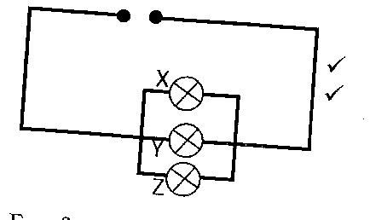
(b) When the switch S is kept open in the circuit shown below the voltmeter reads 1.5V. When the switch is closed, the readings drops to 21.3V and the current through the resistor is 0.5A.

- What is the e.m.f of the cell? (1mk)

- E.m.f = 1.5V

- What is the terminal voltage of the cell? (1mk)

- Terminal voltage = 1.3V
- Calculate the value of R (2mks)
- R =$\frac{V}{I}$
- =$\frac{1.3}{0.5}$
- 2.6Ω

- The Figure below is of an x-ray tube
- Explain how x-rays are produced by the tube. (4mks)
- Connect a high voltage between the cathode and anode
- Electrons are produced by the thermionic emission.
- Electrons accelerated
- Towards the anode and hit the target. Electron interact with the target and produce x-rays.
- Explain briefly the energy changes that take place when the x-ray tube is operating. (3mks)
- Electrical potential Energy (E.H.T) changes to kinetic energy of electrons. Kinetic energy changes heat. Sound and x-ray
- Why is it necessary to maintain a vacuum inside the tube? (2mks)
- So that the electron does not ionize
- The gas inside the tube and loose energy
- The accelerating voltage of an x-ray tube is 12V. Calculate the speed of the electron on reading the anode. (Charge to mass ratio of an electron $\frac{e}{me}$ = 1.76X10¹¹ (3mks)
- Kinetic energy of electrons = electrical work done
½ mV²=eV
V2 =2($\frac{e}{m})V$
2$×1.76×{10}^{11}×12$
- =4.224$×{10}^{12}$
- V = $\sqrt{4.224×{10}^{12}}$
- =2.055$×{10}^{6}m/s$

- (a) A strong positive charged rod is brought close to the cap of a charged electroscope from a high position. It is observed
- State the charge on the electroscope. (1mk)
- Negative
- Explain this observation. (2mks)
- The rod attracts the negative charges from the leaf and the plate to the cap to make the leaf and plate neutral
- One coming closer, more negative charges are attracted and the leaf and the plate becomes positive thus the leaf diverges
(b) A parallel- plate capacitor is connected to an electroscope as shown in fig 7. Below
Figure 7

State and explain the behavior of the leaf when the distance (d) between the plates is increased (2mks)
- The leaf divergence increases
- as d- increases, potential difference (V) across the plates increases, thus the capacitance of the capacitors reduces, and some charges moves to the electroscope.
From C=$\frac{Q}{V}$
Keeping Q-constant
As V- increases
C – decrease
(c) Figure 8 shows an arrangement of capacitors to a 12V d.c. supply

Determine
- Effective capacitance (3mks)
- CT=($\frac{4×6}{4+6}$)+8$√$
- 10.4$μ$F
- OR 1.04$×{10}^{-5}F$

- Charge across the 8µF capacitor. (3mks)
- Q = CV
- =8$×{10}^{-6}×12$
- =9.6$×10-5C$

- (a) Define the term monochromatic light (1mk)
- Monochromatic light is light of one wavelength or particular frequency
(b) The table below shows values of stopping potentials, V₂ and their curves pending frequencies for a metal surface monochromatic light is shone on it.
Stopping potentials, Vs | 1.2 | 0.88 | 0.60 |  | 0.78
0.12Frequency (xx 10¹⁴Hz) | 7.5 | 6.7 | 6.0 | 5.2 | 4.8

- Plot a graph of stopping potentials. Vs against frequency. (4mks)
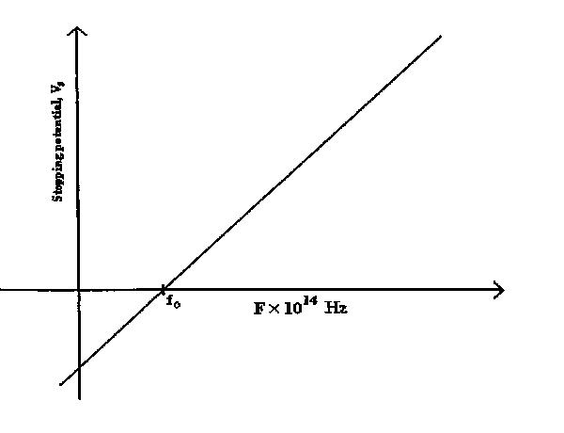
From the graph determine
- Thresh hold frequency (1mk)
- Ƒ_{o}=4.5$×{10}^{14}HZ$
- The Planck’s constant, h (take =1.6⁻¹⁹ x10C) (2mks)
- h=slope $×e$
- =1.6$×{10}^{-19}×slope$
- 6.4$×{10}^{-34}Js$
- The work function (2mks)
- y=intercept = work function in electron volt
- =1.8Ev

- (a) Study figure 8 and answer the following questions.
- State the charge on plate X (1mk)
- Positive
- Identify the radiation A and B (1mk)

- A – Beta particles
- B- gamma rays

- A nuclear reaction is represented by the following equation.
$\bigwedge_{92}^{a}{x }$ $\int_{ b}^{234}{y}$ + Alpa particle

Determine the value of a and b. (2mks)
- a=234+4=238
- b=92-2=90
iv. ●
A radioactive source has an activity of 810c/s and after 63 hours the count rate falls to 110c/s. If the background count is 10c/s, determine the half –life of the source. (3mks)
- the actual counts = 810-10=800c/s
- final counts =110-10=100c/s
- fraction remaining =$\frac{100}{800}=\frac{1}{8}$
- $\frac{1}{8}=\frac{1}{2n}$
- n=ct¹/₂
- t $\frac{1}{2}$=$\frac{T}{n}=\frac{63}{3}=21 hrs$

or

800 ½ 400 ½ 200 ½ 100
3t¹/₂ = 63 hours
T $\frac{1}{2}=\frac{63}{3}=21 hours$

(b)(i) Draw using appropriate symbols the circuit diagram of a junction diode in reverse bias. (1mk)

(ii) Extrinsic semiconductors are made through a process called doping. Explain how doping produces an n-type semi-conductor. (2mks)
- doping a pure semi-conductor with group 5 impurity
- A group 5 impurity has four of its electrons for bonding and the fifth electron being free.
(iii) Distinguish between a semiconductor and a conductor. (2mks)
- Semi-conductors have wide forbidden band while conductors do not have
- Semiconductors conduct by use of holes while conductors by use of electrons

