**NAME………………………………………..CLASS……………………ADM NO……………**

**SIGNATURE……………..INDEX NO……………………… DATE………………**

**232/2**

**PHYSICS**

**PAPER 2**

**2021**

**TIME:2 Hours**

**FORM 4 END TERM 2 EXAMINATION**

***Kenya Certificate of Secondary Education***

***Physics Paper 2***

**INSTRUCTION TO CANDIDATES.**

. Write your ***name*** and ***admission number*** in the spaces provided above

. This paper contain ***two sections***; Section I and Section II.

. Answer all the questions in section **I** and II. In the spaces provided

. All workings and answers **must** be written on the question paper in the spaces provided below each question.

. Marks may be given for correct working even if the answer is wrong.

. Calculators and KNEC Mathematical tables may be used EXCEPT where stated otherwise.

. Show all the steps in your calculations, giving your answers at each stage in the spaces below each question.

***FOR EXAMINER’S USE ONLY***

|  |  |  |  |
| --- | --- | --- | --- |
| **SECTION** | **QUESTION** | **MAX MARKS** | **CANDIDATE’S SCORE** |
| **A** | **1-14** | **25** |  |
| **B** | **15** | **12** |  |
| **16** | **11** |  |
| **17** | **10** |  |
| **18** | **09** |  |
| **19** | **13** |  |
|  | **TOTAL** | **80** |  |

**SECTION A 25 MKS**

1. Figure 1 below shows an ammeter used to measure current flowing through a section of a conductor. The student used the upper scale.

**0**

**2.0**

**2.5**

**1.0**

**1.5**

**0.5**

**0**

**0.4**

**0.8**

**1.0**

**0.6**

**0.2**

**A**

State the reading from the meter. **(1mark)** …………………………………………………………………………………………………………………………………… ……………………………………………………………

1. Why is it safer to carry explosive fuels in metal cans instead of plastic can? **(1mark)**

…………………………………………………………………………………………………………………………………………………………………………………………………………………………………………………………………………………………………………………………………………………………………………………………………………………………………………………………………………………………………………………………………………………

1. What do you understand by rating **9W, 240v** indicated on an energy saving electric bulb? (1mark

…………………………………………………………………………………………………………………………………………………………………………………………………………………………………………………………………………

1. (a) Bulb **X** lights while bulb **Y** does not. Explain. (1mark)

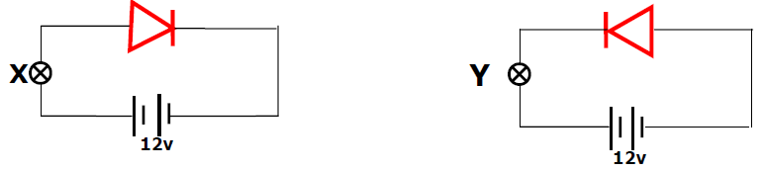

………………………………………………………………………………………………………………………………………………………………………………………………………………………………………………………………………………………………

(b) Figure 3 shows a force on a conductor carrying current when placed in a magnetic field.

Force

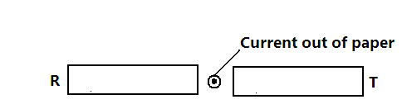

State the polarities ends R and T. (1mark)

T _____________________________________________________

R _____________________________________________________

1. What property does a fuse wire have that make it suitable for controlling excessive currents in circuits? (1mark)

…………………………………………………………………………………………………………………………………………………………………………………………………………………………………………………………………………

1. 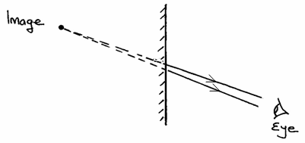(a) The figure 4 below shows an image formed in a plane mirror.

By drawing incident rays for the rays shown, locate the position of the object. **(2 marks)**

(b) An object is placed 20cm in front of a **convex** lens of focal length 15cm. State one characteristic of the image formed. **(1 mark)**

…………………………………………………………………………………………………………………………………………………………………………………………………………………………………………………………………………

1. Figure 6 below shows an arrangement of a cylindrical bar magnet suspended freely close and parallel to a fixed solenoid.

**A fixed solenoid**

**S**

**N**

**Permanent magnet free to move**

**A**

**K**

**B**

Explain what motion you are likely to observe in the arrangement when switch K is closed. **(1mark)**

……………………………………………………………………………………………………………………………………………………………………………………………………………………………………………………………………………………………………………………………………………………………………………………………………………………………………………………………………………………………………………………………………………………………………………………………………………………………………………………………………………………………………………………………………………

1. A coin is placed at the bottom of a beaker filled with water to a height of 2.4cm as shown in the figure 7 below. Given that the refractive index of water is 1.33, determine the vertical displacement of the coin. **(2 marks)**

……………………………………………………………………………………………………………………………………………………………………………………………………………………………………………………………………………………………………………………………………………………………………………………………………………………………………………………………………………………

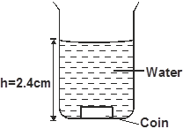

1. (a)The figure 8 below shows an image I formed by an object placed in front of a convex mirror. C and F are the centre of curvature and principal focus of the mirror respectively. Using appropriate rays locate the object position. **(2 marks)**

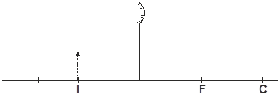

 (b)State one difference between sound waves and electromagnetic waves (1mark)

………………………………………………………………………………………………………………………………………………………………………………………………………………………………………………………………………………………………………………………………………………………………………………………………………………

1. (a) The fig 4 below shows a section of a circuit in domestic wiring.



 Identify one defect in the wiring. (1mark)

………………………………………………………………………………………………………………………………………………………………………………………………………………………………………………………………….………………………………………

(b) State **one** danger of high voltage transmission of electricity over long distances. (1mark)

……………………………………………………………………………………………………………………………………………………………………………………………………………………………………………………………………………………………………………………………………………………………………………………………………………………………………………

1. Radium disintegrates into a new stable element lead  how manyalpha and Beta particles are emitted (2marks)

……………………………………………………………………………………………………………………………………………………………………………………………………………………………………………………………………………………………………………………………………………………………………………………………………………………………………………………………………………………………………………………………………………………

1. The figure 2 below shows an electroscope being charged by induction.

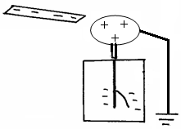

Metal cab

Earth wire

1. State the reason why the cap of the electroscope is made circular.**(1 mark)**

………………………………………………………………………………………………………………………………………………………………………………………………………………………………………………

1. On the same diagram, show the direction of the flow of electrons on the earth wire. **(1mark)**
2. An electric heater is found to have a resistance of **950Ω** when operating normally on a **240V** mains. Find the power of the heater. (2marks)

…………………………………………………………………………………………………………………………………………………………………………………………………………………………………………………………… .

1. ..(a) The figure below shows a set up by a student investigating propagation of sound waves.

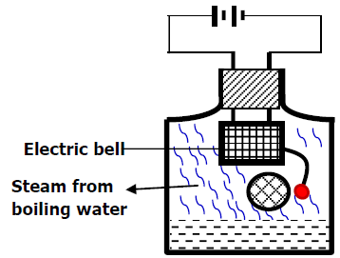

Explain what happens to the sound from the bell as the bottle and its contents are cooled to 0°C . (1mark)

…………………………………………………………………………………………………………………………………………………………………………………………………………………………………………………………………………

(b) In determining the depth of an ocean an echo sounder produces ultrasonic sound. Give one reason why this sound is preferred (1mark)

…………………………………………………………………………………………………………………………………………………………………………………………………………………………………………………………………………

**SECTION B (55 marks)**

1. a) he figure below shows wave fronts approaching the boundary between two media

1

2

Boundary

The speed of the wave in medium (1) is higher than in medium (2). On the same diagram complete the figure to show the wave fronts after crossing the boundaries (1mark)

b**)** A ray of light is incident on a glass-water interface as shown in figure 11 below.

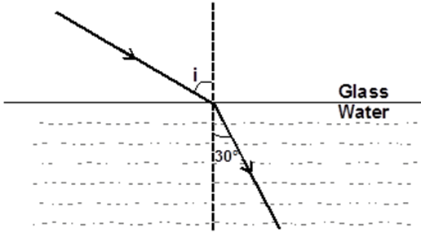

Calculate the angle of incidence i. (Take the refractive index of glass and water 3/2 and 4/3 respectively. **(3 marks)**

…………………………………………………………………………………………………………………………………………………………………………………………………………………………………………………………………………………………………………………………………………………………………………………….

(c.)Prisms are preferred to plane mirrors for use in periscopes. State one reason for this. **(1 mark**

………………………………………………………………………………………………………………………………………………………………………………………………………………………………………………………………………

1. The figure below shows a standing wave on a string of length 27cm.

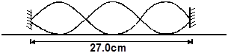

Determine the wavelength of the wave. **(3 marks)**

……………………………………………………………………………………………………………………………………………………………………………………………………………………………………………………………………………………………………………………………………………………………………………………………………………………………………………

e) The figure below shows a longitudinal wave that takes 0.32s to move from point X to Y and at a speed of 50m/s.

**X**

**Y**

Calculate

1. the frequency of the wave **(2marks)**

…………………………………………………………………………..……………………………………………………………………………………………………………………………………………………………………………………………………………………………………………………………………………………………

1. the wavelength of the wave **(2marks)**

…………………………………………………………………………..……………………………………………………………………………………………………………………………………………………………………………………………………………………………………………………………………………………………

1. **a)** State one advantage of an alkaline accumulator over lead acid accumulator. **(1 mark)**

…………………………………………………………………………..………………………………………………………………………………………………………………………………………………………………………………………….

**b)** Figure below shows resistors in a circuit.

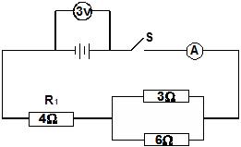

 Calculate Current through the 4 Ω resistor. **(3 marks)**

…………………………………………………………………………..…………………………………………………………………………………………………………………………………………………………………………………………. …………………………………………………………………………..………………………………………………………………………………………………………………………………………………………………………………………….

c) The graph below shows the Voltage current relationship for a certain battery.

**Current (A)**

**0.5**

**0.4**

**0.3**

**0.2**

**0.1**

**0**

**0.5**

**1.5**

**1.0**

**2.0**

**Voltage (V)**

Determine:

(i) The e.m.f of the cell. ………………………………………………… **(1mark)**

(ii) The internal resistance of the cell. **(3marks)**

…………………………………………………………………………..…………………………………………………………………………………………………………………………………..…………………………………………………………………………………………………………………………………..………………………………………………………

(e) Two coils T and S are wound on a soft iron core as shown. T has 1000 turns while S has 600 turns and resistance of 100Ω

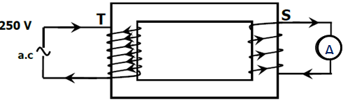

Calculate the maximum current measured by the ammeter. (3marks)

…………………………………………………………………………..…………………………………………………………………………………………………………………………………..…………………………………………………………………………………………………………………………………..………………………………………………………

1. (a) The fig. shows as simple form of cathode ray tube, which produces a sharp shadow of a Maltese cross on a fluorescent screen.

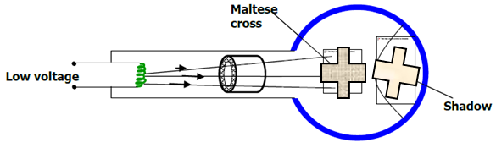

(i) Explain what is meant by cathode rays. (1mark)

…………………………………………………………………………..……………………………………………………………………………………………………………………..…………………………………………

(ii) What property of cathode rays does the fig. above illustrate (1mark)

…………………………………………………………………………..…………………………………………………………………………………………………………………………………..…………………………

(b) State one factor that affects photoelectric emission from a given metal surface. (1mark)

…………………………………………………………………………..…………………………………………………………………………………………………………………………………..……………………………………………………………………………

c). A graph of K.E of photoelectrons emitted by metal surface A against the frequency of radiation used is as shown below

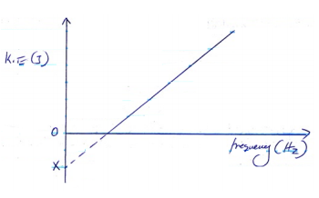

From the graph;

i) What is the significance of the gradient of the graph? (1mark)

…………………………………………………………………………..…………………………………………………………………………………………………………………………………..……………………………………………………………………………

ii) What is the significance of OX (1mark)

…………………………………………………………………………..…………………………………………………………………………………………………………………………………..……………………………………………………………………………

d) The threshold frequency for potassium is 5.37 x 1014Hz. When the surface of potassium

is illuminated by incident radiation from a source, photoelectrons are emitted with the speed of 7.9 x105m/s. Given that h=*6.62 x 10-34 JS and me=9 x 10-31kg, c*alculate:

i) The work function for potassium (2marks)

…………………………………………………………………………..…………………………………………………………………………………………………………………………………..……………………………………………………………………………

…………………………………………………………………………..…………………………………………………………………………………………………………………………………..……………………………………………………………………………

ii) The frequency of the incident radiation from the second source. (3marks)

…………………………………………………………………………..…………………………………………………………………………………………………………………………………..……………………………………………………………………………

…………………………………………………………………………..……………………………………………………………………………………………………………………………………………..…………………………………………………………………………………………………………………………………..……………………………………………………………………………

1. Figure below shows the features of an X-ray tube.

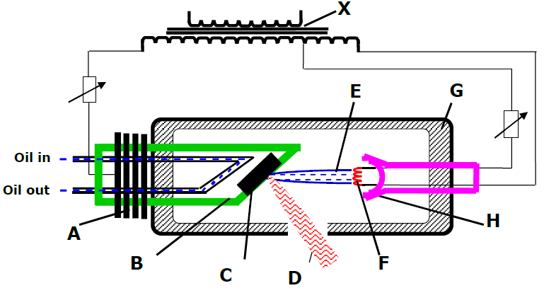

**a)** Name the parts marked with letters **A** and **H** (2marks)

…………………………………………………………………………..…………………………………………………………………………………………………………………………………..……………………………………………………………………………

**b)** Why is tungsten or Molybdenum metal most suitable materials for making part **C** (1mark)

…………………………………………………………………………..…………………………………………………………………………………………………………………………………..……………………………………………………………………………

**c)** Why is part **B** made of thick copper metal (1mark)

…………………………………………………………………………..…………………………………………………………………………………………………………………………………..……………………………………………………………………………

**d)** Why should the machine should be surrounded by material **G**? (1mark)

…………………………………………………………………………..…………………………………………………………………………………………………………………………………..……………………………………………………………………………

**e)** Why is the tube evacuated? (1mark)

…………………………………………………………………………..…………………………………………………………………………………………………………………………………..……………………………………………………………………………

**f)** What effect will increasing current at **F** have on x-ray produced? (1mark))

…………………………………………………………………………..…………………………………………………………………………………………………………………………………..……………………………………………………………………………

**g)** What effect will increasing the p.d. between at **B** and **F** have on the x-rays produced (1mark)

…………………………………………………………………………..…………………………………………………………………………………………………………………………………..……………………………………………………………………………

**h)** State **one** way in which cooling is achieved in this X-ray machine. (1mark)

…………………………………………………………………………..…………………………………………………………………………………………………………………………………..……………………………………………………………………………

1. .(a) State one difference between a capacitor and a cell. (1mark)

…………………………………………………………………………..…………………………………………………………………………………………………………………………………..……………………………………………………………………………………………………………………………………………………………………………………………………………………………

(b) Sketch the electrostatic field pattern due to the arrangement of the charges shown (1mark)

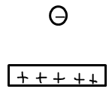

(c)The diagram shows a parallel plate capacitor with a dielectric material in between the plate.

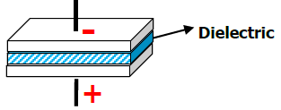

State how each of the following quantities are affected when the dielectric material is pulled out of the parallel plates.

(i) The p.d across the plates. (1mark)

…………………………………………………………………………..…………………………………………………………………………………………………………………………………..……………………………………………………………………………

(ii) The charge on the plates. (1mark)

…………………………………………………………………………..…………………………………………………………………………………………………………………………………..……………………………………………………………………………

(iii) The capacitance of the system. (1mark)

…………………………………………………………………………..…………………………………………………………………………………………………………………………………..……………………………………………………………………………

(d)Three capacitors of 1.5µF, 2.0 µF and 3.0 µF are connected in series to p.d. of 12V. Find the total charge stored in the arrangement (3marks)

…………………………………………………………………………..…………………………………………………………………………………………………………………………………..……………………………………………………………………………

…………………………………………………………………………..…………………………………………………………………………………………………………………………………..……………………………………………………………………………

…………………………………………………………………………..…………………………………………………………………………………………………………………………………..……………………………………………………………………………

(e)The figure below shows a capacitor **C** being charged.

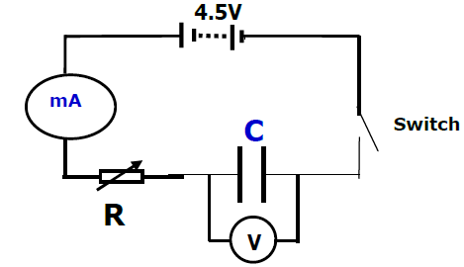

State what would be observed on the following when the switch is closed:

(i) The milliameter (1mark)

…………………………………………………………………………..…………………………………………………………………………………………………………………………………..……………………………………………………………………………

(ii) The voltmeter (1mark)

…………………………………………………………………………..…………………………………………………………………………………………………………………………………..……………………………………………………………………………

(iii) Explain how the capacitor is charged. (2marks)

…………………………………………………………………………..…………………………………………………………………………………………………………………………………..……………………………………………………………………………

…………………………………………………………………………..…………………………………………………………………………………………………………………………………..……………………………………………………………………………

…………………………………………………………………………..…………………………………………………………………………………………………………………………………..……………………………………………………………………………

(c) On the axis provided, sketch the graph of voltage (V) against time (t) (1mark)

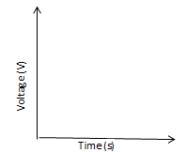

**THIS IS THE LAST PRINTED PAGE** 