MATHIOYA JOINT EVALUATION TEST Dec 2021
Kenya Certificate of Secondary Education
Physics Paper 2 232/2 MARKING SCHEME
- 0.48A | √ 1mark
- Metal cans discharge the static charges while plastic cans accumulate static charges hence can create explosion | √ 1mark
- This means that the bulb is designed to function at maximum voltage of 240V and its energy consumption is 9W. | √ 1mark
- (a) X is connected to a forward biased diode which makes the junction to become smaller while Y is connected to a Reverse biased diode. Diodes conduct only in forward bias.  (b) T= North  R= South both correct; | √ 1mark  √ 1mark
- It has Low melting point i.e it is made of a material with low melting point e.g thin copper wire. | √ 1mark
- .  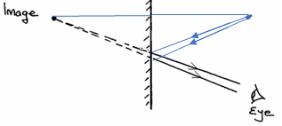  (b) Image is:  - Real  - Inverted  - Magnified  - Formed beyond C | √ 1mark Correct ray  √ 1mark Object  Any one √ 1mark
- The magnet is repelled/the magnet moves away from the solenoid since south and North poles are formed at ends A and B respectively | √ 1mark
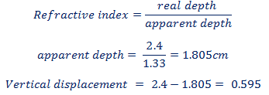 | Correct subst. √ 1mark  Correct ans. With unit  √ 1mark
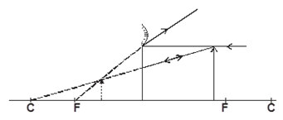  b)  - Sound waves requires material medium (is a mechanical wave) while electromagnetic waves don’t  - Sound waves are longitudinal while electromagnetic waves are transverse in nature | √ 1mark both rays (incident and reflected)  √ 1mark Object position  Any one √ 1mark
- .  - Connecting the 30A fuse along the neutral line of the heating element.  (b) .  - There is a risk of fire to nearby structures or vegetation when the cables get too low.  - There is a risk of electric shock in case the poles collapse or hang too low.  - Harmful effects of electric field. | √ 1mark  Any one √ 1mark
226=206+4x  4x=226-206 4x=20 X=5  86=84+2x-y 86=84+10-y y=94-86 y=8  5-alpha particles and 8- beta particles are emitted | √ 1mark No. of α-Particles  √ 1mark No. of β-Particles  (Marks independent)
- ..i. For even distribution of charges  ii) Upwards  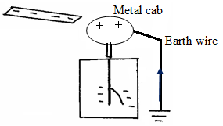 | √ 1mark  √ 1mark  (Allow Upwards along earth wire)
- P = V²/R. P = 240²/950  = 60.63W | √ 1mark Correct subst.  √ 1mark Correct ans. With unit
- .(a)  - The intensity of the sound gradually decreases/sound becomes faint  (The temperature of the air inside decreases, energy of the molecules decrease hence the rate of vibration decreases)  (b)  -Ultrasound penetrates the deepest and  -can be easily reflected by tiny grains. | √ 1mark  (Deny-No sound is heard)  Any one √ 1mark
- (a)  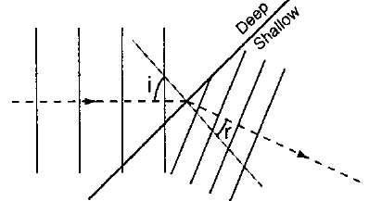(b) 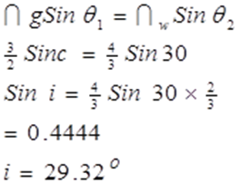 | a) √ 1mark( Refraction tied to smaller-wavelength, uniform wave fronts)  b) √ 1mark- formula &/or  √ 1mark -Correct subst.  √ 1mark- Correct ans. with unit
15 (c)  - Prisms do not absorb energy from incident radiation  - Prism do not produce multiple images  - Prism do not tarnish or peel off like mirrors | √ 1mark- any one
(d) 1.5 λ is proportional to 27.0cm  1λ= x  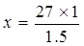 = 18 cm | √ 1mark- proportionality  √ 1mark -Correct subst.  √ 1mark- Correct ans. with unit
e)(i) f=1/T T = 0.32/4 = 0.08 f = 1/0.08 = 12.5 Hz | √ 1mark –T  √ 1mark - Correct ans.
e)(ii) c=λf  λ= c/f  = 50/12.5  =4m | √ 1mark -Correct subst.  √ 1mark- Correct ans.
- . (a)  - Large currents can be drawn from them over a short period of time.  - They require very little attention to maintain.  - They are lighter (more portable) than the Lead – acid accumulators.  - They can be kept in a discharged condition for a very long time before the cells are ruined | √ 1mark- any one
b)  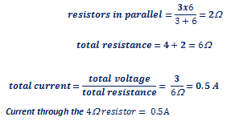 | √ 1mark –Total resistance  √ 1mark-Subst. for I=V/R  √ 1mark- Correct ans.
c(i)  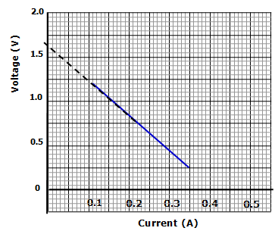 1.65V | √ 1mark- correct value of e.m.f $±0.05$  (Allow value indicated on the extrapolated graph)
ii) E = V + Ir  V= -Ir +E  -r = slope  $$Slope = \frac{change in voltage}{change in current}=\frac{0.4-1.5}{0.31-0.03}=\frac{-1.1}{0.28}= -3.93$$  -r=$-3.93$  Internal resistance = $3.93$ | √ √ 2marks-slope  √ 1mark- relating slope with r and correct value
ii | √ 1mark- formula &/or  √ 1mark -Correct subst.  √ 1mark- Correct ans. with unit
17. a)(i) Cathode rays are streams of electrons emitted from the surface of a metal by thermionic emission  ii) They travel in straight lines  (Other property) They cause fluorescent surfaces to glow  (b) i) Intensity of radiation  ii) Energy of radiation  iii) Type of metal  (c) (i) The slope represents the value of the Planck’s constant h  (ii) The region OX represents the value of Work function Wo in Joules  (d) i) Wo = hfo  = 6.62 x 10⁻³⁴ x 5.37 x 10¹⁴  = 3.55 x 10-59J  (ii) K.E = ½ m_{e}v²  = ½ x 9 x 10-³¹ x (7.9 X 10⁵)2  = 2.808 x 10⁻¹⁹J  hf = Wo + K.E | √ 1mark-  √ 1mark-  √ 1mark- Any one  √ 1mark-  √ 1mark-  √ 1mark -Correct subst.  √ 1mark- Correct ans. with unit  √ 1mark –K.E  √ 1mark –Subst. in Einstein’s equation  √ 1mark- Correct ans.
18 a) A. Cooling fins H. Cathode  b) Tungsten or molybdenum has high melting point to withstand high temperatures.  c) To ensure efficient dissipation of heat.  d) To absorb the stray x-ray radiations which would otherwise affect the x ray tube operators  e) To prevent electrons from losing energy due to collisions with air molecules and ionization.  f) The temperature of the cathode increases. This increases the number of electrons released hence the intensity of x-rays.  g) Hard x-rays of very short wavelengths are produced.  h) By efficient cooling fins on the outside of the tube.  By circulating oil through the channels in the copper anode. | √ 1mark-√ 1mark-  √ 1mark-  √ 1mark-  √ 1mark-  √ 1mark-  √ 1mark-  √ 1mark-  √ 1mark-
19 a)  - Capacitor stores electric charge while cell as a device to convert chemical energy to electrical energy.  - Capacitor is passive component of circuit while cell is an active component of circuit.  - Capacitor discharges instantly while cell runs for longer time.  b)  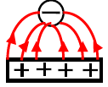  c) (i) P.d increases.  (ii) Charge remains unchanged.  (iii) Capacitance decreases.  d)  e) i)Milliameter reading which is initially high gradually reduces to zero.  ii) Voltmeter reading increases from zero to maximum value (4.5V).  iii) .  - Negative charges flow from negative terminal of the battery to the plate connected to it.  - At the same rate, negative charges flow from the other plate of the capacitor towards the positive terminal of the battery.  - Equal positive and negative charges appear on the plates.  - A potential difference is therefore set on the plates. | √ 1mark- Any one  √ 1mark- (Direction tied to shape of the field lines)  √ 1mark-  √ 1mark-  √ 1mark-  √ 1mark-Capacitance √ 1mark -Correct subst. Q=CV  √ 1mark- Correct ans.  √ 1mark –  √ 1mark –  √ 1mark  √ 1mark
c)  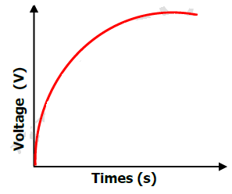 | √ 1mark- Smooth curve flattening for max. voltage

