NAME…………………………..……………….. ADMN NO ……………CLASS…………

DATE.……….……….…………………... SIGNATURE ……………..………
PHYSICS
PAPER 2
232/2
FORM 4 TERM 2 SEPTEMBER 2022
MURANG’A EXTRA COUNTY SCHOOLS JOINT EXAMINATION
Kenya Certificate of Secondary Education.
232/2 PHYSICS
PAPER 2
TIME: 2 HOURS.
INSTRUCTIONS TO CANDIDATES

- This paper consists of two sections A and B.
- Answer all the questions in sections A and B in the spaces provided.
- Non-programmable silent electronic calculators may be used.
- This paper consists of 11 printed pages.
- Candidates should check the questions to ascertain that all the pages are printed as indicated and that no question is missing.

FOR EXAMINER’S USE ONLY.

SECTION | QUESTION | MAXIMUM SCORE | CANDIDATE’S SCORE
A | 1-13 | 25
B | 14 | 10
 | 15 | 13
 | 16 | 11
 | 17 | 11
 | 18 | 10
TOTAL |  | 80

SECTION A: (25MARKS)
- What is observed when the hole of a pinhole camera is enlarged? (1mk)

…………………………………………………………………………………………………………………………………………

…………………………………………………………………………………………………………………………………………

- State one use of a charged electroscope (1mk)
…………………………………………………………………………………………………………………………………………
…………………………………………………………………………………………………………………………………………
- The chart below shows an arrangement of a section of the electromagnetic spectrum
P | Q | R | UV Light | S | Gamma rays
Name the radiation represented by letter Q (1mk)

…………………………………………………………………………………………………………………………………………
- Draw a circuit diagram to show P-N junction diode in the forward biased mode. (2mks)
…………………………………………………………………………………………………………………………………………
…………………………………………………………………………………………………………………………………………
…………………………………………………………………………………………………………………………………………
…………………………………………………………………………………………………………………………………………
- Explain why the walls of studio are padded with woolen materials (1mk)

…………………………………………………………………………………………………………………………………………

…………………………………………………………………………………………………………………………………………

- (a) Define half- life as used in radioactivity (1mk)
…………………………………………………………………………………………………………………………………………
…………………………………………………………………………………………………………………………………………

(b)The initial mass of a radioactive substance is 20g.The substance has half-life of 5yrs.Detemine the mass remaining after 20yrs. (2mks)
…………………………………………………………………………………………………………………………………………

…………………………………………………………………………………………………………………………………………

…………………………………………………………………………………………………………………………………………

- Give a reason why it is necessary to leave the caps of the cells open when charging lead-acid accumulator (1mk)

…………………………………………………………………………………………………………………………………………

…………………………………………………………………………………………………………………………………………

- (a) State one property of soft iron that makes it suitable for use as a transformer core.
(1mk)
…………………………………………………………………………………………………………………………………………

………………………………………………………………………………………………………………………………………...
(b)The primary coil of a transformer has 1200 turns and the secondary coil has 60 turns. The transformer is connected to a 240V a.c source. Determine the output voltage.
(3mks) …………………………………………………………………………………………………………………………………………
…………………………………………………………………………………………………………………………………………
…………………………………………………………………………………………………………………………………………
…………………………………………………………………………………………………………………………………………
- State two ways of minimizing electrical power losses during transmission
(2mks)
…………………………………………………………………………………………………………………………………………

…………………………………………………………………………………………………………………………………………
- A convex mirror is preferred to a plane mirror for use as a driving mirror. Explain why. (1mk)
…………………………………………………………………………………………………………………………………………
…………………………………………………………………………………………………………………………………………
- An electric bulb is rated 60W, 240V. Determine the current that flows through it when it is connected to a 240v supply (2mks
…………………………………………………………………………………………………………………………………………
…………………………………………………………………………………………………………………………………………
…………………………………………………………………………………………………………………………………………
- The figure below shows a defect of vision
- Name the defect. (1mk)

…………………………………………………………………………………………………………………

- List two possible causes of the defect. (2mks)
…………………………………………………………………………………………………………………
…………………………………………………………………………………………………………………

- A broadcasting station produces radio waves of wavelength 600m. Determine their frequency in MHz (speed of air is 3X10⁸m/s) (3mks)
…………………………………………………………………………………………………………………………………………
…………………………………………………………………………………………………………………………………………
…………………………………………………………………………………………………………………………………………
………………………………………………………………………………………………………………………………………...

SECTION B (55MARKS)
- (a) Define the refractive index of a medium (1mk)
…………………………………………………………………………………………………………………………………………
………………………………………………………………………………………………………………………………………...
(b) The figure below shows a ray of light incident on a glass-air interface
θ
Air
Glass

Given that the refractive index of the glass is 1.5, determine angle θ (3mks)
…………………………………………………………………………………………………………………………………………
…………………………………………………………………………………………………………………………………………
………………………………………………………………………………………………………………………………………...
(c) State one condition for total internal reflection to occur (1mk)
…………………………………………………………………………………………………………………………………………

…………………………………………………………………………………………………………………………….............

(d) The diagram below shows a narrow beam of white light shone onto a glass prism
- What is the phenomena represented in the diagram? (1mk)
……………………………………………………………………………………………………………………………..

- Name the colours at A and at B (2mks)
……………………………………………………………………………………………………………………………

……………………………………………………………………………………………………………………………
- Explain the reason for your suggestion of the colours named above. (1mk)

……………………………………………………………………………………………………………………………

…………………………………………………………………………………………………………………………...
- What is the purpose of the slit. (1mk)

……………………………………………………………………………………………………………………………..
- (a) State one factor that affect the resistance of a metallic conductor (1mk)

………………………………………………………………………………………………………………………………………..
(b) The figure below shows resistors in a circuit. The internal resistance of the battery is negligible
3Ω
1Ω
4Ω
2Ω
5.6Ω
6V
P
Q

- Calculate the effective resistance of the circuit (2mks)

……………………………………………………………………………………………………………………………

……………………………………………………………………………………………………………………………

…………………………………………………………………………………………………………………………...
- Find the total current in the circuit (2mks)
……………………………………………………………………………………………………………………………
……………………………………………………………………………………………………………………………
……………………………………………………………………………………………………………………………
…………………………………………………………………………………………………………………………..

- Find the P.d between P and Q (2mks)
……………………………………………………………………………………………………………………………
……………………………………………………………………………………………………………………………
…………………………………………………………………………………………………………………………..
(c) What is the effect of decreasing the distance between the plates of a parallel plate capacitor on the capacitance (1mk)
………………………………………………………………………………………………………………………………………
………………………………………………………………………………………………………………………………………
(d) The figure below shows electrical circuit with three capacitors A, B and C of capacitance 5µF, 6µF and 4µF respectively connected to a 12V battery
Determine
- The combined capacitance of the three capacitors (2mks)
…………………………………………………………………………………………………………………
…………………………………………………………………………………………………………………
………………………………………………………………………………………………………………….
- The potential difference across the capacitor B (3mks)

…………………………………………………………………………………………………………………

…………………………………………………………………………………………………………………

………………………………………………………………………………………………………………….
- (a) Name two factors which determine the frequency of sound from a stretched wire at room temperature (2mks)
…………………………………………………………………………………………………………………………………………
…………………………………………………………………………………………………………………………………………
(b) The figure below shows two loud speakers S₁ and S₂ connected to a signal generator
S1
S2
A
A₁
B₁
B2

- An observer walks along B₁B₂. State what is observed. (1mk)
……………………………………………………………………………………………………………………………………....
- Give reasons for observation above (2mks)
…………………………………………………………………………………………………………………………………………
…………………………………………………………………………………………………………………………………………
………………………………………………………………………………………………………………………………………...
- Another observer walks along AA₁, state and explain what he observed (2mks)
…………………………………………………………………………………………………………………………………………
…………………………………………………………………………………………………………………………………………
………………………………………………………………………………………………………………………………………...
..............................................................................................................................................
..............................................................................................................................................

(c) A stretched string is vibrating between two fixed ends. The figure shows how the string is vibrating
- State the name of: (2mks)
[I] Distance a:
…………………………………………………………………………………………………………………………...
[I] Distance b:
……………………………………………………………………………………………………………………………
(ii) On the diagram, label the node and the antinode (2mks)

- The figure below shows a block diagram of a cathode ray oscilloscope(CRO)
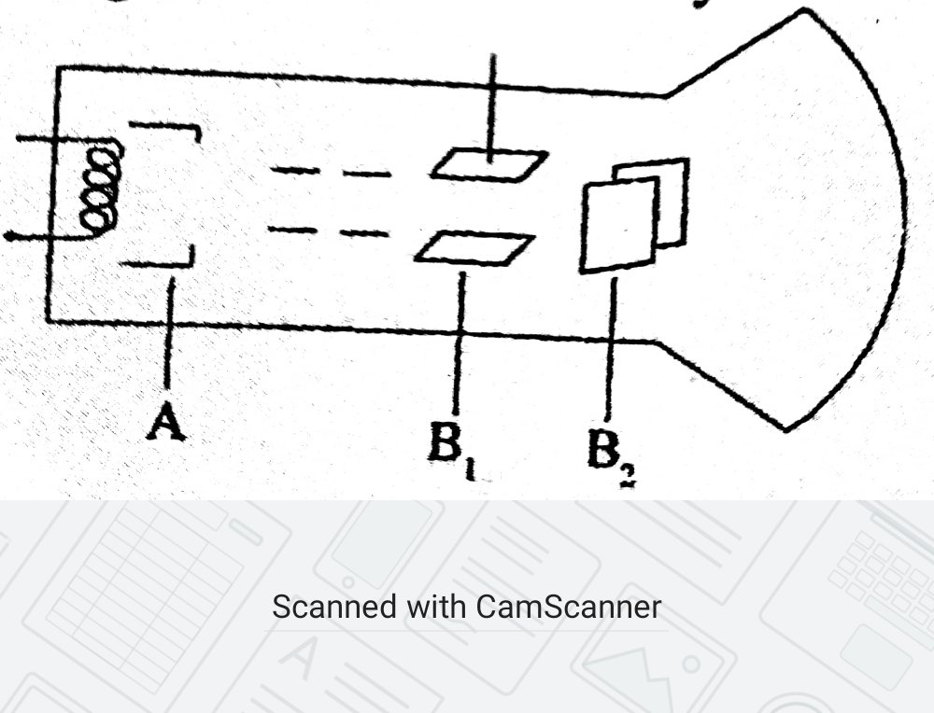
(a)(i)State the names of the parts labelled B₁ and B₂ (2mks)
……………………………………………………………………………………………………………………………………………………
……………………………………………………………………………………………………………………………………………………
(ii)State and explain the function of the part marked A (2mks)
……………………………………………………………………………………………………………………………………………………
…………………………………………………………………………………………………………………………………………………… (ii)Why is the tube highly evacuated? (1mk)
……………………………………………………………………………………………………………………………………………………
…………………………………………………………………………………………………………………………………………………..
(b)Give a reason why the target in an X-ray tube is made of tungsten or molebdnum (1mk)
……………………………………………………………………………………………………………………………………………………
…………………………………………………………………………………………………………………………………………………….
(c) X-rays are used for detecting cracks inside metal beams.State with a reason which type of X- rays is used. (2mks)
……………………………………………………………………………………………………………………………………………………
……………………………………………………………………………………………………………………………………………………
(d) In a certain X-ray tube the electrons are accelerated by a p.d of 12kV.Assuming all the energy goes to produce X-rays, determine the frequency of the X-rays produced .(Planks constant h=6.62x10⁻³⁴ Js and charge of an electron =1.6x10⁻¹⁹C) (2mks)
……………………………………………………………………………………………………………………………………………………
……………………………………………………………………………………………………………………………………………………
…………………………………………………………………………………………………………………………………………………….
18.(a) state two factors that affect photoelectric emission (2mks)
……………………………………………………………………………………………………………………………………………………
……………………………………………………………………………………………………………………………………………………
……………………………………………………………………………………………………………………………………………………
(b)Light of wavelength 4.0x10⁻⁷ m is incident on two different metal surfaces ,nickel and potassium (Take speed of light as 3.0x10⁸ m/s and planks constant h=6.63x10⁻³⁴Js)
(i)Determine the energy of the incident radiation (3mks)
……………………………………………………………………………………………………………………………………………………
……………………………………………………………………………………………………………………………………………………
……………………………………………………………………………………………………………………………………………………
……………………………………………………………………………………………………………………………………………………
…………………………………………………………………………………………………………………………………………………..

(ii)If the work function of nickel is 8.0x10⁻¹⁹ J and that of potassium metal is 3.68x10⁻¹⁹J,state with a reason which of the two metals given light will eject electrons (2mks)
……………………………………………………………………………………………………………………………………………………
……………………………………………………………………………………………………………………………………………………
……………………………………………………………………………………………………………………………………………………
……………………………………………………………………………………………………………………………………………………
……………………………………………………………………………………………………………………………………………………

(iii)Determine the velocity of the emitted electrons from the metal surface in b(ii).( Take mass of an electron as 9.1x10⁻³¹ kg) (3mks)
……………………………………………………………………………………………………………………………………………………
……………………………………………………………………………………………………………………………………………………
……………………………………………………………………………………………………………………………………………………
……………………………………………………………………………………………………………………………………………………
……………………………………………………………………………………………………………………………………………………
……………………………………………………………………………………………………………………………………………………
……………………………………………………………………………………………………………………………………………………
……………………………………………………………………………………………………………………………………………………
……………………………………………………………………………………………………………………………………………………
…………………………………………………………………………………………………………………………………………………..

