NAME…………………………..……………….. ADMN NO ……………CLASS…………

DATE.……….……….…………………... SIGNATURE ……………..………
PHYSICS
PAPER 2
232/2
FORM 4 TERM 2 SEPTEMBER 2022
MURANG’A EXTRA COUNTY SCHOOLS JOINT EXAMINATION
Kenya Certificate of Secondary Education.
232/2 PHYSICS
PAPER 2 MARKING SCHEME
TIME: 2 HOURS.
INSTRUCTIONS TO CANDIDATES

- This paper consists of two sections A and B.
- Answer all the questions in sections A and B in the spaces provided.
- Non-programmable silent electronic calculators may be used.
- This paper consists of 9 printed pages.
- Candidates should check the questions to ascertain that all the pages are printed as indicated and that no question is missing.

FOR EXAMINER’S USE ONLY.

SECTION | QUESTION | MAXIMUM SCORE | CANDIDATE’S SCORE
A | 1-13 | 25
B | 14 | 10
 | 15 | 13
 | 16 | 11
 | 17 | 11
 | 18 | 10
TOTAL |  | 80

SECTION A: (25MARKS)
- What is observed when the hole of a pinhole camera is enlarged? (1mk)
The image becomes brighter and blurred /Not clear.
- State one use of a charged electroscope (1mk)
- Detect type of charge
- Identify conductors and insulator
- The chart below shows an arrangement of a section of the electromagnetic spectrum
P | Q | R | UV Light | S | Gamma rays
Name the radiation represented by letter Q (1mk)
Infrared radiation
- Draw a circuit diagram to show P-N junction diode in the forward biased mode. (2mks)
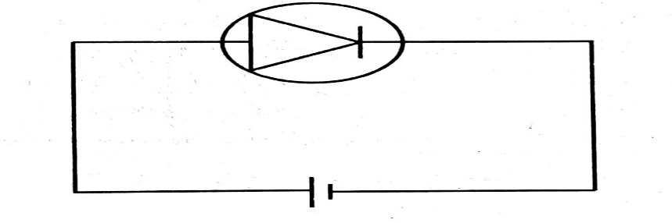

-diode symbol (1mk)
-forward biasing(1mk)
- Explain why the walls of studio are padded with woolen materials (1mk) To absorb incident sound waves hence preventing the formation of an echo
- (a) Define half life as used in radioactivity (1mk)
Time taken for half the number of nuclides initially present in a radioactive sample to decay.
(b)The initial mass of a radioactive substance is 20g.The substance has halflife of 5yrs.Detemine the mass remaining after 20yrs. (2mks)
No. of halflives =20/5 =4
20g -------10g-------5g----2.5g-----1.25g
OR

N=N_{O}(1/2)^{T/t} =20(1/2)^{20/16} =1.25g

- Give a reason why it is necessary to leave the caps of the cells open when charging lead-acid accumulator (1mk)
To allow hydrogen gas produced at the electrodes to escape
- (a) State one property of soft iron that makes it suitable for use as a transformer core.
(1mk)
Iron is easily magnetized and demagnetized/it’s a soft magnetic material.
(b)The primary coil of a transformer has 1200 turns and the secondary coil has 60 turns. The transformer is connected to a 240V a.c source.Determine the output voltage (3mks)
V_{s}/V_{p} =N_{s}/N_{p}
V_{s} =240x 60/1200
V_{s}=12V
- State two ways of minimizing electrical power losses during transmission
(2mks)
Stepping-up the voltage
Using thicker aluminum cables for transmission
- A convex mirror is preferred to a plane mirror for use as a driving mirror. Explain why. (1mk)
Convex mirror provides a wider field of view
- An electric bulb is rated 60W, 240V. Determine the current that flows through it when it is connected to a 240v supply (2mks)
I=P =60 =0.25A
V 240
- The figure below shows a defect of vision
- Name the defect. (1mk)
Long sightedness (hypermetropia)
- List two possible causes of the defect. (2mks)
    - Long focal length
    - Short eyeball

- A broadcasting station produces radio waves of wavelength 600m. Determine their frequency in MHz (speed of air is 3X10⁸m/s) (3mks)
V=f λ
f=V f=3X10⁸ =50 000Hz =5.0X10⁵Hz =0.5MHz
λ 600
SECTION B (55MARKS)
- (a) Define the refractive index of a medium (1mk)
It is the ratio of sine of the angle of incidence to the sine of angle of refraction for a ray of light that is travelling from air to a medium.
(b) The figure below shows a ray of light incident on a glass-air interface
θ
Air
Glass

Given that the refractive index of the glass is 1.5, determine angle θ (3mks)
_{a}n_{g} =sin90 1.5 = 1 sin θ = 1 = 0.6667 θ=41.81⁰
sinθ sin θ 1.5
(c) State one condition for total internal reflection to occur (1mk) - Light must travel from optically denser medium to a less dense medium/rare medium OR The angle of incidence in the optically denser medium must be greater than the critical angle
(d) The diagram below shows a narrow beam of white light shone onto a glass prism
- What is the phenomena represented in the diagram? (1mk)
Dispersion of white light
- Name the colours at A and at B (2mks)
A: Red
B: Violet
- Explain the reason for your suggestion of the colours named above. (1mk)
Red light is the least deviated colour while violet is the most deviated colour. This is because red light travels at a greater velocity in glass than violet
- What is the purpose of the slit. (1mk)
It ensures the beam of the white light is narrow and direct
- (a) State one factor that affect the resistance of a metallic conductor (1mk)
- length of the metal
- cross-sectional area of the metal
- temperature of the metal
-type of the metals

(b) The figure below shows resistors in a circuit. The internal resistance of the battery is negligible
3Ω
1Ω
4Ω
2Ω
5.6Ω
6V
P
Q

- Calculate the effective resistance of the circuit (2mks)

R_{E}= 4X6 + 5.6 R_{E} = 2.4+5.6 = 8.0 Ω
4+6
- Find the total current in the circuit (2mks)
V=IR
I=V/R I=6/8 =0.75A
- Find the P.d between P and Q (2mks)
P.d at 5.6 Ω OR
V=0.75X5.6 = 4.2V V=IR
P.d between P and Q 0.75 X 2.5
6 - 4.2 =1.8V
= 1.8V
(c) What is the effect of decreasing the distance between the plates of a parallel plate capacitor on the capacitance (1mk) Capacitance increases

(d) The figure below shows electrical circuit with three capacitors A, B and C of capacitance 5µF, 6µF and 4µF respectively connected to a 12V battery

Determine
- The combined capacitance of the three capacitors (2mks)
Capacitors in parallel
= 6+5
=11µF
Capacitors in series
= 4X11 =44/15 =2.933µF
11+4
- The potential difference across the capacitor B (3mks)
Q=CV
=2.933X10⁻⁶X12
=3.5196X10⁻⁵C
V=Q/C
=3.5196X10⁻⁵/11X10⁻⁶
=3.1996V

- (a) Name two factors which determine the frequency of sound from a stretched wire at room temperature (2mks)
- Tension of the wire
- Mass per unit length / thickness of the wire
- Length of the wire

(b) The figure below shows two loud speakers S₁ and S₂ connected to a signal generator
S1
S2
A
A1111A’1
B1111₁
B222

- An observer walks along BB₁. State what is observed. (1mk)
The observer experiences alternate loud sound and soft sound
- Give reasons for observation above (2mks)
- Loud sound was due to constructive interference where crests of one wave meets the crest of another wave/
- Trough of one wave meets the trough of another wave/
- Two waves arrive at a point in phase
Soft sound was due to destructive interference where crest of one wave meets the trough of another wave.
- Another observer walks along AA₁, state and explain what he observed (2mks)
- The observer will hear loud sound all through
This is the locus of point equidistant from the two sources where the path difference is zero and constructive interference occurs all through
(c) A stretched string is vibrating between two fixed ends. The figure shows how the string is vibrating
- State the name of: (2mks)
[I] Distance a: Amplitude

[I] Distance b: Wavelength
(ii) On the diagram, label the node and the antinode (2mks)

- The figure below shows a block diagram of a cathode ray oscilloscope(CRO)
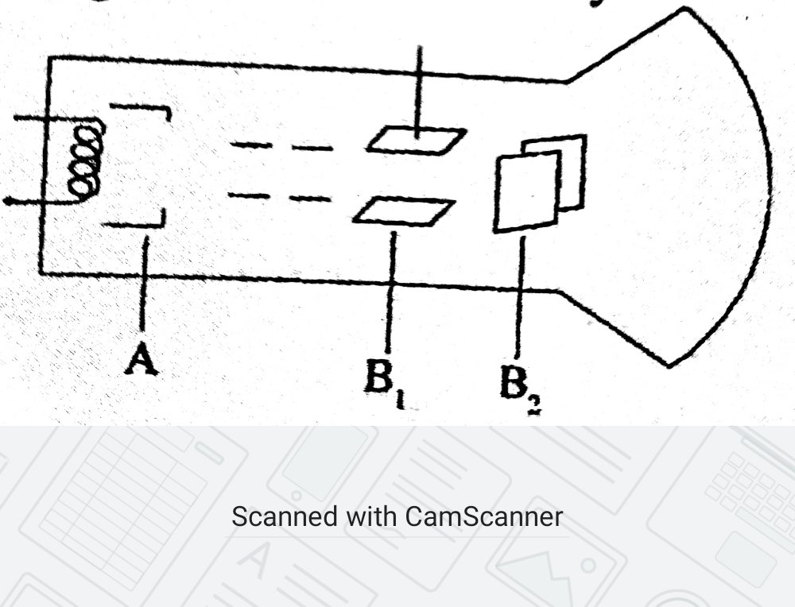
(a)(i)State the names of the parts labelled B₁ and B₂ (2mks)
B1 – Y-plates
B2---X- plates
(ii)State and explain the function of the part marked A (2mks)
A is Grid –It controls the brightness of the spot on the screen. When made more negative ,less electrons flow and brightness reduces.When grid made less negative ,more electrons flow and the brightness increases. (iii)Why is the tube highly evacuated? (1mk) To prevent the cathode rays from losing energy due to collision with air molecules in the tube (b)Give a reason why the target in an X-ray tube is made of tungsten or molebdnum (1mk)
Tungsten or molebdnum have very high melting point hence they can withstand high temperatures (c) X-rays are used for detecting cracks inside metal beams.State with a reason which type of X- rays is used. (2mks)
Hard X-rays – They have higher penetrating power.
(d) In a certain X-ray tube the electrons are accelerated by a p.d of 12kV.Assuming all the energy goes to produce X-rays, determine the frequency of the X-rays produced .(Planks constant h=6.62x10⁻³⁴ Js and charge of an electron =1.6x10⁻¹⁹C) (2mks)
ev =hf
1.6x 10⁻¹⁹ x12000 =6.62x10⁻³⁴xf
f =1.6x10⁻¹⁹ x 12000/6.62x10⁻³⁴
f =2.9x 10¹⁸Hz
18.(a) state two factors that affect photoelectric emission (2mks)
Type of the metal
Frequency/Energy of the radiation
Intensity of the radiation
(b)Light of wavelength 4.0x10⁻⁷ m is incident on two different metal surfaces ,nickel and potassium (Take speed of light as 3.0x10⁸ m/s and planks constant h=6.63x10⁻³⁴Js)
(i)Determine the energy of the incident radiation (3mks)
E =hc/λ
E =6.63X 10⁻³⁴ X 3.0X10⁸/4.0X10⁻⁷
E = 4.9725X10⁻¹⁹J
(ii)If the work function of nickel is 8.0x10⁻¹⁹ J and that of potassium metal is 3.68x10⁻¹⁹J,state with a reason which of the two metals given light will eject electrons (2mks)
Potassium
This is because the energy of the incident radiation is greater than the work function of potassium.
(iii)Determine the velocity of the emitted electrons from the metal surface in b(ii).( Take mass of an electron as 9.1x10⁻³¹ kg) (3mks)
E =Wo +K.E
K.E =E –Wo
=4.9725x10⁻¹⁹ -3.680x10⁻¹⁹
=1.2925x10⁻¹⁹J
1.2925X10⁻¹⁹ =1/2 X9.1X 10⁻³¹ XV2
V2= 1.2925X 10⁻¹⁹/4.55X10⁻³¹
=2.84066X 10¹¹
V =5.330m/s

