NAME………………………………………………...….ADM NO……..…CLASS…………

DATE……………………………………………………………SIGN………………………….

232/1
PHYSICS
FORM FOUR
SEPTEMBER-2022
TIME: 2HRS

MECS JOINT EXAMINATION
Kenya Certificate of Secondary Education 2022

PHYSICS PAPER ONE

INSTRUCTIONS TO CANDIDATES
- Write your name and admission number in the spaces provided above.
- Sign and write the date of examination in the spaces provided above
- This paper consists of TWO sections A and B.
- Answer ALL the questions in section A and B in the spaces provided.
- All working MUST be clearly shown.
- Non programmable silent calculators may be used.
- This paper has 12 pages. It is the responsibility of the candidate to ascertain that all the pages are printed as indicated and that no questions are missing.
- Candidates should answer the questions in English.
Constant: g=10N/kg or 10m/s²

For Examiners Use Only

Section | Question | Maximum Score | Candidate’s Score
A | 1 – 12 | 25
B | 13 | 11
 | 14 | 11
 | 15 | 10
 | 16 | 9
 | 17 | 13
 | TOTAL SCORE | 80

SECTION A: (25 MARKS)

1. The figure below shows a section of a micrometer screw guage with a thimble scale of 50 divisions. When the spindle is in contact with the anvil, the device reads 0.25mm. If the screw guage is used to measure the diameter of a spherical ball, state the actual diameter of the ball. (2marks) 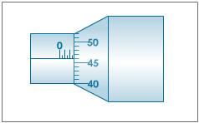
…………………………………………………………………………………………………………………………………………………………………………………………………………………………
2. When washing clothes, it is easier to remove the dirt using soap in warm water than cold water. Explain. (1marks) …………………………………………………………………………………………………………………………………………………………………………………………………………………………
3. The diagram below shows a funnel inverted over a light pith ball on a table. Air is blown into the funnel as indicated on the diagram.
Air
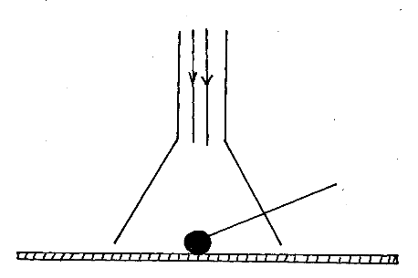

Pith ball

State and explain what is likely to be observed. (2 marks)
………………………………………………………………………………………………………………………………………………………………………………………………………………………………………………………………………………………………………………………………………
4. A car of mass 800 kg is initially moving at 25 m/s. Calculate the force needed to bring the car to the rest over a distance of 20 m. (3marks)
……………………………………………………………………………………………………………

……………………………………………………………………………………………………………

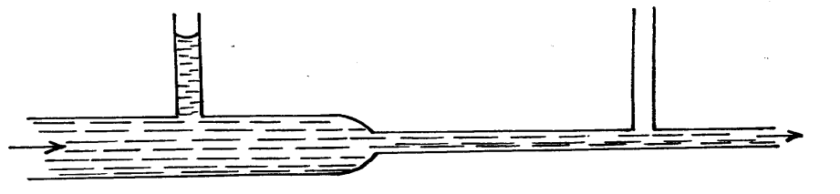
5. The figure below shows water flowing through two sections A and B of a pipe having x-sectional areas of 8cm² and 2cm², respectively.
B
A

- Mark the appropriate level of water in the manometer B (1mark)

- The velocity of water as it flows past the wider section of the pipe is 0.6ms⁻¹. Calculate the velocity at the narrower section. (2marks)
……………………………………………………………………………………………………………………………………………………………………………………………………………………………………………………………………………………………………………………………………….
6. A piece of metal weighs 3N in air and 2N when totally immersed in water. Calculate the volume of the metal. (Density of water = 1000Kg/m³) (3marks)

……………………………………………………………………………………………………………

……………………………………………………………………………………………………………

…………………………………………………………………………………………………………….

7. On the axis provided below, Sketch velocity — time graph of a body moving down a viscous fluid. (1marks)
Velocity (m/s)

Time (s)

8. A uniform half meter rule is supported by force of 3N and 2N as shown in the figure below.

3N
10 cm CMcmCMCCM
5 cm CMcmCMCCM
2N

Determine the weight of the half meter rule (3marks)

………………………………………………………………………………………………………

………………………………………………………………………………………………………

………………………………………………………………………………………………………

………………………………………………………………………………………………………

9. Explain why water in a pond may freeze on the surface only but not deep inside the pond. (1mark)
…………………………………………………………………………………………………………………………………………………………………………………………………………………………

10. A ball is thrown upwards and returns to its starting point after 6 seconds. Calculate the maximum height reached (g=10m/s²) (2marks)
…………………………………………………………………………………………………………………………………………………………………………………………………………………………………………………………………………………………………………………………………………………………………………………………………………………………………………………………………………………………………………………………………………………………………………………………………………………………………………………………………………………………………………………………………………………………………………………………….
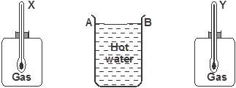
11.The figure below shows a cylindrical container having hot water at 95ºC. End A is shiny while end B is dull black. At equal distances from the container is placed two identical gas jars fitted with thermometers X and Y.

- Compare the readings of the two thermometers after two minutes (1 mark)
.....................................................................................................................................................................

- Give a reason for your answer in (i) above (1 mark)
………………………………………………………………………………………………………………………………………………………………………………………………………………...

12. Two ships moving parallel close to each other are likely to collide. Explain (1mark)

………………………………………………………………………………………………………………………………………………………………………………………………………………

13. State one physical property of a material medium which may be used to measure temperature. (1mark)
………………………………………………………………………………………………………………………………………………………………………………………………………………………………………………………………………………………………………………………………………

Section B (55 marks)

13. (a) Define the term heat capacity (1mark)

………………………………………………………………………………………………………………………………………………………………………………………………………………….............

(b) You are provided with the apparatus shown in the figure below and stop watch
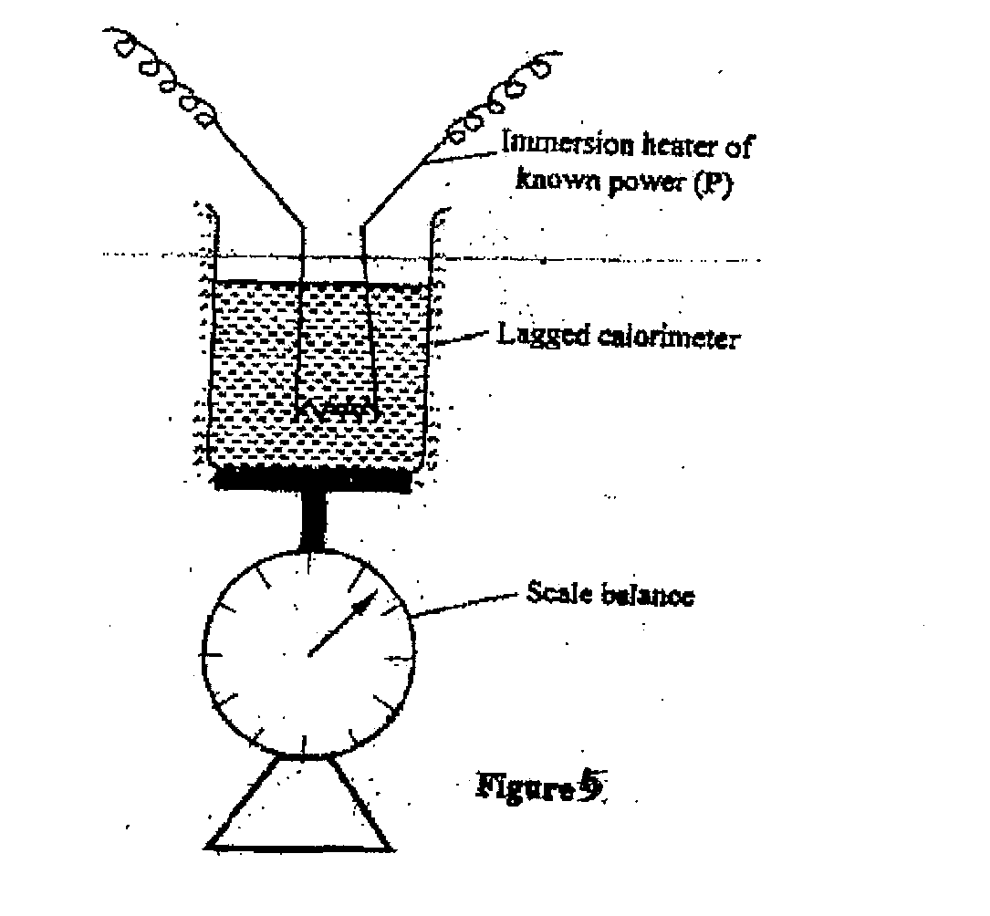

Describe an experiment to determine the specific latent heat of vaporization of water using the set up. In your answers clearly explain the measurements to be made and how these measurements would be used. (4marks)
…………………………………………………………………………………………………………………………………………………………………………………………………………………………………………………………………………………………………………………………………………………………………………………………………………………………………………………………………………………………………………………………………………………………………………………………………………………………………………………………………………………………………………………………………….

(c) A block of metal of mass 150g at 100ºC is dropped into a lagged calorimeter of heat capacity 40JK⁻¹ containing 100g of water at 25ºC. The temperature of the resulting mixture is 34ºC. (Specific heat capacity of water=4200JK⁻¹)
Determine:
(i) Heat gained by calorimeter; (2marks)
………………………………………………………………………………………………………………………………………………………………………………………………………………………….

(ii) Heat gained by water; (1mark)
………………………………………………………………………………………………………………………………………………………………………………………………………………………………………………………………………………………………………………………………………

(iii) Heat lost by the metal block; (1mark)
...............................................................................................................................................................................................................................................................................................................................................................................................................................................................................................................

(iv) Specific heat capacity of the metal block (3marks)
……………………………………………………………………………………………………………………………………………………………………………………………………………………………………………………………………………………………………………………………………………………………………………………………………………………………………………………………………………………………………………………………………………………………………………………………………………………………….

14. (a) In a car, the engine drives an alternator which produces electricity that lights the headlights. List the energy changes involved. (2marks)

……………………………………………………………………………………………………………

……………………………………………………………………………………………………….........

(b) What is the power output of a pump which can raise 60kg of water to a height of 10m every minute? (2marks)

……………………………………………………………………………………………………………

……………………………………………………………………………………………………………

……………………………………………………………………………………………………………

(c) If the efficiency of the pump in 15(b) is 80%, how much power must be supplied? (2marks)

………………………………………………………………………………………………………

………………………………………………………………………………………………………

………………………………………………………………………………………………………

d) (i) The figure below shows an inclined plane and a load of mass 15kg pulled by an effort of 100N.
100N
) 30⁰
15kg

Find the efficiency of the machine (3marks)

………………………………………………………………………………………………………

………………………………………………………………………………………………………

………………………………………………………………………………………………………..

(ii) a) Draw a single pulley arrangement with a velocity ratio of 2. (1mark)

15(a) A glass capillary contains enclosed air by a thread of mercury 15cm long when the tube is horizontal, the length of the enclosed air column 24cm as shown.
24cm
15cm

- What is the length of the enclosed air column when the tube is vertical with the open end uppermost if the atmosphere pressure is 750mmHg? (2marks)

……………………………………………………………………………………….................................

……………………………………………………………………………………………………………..

- Explain why the mercury does not run out when the tube is vertical with the closed end uppermost. (1mark)
……………………………………………………………………………………………………………

…………………………………………………………………………………………………………….

b) Explain why an air bubble increase in volume as it rises from the bottom of a lake to the surface. (2 marks)

…………………………………………………………………………………………………………..

……………………………………………………………………………………………………………

……………………………………………………………………………………………………………

c) When an inflated balloon is placed in a refrigerator it is noted that its volume reduces, use the kinetic theory of gases to explain this observation. (2marks)

……………………………………………………………………………………………………………

…………………………………………………………………………………………………………….

d) A certain mass of hydrogen gas occupies a volume of 1.6$m^{3}$ at a pressure of 1.5 × ${10}^{5}$ Pa and a temperature of 22⁰c. Determine the volume when the temperature is 0⁰c at a pressure of 0.8×10⁵ Pa. (3marks)

……………………………………………………………………………………………………………

……………………………………………………………………………………………………………

………………………………………………………………………………………………………….....

- a) State Archimedes principle. (1 mark)

……………………………………………………………………………………………………………

……………………………………………………………………………………………………………

b) A block of wood measuring 0.8m by 0.5m by 2m floats in water. 1.2m of the block is submerged.(density of water is 1gcm³)

    - Determine the weight of the water displaced. (2 marks)

……………………………………………………………………………………………………………

……………………………………………………………………………………………………………

    - Find the force required to just make the block fully submerged. (3 marks)

……………………………………………………………………………………………………………

……………………………………………………………………………………………………………

……………………………………………………………………………………………………………

……………………………………………………………………………………………………………

………………………………………………………………………………………………….......……..

e) A balloon weighs 10N and has a gas capacity of 2m³. The gas in the balloon has a density of 0.1kg/m³. If density of air is 1.3kgm⁻³, calculate the resultant force of the balloon when it is floating in air. (3 marks)
……………………………………………………………………………………………………………

……………………………………………………………………………………………………………

……………………………………………………………………………………………………………

……………………………………………………………………………………………………………

17.(a) The moon goes round the earth at constant speed. Explain why it is true to say that the moon is accelerating. (1 mark)

……………………………………………………………………………………………………

……………………………………………………………………………………………………

(b) A string of negligible mass has a bucket tied at the end. The string is 60cm long and the bucket has a mass of 45g. The bucket is swung horizontally making 6 revolutions per second. Calculate:
(i) the angular velocity. (1 mark)

……………………………………………………………………………………………

……………………………………………………………………………………………

(ii) the centripetal acceleration. (2 marks)

………………………………………………………………………………………………

……………………………………………………………………………………………..

(iii) the tension on the string. (2 marks)

………………………………………………………………………………………………

………………………………………………………………………………………………

(iv) the linear velocity. (1 mark)

……………………………………………………………………………………………………

……………………………………………………………………………………………………

- A ball of mass 100g is dropped from a height of 1.25m above the ground surface.
It rebounds to a height of 1.1m. Calculate

(i) Velocity of the ball before impact. (3 marks)

……………………………………………………………………………………………………

……………………………………………………………………………………………………

……………………………………………………………………………………………………

- Force of impact if the ball is in contact with the surface for 0.2S (g = 10N/kg). (3marks)

……………………………………………………………………………………………………………

……………………………………………………………………………………………………………

……………………………………………………………………………………………………………

……………………………………………………………………………………………………………

……………………………………………………………………………………………………….……

THIS IS THE LAST PRINTED PAGE:

