NAME………………………………………………...….ADM NO……..…CLASS…………

DATE……………………………………………………………SIGN………………………….

232/1
PHYSICS
FORM FOUR
JULY- 2022
2HRS
MECS JOINT EXAMINATION
Kenya Certificate of Secondary Education 2022

PHYSICS PAPER ONE

INSTRUCTIONS TO CANDIDATES

- Write your name and index number in the spaces provided above.
- This paper consists of two sections A and B
- Answer All the questions in section A and B in the spaces provided
- All workings must be clearly shown in the spaces provided in this booklet.
- Mathematical table and Electronic calculators may be used.

For Examiners Use Only

Section | Question | Maximum Score | Candidate’s Score
A | 1 – 12 | 25
B | 13 | 11
 | 14 | 11
 | 15 | 10
 | 16 | 9
 | 17 | 13
 | TOTAL SCORE | 80

SECTION A: (25 MARKS)

1. The figure below shows a section of a micrometer screw guage with a thimble scale of 50 divisions. When the spindle is in contact with the anvil, the device reads 0.25mm. If the screw guage is used to measure the diameter of a spherical ball, state the actual diameter of the ball. (2marks) 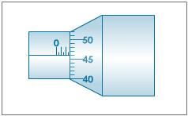
Reading =2.96mm√ 1mk
Actual diameter =2.96-0.25
= 2.71mm√
2. When washing clothes, it is easier to remove the dirt using soap in warm water than cold water. Explain. (1marks)

Warming lowers the surface tension of water increasing the wetting ability of water.

3. The diagram below shows a funnel inverted over a light pith ball on a table. Air is blown into the funnel as indicated on the diagram.
Air
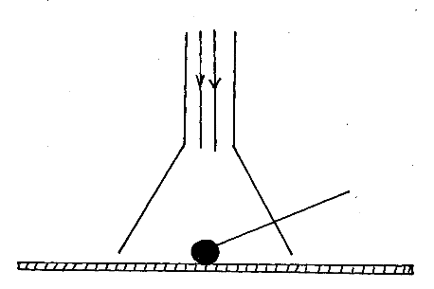

Pith ball

State and explain what is likely to be observed. (2 marks)
The pith ball rises
Air flows at higher velocity in the narrow section reducing the pressure. Pressure difference lifts the ball.
4. A car of mass 800 kg is initially moving at 25 m/s. Calculate the force needed to bring the car to the rest over a distance of 20 m. (3marks)
U=25,V=0,S=20 F=ma
V²=U²+2aS =800X-15.625
0=25²+2XaX20 =-12,500N
a=-625/40
=-15.625m/s

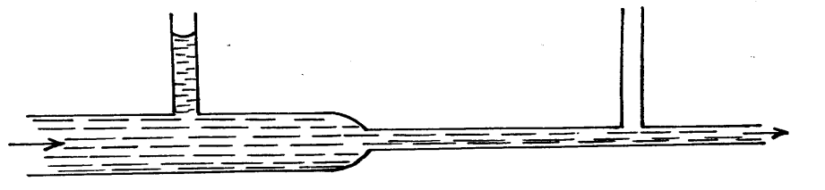
5. The figure below shows water flowing through two sections A and B of a pipe having x-sectional areas of 8cm² and 2cm², respectively.
B
A

- Mark the appropriate level of water in the manometer B (1mark)
Level below that of A

- ii) The velocity of water as it flows past the wider section of the pipe is 0.6ms⁻¹. Calculate the velocity at the narrower section. (2marks)
a₁ v₁ = a₂ v₂
8 x10 ⁻⁴ x 0.6 = 2 x 10 ⁻⁴ v₂
V₂ =8 x 0.6 /2
= 2.4 m/s

6. A piece of metal weighs 3N in air and 2N when totally immersed in water. Calculate the volume of the metal. (Density of water = 1000Kg/m³) (3marks)
Upthrust = 3N – 2N = 1N
Upthrust = weight of water displaced
1 = ρg v
1 = 1000x10xV
V= 1 x10⁻⁴ m³

7. On the axis provided below, Sketch velocity — time graph of a body moving down a viscous fluid. (1marks)

Velocity

Time

8. A uniform half meter rule is supported by force of 3N and 2N as shown in the figure below.
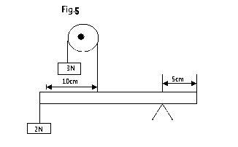

Determine the weight of the half meter rule (3marks)

MA = MC
(2 x 0.45 ) + (0.2W) = 3x 0.35
0.9 + 0.2W = 1.05
W = 0.15/0.2
= 0.75 N

9. Explain why water in a pond may freeze on the surface only but not deep inside the pond. (1mark)
Ice being less dense floats on the surface of the pod while warm water sinks at the bottom since its more denser.

10. A ball is thrown upwards and returns to its starting point after 6 seconds. Calculate the maximum height reached (g=10m/s²) (2marks)
a = -10 , V = 0 , t = 3 ,S= ?
U = V – at = 0 – (-10x3) = 30m/s
S = ut + ½ at²
= (30x3) + ½ x10 x 3²
= 90 - 45
= 45 m

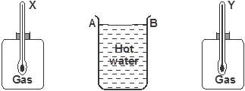
11.The figure below shows a cylindrical container having hot water at 95ºC. End A is shiny while end B is dull black. At equal distances from the container is placed two identical gas jars fitted with thermometers X and Y.

- Compare the readings of the two thermometers after two minutes (1 mark)
Thermometer Y reads a higher temperature than thermometer X

- Give a reason for your answer in (i) above (1 mark)
Dull black surfaces are better heat emitters than shiny surfaces.

12. Two ships moving parallel close to each other are likely to collide. Explain (1mark)

Air in between them moves at a higher velocity lowering the pressure below atmospheric pressure which pushes them together causing a likely collision.

13. State one physical property of a material medium which may be used to measure temperature. (1mark)
Wide range of temperature
Doesn’t wet glass

Section B (55 marks)

13. (a) Define the term heat capacity (1mark)

Heat energy required to change the temperature of a given mass of a body by one Kelvin

(b) You are provided with the apparatus shown in Fig 5 and stop watch
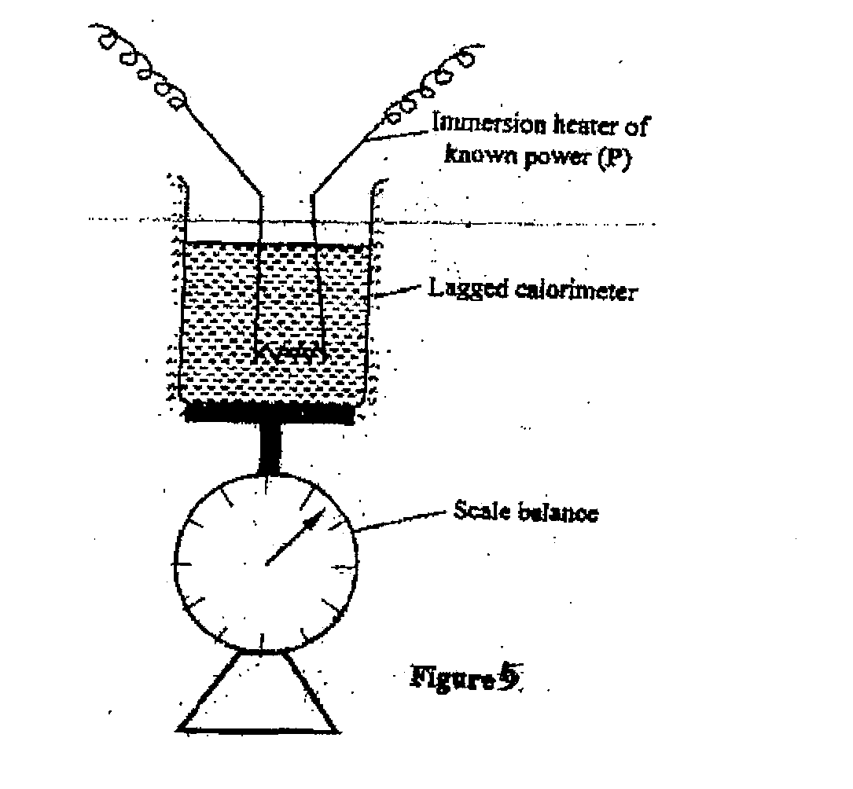

Describe an experiment to determine the specific latent heat of vaporization of water using the set up. In your answers clearly explain the measurements to be made and how these measurements would be used. (4marks)
Measurement of;
Initial and final masses of water and calorimeter √
Time taken to evaporate a given amount of water √
Determination of amount of water that evaporated. √
Equating heat given out by the heater=heat used to evaporate the calculated mass of steam.√
Pt = ml_{v}

(c) A block of metal of mass 150g at 100ºC is dropped into a lagged calorimeter of heat capacity 40JK⁻¹ containing 100g of water at 25ºC. The temperature of the resulting mixture is 34ºC. (Specific heat capacity of water=4200JK⁻¹)
Determine:
(i) Heat gained by calorimeter; (2marks)

C∆T=40x(34-25)=40x9=360J

(ii) Heat gained by water; (1mark)

M_{W}C_{W}∆ T

100x10⁻²x4.2x10³(34-25)=3780J

(iii) Heat lost by the metal block; (1mark)

360+3780
=4140J

(iv) Specific heat capacity of the metal block (3marks)
150x10⁻³xCmx66=4140

Cm = 4140
150x10⁻³x66

= 418J/kg/K

14. (a) In a car, the engine drives an alternator which produces electricity that lights the headlights. List the energy changes involved. (2marks)

Mechanical Electrical Light

(b) What is the power output of a pump which can raise 60kg of water to a height of 10m every minute? (2marks)
power = work done
time
= mgh
t
= 60 x 10 x 10
60
= 100J/S or 100W

(c) If the efficiency of the pump in 15(b) is 80%, how much power must be supplied? (2marks)

Efficiency = Work out put x 100
Work input
80% = 100W x 100
P
P = 10000W
80
= 125W

d) (i) The figure below shows an inclined plane and a load of mass 15kg pulled by an effort of 100N.
100N
) 30⁰
15kg

Find the efficiency of the machine (3marks)

M.A = $\frac{L}{E}$= $\frac{150}{100}$ = 1.5
Eff = $\frac{MA}{VR}$ x 100 = $\frac{1.5}{2}$ x 100 = 75%

(ii) a) Draw a single pulley arrangement with a velocity ratio of 2. (1mark)
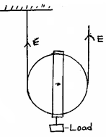

15(a) A glass capillary contains enclosed air by a thread of mercury 15cm long when the tube is horizontal, the length of the enclosed air column 24cm as shown.
24cm
15cm

- What is the length of the enclosed air column when the tube is vertical with the open end uppermost if the atmosphere pressure is 750mmHg? (2marks)

P₁V₁=P₂V₂
24×750= (750+15)V₂
V₂=$\frac{24×75o}{765}$ =23.53cm

- Explain why the mercury does not run out when the tube is vertical with the closed end uppermost. (1mark)
The mercury does not run out because the upwards atmospheric pressure in the mercury column is greater than the downward pressure due to the enclosed air and its own mass

b) Explain why an air bubble increase in volume as it rises from the bottom of a lake to the surface. (2 marks)

At the bottom of the lake, the bubble is under the pressure of water column + the atmospheric pressure on the surface of water. As the bubble rises the depth of the water column decreases resulting into a decrease in pressure which in turn causes a increase in volume since PV=a constant (Boyle’s law)

c) When an inflated balloon is placed in a refrigerator it is noted that its volume reduces, use the kinetic theory of gases to explain this observation. (2marks)

Low temperature reduces the kinetic energy of molecules which lead to lower rate of collision which results to reduction of pressure.

d) A certain mass of hydrogen gas occupies a volume of 1.6$m^{3}$ at a pressure of 1.5 × ${10}^{5}$ Pa and a temperature of 22⁰c. Determine the volume when the temperature is 0⁰c at a pressure of 0.8×10⁵ Pa. (3marks)

$\frac{P1V1}{T1}$=$\frac{P2V2}{T2}$
$\frac{1.5×{10}^{5}×1.6}{295}$=$\frac{0.8×{10}^{5}×V2}{273}$
V₂= 2.776cm³

- a) State Archimedes principle. (1 mark)

When a body is fully or partially immersed in a fluid it experiences an up thrust force equal to the weight of the fluid displaced√1

b) A block of wood measuring 0.8m by 0.5m by 2m floats in water. 1.2m of the block is submerged.(density of water is 1gcm³)

    - Determine the weight of the water displaced. (2 marks)

Weight = ρgV
= 1,000 x10 x (0.8x0.5x1.2)
= 4,800N

    - Find the force required to just make the block fully submerged. (3 marks)
Upthrust = ρgV
=1,000 x 10 x ( 0.8x0.5x2)
=8,000N

Extra force = 8,000 -4,800
=3,200N

e) A balloon weighs 10N and has a gas capacity of 2m³. The gas in the balloon has a density of 0.1kg/m³. If density of air is 1.3kgm⁻³, calculate the resultant force of the balloon when it is floating in air. (3 marks)
upthrust = ρgV
= 1.3 x 10 x 2
=26N
Weight of gas = ρVg
=0.1 x 2 x10
=2N
Total weight = 10+2 =12N
Resultant force = 26 – 12 =14N

17.(a) The moon goes round the earth at constant speed. Explain why it is true to say that the moon is accelerating. (1 mark)

The direction is continuously changing. This implies change in velocity hence acceleration.

(b) A string of negligible mass has a bucket tied at the end. The string is 60cm long and the bucket has a mass of 45g. The bucket is swung horizontally making 6 revolutions per second. Calculate:
(i) the angular velocity. (1 mark)

$$ω=2πf=2×3.142×6=37.704rad/s$$

(ii) the centripetal acceleration. (2 marks)

$a=\frac{v^{2}}{r}=rω^{2}=37.704×37.704×0.6=852.955m/s$²

(iii) the tension on the string. (2 marks)

$T=F$_{c}=$mrω$²$=0.045×0.6×37.704×37.704=38.38N$

(iv) the linear velocity. (1 mark)

$$V=rω=0.6×37.704=22.62m/s$$

- A ball of mass 100g is dropped from a height of 1.25m above the ground surface.
It rebounds to a height of 1.1m. Calculate

(i) Velocity of the ball before impact. (3 marks)

V² = U² + 2as ¹
U = 0
V² = 2 x 10 x 1.25 ¹
V = 5m/s ¹

- Force of impact if the ball is in contact with the surface for 0.2S (g = 10N/kg). (3marks)
¹
Rebound velocity = V
Kinetic energy = Potential energy gained
= 4.69m/s
¹ = -0.155N ¹

