**Name** …….……………………………………………..…… **Class** ………………………………………

**231/ 3 ADM NO** ………………….…...………..

**BIOLOGY**

**Paper 3**

**(Practical) Date** …………………..

**September, 2022**

1¾ hours

SUNRISE 2 EXAMINATION - 2022

FORM FOUR

***Instructions to candidates***

*Write your name and class in the spaces provided above.*

*Sign and write the date of examination in the spaces provided above.*

*Answer* ***ALL*** *questions in the spaces provided.*

*Additional pages* ***MUST NOT*** *be inserted.*

*Candidates will be penalized for incorrect spelling especially of technical terms and for use of slovenly language*

*You are required to spend the first* ***15 minutes*** *of the* ***1¾hours*** *allowed for this paper reading the whole paper carefully before commencing your work.*

**For Examiner’s Use Only**

|  |  |  |
| --- | --- | --- |
| **Question** | **Maximum**  **Score** | **Candidate’s**  **Score** |
| **1** | **12** |  |
| **2** | **15** |  |
| **3** | **13** |  |
| **Total score** | **40** |  |



***This paper consists of 6 printed pages.***

***Candidates should check the question paper to ascertain that ALL the pages are***

***Printed as indicated and no questions are missing***

1. You are provided with solution labeled **K**

(a) Using the reagents provided test for the food substances found in solution K. Record the food you have tested for, procedure observation and conclusion in the table below (10mks)

|  |  |  |  |
| --- | --- | --- | --- |
| Food substance | Procedure | Observation | Conclusion |
|  |  |  |  |
|  |  |  |  |
|  |  |  |  |
|  |  |  |  |

(b)(i) Name an enzyme that may be required to digest the food substance found in solution **K** in a human being. (1mk)

………………………………………………………………………………………………………………………………………………………………………………………………

(ii) State the name of the part of alimentary canal in which the enzyme named in (b)(i) above is found (1mk)

………………………………………………………………………………………………………………………………………………………………………………………………

1. **(a)** Study photograph **A** below which shows a plant specimen and an associated sisal pole study and answer the questions that follow

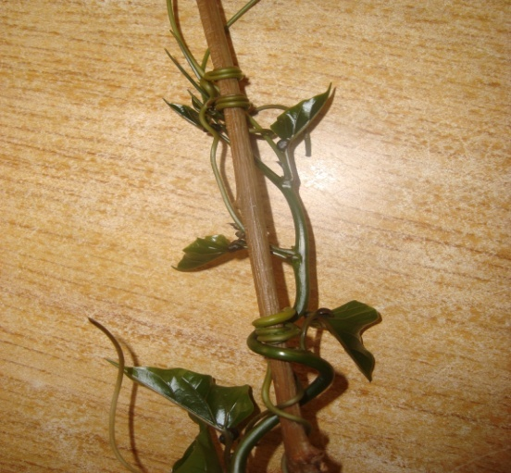

**A**

**Bamboo pole**

1. What name is given to the coiled part of the plant specimen shown in photograph**A**?

**(1 mark)**

……………………………………………………………………………………………………………

1. Name the type of response exhibited by the coiled part of the plant specimen in photograph **A** **(1 mark)**

……………………………………………………………………………………………………………

1. Specify the stimulus responsible for the response named in **(a)(ii)** above **(1 mark)**

……………………………………………………………………………………………………………

1. Explain how the response exhibited by the coiled part of the plant specimen in photograph **A** occurred **(3 marks)**

……………………………………………………………………………………………………………

……………………………………………………………………………………………………………

……………………………………………………………………………………………………………

……………………………………………………………………………………………………………

……………………………………………………………………………………………………………

1. State the biological significance of the response described in **(iv)** above to the survival of the plant **(1 mark)**

……………………………………………………………………………………………………………

……………………………………………………………………………………………………………

1. Study photographs **B1** and **B2** below carefully and answer the questions that follow. The part in **B2** was extracted from the specimen in**B1**

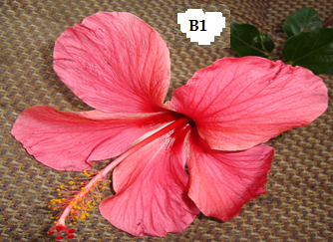 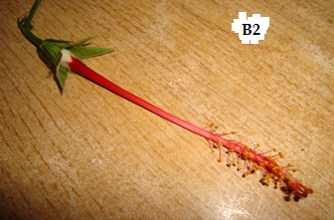

1. Identify the agent of pollination of the specimen shown in the photographs above

**(1mark)**

……………………………………………………………………………………………………………

1. Give a reason for your answer in **(b)(i)** above **(1mark)**

……………………………………………………………………………………………………………

1. Describe the pistil of specimen **B1 (2 marks)**

……………………………………………………………………………………………………………

……………………………………………………………………………………………………………

1. What is the name given to the type of pistil found in specimen **B1**? **(1 mark)**

……………………………………………………………………………………………………………

1. Describe the external features of the leaves of the plant from which specimen **B1** was obtained **(3marks)**

……………………………………………………………………………………………………………

……………………………………………………………………………………………………………

……………………………………………………………………………………………………………

1. The diagram below shows structures which occur in a mammalian kidney. Study the figure carefully and answer the questions that follow.

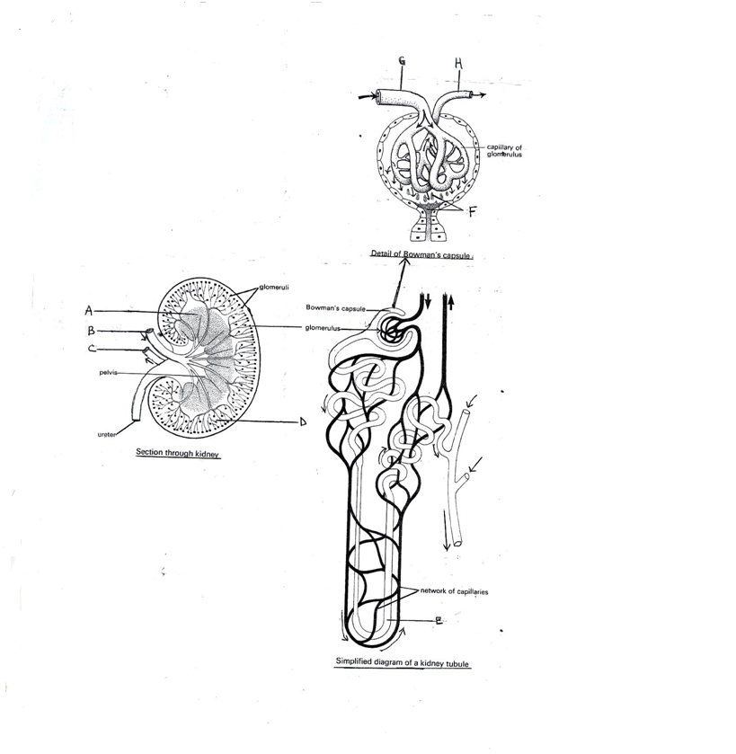

**A**

**B**

**C**

**Glomerulus**

**Detail of bowman’s capsule**

**D**

**Network of capsule**

**E**

**Simplified diagram of a kidney tubule**

**Capillary of glomerulus**



i) Name the parts marked ( 2 marks)

A........................................................................................................................................................

D........................................................................................................................................................

ii) Identify the blood vessels labeled: ( 4 marks)

B.........................................................................................................................................................

C.........................................................................................................................................................

G........................................................................................................................................................ H........................................................................................................................................................

b) i) Name the filtrate labeled F ( 1 mark)

........................................................................................................................................................................................................................................................................................................................

ii) Explain how the filtrate named in (b) (i) above is formed ( 3 marks)

................................................................................................................................................................................................................................................................................................................................................................................................................................................................................................................................................................................................................................................

c) Explain the difference in structure E in a desert and a fresh water animal. (2 marks)

....................................................................................................................................................................................................................................................................................................................................................................................................................................................................................

d) Name the hormone which regulates reabsorption of sodium ions in the kidney tubules. (1 mark) ........................................................................................................................................................................................................................................................................................................................