Name………………………………………………………ADM No……………………………………..….…….
School …………………………………………................. Class …………………..………………………

231/2
BIOLOGY
PAPER 2
(THEORY)
SEPTEMBER 2022
TIME: 2 HOURS

FORM FOUR

231/2
Biology
Paper 2
2 hours

INSTRUCTIONS TO CANDIDATES

- Write your name, index number and school in the spaces provided
- Sign and write the date the examination was done in the spaces provided
- This paper consists of two sections, section A and section B. Answer ALL the questions in section A in the spaces provided on the question paper. In section B, answer question 6 (compulsory) and either question 7 or 8 in the spaces provided after question 8
- Be brief and precise. Unnecessary information and wrong spellings especially of technical terms shall be penalized
- All answers must be written in the English language

FOR EXAMINER’S USE ONLY

QUESTION NUMBER | QUESTION | MAXIMUM SCORE | CANDIDATE’S SCORE
SECTION A | 1 | 08
 | 2 | 08
 | 3 | 08
 | 4 | 08
 | 5 | 08
SECTION B | 6 | 20
 | 7 | 20
 | 8 | 20
TOTALSCORE |  | 80

- The diagram below shows the exchange site between circulatory system and body cells.
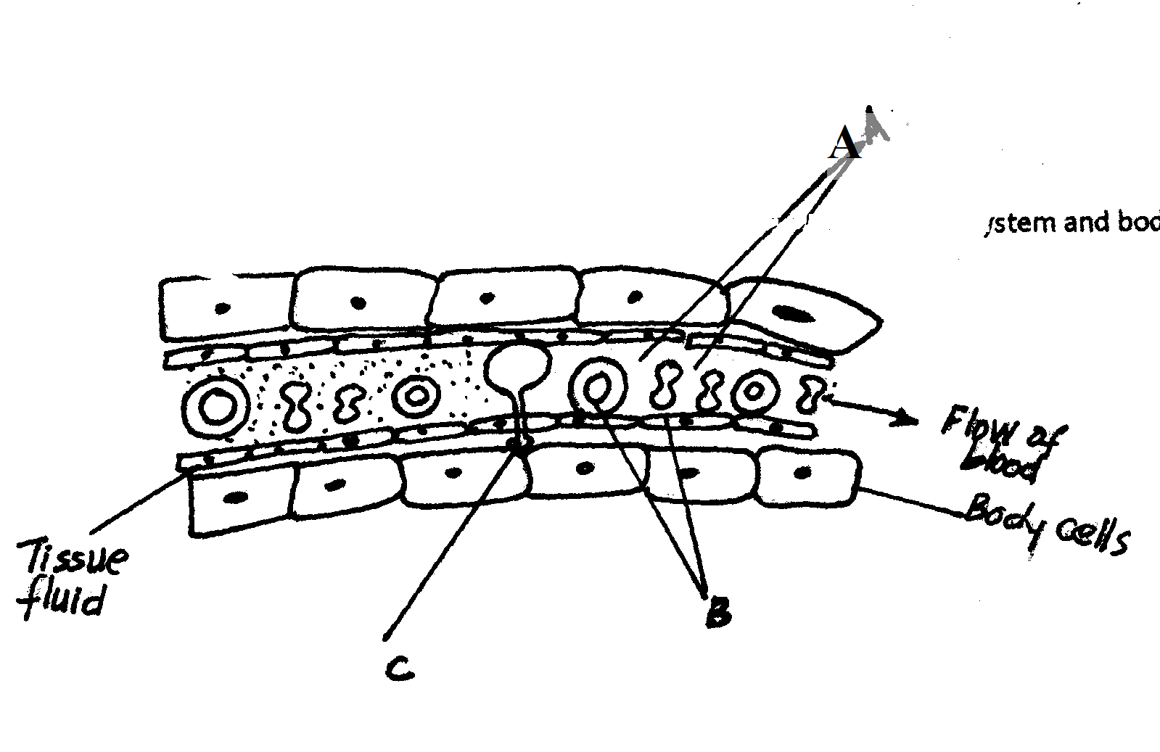
a) State two adaptations of the capillaries. (2mks)
........................................................................................................................................................................................................................................................................................................................................................................................................................................................................................................................................................................................................................................................................
b) (i) Name the blood cells labeled B. (1mk)
....................................................................................................................................................................................................................................................................................................................................
(ii) State the gas that diffuses from B to the tissue cells. (1mk)
....................................................................................................................................................................................................................................................................................................................................
c) State two functions of the part labeled A. (2mks)
......................................................................................................................................................................................................................................................................................................................................................................................................................................................................................................
d) Name the blood vessel with the highest concentration of;
Oxygen. (1mk)
....................................................................................................................................................................................................................................................................................................................................
Urea. (1mk)
....................................................................................................................................................................................................................................................................................................................................

- The diagram below shows how blood glucose in mammalian body is regulated.

Pancrease secretes

Rise Hormone X
Fall

Normal glucose level Normal glucose level
90mg/100ml 90mg/100ml

Fall rise

Less hormone X secreted
Hormone Y released

(a) Name the hormone X and Y (2mks)
X _______________________________________
Y _______________________________________
(b) State two ways by which hormone X lowers glucose level in the blood when it rises above 90mg/100ml (2mks)
.................................................................................................................................................................. ....................................................................................................................................................................................................................................................................................................................................
..................................................................................................................................................................
(c) Name the organ that produces hormone Y (1mk)
....................................................................................................................................................................................................................................................................................................................................
(d) Suppose there is deficiency of hormone X, state the disease the person would suffer
from (1mk)
....................................................................................................................................................................................................................................................................................................................................
(e) Explain how the disease mentioned in (d) above can be controlled. (2mks)
.................................................................................................................................................................. ....................................................................................................................................................................................................................................................................................................................................
..................................................................................................................................................................

- In human beings, a downward pointed frontal hairline (“windows peak”) is a heritable trait. A person with windows peak always has at least one parent who has his trait; whereas persons with frontal hairline may occur in families in which one or even both parents have windows peak. Using B and b to symbolize genes for this trait.
a) Determination the f1 generation if a homozygous windows peak male parent is married to a Homozygous frontal hairline female parent. (4mks)
................................................................................................................................................................................................................................................................................................................................................................................................................................................................................................................................................................................................................................................................................................................................................................................................................................................................................................................................................................................................................................................................................................................................................................................................................................................................................................................................................
b) State two causes of variations. (2mks)
........................................................................................................................................................................................................................................................................................................................................................................................................................................................................................................................................................................................................................................................................
c) Name two examples of discontinuous variation. (2mks)
......................................................................................................................................................................................................................................................................................................................................................................................................................................................................................................
- The drawing below represents a mature bread mould (rhizopus).Study it and answer the questions which follow.

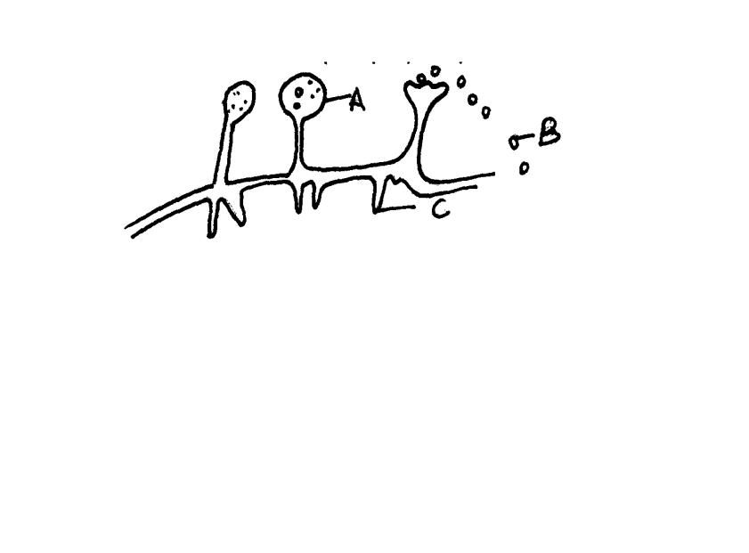

a) Name the structures labeled A, B and C. (3mks)
A......................................................................................................................................................
B ………………………………………………………………………………………………….
C.......................................................................................................................................................
b) Identify the type of asexual reproduction represented in the diagram (1mk)
....................................................................................................................................................................................................................................................................................................................................
c) Give one function of structure C. (1mk)
......................................................................................................................................................................................................................................................................................................................................................................................................................................................................................................
d) Define the term fertilization. (1mk)
......................................................................................................................................................................................................................................................................................................................................................................................................................................................................................................
e) Compare an ovum cell and a zygote. (2mks)
........................................................................................................................................................................................................................................................................................................................................................................................................................................................................................................................................................................................................................................................................
- The diagram below shows three different types of neurons along a reflex.
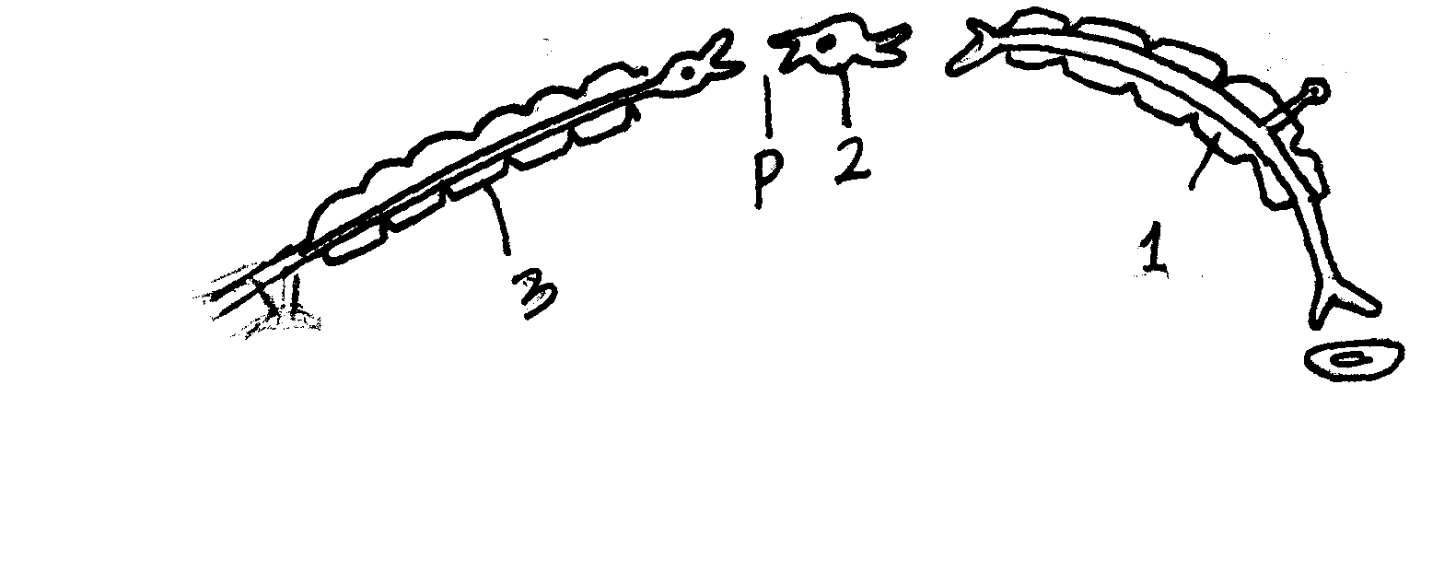
a) Identify the neuron labeled 1, 2 and 3 (3mks)
1..............................................................................................................................................
2..............................................................................................................................................
3............................................................................................................................................
b) Using arrow show the direction of impulse transmission on the diagram. (1mks)
c) Name the part of the spinal cord where the cell bodies of neuron 2 and 3 are located.
(1mk)
........................................................................................................................................................................................................................................................................................................................................................................................................................................................................................................................................................................................................................................................................d) Describe the transmission impulses across the part labeled P. (3mks)
..............................................................................................................................................................................................................................................................................................................................................................................................................................................................................................................................................................................................................................................................................................................................................................................................................................................................................................................................................................................................................................................................................................................................................................................

SECTION B
Answer question 6(compulsory) in the spaces provided and either question 7 or 8 in the spaces provided after 8.
- During germination and growth of a cereal, the dry weight of endosperm, the embryo and the total dry weight were determined at two day intervals. The results are shown in the table below:
Time after planting (days) | Dry weight of endosperm (mg) | Dry weight of embryo (mg) | Total dry weight (mg)
0 | 43 | 2 | 45
2 | 40 | 2 | 42
4 | 33 | 7 | 40
6 | 20 | 17 | 37
8 | 10 | 25 | 35
10 | 6 | 33 | 39
- Using the same axes, draw graphs of dry weight of endosperm, embryo and the total dry weight against time. (7marks)

- What was the total dry weight on day 5 (1mark)
........................................................................................................................................................................................................................................................................................................................................................................................................................................................................................................................
- Account for
- Decrease in dry weight of endosperm from 0 to 10 (2marks)
........................................................................................................................................................................................................................................................................................................................................................................................................................................................................................................................................................................................................................................................................................................................................................................................................................................................................
- Increase in dry weight of embryo from day 0 to day 10 (2marks)
........................................................................................................................................................................................................................................................................................................................................................................................................................................................................................................................................................................................................................................................................................................................................................................................................................................................................
- Decrease in total dry weight from day 0 to day 8 (1mark)
................................................................................................................................................................................................................................................................................................................................................................................................................................................................................................................................................................................................................................................................................................
- Increase in total dry weight after day 8 (1mark)
................................................................................................................................................................................................................................................................................................................................................................................................................................................................................................................................................................................................................................................................................................
- State two factors within the seed and two outside the seed that cause dormancy
- Within the seed. (2marks)
........................................................................................................................................................................................................................................................................................................................................................................................................................................................................................................................
- Outside the seed (2marks)
........................................................................................................................................................................................................................................................................................................................................................................................................................................................................................................................
- Give two characteristics of meristematic cells (2marks)
................................................................................................................................................................................................................................................................................................................................................................................................................................................................................................................................................................................................................................................................................................
- Explain how abiotic factors affect plants. (20marks)
- (a) Discuss eye accommodation. (10mks)
(b) Discuss the process of hearing in man. (10mks)

........................................................................................................................................................................................................................................................................................................................................................................................................................................................................................................................................................................................................................................................................................................................ ........................................................................................................................................................................................................................................................................................................................................................................................................................................................................................................................................................................................................................................................................................................................ ........................................................................................................................................................................................................................................................................................................................................................................................................................................................................................................................................................................................................................................................................................................................ ........................................................................................................................................................................................................................................................................................................................................................................................................................................................................................................................................................................................................................................................................................................................
........................................................................................................................................................................................................................................................................................................................................................................................................................................................................................................................................................................................................................................................................................................................ ........................................................................................................................................................................................................................................................................................................................................................................................................................................................................................................................................................................................................................................................................................................................
........................................................................................................................................................................................................................................................................................................................................................................................................................................................................................................................................................................................................................................................................................................................ ........................................................................................................................................................................................................................................................................................................................................................................................................................................................................................................................................................................................................................................................................................................................
........................................................................................................................................................................................................................................................................................................................................................................................................................................................................................................................................................................................................................................................................................................................ ........................................................................................................................................................................................................................................................................................................................................................................................................................................................................................................................................................................................................................................................................................................................ ........................................................................................................................................................................................................................................................................................................................................................................................................................................................................................................................................................................................................................................................................................................................ ........................................................................................................................................................................................................................................................................................................................................................................................................................................................................................................................................................................................................................................................................................................................ ........................................................................................................................................................................................................................................................................................................................................................................................................................................................................................................................................................................................................................................................................................................................ ..............................................................................................................................................................................

