BIOLOGY
Paper 2
THEORY
September - 2022
Time: 2 Hours
SUNRISE EXAMINATION-2022.
Form four

Marking scheme.
- a) Adaptations of capillaries.
-Their walls are made up of an endothelium only which allows only part of the blood to move into the intercellular spaces;
-They are numerous thus creating a large S.A for exchange of materials;
-Have narrow lumen that maintains high blood pressure;
-Have sphincter muscle at the arteriole end enabling regulation of blood flow;
b) (i) Blood cells labeled B.
Red blood cells;
ii) Oxygen gas;
c) (i) Transport of food nutrients;Metabolic wastes;antibodies involved in defense against diseases;
(ii) Distribution of body heat;
d) (i) Pulmonary vein;
(ii) Hepatic vein;
- (a) Gene for the window peak is dominant over gene for frontal hair lined.

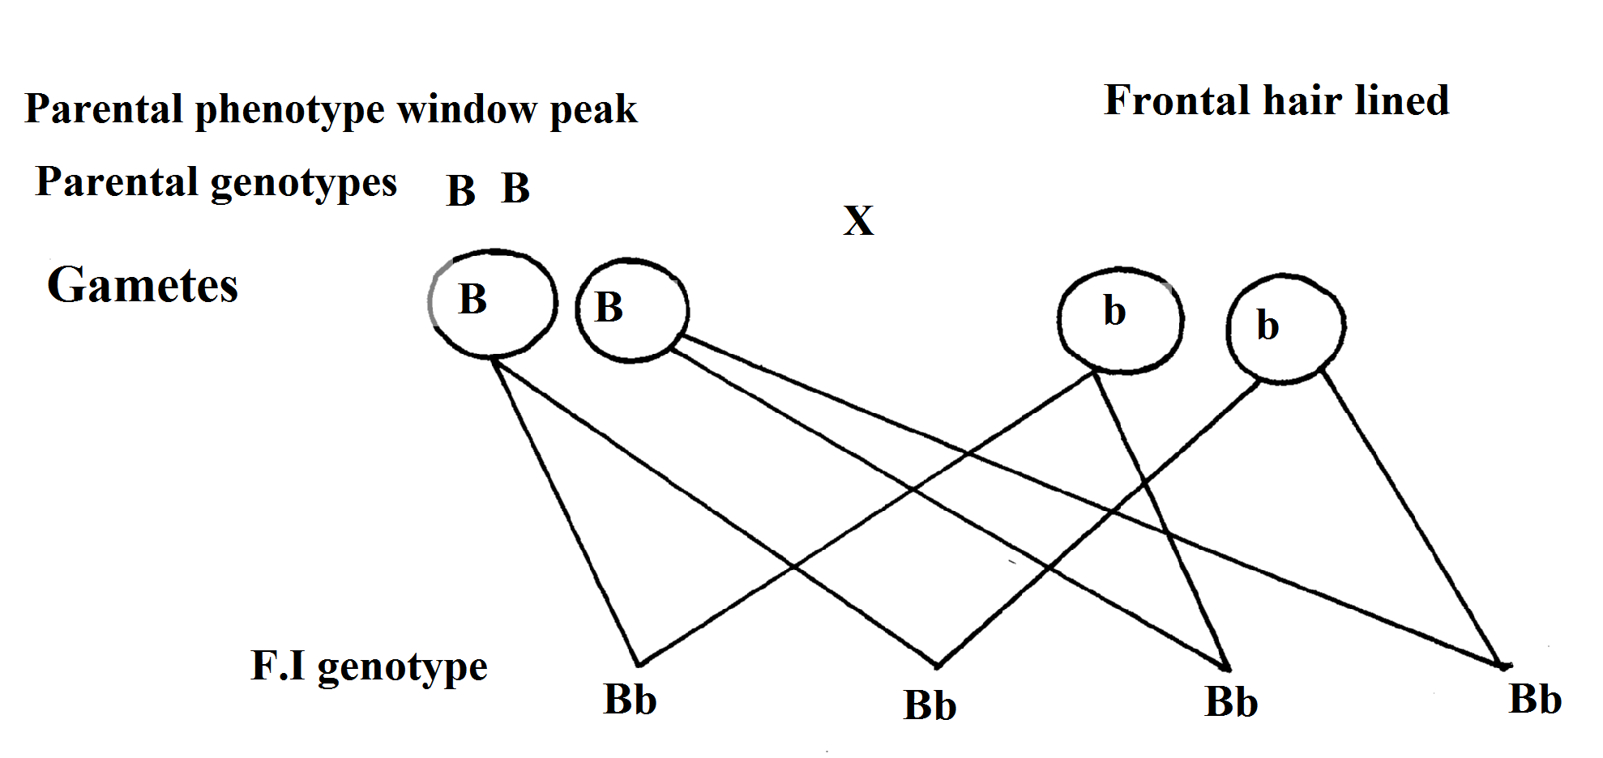
;
;
;
;

Accept pun net square but genotypes must be present in order to score.
b) 1. -Gamete formation-independent assortment;
-Crossing over;
2. -Fertilization;
3. -Mutations;

c) -Tongue rolling;
-Sex;
-ABO (blood group);
-Free ear lobe and attached one;
-Pawpaw (male and female pawpaw);
d) Are genes located on the sex chromosomes and are transmitted together with those that are transmitted together with those that determine sex;
- (a) X – Insulin;
Y – Glucagon;
(b) – Stimulates conversion of glucose to glycogen/fats;
- Oxidation of glucose to release energy;
(c) Pancreas;
(d) Diabetes mellitus;
(e) Regular insulin injection; with controlled diet and exercise;

- (a)
A-Sporangium;
B-Spore; (rej; spores)
C-Rhizoid; (rej. Rhizoids)
b) Sporulation/spore formation;
c) Absorption of water and mineral nutrients from decaying materials;
d) (i) Process by which female and male gamete nuclei fuse to form a diploid zygote;
(ii)
Ovum | Zygote
Haploid | Diploid;
Lower mass | Higher mass;

- (a) -Sensory /Afferent Neuron;
-Relay/intermediate Neuron;
-Motor/Efferent Neuron;

b)

(must be drawn)
c) Grey matter;
d) Impulse reaching the dendrite end of relay neuron causes the synaptic vesicle to release a acetylcholine;(transmitter substance) that diffuse across the cliff
;and causes the depolarization of the motor neuron;

- a) Graph
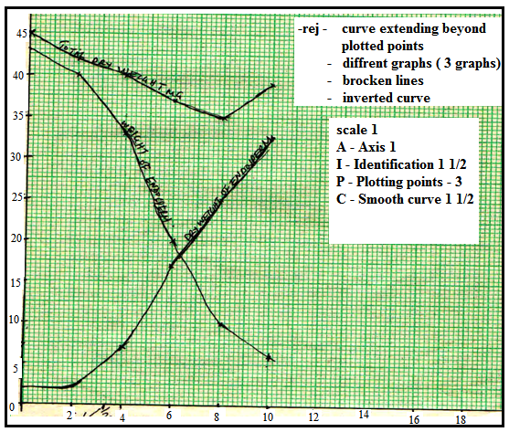

b) Total dry weight 38.5mg; acc ±0.5
c)
- Hydrolysis of starch into simple sugars/glucose which are translocated to the embryo;
Oxidation/respiration of( simple sugars) to the embryo;
CO2/energy/heat; acc water vapor
- New cells/tissues materials are synthesized (from proteins);bring about growth of embryo
- The rate of respiration is faster than that of synthesis of materials for growth;
- First leaf carried out photosynthesis; (leading to growth
d)

- Presence of absissic acid; (ABA)
- Presence of germination inhibitors;
- Embryo not fully developed/immature embryo;

✓ Absence of hormones/enzymes that stimulate germination;
Acc inactivity of hormones/enzymes inhibitors;
✓ Impermeable seed coat;
Acc for germination hormones such as cytokines, gibberellins;
i. Unsuitable temperatures/lack of suitable/unfavorable temperatures; absence of light; lack of O2 Rej lack of air
Lack of water
e)
• Dense cytoplasm; thin cell walls
• Absence of vacuoles (cell sap);
7.
• Wind;
Windy conditions transpiration;
Wind disperses fruits/seeds/spores; an agent of pollination;
• Temperature;
Change in temperature affect rate of photosynthesis/other biochemical reactions/ metabolic/enzymatic reactions; rise in temperature rises transpiration.
• Light;
(Green) plants need light for photosynthesis;
Some plants need it for flowering;
Some seeds (like lattice) require it for germination;
• Humidity
When humidity is low, transpiration rate rises;
• PH
Each plant requires specific PH to grow well;
Acidic or alkalinity or neutral
• Salinity
Plants with salt tolerant tissues (e.g. mangrove) grow in saline area; plants in estuaries adjust to salt fluctuations;
• Topography
North falling slopes in temperate lands have more plants than south facing slopes;
Windward side plants have stunted and distorted growth; leeward side plants are stunted/wind ward normal growth;
• Rainfall/water
Few plants in dry areas/where rainfall is less;
Water for germination;
Water as a raw material for photosynthesis;
Water as solvent for mineral salts;
Provides turgidity;
Water for dispersal;
A medium of transport of plant nutrients;
• Mineral salts
Plants thrive (grow well in soils with mineral salts)
Plants living in soil with deficiency of particular element have special methods of obtaining it. Legumes obtain nitrogen by nitrogen fixation /carnivorous plants/insectivorous plants, carnivorous trees obtain their nutrients from mycorrhizal association;
8. (a) Accommodation is the ability of the eye to focus both far and near objects;
For accommodation of a distant object ciway Muscles realx; creating a tension on suspensory ligametns /suspensory ligments contract; the lens become flattened otr less convex; minimizing the refractive power of lens; bringing light rays from afar object to focus on the retina;

For a accommodation of a neat object aliany muscles contracts relaxing lesion on suspensory ligametns/sensory ligaments spherical in shape; this increase the refractive power of lens; that brings light rays from a near object to focus on the retina;

(b) funnel shaped pinna collects sound waves; and directs them to the auditory meatus/ear drum;
Ear drum vibrates and transforms sound wave into vibrations; the vibrations core transmitted to the ear ossiclis where they are amplified and transmitted to the oral window. Vibrations front eh oral windo. Vibrations from the oral window creates pressure waves on the fluid/perlymph in cochlea; movement of fluid in cochlea causes sensory hairs to be stimulated /torched; generating an impulse; the impulse is transmitted to the brains via auditory nerve for interpretation on pitch. intensity and direction of sound;

