NAME ............................................................................ ADM NO. …………………..
SCHOOL ………………………………………………… CLASS …………………..
DATE …………………..

231/1
BIOLOGY
(THEORY)

PAPER 1
SEPTEMBER, 2022

TIME: 2 HOURS

SUNRISE 2 EXANINATION TERM TWO - 2022
FORM FOUR

231/1
BIOLOGY
(THEORY)
PAPER 1
TIME: 2 HOURS

INSTRUCTIONS TO CANDIDATES
- Write your name, school and admission number in the spaces provided above.
- Sign and write date of examination in the spaces provided above.
- Answer all the questions in the spaces provided.
- Additional pages must not be inserted.
- Candidates may be penalized for false information and even wrong spellings of technical terms.
- This paper consists of 8 printed pages.
- Candidates should check to ensure that all pages are printed as indicated and no questions are missing.

FOR OFFICIAL USE ONLY

Question | Maximum score | Candidate’s score
1 − 27 | 80

- Explain the meaning of the following branches of biology.
a) Cytology (1mark)
……………………………………………………………………………………………………………...
b) Mycology (1mark)
……………………………………………………………………………………………………………...
- State three reasons why it’s necessary to classify living organisms. (3marks)
……………………………………………………………………………………………………………...
……………………………………………………………………………………………………………...
……………………………………………………………………………………………………………...
……………………………………………………………………………………………………………...
- The diagram below represents a neuron.
D
A
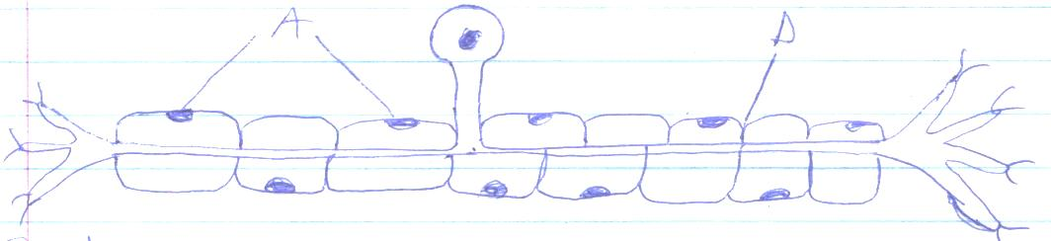
- i) Identify the neuron. (1mark)
……………………………………………………………………………………………………………...
ii) Give a reason. (1mark) ……………………………………………………………………………………………………………...
……………………………………………………………………………………………………………...
b) Identify the parts labeled A and D. (2marks)
A ………………………………………………………………………………………………………….
D ………………………………………………………………………………………………………….
c) State the function of neuron. (1mark) ……………………………………………………………………………………………………………...
……………………………………………………………………………………………………………...
- A form one student trying to determine the size of onion cells observed the following on a microscopes field of view.

If the student observed 2 cells across the field of view calculate the length of one cell in micrometers (3marks)
- The diagram below represents a certain organism collected by a student on his way to school
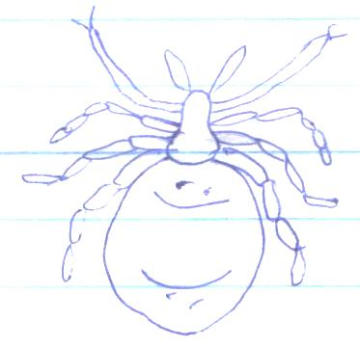
a) State the class to which the organism belongs (1mark)
___________________________________________________________________________________
- Give two reasons for your answer 5(a) above (2mark)
……………………………………………………………………………………………………………...
……………………………………………………………………………………………………………...
- What is meant by the following terms as used in ecology?
i) Biomass (1mark)
……………………………………………………………………………………………………………...
……………………………………………………………………………………………………………...
ii) Ecosystem (1mark)
……………………………………………………………………………………………………………...
……………………………………………………………………………………………………………...
- The diagram below represents a synapse
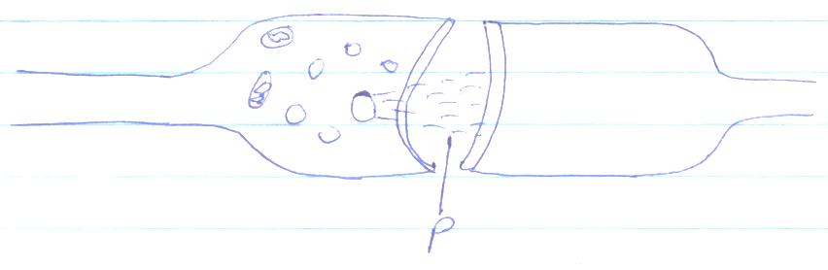
P
a) Indicate the direction of the impulse on the diagram (1mark)
b) State two significances of a synapse in the body (2marks)
……………………………………………………………………………………………………………...
……………………………………………………………………………………………………………...
……………………………………………………………………………………………………………...
- Name a tissue whose cells are thickened with
a) Cellulose and pectin (1mark)
……………………………………………………………………………………………………………...
b) Lignin (1mark)
……………………………………………………………………………………………………………...
- The diagram below shows the structure of an organelle
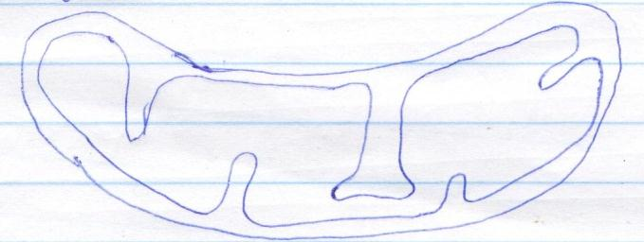
a) State the function of the organelle (1mark)
……………………………………………………………………………………………………………...
……………………………………………………………………………………………………………...
b) State one adaptation of the above organelle to its function (1mark)
……………………………………………………………………………………………………………...
……………………………………………………………………………………………………………...
- Give the function of the following cell organelles
- Lysosomes (1mark)
……………………………………………………………………………………………………………...
……………………………………………………………………………………………………………...
- Golgi bodies (1mark)
……………………………………………………………………………………………………………...
……………………………………………………………………………………………………………...
- The diagram below represents across section of a certain plant
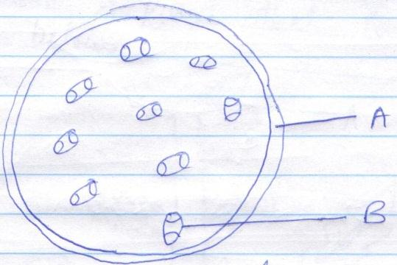
B
A
- Name the parts labeled A and B (2marks)
A …………………………………………………………………………………………………………..
B …………………………………………………………………………………………………………..
b) i) State the class to which the plant above belongs (1mark)
……………………………………………………………………………………………………………...

ii) Give a reason (1mark)
……………………………………………………………………………………………………………...
……………………………………………………………………………………………………………...
- During research on different types of plants students found a plant that looked like the one shown below
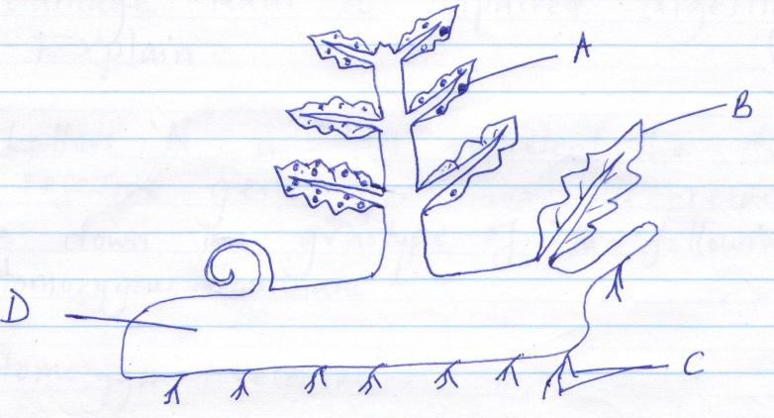
D
C
B
A
a) Identify the plant. (1mark)
……………………………………………………………………………………………………………...
……………………………………………………………………………………………………………...
- Name the parts labeled A, B, C and D. (4marks)
A …………………………………………………………………………………………………………..
B …………………………………………………………………………………………………………..
C …………………………………………………………………………………………………………..
D ………………………………………………………………………………………………………….
c) State the division to which the plant belongs. (1mark)
……………………………………………………………………………………………………………...
- Why do you think we experience more discomfort in hot humid weather than we do in hot dry weather (3marks)
……………………………………………………………………………………………………………...
……………………………………………………………………………………………………………...
……………………………………………………………………………………………………………...
……………………………………………………………………………………………………………...
- Explain why a water logged soil does not support plant growth. (3marks)
……………………………………………………………………………………………………………...
……………………………………………………………………………………………………………...
……………………………………………………………………………………………………………...
……………………………………………………………………………………………………………...

- Name the carbohydrate that is.
- Found in abundance in mammalian blood. (1mark)
……………………………………………………………………………………………………………...
b) Stored in a mammalian liver. (1mark)
……………………………………………………………………………………………………………...
- Liver damage leads to impaired digestion of fats. Explain. (2marks)
……………………………………………………………………………………………………………...
……………………………………………………………………………………………………………...
……………………………………………………………………………………………………………...
……………………………………………………………………………………………………………...
- The letters ‘N’ and n represents the dominant and recessive genes for hemophilia respectively.
Write down the genotype of the following (3marks)
- Homozygous dominant________________________________________________________________
- Homozygous recessive________________________________________________________________
- Heterozygote__________________________________________________________________
- Give three adaptations of human male gamete to its functions. (3marks)
…………………………………………………………………………………………………………………...……………………………………………………………………………………………………………...………………………………………………………………………………………………………...……………………………………………………………………………………………………………
- The diagram below represents a longitudinal section of a bean study it and answer the questions tha follow:
A
D
C
B
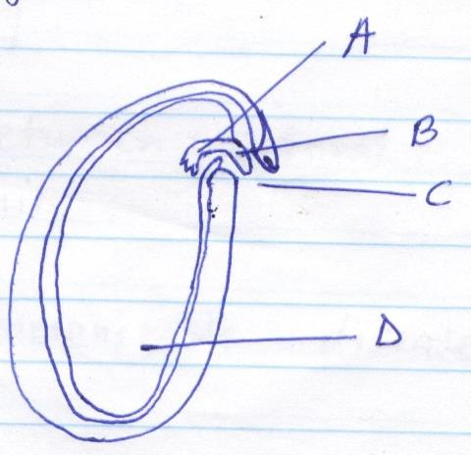
a) Identify the parts labeled A to D. (2marks)
A ______________________________________________________________________________
B ______________________________________________________________________________
C_______________________________________________________________________________
D ______________________________________________________________________________
b) Give the role of the plant labeled D. (1mark) ……………………………………………………………………………………………………………...
……………………………………………………………………………………………………………...
c) What type of germination would the seed shown above undergo? (1mark)
……………………………………………………………………………………………………………...
……………………………………………………………………………………………………………...
- a) A person who is blood group AB has an advantage over a person who is blood group O. Explain.
(2marks) ……………………………………………………………………………………………………………...
……………………………………………………………………………………………………………...
b) Give two reasons for screening blood before transfusion. (2marks)
……………………………………………………………………………………………………………...
……………………………………………………………………………………………………………...
- a) Define immunity. (1mark) ……………………………………………………………………………………………………………...……………………………………………………………………………………………………………...
b) Distinguish between natural immunity and acquired immunity. (1mark) ……………………………………………………………………………………………………………...
……………………………………………………………………………………………………………...
……………………………………………………………………………………………………………...
……………………………………………………………………………………………………………...
c) Identify one immunisable disease in Kenya. (1mark)
……………………………………………………………………………………………………………...
……………………………………………………………………………………………………………...
- State the causative agent of;
i) Cholera (1mark)
……………………………………………………………………………………………………………...
ii) Amoebic dysentery. (1mark) ……………………………………………………………………………………………………………...
……………………………………………………………………………………………………………...
- Explain why it difficult to calculate the respiratory quotient (RQ) in plants. (2marks) ……………………………………………………………………………………………………………...……………………………………………………………………………………………………………...
- The diagram below represents a stage in the development of human foetus.
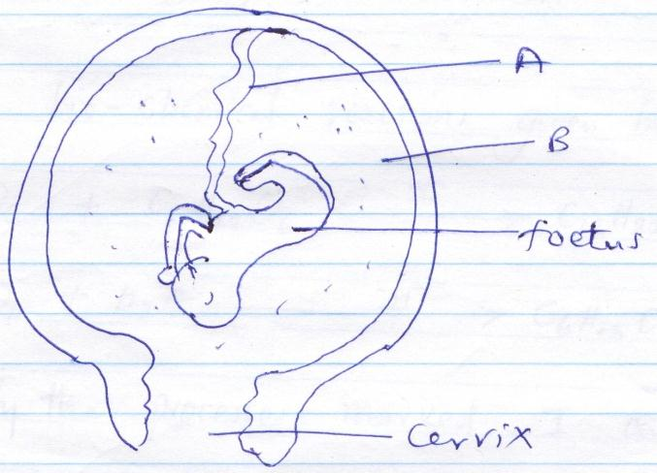
Cervix
Foetus
B
A
a) State one function of each of the structures labeled A and B. (2marks)
A _________________________________________________________________________________
_________________________________________________________________________________
B _________________________________________________________________________________
_________________________________________________________________________________
b) Apart from the size of the foetus what else from diagram illustrates that birth was going to occur in the near future.
……………………………………………………………………………………………………………...
……………………………………………………………………………………………………………...
- Give the reasons why Lamar’s theory on natural selection in organic evolution was discarde. (2marks) ……………………………………………………………………………………………………………...……………………………………………………………………………………………………………...
25. Explain why the following process is essential in living organism.
- Reproduction (1mark)
……………………………………………………………………………………………………………...
……………………………………………………………………………………………………………...

- Excretion (1mark)
……………………………………………………………………………………………………………...
……………………………………………………………………………………………………………...
- Explain why there are only a few days in each menstrual cycle when fertilization can occur. (2marks) ……………………………………………………………………………………………………………...……………………………………………………………………………………………………………...
- 27. Study the bio-chemical reactions given below.
I
C₆ H₁₂ O₆ + C₆ H₁₂ O₆ C₁₂ H₂₂ O_{n} + H₂O
II
C₁₂ H₂₂ O₁₁ + H₂O C₆ H₁₂ O₆ + C₆ H₁₂ O₆
- Identify the process marked I and II (2marks)
I _________________________________________________________________________________
II _________________________________________________________________________________
b) Explain how the process marked II can be carried out in a laboratory. (1mark)
……………………………………………………………………………………………………………...
……………………………………………………………………………………………………………...

