END OF TERM TWO 2021 EXAMINATIONS
FORM 4 BIOLOGY PAPER 3
NAME………………………………………………………………. ADM………………………
CLASS…………………………. DATE……………………...
231/3
BIOLOGY (PRACTICAL)
TIME: 1 ¾ HOURS

INSTRUCTIONS TO CANDIDATES
- Write your name and Admission Number in the spaces provided above.
- Read through the questions and understand them before answering.
- Answer ALL questions in the spaces provided.
- ALL answers must be clear, precise and in correct English

FOR EXAMINER’S USE ONLY
QUESTION | MAXIMUM SCORE | CANDIDAT’S SCORE
1 | 12
2 | 16
3 | 12
TOTAL | 40

This paper consists of 5 printed pages. Candidates should check the question paper to ascertain that all pages are printed as indicated and no questions are missing.

- You are provided with a photograph of a living organism below. Study it carefully and answer the questions that follow.

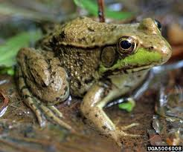
E

- Name the class to which the organism belongs. (1mk)
………………………………………………………………………………………….
- State two observable features from the photograph for your answer in (a) above. (2mks)
……………………………………………………………………………………………………………………………………………………………………………………
- Name any two organs used for gaseous exchange by the organism in the photograph above. (2mks)
……………………………………………………………………………………………………………………………………………………………………………………
- Give three reasons why the above organism is said to be the most advanced among other organisms in its class. (3mks)
………………………………………………………………………………………………………………………………………………………………………………………………………………………………………………………………………………
- What is the function of the part labelled E? (1mk)
…………………………………………………………………………………………
- State three similarities between organisms of the class identified in (a) above and reptiles. (3mks)
………………………………………………………………………………………………………………………………………………………………………………………………………………………………………………………………………………………………………………………………………………………………………………………………………………………………………………………………………………………………………………………………………………………………
- You are provided with 10% glucose solution, 2 grams of substance P, lime water, a delivery tube connected to a cork, boiling tube, liquid paraffin, hot water bath maintained at 35⁰C, measuring cylinder and a means of timing.
Put 20ml of 10% glucose solution into the boiling tube and add substance P. On top of this mixture, add a thin layer of liquid paraffin and set up the apparatus as shown below.
Liquid paraffin
Substance P and 10% glucose solution
Lime water

Then place the boiling tube in the hot water bath provided and maintained at 35⁰C. Allow the set-up to stand in the hot water bath for 30 minutes.

- Record your observations after 30 minutes in the table below. (4mks)
Observation | Conclusion
- Name the process that took place in the boiling tube. (1mk)
…………………………………………………………………………………………..
- A drop of the contents in the boiling tube was placed on a microscope glass slide, observations made and recorded as in the photograph below.

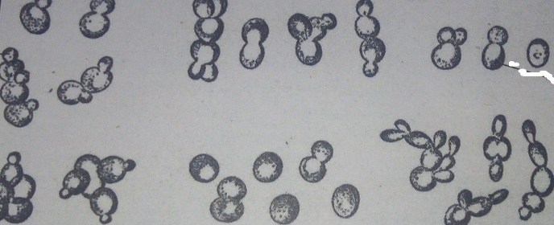
A₂

A₁
Name the parts labelled;
A₁ ………………………………………………………………………. (1mk)
A₂ ………………………………………………………………………. (1mk)
- Identify the substance labelled P? (1mk)
……………………………………………………………………………………….
- Explain the expected results if the experiment was carried out at different temperatures as follows. Give a reason for each case.
- 5⁰C
Expected results (1mk) ……………………………………………………………………………..........
Reason (1mk)
…………………………………………………………………………………..
- 65⁰C
Expected result(s) (1mk)
……………………………………………………………………………..........
Reason (1mk)
…………………………………………………………………………………..

- You are provided with a specimen labelled S. Use it to answer the questions that follow.
- Using a sharp scalpel provided, make a transverse section of the specimen S. Observe the section and draw a well labelled diagram of the observed features. Show your magnification. (4mks)

- You are provided with a small beaker, test tubes, droppers, test tube holder, white tile and means of heating. You are also provided with iodine solution, Benedict’s solution and DCPIP. Squeeze some juice from the specimen into the beaker. Label it J using a label provided

Using the reagents provided and the juice labelled J, carry out tests to determine type of food present in the specimen. Fill the table below appropriately. (12mks)
Test | Procedure | Observation(s) | Conclusion

THIS IS THE LAST PRINTED PAGE

