END OF TERM TWO 2021 EXAMINATIONS
FORM 4 BIOLOGY PAPER 3
MARKING SCHEME

231/3
BIOLOGY (PRACTICAL)
MARKING SCHEME

INSTRUCTIONS TO CANDIDATES
- Write your name and Admission Number in the spaces provided above.
- Read through the questions and understand them before answering.
- Answer ALL questions in the spaces provided.
- ALL answers must be clear, precise and in correct English

FOR EXAMINER’S USE ONLY
QUESTION | MAXIMUM SCORE | CANDIDAT’S SCORE
1 | 12
2 | 16
3 | 12
TOTAL | 40

This paper consists of 5 printed pages. Candidates should check the question paper to ascertain that all pages are printed as indicated and no questions are missing.

- You are provided with a photograph of a living organism below. Study it carefully and answer the questions that follow.

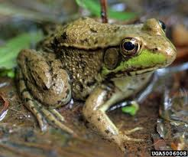
E

- Name the class to which the organism belongs. (1mk)
Amphibia; Rej; if begins with small a or wrong spelling or Amphibians
- State two observable features from the photograph for your answer in (a) above. (2mks)
- Has two eyes with eardrum; (acc: tympanic membrane) behind them
- Has (four) well developed limbs for movement
- Name any two organs used for gaseous exchange by the organism in the photograph above. (2mks)
- Lungs
- Skin
- Lining of mouth/buccal cavity
- Give three reasons why the above organism is said to be the most advanced among other organisms in its class. (3mks)
- Stays more on land than in water
- Uses lungs more than the skin for gaseous exchange
- Its skin is less moist and can withstand dry conditions
- What is the function of the part labelled E? (1mk)
Converts sound waves into mechanical vibrations in order to perceive sound
- State three similarities between organisms of the class identified in (a) above and reptiles. (3mks)
Both have double circulatory systems;
Both lay eggs; for reproduction
Both have three chambered hearts (with two atria and one ventricle) apart from crocodiles;
Both are ectothermic;

Rej: If the term both is omitted (because it is comparison of two classes)
- You are provided with 10% glucose solution, 2 grams of substance P, lime water, a delivery tube connected to a cork, boiling tube, liquid paraffin, hot water bath maintained at 35⁰C, measuring cylinder and a means of timing.
Put 20ml of 10% glucose solution into the boiling tube and add substance P. On top of this mixture, add a thin layer of liquid paraffin and set up the apparatus as shown below.
Lime water
Substance P and 10% glucose solution
Liquid paraffin

Then place the boiling tube in the hot water bath provided and maintained at 35⁰C. Allow the set-up to stand in the hot water bath for 30 minutes.

- Record your observations after 30 minutes in the table below. (4mks)
Observation | Conclusion
Bubbles formed/Effervescence takes place | There is production of (Carbon (IV) Oxide) gas
White precipitate/white suspension is formed in limewater | Gas produced is carbon (IV) Oxide which reacts with limewater; to form white precipitate  Acc: calcium carbonate; CaCO₃
- Name the process that took place in the boiling tube. (1mk)
Anaerobic respiration/Alcoholic fermentation; Rej: Respiration alone
- A drop of the contents in the boiling tube was placed on a microscope glass slide, observations made and recorded as in the photograph below.

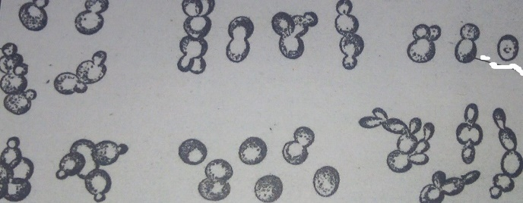
A₁
A₂

Name the parts labelled;
A₁ Parent cell (1mk)
A₂ Bud (1mk)
- Identify the substance labelled P? (1mk)
Enzyme/ Yeast
- Explain the expected results if the experiment was carried out at different temperatures as follows. Give a reason for each case.
- 5⁰C
Expected results (1mk) Low rate of reaction/ less carbon (IV) oxide produced
Reason (1mk)
Enzyme/Yeast deactivated by very low temperature. (Rej; if the word very is omitted)
- 65⁰C
Expected result(s) (1mk)
Reaction stopped/ No carbon (IV) oxide produced/ No effervescence/bubbling (OWTTE) Rej: Low rate of reaction/ Less carbon (IV) produced; No observable change
Reason (1mk)
Enzyme/Yeast destroyed/denatured by very high temperature.

- You are provided with a specimen labelled S. Use it to answer the questions that follow.
- Using a sharp scalpel provided, make a transverse section of the specimen S. Observe the section and draw a well labelled diagram of the observed features. Show your magnification. (4mks) D$√$ 1mk; L $√$ Any 3 = 3mks (Total = 4mks)
$$√$$
$$√$$
$$√$$
$$√$$
$$√$$
$$√$$
E.g. Magnification = X ½ or any other relevant figure. (Not part of marking in this paper but important to always indicate)
NB: The diagram mark scores only when;
- It has two continuous outer lines and outline for all other structures is continuous.
- Label lines are continuous, touching the intended structure, not crossing one another and not arrows
- It has no shading.
Please note that unless it is a wrong diagram, a student may miss a the diagram mark but score on labels. Wrong diagram constitutes;
- Diagram of other parts of plant or animals other than fruit or a longitudinal section of the fruit.

- You are provided with a small beaker, test tubes, droppers, test tube holder, white tile and means of heating. You are also provided with iodine solution, Benedict’s solution and DCPIP. Squeeze some juice from the specimen into the beaker.
Using the reagents provided and the juice squeezed, carry out tests to determine type of food present in the specimen. Fill the table below appropriately. (12mks)
Test | Procedure | Observation(s) | Conclusion
Iodine/Starch test | Put some juice J in a clean test tube. Add iodine solution to the juice J.  Rej; Wrong procedure (for all procedures) and don’t continue marking other columns | Color of Iodine retained/persists | Starch absent  Rej; Absence of starch
DCPIP/Ascorbic acid/Vitamin C test | Put some DCPIP in a clean test tube. Add the juice J dropwise while shaking and observe. | DCPIP is decolorized/turn from blue color to colorless | Ascorbic acid/Vitamin C present.  Rej; Presence of……….
Benedict’s/Reducing sugars test  Rej; if started with a small b | Put some juice J in a clean test tube. Add equal amount of Benedict’s solution. Heat the mixture to boil/boiling.  Rej; if equal is omitted | Color changes to orange/red/brown.  NB: If a students commits to write all the colors, the sequence MUST be correct….color changes to green, yellow and orangered/brown. | Reducing sugars present.  Rej; Presence of……….
THIS IS THE LAST PRINTED PAGE

