NAME: ………………………………………………………………………ADM NO: ….......
SCHOOL: ……..……………………………………………………………….DATE: …………
CANDIDATE’S SIGNATURE…………………..
ASUMBI GIRLS HIGH SCHOOL
PRE-MOCK
MAY-JUNE
2022

Kenya Certificate of Secondary Education (K.C.S.E.
BIOLOGY PAPER THREE 231/3
TIME 1HOUR 45 MINUTES

INSTRUCTIONS TO CANDIDATES
- Write, index number and admission number in the spaces provided at the top of this page.
- Sign and write the date of examination in the spaces provided above.
- Answer ALL the questions.
- You are required to spend the first 15 minutes of the 1¾ hours allowed for this paper reading the whole paper carefully before commencing your work.
- Answers MUST be written in the spaces provided in this question paper.
- Additional pages MUST NOT be inserted.
- This paper consists of five (5) printed pages.
- Check the question paper to ascertain that all the pages are printed as indicated and that no questions are missing.
FOR EXAMINERS USE ONLY
Question | Maximum Score | Candidate’s Score
1 | 13
2 | 11
3 | 16

1. You are provided with Specimen K .Carefully cut a transverse section through specimen K using a scalpel provided.

- (i) By observing one of the two halves of specimen K, Give two reasons to prove that specimen K has axile placentation (2mks)

…………………………………………………………………………………………….

…………………………………………………………………………………………….

(ii) Squeeze some juice from specimen K into 100ml beaker provided and label it as juice K. using a portion of juice K, carry out the food test using the reagents provided and complete the table below. (NB preserve the remaining portion of juice K for use in question 2.) (8mks)

Food substance | Procedure | Observation | conclusion

(iii) Name the deficiency disease that results from lack of the food substance present in juice K.
(1mk)
…………………………………………………………………………………………………..

(iv) Highlight two symptoms of the disease named in (a) (iii) above . (2mks)

………………………………………………………………………………………………….

…………………………………………………………………………………………………..

………………………………………………………………………………………………
……………………………………………………………………………………………………

2. Put 2cm³ of liquid labelled C into a test tube. Draw some of the juice from specimen K into a dropper. Add 4 drops of the juice into the test tube with solution C and shake.
(a) (i) State your observation. (1mk)

……………………………………………………………………………………………

(ii) State the part of the human body where the process demonstrated above occurs and the enzyme that carries out the process.

Part of body…………………………………………………………………………..……. (1mk)

Enzyme…………………………………………………………………….………………. (1mk) (iii) Which gland produces the enzyme stated in (a)(ii) above? (1mk)
…………………………………………………………………………………………………
(b) Take a small amount of substance B provided and add to it 2cm³ of sodium hydrogen carbonate solution.
(i) State your observations (1mk)
………………………………………………………………………………………………..
(ii) Which process in the body is illustrated above? (1mk)
………………………………………………………………………………………………..
(iii) State the part of the body where the above process takes place (1mk)
……………………………………………………………………………………………… (iv) State two functions of substance B in the body (2mks

(v) Name two diseases of the circulatory system caused by excess cholesterol in food. (2mks)
3. (A) photograph J shows the circulatory system of organism represented by photograph G.

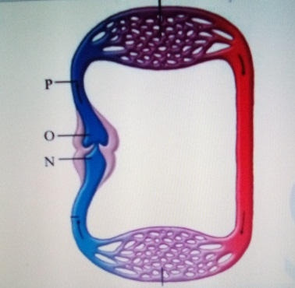
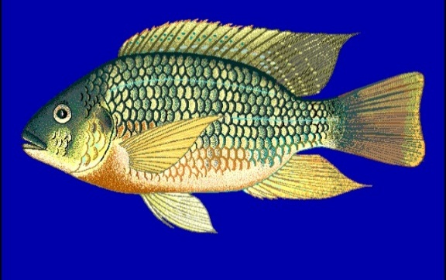

M

J G

Systemic circulation

(i) Giving two reasons to your answer name the class to which specimen G belongs.
Class…………………………..……………………………………………….. (1mk)
Reasons………………………………………………………………………… (2mk)
……………………………………………………………………………….
……………………………………………………………………………….

(ii) Name the part labelled: M…………………………………………….………….. (1mk)
N………………………………………………..…….…. (1mk)
O ……………………………………………….……..… (1mk)
(iii) Giving one reason to your answer state the type of closed circulatory system shown by photograph J

Type of circulatory system…………………………………………………………..… (1mk)
Reason……………………………………………………………………………….….(1mk)

(iv) State two features of specimen G that enhances its streamlined shape (2mks)
………………………………………………………………………………………
……………………………………………………………………………………..

(B) Below are photographs of Venus flytrap (an insectivorous plant). Study them and answer the questions that follow.
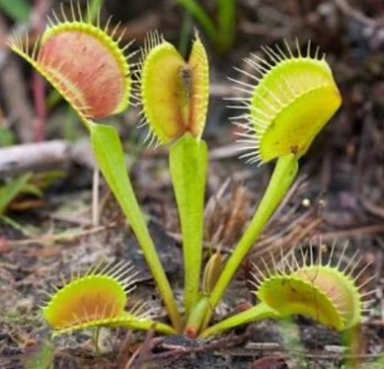
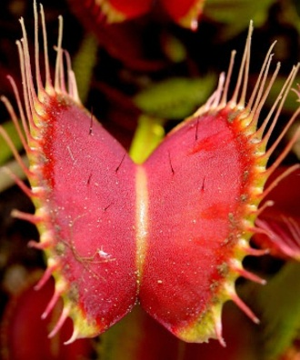
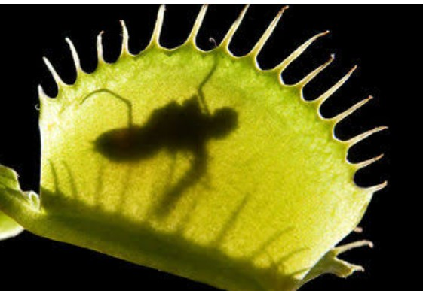
A B C
Trapped insect
Spines
Sensitive hairs

(i) Name one major nutrient that is deficient in the soil where the above plant grows. (1mk)
…………………………………………………………………………………………………
(ii) Name the type of response shown by plate C (1mk)
…………………………………………………………………………………………………..

(iii) Describe how the above plant trap the insect (4mks)
…………………………………………………………………………………………………
………………………………………………………………………………………………….
………………………………………………………………………………………………….
………………………………………………………………………………………………….
………………………………………………………………………………………………

