END OF TERM TWO 2021 EXAMINATIONS
FORM FOUR BIOLOGY PAPER 2MARKING SCHEME
1. (a)Osmosis; (1mk)
(b) (i) Isotonic solution; (1mk)
(ii) Hypotonic solution; (1mk)
(c)Feeding in insectivorous plants;
- Absorption of water from the soil;
-Support;
- Opening and closing of stomata;
(3mks) mark 1st three
(d) (i) Possession of electric charges /polarity; 1mk
9ii)Semi-permiability;1mk
2 (a)Moist surfaces;Rj moist alone
Numerous to increase surface area for gaseous exchange.
Highly vascularised;OWTTE.
Large surface area /enlongated;
Thin membrane /one cell thick; 2mks (mark 1st two)
(b)(i) From contaminated surfaces then transferred to mouth /nose/eyes;(through hands)
-Inhaling air contaminated with droplets and small particles containing the virus; 1 mk
(ii) (a)Filter out particles containing the virus from inhaled /exhaled air reducing infection; 1mk OWTEE
-Limit the volume and travel distance of expiratory droplets when talking or breathing ; OWTTE 1mk
(b)Kill the virus /soap dissolve virus lipid coat hence killing it ;1 mk
(c) (i)Medulla oblongata; (1mk
(ii)Mycobacterium tuberculosis; 1mk
3.(ii) Presence of abscisic acid /germination inhibators;
Embryo not fully developed;
Impermeamble seed coat;
-Embryo destroyed by pest;
Absence of growth promoters/
Enzymes that control germination;
Mark 1st three 3mks
(ii)Hydrolysis of stored food;
Transport medium ;
Soften seed coat;
Unfavourable temperature 2mks mark 1st two
(iii) The tip of the shoot containing auxin was removed ;apical growth takes place only at the tip under influence of auxin; Hence apical dorminance removed 3mks
4 . (a) (i)Anlogous structure; 1mk
(ii)convergent evolution; 1mk
(b)This is the process where nature selects organisms with favourable characteristics /traits well adapted to prevailing environmental conditions survive; reach adulthood and reproduce giving forth offsprings that inherit the favourable characteristics ;while those with unfavourable characteristics do not survive the competition die young and their genes are eliminated from nature; 3 mks

(c) (i)The malaria parasite (plasmodium) mutated and become resistant to the drug. This characteristics are transmitted to the offspring ;(survive in presence of the drug) 2mks
(iii)Erect posture/upright /bipedal gait;
-Enlarged brain capacity /higher intellectual capacity.
-Communication through speech /language
-Prehensible fore limb
-Binocular vision;
Mark 1sttwo 2mks
5.(a) (i)Mode -:Herbivory Rj herbivore
Reasons-:Lack of upper incisors/presence of a horny pad
-Presence of diastema;1mk
(ii)horny pad;1mk
b.(i) (paucreatic )Amylase;
(ii)trypsin;1mk
6.(a)Scale 2mks
Axis 2mks
Plotting 2mks
Curve 1mk
Labeling 1mk
8mks

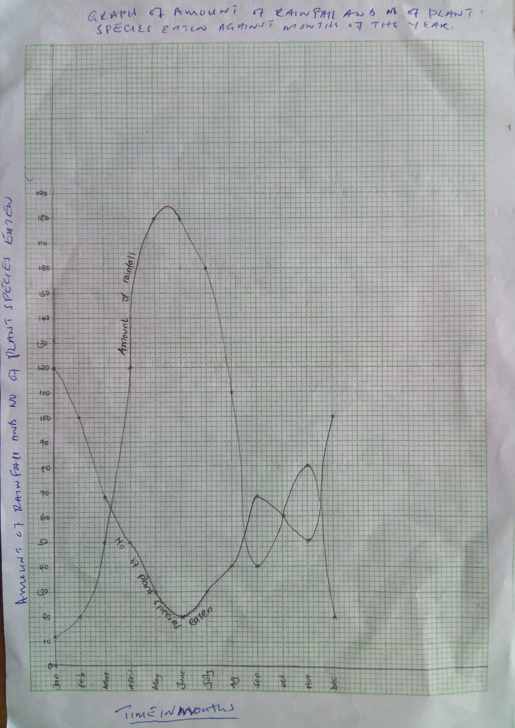
(b)June ;rainfall highest so productivity per plant species highest / abundant food; so mammals eats its most favourable plant species only;3mks
(c)The number of plant species eaten is highest /high ;There is less rain during the months so less amount of food available /less productivity per plant species ;forcing the animals to eat a number of different species to meet its food requirement; (3mks)
(c)The animal is able to obtain its dairy fopod requirements irrespective of seasonal charges; 1mk
(d)Observe and record plant species eaten /Analyse the animals dropping ;Fistulation; 2mks

7..applicationof geneticknowledge today.
(i)Inbloodtransfusion.;
Bloodtyping ABantigenandrhesusantigen isnecessarytoensurecompatibility ofrecipient'sand donor's bloodtoprevent agglutination.;

ii)Geneticcounselling.:
Where couplesareadvisedonchancesofoffspring's inheriting hereditary disease~e.g. Sicklecell anemia, hemophilia, albinism etc.;

Alsosomehereditary disordersarescientifically explainecd e.g.hemolytic diseaseofthe newborn,
turners' syndrome andDownsyndrome. J

iii)Insolvingdisputed parentage.;
Theknowledge ofbloodgroupsinheritance andDNAmatching arebeingusedassupportive evidencein courtswhere parentage isdisputed.:,-

iv)Inplantsandanimal breeding._;
Bettercropsandlivestockareselectedthencrossedrespectively toproduce individuals with better . performance/ higherheterozygozity/ higherhybrid.;

v)Inmediciner
I
Inmedicine anorganismcalledEscherichiacoliE.coli hasbeenmodified toproduce a hormone called
somatotrophin forthetreatment ofdwarflsrn.z
/ .
Thefungus(yeast)hasbeenmodified toproduceanti-hepatitis-B vaccine.;
Insheepthere hasbeenmodification toproducemilkwith medicinal proteins torelief h~mophilia and
emphysema.; "
Ingenetherapy wherefaulty genesarereplacedwith normalonestocorrect genetic disorders'e.g. Lung
cysticfibrosis. ; '

vi)lntheenvironment.;
Agenetically modified pseudomonous bacterium capableofbreakingdown synthetic hydrocarbon has beendeveloped tocontrol pollution.;

vii)Incrimedetection.z

DNA/finger printing fromthesceneofcrimeandsuspectshairsorbloodsamplesorsemenfrom thesuspectshasbeenusedtoidentify criminals.;

viii) Incloning.;
Ithasbeenusedtoasexually(without fertilization) producing genetically identical offsprings e.gdolly thesheep.;Clonescan beusedtoproduce humanspareparts.;

ix)Inagriculture;
Intissueculture newvarieties ofpyrethrum, bananahasbeenproduced.
x]Ingenetic engineering.;
Desirable genes are identified,altered,isolated and transferred; (to another organism)
8.Xerophytes
-Roots extensively developed /superficial roots ;to provide large surface area;
Roots grow deep/long roots;to reach water source deep in the ground;
-Sacculent /fleshy/possession of water storage tissues ;to store water /to survive drought;
-possession of thick waxy cuticle;
-hairly leaves;sunken stomata;
Reduced leaf size /spines /scales/thorns/reduced number of stomata/needle shaped leaves;
Rolled leaves Acc folded leaves; shedding of leaves;
-rolled leaves Acc folded leaves;s hedding of leaves;
Reversed stomatal rhythm; to reduce rate of transpiration;
-short life cycle /quick growth after rain; to make use of available water quickly; 16mks max 13
Hydrophytes
Aerenchyma/air spaces /large intercellular spaces/long fibrous roots ;for bouyency/floating in water;
Poorly developed conducting tissue /xylem and phloem;plants obtain water by diffusion ;
Poorly developed supportive tissue (schlerenchyma;because water provide necessary support;
Upper epidermis of leaves have more stomata than the lower epidermis;for gaseous exchange /for increased rate of transpiration;
ACCb all stomata on the upper side 8mks.

