END OF TERM 2 EXAMINATION
BIOLOGY PAPER 1(231/1) NOV 2021
TIME 2HRS
INSTRUCTION: DO ALL QUESTIONS ON THE SPACE PROVIDED
NAME……………………………………………………………………………………INDEX NO……
1. Name the branch of Biology that deals with the study of fish. (1mk)
……………………………………………………………………………………………………...
2. State one advantage of metamorphosis in the life of insects (1mk)
………………………………………………………………………………………………………………………………………………………………………………………………………………

3. Name the phylum whose members possess notochord. (1mk)
…………………………………………………………………………………………………
4. The diagram below represents a bread mould.

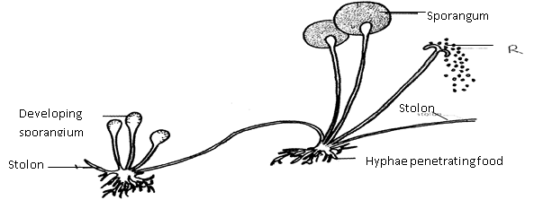
- (i) Name the Kingdom to which bread mould belongs. (1mk)
……………………………………………………………
(ii) Give two distinguishing characteristics of the Kingdom named in (a)(i) above. (2mk)……………………………………………………………………………………………………………………………………………………………………………………………………
(b) State the function of the part labeled R. (1mk)
…………………………………………………………………………………………………….

5. Explain why the following processes are important during the preparation of temporary
slides:- (a) Staining (1mk)
…………………………………………………………….................................... b)Use of a sharp cutting blade (1mk) ……………………………….…………………………………………………………………
6. In a laboratory exercise, a student observing a drop of pond water under a microscope saw and drew a spirogyra. If the magnification of the eye-piece was x5 and that of the objective lens was x100, what was the magnification of the spirogyra? (2mks)
………………………………………………………………………………………………………………………………………………………………………………………………………………………………………………………………………………………………………………………………………………………………………………………………………………………………
7. Identify the structures of the cells that perform the following functions:- (a) Synthesize ribosomes. (1mk)
………………………………………………………………………………………………… (c)Regulate exchange of substances in and out of the nucleus. (1mk)
……………………………………………………………………………………….
8. What are the functions of the following parts of a light microscope?
(a) Condenser (1mk)
………………………………………………………………………………… b)Diaphragm (1mk)
…………………………………………………………………………………
9. Potato cylinders were weighed and kept in distilled water evernight. They were then
reweighed.

2.5 g 2.4g 2.7g 3.0 g 3.1 g 3.2g
At the beginning of the Experiment. At the end of the experiment
- Calculate the average mass of potato cylinders after reweighing. Show your working. (2mks)
……………………………………………………………………………………………………………………………………………………………………………………………………………………………………………………………………………………………………………………..
- Explain why mass of the cylinders hand increased. (2mks)
…………………………………………………………………………………………………

10. The diagram below represents a cell at a certain stage in meiotic cell division
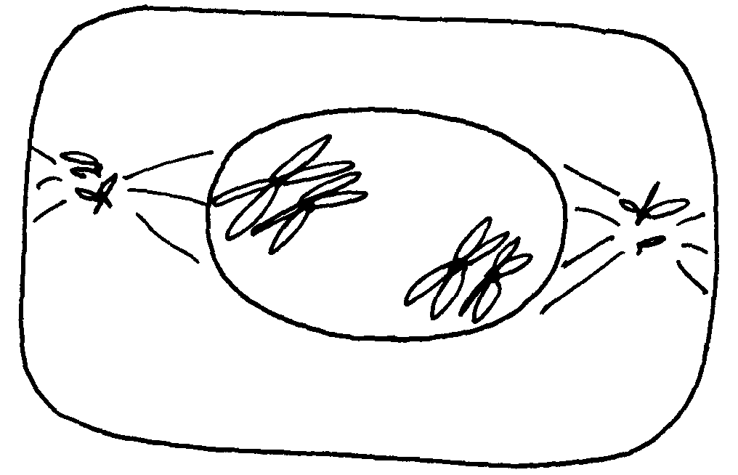

a) Name the stage at which the cell drawn above represents (1mk)
………………………………………………………………………………………………………………………………………………………………………………………………………… b)Give a distinguishing reason for your answer in 10(a) above .(1mk)
………………………………………………………………………………………………………………………………………………………………………………………………………………

11. The chemical equation below represents a physiological process that takes place in living
R
organisms:
C₆H₁₂O₆ + C₆H₁₂O₆ C₁₂H₂₂O₁₁ + Q
- Name the process R (1mk)
……………………………………………………………………………………………………………………………………………………………………………………………………………

- Name the substance Q (1mk)
……………………………………………………………………………………………………………………………………………………………………………………………………………

12. The diagram below shows cells in plants:-
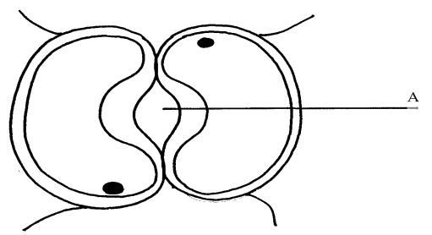

- Identify the cells shown above (1mk)

……………………………………………………………………………………

- Explain how the cells are adapted to their function (2mks)
…………………………………………………………………………………………

(c) Explain how accumulation of carbon (IV) Oxide in the cells above would lead to the closure of structure A. (2mks)

………………………………………………………………………………………………………………………………………………………………………………………………………………………………………………………………………………………………………………………
13. Below is a process that takes place along the mammalian digestive system:
Lipids
Fatty acids + glycerol
B
A

- Name the processes represented by A and B. (2mks)
A……………………………………………………………………

B…………………………………………………………………………
(b) Name part of the alimentary canal where the process B takes place (1mk)
……………………………………………………………………………………………………………………………………………………………………………………………………………..

14. In an experiment to investigate an aspect of digestion, two tubes A and B were set up as shown in the diagram below.
Starch + saliva
Starch + boiled saliva
Water bath at 37ºC
A
B

The test tubes were left in the water bath for 30 minutes. The content of each tube was then tested for starch using iodine solution.
- What was the aim of the experiment? (1mk)
………………………………………………………………………………………
- Explain the expected results in the tube. (2mks)

A………………………………………………………………………………………………….
B…………………………………………………………………
15. Name the blood vessel that nourishes the heart (1mk).
………………………………………………………………………………………………………………………………………………………………………………………………………
16. a) In which form is oxygen transported in the blood. (1mk)
…………………………………………………………………………………………………

- Why do plants not take in oxygen during the day although they need it for respiration. (2mks)
………………………………………………………………………………………………………………………………………………………………………………………………………………………………………………………………………………………………………………………
17.. The diagram below represents a transverse section of a young stem.
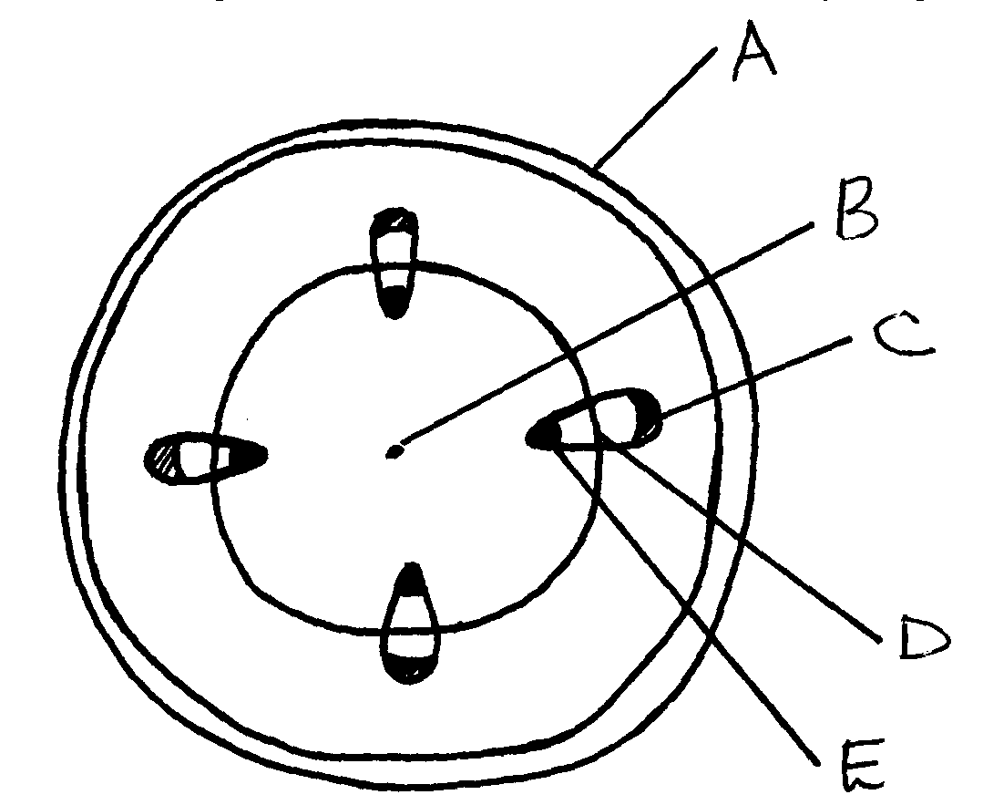

- State the functions of the parts labeled C and E . (2mks)
C………………………………………………………………………………….
D……………………………………………………………………………………

18. Give a reason for each of the following on mammalian Red blood cells (2mks)
(a) Absence of the nucleus ……………………………………………………………………………………………………………………………………………………………………………………………
- Biconcave shape
……………………………………………………………………………………………………………………………………………………………………………………………………………
19. Name the nitrogenous wastes excreted by the following organisms:- (3mks)
Animal Nitrogenous Waste
(i) Desert mole …………………….
(ii) Marine fish ………………………..
(iii) Tilapia ………………………….

20. Study the homeostatic scheme below:
Excess
Less hormone A
released
Normal concentration of sodium ions in the blood
Release of hormone A
Normal concentration of sodium ions in the blood
Further deficiency
D
Deficiency
C
C

(a) Identify the hormone labeled A. (1mk) ………………………………..
(b) Name the site of action of hormone A (1mk) ………………………………..
(c) Identify the feedback labeled D (1mk) ……………………………………..
21. A student wanted to estimate the number of grasshoppers in 5km² grass field near the school compound. Using a sweep net he captured 36 grasshoppers. He used a red felt pen to mark the thorax of each insect before releasing it back into the field. Three days later he made another catch of grasshoppers. He collected 45 grasshoppers of which only 4 had been marked with red mark.
a) Name the above method used in the population estimation (1mk)
………………………………………………………………………………………………………………………………………………………………………………………………………………
b) Calculate the population of grasshoppers using the above data (3mks) .
………………………………………………………………………………………………………………………………………………………………………………………………………………………………………………………………………………………………………………………………………………………………………………………………………………………………………………………………………………………………………………………………………………………………………………………………………………………………………………

22. The figure represents a feeding relationship in an ecosystem
Grasshopper
Grass
Guinea fowls
Termites
Gazelles
Leopards
Vulture

- Write down the food chain in which the Guinea Fowls are secondary consumers. (2mks)
………………………………………………………………………………………………………………………………………………………………………………………………………………

- What would be the short term effects on the ecosystem if lions invaded the area. (2mks)
………………………………………………………………………………………………………………………………………………………………………………………………………………………………………………………………………………………………………………………
(c) Name the organism through which energy from the sun enters the food web. (1mk)
………………………………………………………………………………………………………………………………………………………………………………………………………………
23. The diagram below represents a mature embryo sac. Study it carefully and answer the questionsthat follow:
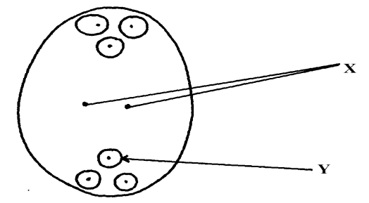

- Identify structures X and Y (2mks)
X……………………………………………………..

Y………………………………………………………….

- Why is cross pollination more advantageous to a plant species than self pollination? (2mks)
…………………………………………………………………………………………………………………………………………………………………………………….

24. Explain why menstrual periods stop immediately after conception? (2mks)
……………………………………………………………………………………………………………………………………………………………………………………………………………………………………………………………………………………………………………………………………………………………………………………………………………………………..
25. The diagrams below represent two gynoecia A and B obtained from two different plants.

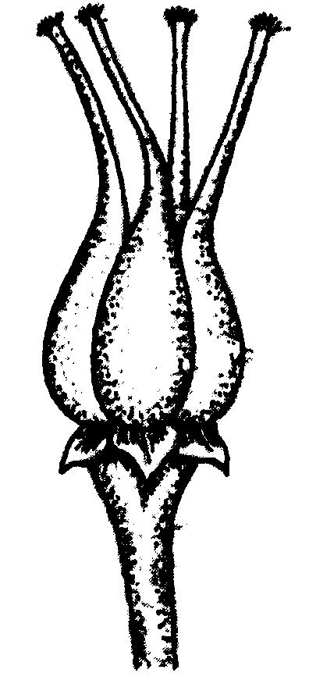
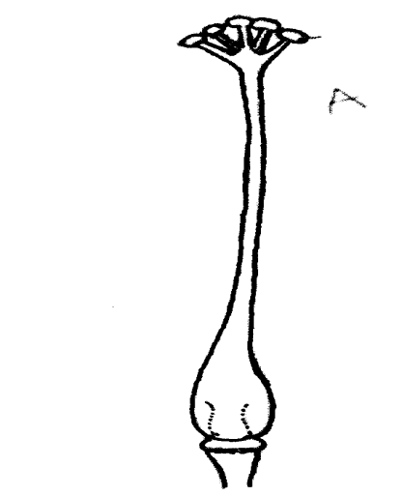
A
B

(a) What name is given to; Gynoecium A? …………………………….(2mks)

Gynoecium B? ……………………………….

- State the observable difference between the gynoecia A and B (1mk)
……………………………………………………………………………………………………………………………………………………………………………………………..

- State the role played by Heterostyly in plants. (1mk)
………………………………………………………………………………………………………………………………………………………………………………………………

26. State the difference between the sperm cell and the ovum. (3mks)
………………………………………………………………………………………………………………………………………………………………………………………………………………………………………………………………………………………………………………………………………………………………………………………………………………………………………………………………………………………………………………………………………

27. State two sources of variation (2mkS)
………………………………………………………………………………………………………………………………………………………………………………………………………………………………………………………………………………………………………………………

28. The table below is a representation of a chromatid with genes along its length. It undergoes mutation to appear as shown below:
Before mutation | L | M | N | O | P | Q
After mutation | L | O | N | M | P | Q
- Name the type of chromosomal mutation represented (1mk).
………………………………………………………………………………………………….
b) Name one mutagenic agent (1mk) ……………………………………………………………………………………
29. a) Distinguish between homologous and analogous structures in evolution. (1mk)
………………………………………………………………………………………………………………………………………………………………………………………………………………………………………………………………………………………………………………………………………………………………………………………………………………………………
- Name one vestigial structure in mammals. (1mk)
……………………………………………………………………………………………………………………………………………………………………………………………………
30. (a) What is meant by the term natural selection (1mk)
…………………………………………………………………………………………………………………………………………………………………………………………………………………………………………………………………………………………………………………
31. A response exhibited by a certain plant tendril is illustrated below:

(i) Name the type of response. (1mk) …………………………………………………………………………………………………………………………………………………………………………………………………
(ii) Explain how the response named in (i) above occurs (2mks)
………………………………………………………………………………………………………………………………………………………………………………………………………………

