Name: ………………………………………………………….. Class: ……..…..............................................

Date: …………………………………………………………… Adm No: ……………………………………..

121/2
MATHEMATICS
PAPER 2
AUGUST 2022

TIME: 2 HOURS 30 MINUTES

MECS JOINT EXAMINATION
FORM FOUR
TERM 2 2022

INSTRUCTIONS TO CANDIDATES:
- Write your name, admission number and write date of examination in the spaces provided
- The paper contains two sections. Section I and Section II.
- Answer ALL the questions in section I and any five questions in section II.
- Answers and working must be written on the question paper in the spaces provided below each question.
- Show all steps in your calculations below each question.
- Marks may be given for correct working even if the answer is wrong.
- Non programmable silent electronic calculators and KNEC mathematical table may be used, except where stated otherwise.

FOR EXAMINERS USE ONLY
SECTION I
Question | 1 | 2 | 3 | 4 | 5 | 6 | 7 | 8 | 9 | 10 | 11 | 12 | 13 | 14 | 15 | 16 | TOTAL
Marks
SECTION II
GRAND TOTAL

Question | 17 | 18 | 19 | 20 | 21 | 22 | 23 | 24 | TOTAL
Marks

SECTION I (50 MARKS)
Answer all the questions from this section
- Use Logarithms correct to four significant figures to evaluate. (4marks)
$$\sqrt[3]{\frac{24.36×0.066547}{{1.48}^{2}}}$$

- Find the value of $x$ given that the matrix $\left[\begin{matrix}x+7 & 4 \\ -3 & x\end{matrix}\right]$ is singular (3 marks)

- In the figure below QT is a tangent to the circle at Q. PXRT and QXS are straight lines.
PX = 6cm, RT = 8cm, QX = 4.8cm and XS = 5cm.
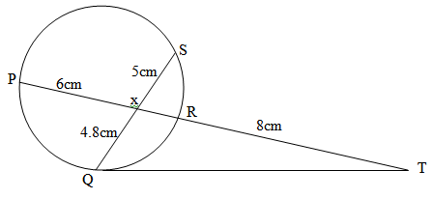

Find the length of QT (3 marks)

- Use the trapezium rule with seven ordinates to find the area bounded by the curve$y= x^{2}+1$lines x = -2, x = 4 and x – axis (3 marks)

- Given that$x=\sqrt{\frac{tp}{2 m+p}}$make $p$ the subject of the formula (3 marks)

- (a) Construct triangle PQR such that PQ = 7cm, QR = 5cm and $<PQR=30°$ (2 marks)

(b) Construct the focus L₁ of points equidistant from P and Q to meet the locus L2 of points equidistant from Q and R (2 marks)

- The points (5, 5) and (-3, -1) are ends of a diameter of a circle centre A. Determine:
a) The coordinates of A. (1 mark)

b) The equation of a circle expressing it in form x² + y² + ax + by + c = 0 (2 marks)

- A transformation is represented by the matrix$\left[\begin{matrix}1 & 3 \\ 4 & 2\end{matrix}\right]$ . This transformation maps a triangle ABC of the area 12.5cm² onto another triangle A′B′C′. Find the area of triangle A′B′C′. (3marks)

- Pipe A can fill a tank in 2 hours, pipes B and C can empty the tank in 5 hours and 6 hours respectively. How long would it take
(a) To fill the tank if A and B are left open and C closed (2 Marks)

(b) To fill the tank with all the pipes open (2 Marks)

- i) Expand and simplify (1-3x)⁵ upto the term in x³ (2 marks)

ii) Hence use your expansion to estimate (0.97)⁵ correct to 4d.p. (2 marks)

- Solve for x in the equation:
$2cos4x= -1$ for $0^{0}$< x <${180}^{0}$ (3 marks)

- Wanjiku pays for a car on hire purchase in 15 monthly instalments. The cash price of the car is Ksh.300, 000 and the interest rate is 15%p.a. A deposit of Ksh.75, 000 is made. Calculate her monthly repayments. (3 marks)

- The gradient function of a curve is given $\frac{dy}{dx}$ = 3x² – 8x + 2. If the curve passes through the point, (2, –2), find its equation. (3 marks)

- Simplify the following surds leaving your answer in the form a+ b$\sqrt{c}$ (3marks)
$$\frac{\sqrt{5}}{2\sqrt{2} -\sqrt{5 }} + \frac{\sqrt{2}}{2\sqrt{2}+\sqrt{5 }}$$

- The sum of two numbers is 24. The difference of their squares is 144. What are the two numbers? (3marks)

- The data below represents the marks scored by 9 form 4 students in an exam:
40, 37, 39, 40,41,43,44, 37,44
Calculate the interquartile range of the above data (3 marks)

SECTION II (50 MARKS)
Answer five questions only from this section
- The following table shows the rate at which income tax was charged during the year 2021
Monthly taxable income in Ksh. | Tax rate %
0 – 9860 | 10
9861 – 19720 | 15
19721 – 29580 | 20
29581 – 39440 | 25
39441 – 49300 | 30
49301 – 59160 | 35
over 59160 | 40
Maina earns a basic salary of Ksh.42000 and a monthly house allowance of sh.13000. He contributes 7.5 % of his basic salary to pension scheme. This contribution is exempted from taxation. He is entitled to a personal relief of sh.2400 per month. Calculate:
a) His monthly Taxable income (2 marks)

b) Calculate his net monthly tax (6 marks)

c) Maina’s monthly salary (2 marks)

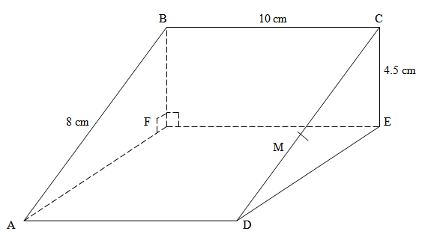

The above diagram represents a wooden prism. ABCD is a rectangle. Points E and F are directly below C and B respectively. M is the mid-point of CD. AB = 8 cm, BC = 10 cm and CE = 4.5 cm.
(a) Calculate the size of angle CDE (2 marks)

(b) Calculate the
(i) Length of AC (2 marks)

(ii) Angle AC makes with the plane ADEF (2 marks)

(c) Find the:
(i) Length of MB (2 marks)

(ii) Angle CBM (2 marks)

- An aeroplane left town $P({65}^{o}N, {15}^{o}E)$ to another town $Q({65}^{o}N , {165}^{o}W)$ at a speed of 200 knots using the shortest route. $(Take π = \frac{22}{7} , R = 6370km)$
a) Find
i) The shortest distance travelled in nautical miles. (3 marks)

ii) The time taken from P to Q in hours. (2 marks)

b) Another plane left P at 1.30 p.m local time and travelled to T (650N, 60 ⁰E) along the parallel of latitude. Find
i) The distance between P and Q to the nearest kilometres. (3 marks)

ii) The local time of arrival at T if the plane flew at 470km/hr. (2 marks)

- The probability that a student goes to school by a boda-boda is $\frac{2}{3}$ and by a matatu is $\frac{1}{4}$ . If he uses a boda-boda the probability that he is late is $\frac{2}{5}$ and if he uses matatu the probability of being late is $\frac{3}{10}$. If he uses other means of transport the probability of being late is $\frac{3}{20}$.
a) Draw a tree diagram to represent this information. (3marks)

b) Find the probability that he will be late for school. (3marks)

c) Find the probability that he will be late for school if he does not use a matatu. (2marks)

d) What is the probability that he will not be late to school? (2marks)

- A farmer has 50 acres of land. He has a capital Shs. 2,400 to grow carrots and potatoes as cash crops. The cost of growing carrots is Shs.40 per acre and that of growing potatoes is Shs.60 per acre. He estimates that the respective profits per acre are Shs.30 (on carrots) and Shs. 40 (on potatoes). By letting x and y to represent the acres of carrots and potatoes respectively:-
- Form suitable inequalities to represent this information. (4marks)

- b) By representing this information on a graph, determine on how many acres he should grow each crop for maximum profit (4marks)

- Find the maximum profit. (2marks)

- The 2nd and 5th terms of an arithmetic progression are 8 and 17 respectively. The 2nd, 10th and 42nd terms of the A.P. form the first three terms of a geometric progression. Find
(a) the 1st term and the common difference. (3marks)

(b) the first three terms of the G.P and the 10th term of the G.P. (4marks)

(c) The sum of the first 10 terms of the G.P. (3marks)

- In the triangle PQR below L and M are points on PQ and QR respectively such that PL:LQ=1:3 and QM:MR=1:2, PM and RL intersect at X, given that PQ = b and PR = c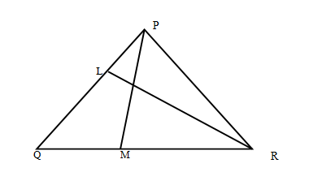
P
- Express the following vectors in terms of b and c
(i) QR (1mark)

(ii) PM (1mark)

(iii) RL (1mark)

- By taking PX = hPM and RX = kRL where h and k are constants find two expressions of PX in terms of h, k, b and c. Hence determine the values of the constant h and k. (6marks)

- Determine the ratio LX:XR (1mark)

- Given that y = 2sin 2x and y = 3cos (x + 45)º
- Complete the table below. (2mks)
X | 0⁰ | 20⁰ | 40⁰ | 60⁰ | 80⁰ | 100⁰ | 120⁰ | 140⁰ | 160⁰ | 180⁰
2sin2 x | 0 |  | 1.97 |  | 0.68 | -0.68 | -1.73 |  | -1.29 | 0.00
3cos (x+ 45⁰) | 2.12 | 1.27 |  | -0.78 |  | -2.46 |  |  | -2.72 | -2.12
- Use the data to draw the graphs of y = 2 sin 2x and y = 3 cos (x + 45º) for 0º≤ x ≤ 180ºonthe same axes. (4marks)
  - State the amplitude and period of each curve. (2marks)

  - Use the graph to solve the equation 2 sin 2x – 3cos (x + 45⁰) = 0 for 0⁰≤ x ≤ 180⁰
(2marks)

