MECS JOINT EXAMINATION

MATHEMATICS
121/1
PAPER 1
END OF TERM 2 - SEPTEMBER, 2022
Form 4

MARKING SCHEME
1. | $\frac{2}{3}+\frac{5}{6}$ = $\frac{4+5}{6}= \frac{9}{6}- \frac{5}{4}= \frac{18-15}{12}= \frac{3}{12}= \frac{1}{4}$  $\frac{16}{3}+\frac{9}{10}$= $\frac{160+27}{30}= \frac{187}{30} \frac{16}{5}×\frac{7}{8} × \frac{11}{6}= \frac{77}{15}$  $\frac{2}{7}+\frac{77}{15}= \frac{30+539}{105}= \frac{569}{105}$ - $\frac{187}{30}=$ = $\frac{-57}{70}$  $\frac{1}{4}×\frac{-70}{57}$ = $\frac{-35}{144}$ | M1  M1 A1
2. | $$\sqrt{6.458 ×{10}^{-2}}+ 2 {\left(\frac{1}{0.4327}\right)}^{2}$$  2.541x10⁻¹ + (2x2.311)²  = 0.2541 + (4.622)²  = 0.2541 + 21.363  =21.62 | M1  M1  M1  A1
3. | log₂9 + log₂ $\left(x^{2}- \frac{x}{3}\right)={\log_{2}}^{2}$  $${9x}^{2}- 3x-2=0$$  $$\left(3x+1\right)\left(3x-2\right)=0$$  $x= \frac{-1}{ 3}$ or $\frac{2}{3}$ | M1  M1  A1
4 | 840 = $2^{3}×3×5×7$  $$396= 2^{2}×3^{2}×11$$  G.C.D = $2^{2}×3^{2}=12$  Area = 12 $×12=144$ | M1  M1  A1
5 | Mass(kg) frequency  41-50 20  51-55 25  56-65 40 | B1  B1  B1 | For frequency  For each bar
6 | 2x – 2 $≤3x+1$  -2 – 1 $≤3x-2x$  -3 $≤x$ B1 for -3$≤x$  3x + 1 < x + 11  2x < 10  X<5 B1 for x < 5  -3 $≤x<5$  Integral values -3,-2, -1, 0, 1,2,3,4 B1 – All correct integral values | B1  B1  B1
7 | Sum of int. angles = $\left(2n-4\right)90=\left(2\left(6\right)-4\right)90=720$  $$\frac{1}{2}+4x+40+2x+160+110+130=720$$  $$x=80$$  smallest angle$={40}^{0}$ | M1  M1  A1
8 | AC = $\sqrt{({85}^{2}{-75}^{2})}$ = 40M  Area of quadrilateral A B C D  = $\frac{1}{2}×40×75+75+75(75-60)(75-50)(75-40)$  = 2492m²  In hectares; 2492 = 0.2492 ~ 0.25ha  10,000 | M1  M1  A1  B1 | Sum of both areas  For area  In hectares to 2 decimal places.
9 | (i) In 1 hour:  11 x 3600 = 7920cm³  5  Capacity of water lost = 7.92 litres  (ii) Volume of tank = 3.142 x 30² x 30  = 84834cm³  = 84.834 litres  Time = 84.834  7.92  = 10.711 ~ 10.71 hours | M1  A1  M1  A1
10 | $${\left(\frac{3^{3}}{2^{3}}\right)}^{x+7}={\left(\frac{3^{2}}{2^{2}}\right)}^{3x}$$  $${\left(\frac{3}{2}\right)}^{3x+21}={\left(\frac{3}{2}\right)}^{6x}$$  3x + 21 = 6x  3x = 21  x = 7 | M1  M1  A1
 |  | 03
11 | 1 + T = - 1  2 2  T = -1 - 1  2 2  = -2  0  x + - 2 = -3  y 0 -3  x = -3 - -2  y -3 0  = -1  -3  R(-1, -3) | B1  M1  A1
12 | No. of oranges sold on Monday;  6144 = 768  8  No. of oranges that remained on Sunday;  768 – 560 = 208  No. of oranges bought on Saturday.  208 + 750 + 750 + 240  = 1948 | M1  M1  M1  A1 | √ division  √ subtraction  √ Addition
13 | $$\frac{2x-3}{3}- \frac{x-2}{2}- \frac{1-x}{4}= \frac{4\left(2x-3\right)- 6\left(x-2\right)-3\left(1-x\right)}{12}$$  $$= \frac{8x -12-6x+12-3+3x}{12}$$  $$= \frac{5x -3}{12}$$ | M1  M1  A1
14 | Vol of water: ¾ x 2.5 = 1.875l  Vol of ethanol ¼ x2.5 = 0.625l  Mass of water 1875 x 1 = 1875g  Mass of ethanol 625 x 1.2 = 759g  Mass of mix= 1875 + 750=2625g | M1  M1  A1
15 | 9.74 x 105,000=Ksh.1,022,700  1,022,700-403897=Ksh.618,803  $\frac{618803 x 100}{75.12}$= 832,752.66 yen | M1  M1A1
16 | `1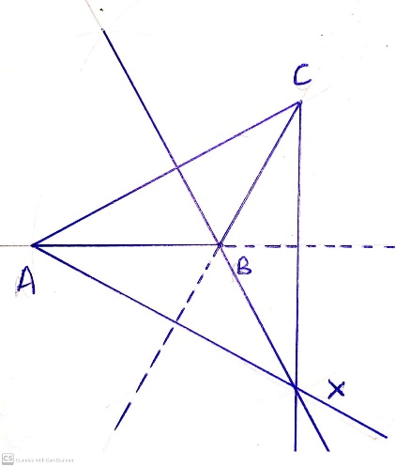 | B1  B1  B1 | For √ const. of 60⁰  For 2 correctly dropped perpendicular  For identifying point X.
 |  | 3
17 | - $m_{1}=\frac{6-3}{-1+2}=3$  $\frac{3}{1}=\frac{y-3}{x+2}$  $$y-3=3\left(x+2\right)$$  $$y=3x+9$$  - $m_{2}=-\frac{1}{3}$  $$\frac{-1}{3}=\frac{y-6}{x+1}$$  $$3y-18=-x-1$$  $$x+3y-17=0$$  - $m_{3}=3$  $$\frac{3}{1}=\frac{y-2}{x-2}$$  $y=3x-1$  At $x$ intercept; $y=0, x=\frac{1}{3};x-intercept= \frac{1}{3}$  At y intercept; $x=0, y=-1;y intercept=-1$  - At point of intersection, y values are equal  $$3x-1=\frac{-x}{3}+\frac{17}{3}$$  $$9x-3=-x+17$$  $$10x=20; x=2$$  $$y=3\left(2\right)-1=5$$  Point of intersection (2, 5) | M 1  A 1  M 1  A 1  M 1  A 1  A 1  M 1  M 1  A 1
 |  | 10
18 | (a) 108 x 22 x 20 x 20  36 7  377.14  (b) 3.77.14 = $\frac{22}{7}$ x r x 20  r = 377.14 x 7  22 x 20  r = 6.0  (c) h² + 6² = 20²  h = $\sqrt{{20}^{2} – 6^{2}}$  h = 19.079  h = 19.1  (d) 19.08 = 6  12 r  r = 3.774  Volume of smaller cone =$\frac{1}{3}$ ×$\frac{22}{7}$ (3.774)² x 12  = 179.1  Volume of larger cone $\frac{1}{3}$ ×$\frac{22}{7}$ (6)² x 19.08  = 719.6  719.6 - 179.1  = 540.5 | M1  A1  M1  M1  A1  M1  A1  M1  M1  A1 | Expression for the 2 Volume  Subtraction
 |  | 10
19 | 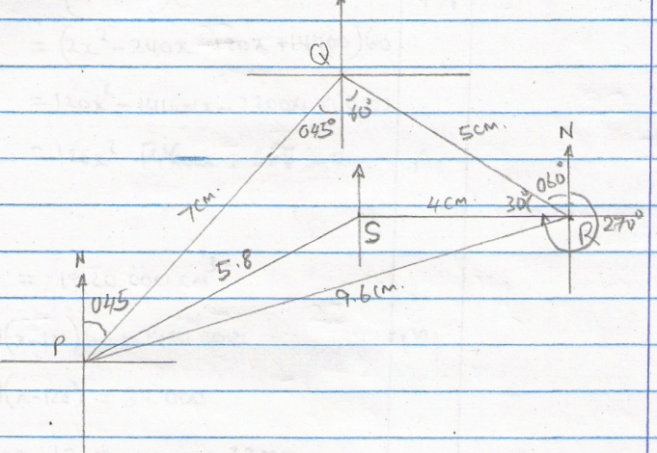  (a)  (b) (i) 9.6 km + 0.1  75⁰ + 0.1  (ii) 5.8 km + 0.1  246⁰ + 0.1  (iii) Area = ½ x 7 x 5 sin 105⁰ – ½ x 4 x 5.8 sin 154  = 16.90370196 – 5.085105303  = 11.81859666  = 11.82 cm² | B1  B1  B1  B1  B1  B1  B1  M1 M1  A1 | Location of point Q  Location of point R  Location of point S.  Distance of R from P  Bearing of R from P  Distance of P from S  Bearing of P from S  Follow through
20 | $w$ = $\frac{28}{X}$  Area = $\left(x-1\right)\left(\frac{28}{x}-1\right)$ = $\frac{3600}{200}$  $\left(x-1\right)$ $\left(\frac{28}{x}-1\right)$ = 18  28 – $x$ - $\frac{28}{x}$ + 1 – 18 = 0  -$x$ - $\frac{28}{x}$ + 11 = 0  $x^{2}$ + 28 - 11$x$ = 0  $x^{2}$ - 11$x$ + 28 = 0  $x^{2}$ - 7$x$ - 4$x$ + 28 = 0  $x\left(x-7\right)$ - 4$\left(x-7\right)$ = 0  $\left(x-7\right)$ $\left(x-4\right)$ = 0  $x$ = 7 or $x$ = 4  Length = 7m  Area not previously covered = 28 – 18 $m^{2}$  = 10 $m^{2}$  Cost = 10 × $\left(200+150\right)$  = 10 × 350  = sh. 3500 | B1  B1  M1 M1  M1  M1  A1  M1  M1  A1 10 | For 28  For $\frac{28}{X}$  For $\frac{3600}{200}$ and area  Accept alt
21 |  | B1  B1  B1  B1  M1  M1  A1  M1  M1  A1
22 | - $Distance of A before B started=65 ×2\frac{1}{6}$  $$=140.83km$$  $$Distance shared=460-140.83$$  $$=319.17km$$  $$Time to meet=\frac{319.17km}{145}$$  $$=2.2011hrs$$  $$Distance from B =80 ×2.2011$$  $$=176.09km$$  - $Time ≈2hrs 12 minutes$  $$Meeting time=1055hrs+2hrs 12 min$$  $$=1307hrs$$  $$=1.07pm$$  - $Time taken by minibus= \frac{460}{65}$  $$≈7 hrs 05minutes$$  $$Time to reach B= 0845hrs+7 hrs 5 mins$$  $$=1550hrs$$  $$= 3.50pm$$  $$Time of the motorist= 1550hrs-0915hrs$$  $$=6hrs 35minutes$$  $$Distance= 120×6\frac{35}{60}$$  $$=790km$$ | M1  M1  M1  A1  M1  A1  M1  M1  M1  A1
23 | (a) 250 x 14 x 2 x 2 = 14000  Net profit = 14000 – 6000  = KSh. 8000  (b) 8000 x 25 = 200,000  = 190,000  (c) Saving: $\frac{40}{100}$ x 190,000  = 76000  Remaining profit = $\frac{36}{100}$ x 190,000  = 68,400  Muthoka’s share  $\frac{45,600}{3}$ + $\frac{2}{9}$ x 68,400  = 30,400  (d) 475,000 x 3 x 100  95  = 1,500,000 | M1 Profit  A1  B1 Profit  M1 Equation for equal share  A1  M1 Expression of Muthoka’s share  A1  M1M1  A1
 |  | 10
24 | (a) Initial acceleration is at t = 0  $V=\frac{ds}{dt}$ = - 6$t^{2}$ + 3t + 3  a = $\frac{dv}{dt}$ = -12t + 3  when t = 0, a =[ 0 + 3  ∴ a = 3m/s²  (b) (i) at rest V = 0  -6$t^{2}$ + 3t + 3 = 0  (2t + 1) (t-1) = 0  t = -$\frac{1}{2}$ or t = 1 (t = -$\frac{1}{2}$ not applicable)  (ii) S = -${2t}^{3}$ + $\frac{3}{2}t^{2}$ + 3t  When t =m 1, s = -2${(1)}^{3}$ + $\frac{3}{2}$ ${(1)}^{2}$ + 3 (1)  2.5M  (c) When velocity is maximum, a = 0  -12t + 3 = 0  t = $\frac{1}{4}$  Max v = -6 ${\left(\frac{1}{4}\right)}^{2}$ + 3$\left(\frac{1}{4}\right)$ + 3 = 3.375 m/s | M1  M1  A1  M1  M1  A1 for t = 1  M1 Substitution  A1  M1For substitution  A1
 |  | 10

