Mathematics Activities - CBC Grade 1 Term 1 Exams 2023 Set 1

Questions
- Arrange from the largest to smallest.
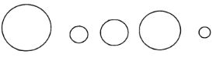
- Write these numbers in symbols
Fifty _______________
Seventeen _______________
Forty six _______________
Thirty nine _______________
Twenty three _______________
- Match the numbers with the objects
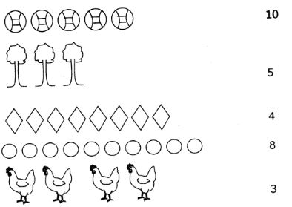
- Circle the ones that are the same in numbers.
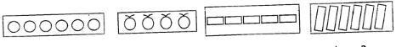
- A class has 20 learners. 10 are boys. How many girls are there?
- What is 16 take away 8?

  - 30
-20
  - 40
- 20
  - 60
-30
- A farmer had 20 cows. He bought 10 more cows. How many cows did he have altogether?

  - 52
+7
  - 32
+14
  - 18
+11
  - 40
+30
- Write the missing numbers. (5m arks)
  - 10, 15, ____,25
  - 35, 33, 31,____
  - 30, 32, ___, 36
  - 40,45, 50,___
  - 37, 39, 41,___
- Count and write backward by 5 from 35 to 15 (5marks)
___,____, ____,_____, ____
- There are ________ days in a week.(6, 5, 7)
- Fill in the missing days (4marks)
Sunday,_______ , Tuesday,________,________, Friday,_______

Marking Scheme

- 50
17
46
39
23

- 10
- 8

  - 10
  - 20
  - 30
- 30

  - 59
  - 46
  - 29
  - 70

  - 20
  - 29
  - 34
  - 55
  - 43
- 35,30,25,20,15
- 7
- Sunday, Monday, Tuesday, Wednesday, Thursday, Friday, Saturday

