Mathematics Activities - CBC Grade 1 Term 1 Exams 2023 SET 2
QUESTIONS
- Count and Write
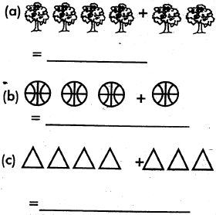
- Fill the missing numbers
  - 1, 2,____, 4, 5
  - 7, 8,____, 10, 11
  - 10,11, 12, ____,14
- Match the shapes
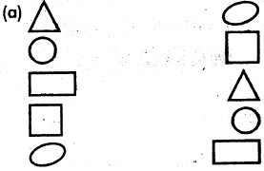
- Draw balls
  - 5=
  - 6=
  - 8=
  - 10=
- A cow has____legs
- Take away
  - 57
-23
  - 28
-13
  - 19
- 9
  - 9 - 8
- Write tens and ones
11 =1 tens and 1 ones
  - 24 = ____tens and____ ones
  - 36 = ____tens and____ ones
  - 16 = ____tens and____ ones
- Count how many
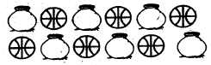
  - balls
  - pots
- Write in words
2____________
5____________
8____________
9____________
10____________
- Arrange the numbers from the biggest
  - 6,8,10,11,9
  - 4,7,3,1,10
  - 5,2,0,1
- Put together
  - 3 + 3 + 2 =____
  - 4 + 4 = ____
  - 5 + 3 =____
  - 6 + 7 =____
- Four hens have____ legs

- Five cats have ____eyes

MARKING SCHEME

  - 6
  - 4
  - 7
  - 5

  - 3
  - 9
  - 13

- 4

  - 34
  - 15
  - 10
  - 1

  - 2,4
  - 3,6
  - 1,6

  - 6
  - 6
- two
five
eight
nine
ten

  - 6,8,9,10,11
  - 1,3,4,7,10
  - 0,1,2,5

  - 8
  - 8
  - 8
  - 13
- 8
- 20

