Mathematical Activities - Grade 1 Term 1 Exam 2023
Writing the missing numbers
- 1, __, 3, __, 5, __,7
- 5, 6, 7, __, __,
- 4, 6, __, 10
Add
- 6+3=____
- 7+4=____
- 5+5=____
Writing the missing numbers
- 2 + __ =3
- ___+ 4 =6
- 5 + __ =7
- 6
+5
___
- 5
+3
___
Take away
- 6 take away 2 is =______
- 4 take away 1 is =______
- 8 take away 6 is =______
- 11 - 5 = ______
- 16 - 8 =______
- 6
- 1
___
- 12
-6
___
- Which one holds less
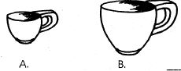
- WHich one is heavier
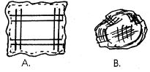
How many
- 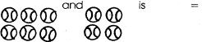
- 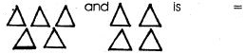
Draw values
- 13=________________
- 15= ________________
- 17=________________

