GRADE 1
ART/CRAFT /MUSIC TERM 1 2023
- Colour the musical instrument

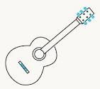

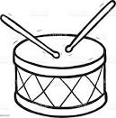

- Name these lines (straight, zigzag, wavy)

a. b.

______________ ________________________

c.
________________________
- Match the surface and the feeling
Coconut smooth
Banana rough

- Complete the numeral patterns
      - 01 01 01_____________________________
      - 5 6 5 6_________________________

- Which patterns are this (line numeral)
66666666
222222222
11111111

___________
________

- Singing games are song sung by ___________(children, birds)
- _____________is the tune of music (melody, mercy)
- I sing _________to sooth the baby (lullaby)
- I love my county I sing _____________________ (patriotic, round song)

- Fill in
Ee mungu nguvu ______________,
Ilete ___________ kwetu,
Haki iwe _____________ na mlinzi,
Natukae na undugu,
Αmani na _________________,
Raha _________________ na ustawi.
When do we sing the National anthem
a. _______________________________________.
b. _______________________________________.

