GRADE 1
MATHEMATICS ACTIVITIES TERM 1 2023
- colour the biggest picture
a.

b.

c.

2. Use more than, less than or equal to.

- 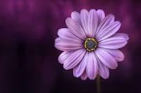__________

- 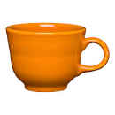______________

3. ___________

Tick the rough one and colour the smooth one

banana
stone
Pine apple
apple

b.

c.
egg
basket

- Fill in
1 2 3 4____6____8 9_____
4 8 12 ___16 ___20
15 ___25 ____ ___ 40
10 20 _____ _____50

- Write the missing numbers
24=
45=
5=
42= ________tens _____ones
8= _________tens ______ones
- Write in words
7- ___________________
6- ___________________
8- ___________________
10-__________________
- Add
3 +6 = ________________
2 + 5+2=__________________
- Take away

